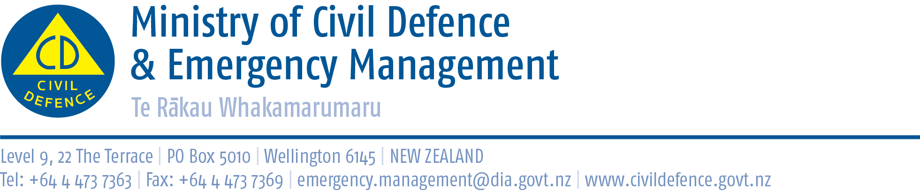

Media Release 5 October 2012

Release of independent review into earthquake response

The independent Review of the Civil Defence Emergency Management Response to the 22 February Christchurch Earthquake was today released by the Ministry of Civil Defence & Emergency Management. http://www.civildefence.govt.nz/memwebsite.nsf/wpg_URL/For-the-CDEM-Sector-Publications-Review-of-the-Civil-Defence-Emergency-Management-Response-to-the-22-February-Christchurch-Earthquake?OpenDocument

The Director of Civil Defence Emergency Management (CDEM), John Hamilton, said the Ministry commissioned the report to identify lessons for the management of future emergencies.

The report found that: “Overall, the response to this extremely challenging situation can justifiably be regarded as having been well managed and effective”.

In particular it found that:
- the initial response strategy was sound
- emergency services responded rapidly and worked together well
- private utility providers and Christchurch City Council were well prepared and responded well from a lifelines perspective
- voluntary groups provided major assistance
- technical aspects of inspecting damaged buildings were performed well
- the decision to provide a subsidy for wages was highly effective and successful
- communication between Ministers, departments, the Officials’ Committee for Domestic and External Security Coordination, and the National Crisis Management Centre ran well.

The report concludes: “Despite ongoing difficulties of historical nature within the local CDEM structure it was reassuring to discover the way in which those managing the emergency and in the Christchurch community dealt with challenges unprecedented in New Zealand. Overall the response went well, but some aspects could be done better in future. What the review learnt of the strengths and weaknesses of the response can be applied to help cities in New Zealand even more vulnerable to major disasters than is Christchurch.”

It also concluded that: “legislation and subsidiary documents provide an adequate basis for emergency management and the changes in structures and operations proposed in the review would require relatively straightforward and limited amendments to the documents.”

The report makes 108 recommendations that would involve work across different central and local government agencies. The Ministry will coordinate an interagency corrective action plan for work programmes over the next two years. It will report back to the Cabinet Committee for Canterbury Earthquake Recovery with the corrective action plan in November.

The report made six major recommendations, and, in response, the Ministry will:
- continue to work with all 16 regional CDEM Groups to assist with strengthening local response arrangements
- explore options for the availability of suitably experienced emergency managers to support response operations in large-scale emergencies
- review its guidelines and promote better connection between the official emergency response and community organisations
- review its guidelines and ensure higher priority is given to preserving businesses and jobs after an emergency
- remain a business unit in the Department of Internal Affairs
- continue to promote a culture of preparedness for emergencies among individuals, families and organisations in all sectors.
Two of the report’s major recommendations have not been adopted. They were that:
Territorial local authorities no longer have power to control the response to emergencies, but that they still retain the power to declare them.
Mr Hamilton said the Ministry will, instead, continue to work with the 16 regional CDEM Groups to strengthen, rather than diminish, the role of councils in all aspects of CDEM. The ongoing commitment of councils is crucial to the success of CDEM responses. Most emergencies are short, localised events that are best dealt with at the local level without needing the CDEM Group to formally lead the response.

Consideration be given to relocating the Ministry within the Department of Prime Minister and Cabinet so as to provide a better platform for launching responses.
The Ministry will remain within the Department of Internal Affairs and will work to increase other agencies’ awareness of its lead role in a major emergency. The Department of Internal Affairs will continue to provide support services such as information and communications technology, finance, facilities and supplementary staff. After the Christchurch earthquake, the Department quickly reprioritised its resources to give full support to the Ministry and the response.

“I would like to thank the reviewers for their work. Their report provides a good overview of the response to the earthquake, and how we can strengthen our country’s CDEM arrangements,” Mr Hamilton said. “We are carefully considering each of their recommendations and will report to Cabinet how we will implement them.”

Media contact:
Public Information Duty Officer,
Telephone: 04 494 6951
E-mail: pim@ncmc.govt.nz

Follow the Ministry on Twitter or subscribe to our RSS feed

 If a disaster happened now, would you be ready? www.getthru.govt.nz

