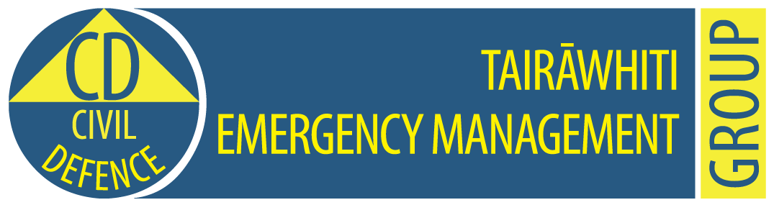

**Tairawhiti CDEM Group Emergency Coordination Centre**

**Exercise Tangaroa Only**

**MEDIA RELEASE**

**10.15am, 31 August 2016                                                   Release No: 2**

**Focus now on evacuating Gisborne coastal residents**

Residents living close to Gisborne’s coast this morning are being evacuated as tsunami waves of up to three metres are expected to strike Wainui and Gisborne coastlines soon after 10.20am.

The tsunami wave arrived at 10.03am at Te Araroa, earlier than expected, and has pushed debris on to Moana Parade, parallel to the coast.

Tairawhiti Civil Defence Emergency Managemenet controller John Clarke advised people that the first wave is not necessarily the biggest.

“All people should get to higher ground and stay away from the beaches. Do not go sightseeing.”

A Civil Defence emergency was declared at 9.50am.

Evacuation is under way from tsunami evacuation zones.  Many people have self-evacuated.

State Highway 35 is closed from Okitu north through to Opotiki closed.

Awapuni Road from the Jolly Stockman corner is also closed.

State Highway 2 will be closed from Customhouse Street to restrict access within the Gisborne city’s evacuation zone,

A 9 magnitude earthquake was reported in the Kermadec Islands shortly after 9am this morning.

All people living or near the coast in the Gisborne district are advised to get to higher ground or move inland and keep listening to the radio for advice from Tairawhiti Civil Defence Emergency Management.

Schools have self-evacuated at Te Araroa, Tokomaru Bay and Tolaga Bay.

Tairawhiti Civil Defence Emergency Management centre has been activated along with the National Crisis Management Centre.

The earthquake was centred at 29.8S and 177.5W at a depth of 33km deep.

This information is part of Exercise Tangaroa. There is no tsunami. We are part of a test of New Zealand’s arrangements for preparing for, responding to, and recovering from a national tsunami impact. For more information to go <http://www.civildefence.govt.nz/cdem-sector/exercises/exercisetangaroa2016/>

**For further information contact:   Louise Bennett                      Mobile: 027 416 9475**

**Sheridan Gundry 0274 782 900**

**Email:** [CD.Media@gdc.govt.nz](mailto:CD.Media@gdc.govt.nz)