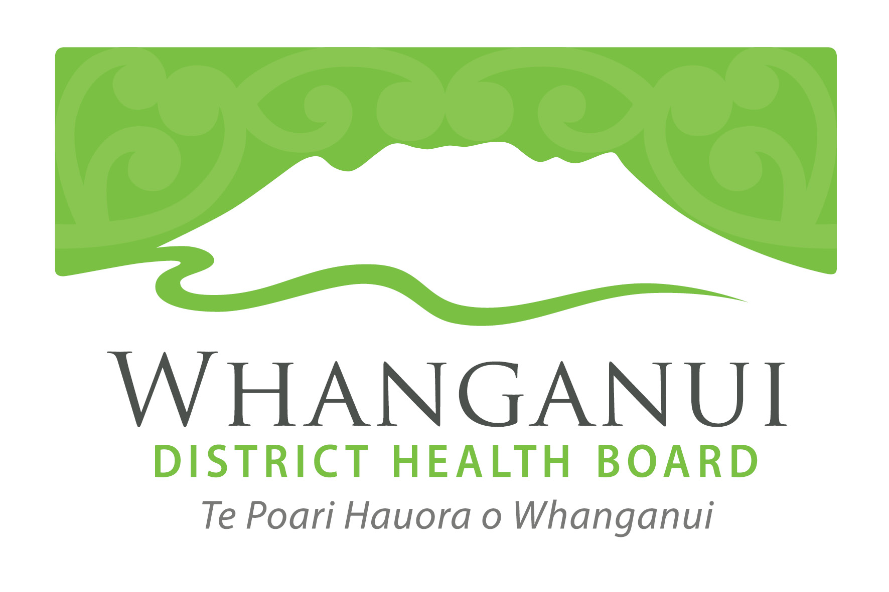

Whanganui DHB tsunami update

31 August 2016

A tsunami struck the Castlecliff coastline in Whanganui at 12.34pm as a result of a large, shallow earthquake which occurred close to the Kermadec Islands around 9am this morning.

Whanganui DHB’s Emergency Operations Centre (EOC) is communicating with staff and preparing the hospital for residents presenting with injuries.

All non-urgent appointments at Whanganui Hospital have been cancelled.

Please only use the national 111 emergency number in the case of an emergency. For minor issues, please call Healthline on 0800 611 116.

The WDHB has reiterated that it’s important people remain calm while taking all precautions to make sure they and their families are safe.

The safety of the water around Whanganui has not yet been confirmed. Please be safe and stay out of, and do not drink, the water. Please boil all water before consuming. Conserve water where you can and please check the reserves of bottled water you have available to you and your family.

Whanganui DHB staff:
If you are rostered on but are unable to get to work or you are not rostered on but are available, please contact the Duty Nurse Manager via the switchboard.

Whanganui residents are advised to go to the Whanganui District Council’s (WDC) website and Facebook page for updates and advice in response to the tsunami. The WDC’s website is: www.whanganui.govt.nz and Facebook www.facebook.com/pages/Wanganui-District-Council/45408007048

We will provide updates to local and national media as and when information comes to hand. We would be grateful if reporters wait for these updates. Individual phone calls and emails cannot be answered.

For further media comment please contact WDHB communications manager Sue Campion on 021 246 8126 or 06 348 3170.

