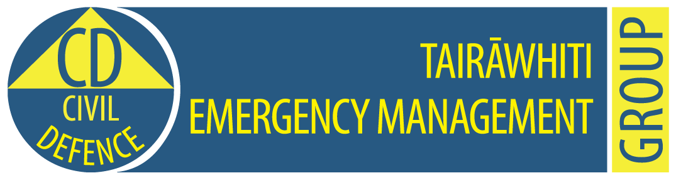

**Tairawhiti CDEM Group Emergency Coordination Centre**

**Exercise Tangaroa Only**

**MEDIA RELEASE**

**1.15am, 31 August 2016                                                     Release No: 6**

**Notice for transmitting to drivers caught on closed roads**

This morning at 9.02am, an earthquake measuring 9.2 struck near the Kermadec Islands.

This prompted a series of tsunami waves which began affecting Hicks Bay and Te Araroa from just after 10am.

More aftershocks and tsunami waves are expected for the Gisborne coastline over at least the next 24 hours.

State Highways 35 and 2 north and south are both closed. People who are in their vehicles on the road between Gisborne and Te Araroa and listening to this on the radio:

* Be prepared to stay at a welfare centre near you for at least two days,
* Keep listening to your radio

Welfare centres have been set up in Gisborne district at:

* Hospital Hill, Te Araroa
* Hicks Bay Motel
* Rahui Marae, Tikitiki
* Ngata Memorial College, Ruatoria
* Te Puia Hospital, Te Puia
* Tolaga Bay Fire Station
* Whangara B5 woolshed.
* Salvation Army Citadel, Gladstone Road, near Noel Leeming.

People who have evacuated themselves to friends and family are asked to register with Civil defence welfare at 0800 WELFARE.

Tairawhiti Civil Defence Emergency Management advises people to

* Stay away from beaches, rivers and streams
* Go to higher ground or as far inland as possible
* Keep listening to the radio for further information from Tairawhiti Civil Defence.
* If you don’t have a portable radio and your car is in a safe place, listen to the car radio,
* Do not go sightseeing.
* Be aware that the first tsunami wave is not always the biggest. More waves will follow for at least 24 hours or more.

This information is part of Exercise Tangaroa. There is no tsunami. We are part of a test of New Zealand’s arrangements for preparing for, responding to, and recovering from a national tsunami impact. For more information to go <http://www.civildefence.govt.nz/cdem-sector/exercises/exercisetangaroa2016/>

**For further information contact:   Louise Bennett                      Mobile: 027 416 9475**

**Sheridan Gundry 0274 782 900**

**Email:** [CD.Media@gdc.govt.nz](mailto:CD.Media@gdc.govt.nz)