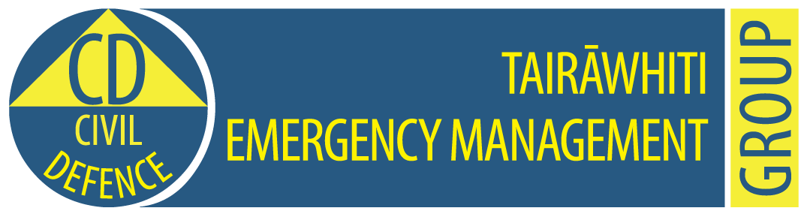

**Tairawhiti CDEM Group Emergency Coordination Centre**

**Exercise Tangaroa Only**

**MEDIA RELEASE**

**11.50am, 31 August 2016                                                   Release No: 4**

**Homes destroyed, welfare centres being set up**

About 20 homes at Hicks Bay and Tokomaru Bay have been destroyed by successive tsunami waves this morning following the magnitude 9 earthquake centred in the Kermadec Islands.

Five tsunami waves have now reached Te Araroa with worsening effects – houses and bridges have been washed away, and waves and debris have reached as far inland as the kohanga reo within the township.

In Gisborne city, Police, Fire and Search and Rescue volunteers are undertaking a co-ordinated evacuation of people in the tsunami inundation zone.

A second wave has reached Gisborne beaches with large surges pushing debris over the sand dunes. Boats in Gisborne harbour are straining at their moorings,

A welfare centre has been set up in Gisborne city at the Salvation Army Citadel, Gladstone Road, near Noel Leeming.

The expected waves in the Gisborne coastline area has now been downgraded to waves being up to three metres. Earlier, waves of up to five metres were expected.

Roads in an out of the region have been closed. Gisborne Airport is also closed.

Gisborne Police advise that the Awatere Bridge, south of Te Araroa and Wharekahika Bridge, Hicks Bay are both closed.

Police have a helicopter attending to a medical emergency at Tuparoa where an air search continues for two fishermen washed away from the shore.

A fishing boat with two people on board has not returned from Hicks Bay.  Two cars have been washed out to sea at Waima and at Turihaua, north of Gisborne, two logging trucks and four cars have been washed out to sea after a large surge of water washed over State Highway 35.

A Civil Defence emergency was declared at 9.50am.

Tairawhiti Civil Defence Emergency Management advises people to

* Stay away from beaches, rivers and streams
* Go to higher ground or as far inland as possible
* Keep listening to the radio for further information from Tairawhiti Civil Defence.
* If you don’t have a portable radio and your car is in a safe place, listen to the car radio,
* Do not go sightseeing.
* Be aware that the first tsunami wave is not always the biggest. More waves will follow for at least 24 hours or more.

This information is part of Exercise Tangaroa. There is no tsunami. We are part of a test of New Zealand’s arrangements for preparing for, responding to, and recovering from a national tsunami impact. For more information to go <http://www.civildefence.govt.nz/cdem-sector/exercises/exercisetangaroa2016/>

**For further information contact:   Louise Bennett                      Mobile: 027 416 9475**

**Sheridan Gundry 0274 782 900**

**Email:** [CD.Media@gdc.govt.nz](mailto:CD.Media@gdc.govt.nz)