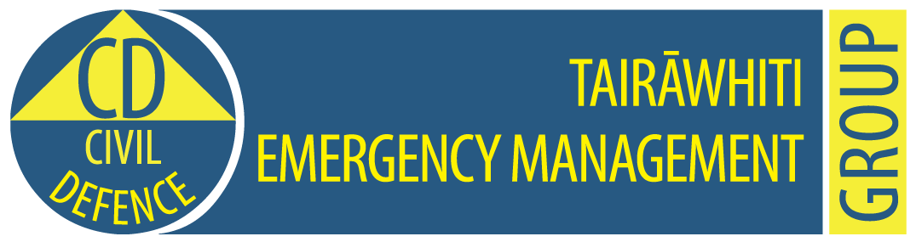

**Tairawhiti CDEM Group Emergency Coordination Centre**

**Exercise Tangaroa Only**

**MEDIA RELEASE**

**11.10am, 31 August 2016                                                   Release No: 3**

**Keep away from the beaches, rivers and streams**

Keep away from beaches, rivers and streams – that’s the message from Tairawhiti Civil Defence Emergency Management this morning in the wake of the magnitude 9 earthquake centred in the Kermadec Islands.

Tairawhiti Civil Defence Emergency Management controller John Clarke advises people that the first tsunami wave is not always the biggest wave. Several coastal townships have already been hit by second and third tsunami waves, some up to five metres high.

“The beaches, rivers and streams will be unsafe for at least 24 hours or more. The waves that follow the first wave may be even bigger than the first.”

Waves have reached Gisborne beaches with large surges  pushing debris on to the sand dunes.

A fishing boat with two people on board has not returned from Hicks Bay.  Two fisherman have been washed away at Tuparoa, on the coats from Ruatoria. Two cars have been washed out to sea at Waima and at Turihaua, north of Gisborne, two logging trucks and four cars have been washed out to sea after a large surge of water washed over State Highway 35.

At Onepoto Bay, Hicks Bay – eight to 10 homes have been destroyed by a third tsunami wave, and the road is washed out.

A house at Waima has been destroyed by a third tsunami wave and debris litters the road.

Tauwhareparae Road is out of action. Waimata-Hokoroa Road is also closed.

A welfare centre is being set up in Gisborne city

A Civil Defence emergency was declared at 9.50am.

Tairawhiti Civil Defence Emergency Management advises people to

* Stay away from beaches, rivers and streams
* Go to higher ground or as far inland as possible
* Keep listening to the radio for further information from Tairawhiti Civil Defence.
* Do not go sightseeing.
* Be aware that the first tsunami wave is not always the biggest. More waves will follow for at least 24 hours or more.

This information is part of Exercise Tangaroa. There is no tsunami. We are part of a test of New Zealand’s arrangements for preparing for, responding to, and recovering from a national tsunami impact. For more information to go <http://www.civildefence.govt.nz/cdem-sector/exercises/exercisetangaroa2016/>

**For further information contact:   Louise Bennett                      Mobile: 027 416 9475**

**Sheridan Gundry 0274 782 900**

**Email:** [CD.Media@gdc.govt.nz](mailto:CD.Media@gdc.govt.nz)