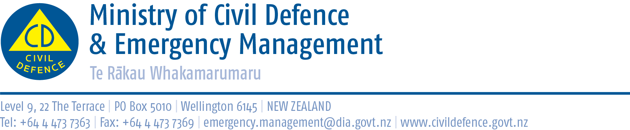

This information is part of Exercise Tangaroa. We are part of a test of New Zealand’s arrangements for preparing for, responding to, and recovering from a National tsunami impact. For more information go to <http://www.civildefence.govt.nz/>

# Media release - 31 August 2016 – 9.45am

**Tsunami potential threat to New Zealand**

**The Ministry of Civil Defence & Emergency Management (MCDEM) has issued a tsunami warning for all New Zealand coastal areas including the Chatham Islands from 10.17am, 31 August 2016.**  
  
**A tsunami is possible. If a tsunami has been generated, the first waves may arrive in New Zealand in the areas around East Cape from 10.17am on 31 August 2016. The first wave activity may not be the most significant. Tsunami activity will continue for several hours and the threat must be regarded as real until this warning is cancelled.**

**MCDEM is still assessing the threat and will provide more information within the next hour.**  
  
**Meanwhile, people in coastal areas should:**  
**1. Stay out of the water (sea, rivers and estuaries, including boating activities)**   
**2. Stay off beaches and shore areas**  
**3. Do not go sightseeing**  
**4. Share this information with family, neighbours and friends**  
**5. Listen to the radio and/or TV for updates**  
**6. Follow instructions of local civil defence authorities**  
 **This warning will remain in effect until a cancellation message is issued by MCDEM or it is upgraded to a Tsunami Warning.**

**More Detail:** An earthquake has occurred with these parameters:

|  |  |
| --- | --- |
| Origin time: | 2102 UTC AUG 30 2016 |
| NZ time: | 0902 hours 31 August 2016 |
| Co-ordinates: | 29.8 SOUTH  177.5 WEST |
| Depth: | 33 KM / 20 MILES |
| Location: | NEAR THE KERMADEC ISLANDS |
| Magnitude: | 8.8 |

The above magnitude is provisional and may be increased or decreased as more seismic data becomes available.

**Only messages issued by MCDEM represent the official warning status for New Zealand.  We note the Pacific Tsunami Warning Centre (PTWC) has issued a Tsunami Threat for this event. PTWC messages do not represent the official warning status for New Zealand.**

**This advisory has been issued to all local civil defence authorities, emergency services, other agencies and media.**

ENDS

**Media contact**

Public Information Duty Officer

Media phone: 06 3660999

E-mail: [comms@horowhenua.govt.nz](mailto:comms@horowhenua.govt.nz)