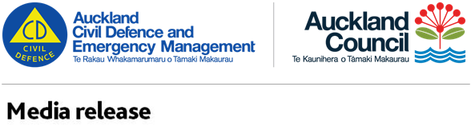

For immediate release

**31 August 2016**

**14.27pm**

**6**

**Important announcement : further waves**

Further tsunami waves are expected to hit the East Coast of Auckland from 14.30pm.

The next waves are expected to be bigger than any of the others so far.

Further waves have already hit Great Barrier Island.

People are asked to keep evacuating from the east coast’s low lying areas and get as far away from the coast as possible.

Do not return to your home or work until you are notified. Community-led evacuation centres are open at

* Silverdale Ambulance Station
* Orewa North School
* Salvation Army Hall Orewa
* Churches on Callipoe Road, Devonport and Kerr Street Onehunga

If you are able to return home, check on your neighbours and prepare for potential power and telephone cuts.

If you need urgent medical assistance, or you are a medical professional who can assist, we are opening to following triage centres at

* Silverdale Fire Station
* Orewa Primary School

**Turn on their radios and listen to the advice from civil defence**

* **Keep away from areas below until cancellation of the warning:**
  + **Low-lying areas / roads / bridges**
  + **Beaches**
  + **Estuaries**
  + **Marinas and harbours due to fast-running currents**
  + **Do not go sight-seeing**
  + **Follow all civil defence and emergency service instructions**
  + **Ensure you are following official sources. Follow @ExTangAklCDEM @ExtangMCDEM for latest updates.**

**ENDS**

**Useful websites**

* [www.aucklandcivildefence.org.nz](http://www.aucklandcivildefence.org.nz)
* [www.civildefence.govt.nz](http://www.civildefence.govt.nz)
* <http://www.getthru.govt.nz/web/GetThru.nsf/web/BOWN-7GZVAT?OpenDocument> – Get Ready Get Thru Tsunami information