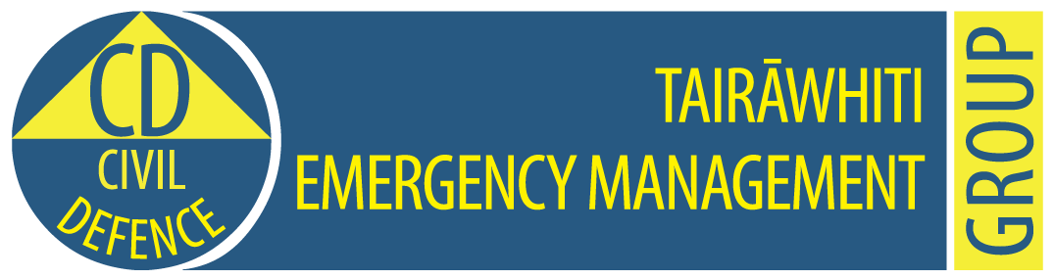

**Tairawhiti CDEM Group Emergency Coordination Centre**

**Exercise Tangaroa Only**

**MEDIA RELEASE**

**9.50am, 31 August 2016                                                     Release No: 1**

**Civil Defence Emergency declared.**

**Communities evacuating after Kermadec quake**

A Civil Defence emergency has been declared in the Gisborne region after an earthquake in the Kermadec Islands.

Te Araroa and Hicks Bay communities are being evacuated as tsunami waves of up to three metres are expected to hit the East Cape shoreline in about half an hour.

People living along the coast in the Gisborne district are advised to get to higher ground or inland and keep listening to the radio for advice from Tairawhiti Civil Defence Emergency Management.

Schools have self-evacuated at Te Araroa, Tokomaru Bay and Tolaga Bay.

Roads have been closed at Okitu and Opotiki to keep people off the roads.

Tairawhiti Civil Defence Emergency Management centre has been activated along with the National Crisis Management Centre.

The tsunami has been generated by an earthquake of 9 magnitude centred near the Kermadec Islands.

The earthquake is centred at 29.8S and 177.5W at a depth of 33km deep.

This information is part of Exercise Tangaroa. There is no tsunami. We are part of a test of New Zealand’s arrangements for preparing for, responding to, and recovering from a national tsunami impact. For more information to go <http://www.civildefence.govt.nz/cdem-sector/exercises/exercisetangaroa2016/>

**For further information contact:   Louise Bennett                      Mobile: 027 416 9475**

**Sheridan Gundry 0274 782 900**

**Email:** [CD.Media@gdc.govt.nz](mailto:CD.Media@gdc.govt.nz)