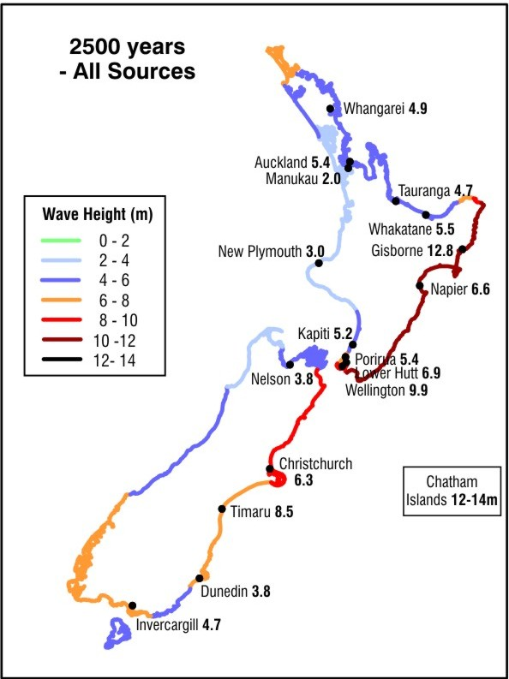
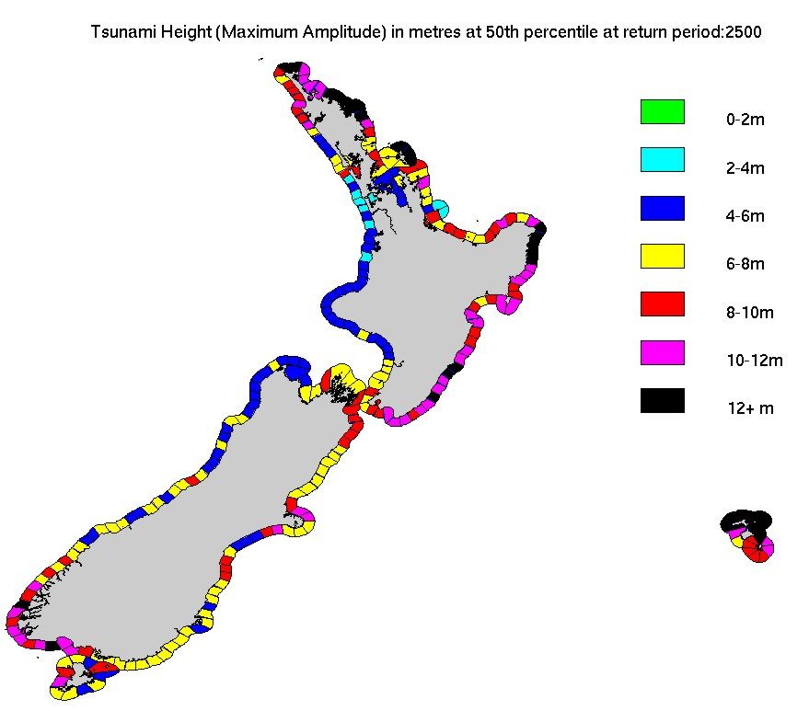
2005 Tsunami Report 2013 Tsunami Report
Tsunami heights calculated at urban centres and estimated by expert judgement elsewhere
Tsunami heights calculated within each 20km zone

