**Auckland Emergency Management**

### Response to Recovery Transition Report

Event: January Flood and Cyclone Gabrielle Regions/Districts/Wards affected: Auckland Region

Prepared by: Auckland Emergency Management

Handover from: Group Controller

Handover to:

Recovery Manager

Date of handover from Controller to Recovery Manager:

Status:

Auckland Emergency Management - Response to Recovery Transition Report - February/March 2023 Information in this report is current as at 1400 hrs, Wednesday, 1 March 2023 unless otherwise indicated 1

**Content**

Foreword 4

Executive Summary 5

Impact of the events 5

Key priorities and risks for the recovery phase 6

Transition to recovery 9

Emergency and Response 11

Overview of the events and response 11

Summary of the response 12

Funding and support 19

Expenditure 20

Response staff 21

Information management 21

Extraordinary powers 23

Summary of emergency powers exercised 24

Impacts 25

Welfare and Social Impacts 25

Māori Impacts 29

Economic Impacts 30

Built Environment 33

Natural Environment 37

Lifeline utilities 41

Nature and extent of consequences (short, medium and long-term) 44

Welfare and Social Consequence 44

Economic Consequence 47

Natural Environment Consequence 49

Built Environment Consequence 50

Transport and lifeline utilities infrastructure 54

Transition to Recovery 55

Response Handover 55

Recovery Plan 55

Recovery Managers 55

Recovery Structure and Resourcing 55

Auckland Emergency Management support in recovery 55

Reporting 56

Upcoming Meetings and Forums 56

Partnership with Mana Whenua for Recovery 56

Engagement and communications 56

Other key stakeholders 56

Risks and issues 57

Economic Environment 59

Transition of CDEM Welfare Response to Recovery 63

Community support information 63

Appendices 67

Appendix I: Powers of a Recovery Manager during Transition 67

List of Figures 69

# Foreword

This Transition to Recovery Report aims to provide situational awareness to the Recovery Manager and Team outlining key response arrangements and ongoing risks as the response transitions to recovery.

The information contained within this report is valid at 1400, Wednesday 1 March 2023 and predominantly derived from situation reports, status reports, and the response team and agencies’ functional briefings. It is not possible to capture all activities underway across the region nor outline all impacts within this report. The report does, however, highlight key matters and potential risks that should be considered within the future development of an Auckland Recovery Plan and Action Plan.

# Executive Summary

1. On 27 January 2023 the Mayor of Auckland declared a State of Local Emergency in response to the January Flood, which caused widespread flooding and landslides in Auckland. This was followed by a declaration of a State of National Emergency on 14 February 2023 by the Minister for Emergency Management in response to Cyclone Gabrielle, which caused widespread landslides and further damage across the North Island, including Auckland.
2. The State of National Emergency ended on 3 March 2023, and a National Period of Transition Period commenced on the same date.
3. Auckland Emergency Management stood up the Incident Management Team at 1700hrs on 27 January 2023. The incident response has been continuous since 27 January, in response to the January Flood, and subsequently Cyclone Gabrielle. This report summarises the response actions, the cumulative impact and consequence of both events.
4. These events have had widespread and enduring social, economic, natural and built environment impacts on Auckland.

## Impact of the events

1. There are significant trauma, welfare and psychosocial impacts on people and the community, include:
   * The tragic loss of []lives.
   * A significant number of people have been displaced as a result of damaged homes and contents due to flooding and landslides, or from sustained outages to lifeline utilities. Over the course of the events this has included 560 households in Emergency Accommodation, transferred to Temporary Accommodation, as well as an unknown number of people staying with friends and family.
   * A high concentration of the impacted people are located in disadvantaged communities in west and south Auckland, adding further challenges to socio-economic wellbeing.
   * Four isolated or priority communities remain isolated or significantly impacted, which continue to be supported by the Incident Management Team:
     + Karakare isolated
     + Muriwai severely impacted
     + Piha severely impacted
     + Waimauku highly impacted
2. There are significant economic impacts to the Auckland region, further delaying the region’s recovery from the effects of the COVID-19 pandemic. While the full impact is not yet known, effects include:
   * Business suffering losses to operational premises, stock and trading revenues.
   * Severe impact on the rural sector, including loss of food crop and stock feed crops, erosion and damage to farm buildings and facilities. These will have a direct impact on food supply and food price inflation.
   * Closure of Auckland Airport and the cancellation of large-scale events will have a direct impact on Auckland’s tourism sector, and potentially reputational damage to the city as a destination in the long run.
3. Māori impacts include mana whenua and mataawaka living in Auckland that have been impacted as individuals and whānau; damaged marae, waahi tapu, sites and buildings of cultural significance, and impact to Māori business and enterprises. Mana whenua as kaitiaki of Auckland’s environment are also affected by damage to awa (streams and rivers), repō (wetlands) and moana (sea), ngahere (forest) and native species such as kauri.
4. The storm events have caused serious, wide-ranging, and complex damaging effects to Auckland’s indigenous ecosystems and natural areas. The most immediately obvious effects are the direct destruction of terrestrial, freshwater, and marine habitats from flooding, landslips, wind and wave damage. This damage not only reduces indigenous habitats but may have affected threatened species populations. Landslips and flooding in kauri forests risks the spread of kauri dieback disease. Resulting clean-up and rehabilitation works also risk spreading the disease.
5. Several thousand landslides were triggered across the Auckland region, including an estimated thousand directly impacting on property and infrastructure. Known active slips are still present in Piha, Muriwai and Karekare and many other locations across Auckland ranging from Rodney to Franklin.
6. Over 2,840 red and yellow placards have been issued for damaged buildings across much of the Auckland region, as a result of flooding, storm damage or land stability. Rapid building assessments are ongoing for Cyclone Gabrielle and the final figure for damaged buildings is not yet available. Damage to buildings has generated a large amount of waste and debris which has required a substantial and ongoing clean-up operation.
7. There has been extensive damage to parks, regional and community facilities and amenities. Current known damage includes 148 impacted community facilities and 382 impacted reserves and parks. Six regional parks in the north and south of Auckland have been closed. Key regional facilities impacted include major flooding of Western Springs Stadium (which remains closed) and the lower portion of Auckland Zoo, as well as damage to Aotea Centre, the Civic Theatre, Auckland Town Hall and the Auckland Film Studios.
8. While services to local roads and state highways, public transport and lifeline utilities (telecommunications, power, water and wastewater) have been largely restored, there has been considerable damage to infrastructure that will take time to assess, prioritise and remediate. The complexity and scale of works to be undertaken is significant.
9. Displaced persons and whānau, impacted businesses, farms, individuals and communities face a daunting future as recovery progresses. Not only will financial hardship continue but increasing psychosocial harm issues are likely to emerge.
10. The extensive clean up, rebuild, and the ongoing social and economic impacts signal a long- term recovery process ahead.

## Key priorities and risks for the recovery phase

1. The following priorities and risks are intended to inform the initial recovery planning and needs. This is not an exhaustive list and further recovery assessments over time will inform more comprehensive recovery needs, actions and interventions.

###### Continuing to support impacted people and communities, ensuring no one falls through the gaps:

* + Ensuring adequate provision of temporary accommodation is a key issue. There is a current trend of increasing demand and diminishing supply for emergency accommodation and temporary accommodation.
  + Immediate and ongoing needs for community outreach and welfare assessments. An extensive, coordinated, multi-agency communications and outreach programme is required to connect with the diverse range of ethnicities, ages and varying circumstances within the communities affected. Priority should be given to communities of greatest need.
  + Identify and understand the emerging and ongoing needs of affected communities to determine their specific requirements and how best to meet those needs in partnership with agencies, Māori, Pasifika and other ethnic providers and community organisations.
  + Consider the existing and subsequent psychosocial needs of those affected by the floods and cyclone and the development of a psychosocial plan.
  + Strongly recommend establishing teams of navigators to assist with accessing services for financial assistance, insurance, accommodation, psychosocial support, etc. This is due to the large numbers of impacted people from diverse backgrounds.
  + Continuing focus on supporting isolated communities in west Auckland.
  + There will need to be a continued and focused effort on clearing contaminated waste from affected homes, including supporting vulnerable and elderly people to remove flood damaged household items. This is a significant public health risk.
  + Appropriate mātauranga Māori and cultural practices for the spiritual recovery of impacted waahi tapu, sites and buildings of cultural significance.
  + Risks include:
    - There is a risk that impacts to the agriculture sector could result in food price inflation.
    - The increasing demand for accommodation support, and delay in getting houses repaired, will increase welfare and psychosocial issues

###### Supporting impacted businesses, sectors and wider economic impacts:

* + Provide outreach and support to businesses and sectors significantly impacted. Business impact could result in loss of employment and income, exacerbating welfare and psychosocial issues and existing socioeconomic inequalities.
  + Expedite insurance, consenting and repair process to enable businesses to resume trading as soon as possible.
  + Support for rural sector (farmers and growers) to navigate the process of insurance claims and funding application processes so access to support is user-friendly.
  + Further assessment of the economic impacts will need to be undertaken to fully understand the direct and indirect implications of the weather event to the regional economy.

###### Restoration of the natural environment:

* + A comprehensive assessment should be undertaken to understand the extent of impacts on ecosystems, and plans for restorations developed, in partnership with mana whenua.
  + Continue clean-up efforts on contaminated beaches, rivers and waterways.
  + An approved earthworks risk management plan will be required for remediation earthworks

in kauri areas.

###### Enabling remediation of damaged properties and infrastructure:

* + Ensure insurance claims are assessed and resolved as quickly as possible. The use of MBIE Residential advisory services should be considered.
  + Clear communications need to be given to private landowners about the roles and responsibilities of their insurers and of local government.
  + Auckland Council will hold information with respect to placarded buildings, as well as tracking their remedial status over time. Information will be shared with other agencies as appropriate to support the recovery.
  + Many properties may require similar options for remediation. There is an opportunity to consider streamlined a consenting process as part of the recovery plan.
  + Risks include:
    - Homes that may not be insured or may be under-insured.
    - Many landslides cross land ownership boundaries. Where the adjacent landowners have different priorities (for example, residential house adjacent to fields) it can become challenging to agree appropriate remedial options between the parties.
    - The ability for the construction sector to support the increased demand for repair and replacement of building and infrastructure needs to be considered. This sector was experiencing resourcing issues (staff shortfall), supply chain issues and increased materials costs before the emergency events, and these problems will now be exacerbated.
    - Increasing cost of remedial work will increase financial hardship and delays to repair.
    - Former residents bypassing cordons and accessing red placarded homes.
    - There is concerns that heavy rain on saturated soils will cause further slips or movement of existing slips in impacted areas through the Waitakare ranges or on the west coast.

1. Coordinate remedial works lead by public sector asset owners and utilities operators, such as Auckland Council, Watercare and Auckland Transport. A coordinated effort will be required to “build back better”. This will require a strategic approach with clear shared objectives between infrastructure owners. Efficiencies and improved outcomes can be achieved by learning lessons from previous events where entities have worked together.
   * Key risks include pressure on existing budgets, resourcing and cost escalation could further exacerbate the ability to progress remedial works.
   * Collaboration between entities to share resources for projects in close geographical proximity will be required to make efficient use of resources and data. Lessons from past events (e.g. Canterbury Earthquake Recovery Authority, Stronger Christchurch Infrastructure Rebuild Team) should be considered, including:
     + <https://oag.parliament.nz/2017/cera/lessons.htm>
     + <https://scirtlearninglegacy.org.nz/>
2. A broader assessment will be required to understand the full impact of the event on Auckland’s infrastructure network. The risk of future flood event and the impact of climate change, land and coastal stability may require consideration of land use planning, future growth and development areas.

## Transition to recovery

1. This report forms the basis of the handover brief to the Recovery Manager.
2. It is critical to ensure a smooth transition to recovery, particularly in the welfare space, so no one ‘falls through the gaps’. This includes ensuring management of welfare services and associated processes continue through to Recovery, maintaining links and continuing to coordinate with agencies, community partners, and Māori, Pasifika and other ethnic providers.
3. Continue to provide public information in an accessible format so all affected persons and businesses know where they can access support. Develop and communicate key messaging on recovery activities and progress to key agencies and affected communities. Integrate Auckland Council communication processes to provide seamless messaging, including for culturally and linguistically diverse (CALD) communities.
4. Ensure transition from Response to Recovery at the appropriate time, giving due consideration to the powers available during the Response phase, especially under a State of Local Emergency, and giving due consideration to the powers made available to the Recovery Manager under a Notice of Transition Period, ensuring that that is sufficient to protect the communities which this Report identifies as suffering ongoing impacts. See the Ministry of Civil Defence & Emergency Management guidance document Powers of a Recovery Manager during Transition (Appendix I).
5. The Recovery Plan should be developed in partnership with Māori, to ensure there is a good understanding of the needs of iwi mana whenua, mataawaka, marae and Māori businesses and what support can be offered. Partner with mana whenua to develop recovery plans for the natural environment and potential changes to future land-use. Consideration should also be given to how marae and Māori-led organisations can be involved in leading the recovery for their communities.
6. The Auckland Civil Defence Emergency Management Group Plan, 2016 outlines the planned transition from response to recovery, with reference to Mayoral and Chief Executive briefings similar to response, Terms of Refence between the Chief Executive and Recovery Manager and termination of any declarations that may be in force. A Terms of Reference is being prepared for the appointed interim Recovery Manager and the Deputy Recovery Manager, and may be refined on the appointment of the Recovery Manager.
7. A critical issue is the different circumstances of some communities who remain isolated, without physical access available to them as a result of Cyclone Gabrielle, while the majority of the region is emerging or has emerged from the immediate response and is ready for ready for recovery. The welfare needs of the communities isolated in this way are very much the same as those presented in response, with additional deterioration due to the increasing passage of time. The isolated community of Karekare is the clearest example. NEMA has clarified that welfare response activities can continue to be reimbursed.
8. In addition to the steps for the formal transition from response to recovery, next steps for the Recovery Manager’s consideration include:
   * Key findings from this Transition Report
   * Interim Auckland Recovery Team to be established and resourced
   * Commence preparation of Recovery Action Plan #1
   * Recovery Communications and Engagement Plan to be developed

# Emergency and Response

## Overview of the events and response

1. The Auckland Emergency Management Incident Management Team was initially stood up to respond to the Auckland Flood event from 27 January (the 27 January Flood). A local State of Emergency was declared to support the response, and subsequently extended.
2. A second event, Cyclone Gabrielle, emerged while the response to the January Flood and local Declaration of Emergency was ongoing. A national Declaration of Emergency was declared on 14 February 2023 and subsequently extended on 20 February 2023 and 28 February 2023.
3. This report details the emergency response and impacts for both the January Flood and Cyclone Gabrielle.

#### Timeline of events

|  |  |
| --- | --- |
| **DATE** | **EVENT** |
| 27 January | Local State of Emergency declared |
| 3 February | Local State of Emergency extended |
| 10 February | Local State of Emergency extended, in preparation of Cyclone Gabrielle |
| 14 February | National State of Emergency declared |
| 20 February | National State of Emergency extended |
| 28 February | National State of Emergency extended |

1. The State of National Emergency ended on 3 March 2023, and a National Period of Transition Period commenced on the same date.

#### January Flood

1. A record-breaking rainfall event on 27 January 2023 impacted almost the entire Auckland region, causing widespread flooding and landslips. Over 250mm of rain fell that day, with up to 71mm in an hour in the evening.
2. This rapidly overwhelmed the stormwater system, creating significant overland flows across both urban and rural areas. This resulted in damage to houses, business premises, infrastructure, council amenities, farming lands and crops. Landslides created further damage to property and infrastructure. There have been ] confirmed deaths in the Auckland region from this event.
3. Ongoing heavy rainfall periods occurred through to 1 February 2023 causing further flooding and landslips.
4. A local State of Emergency was declared by Mayor ”” on 27 January 2023 and subsequently extended to 10 February 2023. Auckland’s State of Emergency was extended a further seven days on 10 February until 17 February 2023.

#### Cyclone Gabrielle

1. Cyclone Gabrielle caused widespread flooding, landslips and damage across the upper North Island overnight on 13 February 2023 and the early hours of 14 February 2023.
2. The cyclone has caused significant damage across the roading network and widespread power outages. Many cell towers became non-operational, hampering communication channels. In Auckland the west has been particularly hard hit with the communities of Piha and Karekare cut off. Many other roads are currently closed, blocked and impassable. There have been confirmed deaths in the Auckland region from this event,.
3. The Minister for Emergency Management declared a National State of Emergency at 0843hrs on Tuesday 14 February, after which point the NEMA National Coordination Centre began leading the response to the North Island Severe Weather. The National Declaration applies to the six regions that have already declared a state of emergency: Northland, Auckland, Tairāwhiti, Bay of Plenty, Waikato and Hawkes Bay.
4. The National State of Emergency was extended for a further 7 days on 20 February 2023 until 28 February, and for a further seven days on 28 February until 7 March 2023.

## Summary of the response

1. In response to the 27 January Flood event, the Auckland Emergency Management stood up the Incident Management Team at 1700hrs on 27 January 2023. The Emergency Coordination Centre was activated to Orange Status.
2. The Incident Management Team’s response has been continuous since 27 January, in response to the January Flood, and subsequently Cyclone Gabrielle.
3. From 14 February when the National State of Emergency was declared, the response was led by the National Coordination Centre, supported by the Auckland Emergency Coordination Centre.
4. Key up to date information can be found on Auckland Council website: [Important Storm](https://ourauckland.aucklandcouncil.govt.nz/news/2023/01/january-storm-event/)  [Updates – OurAuckland (aucklandcouncil.govt.nz)](https://ourauckland.aucklandcouncil.govt.nz/news/2023/01/january-storm-event/)
5. This report summarises the current status and response actions since 27 January, covering both the January Flood event and Cyclone Gabrielle.
6. Additional recovery actions, both in the short and longer term, are either highlighted later in the report or are yet to be determined.

#### Fire and Emergency response

1. Fire and Emergency New Zealand and the New Zealand Police responded to over 2,300 call outs, which included people trapped in homes and cars by the flooding.
2. There have been confirmed deaths in relation to the January Flood and Cyclone Gabrielle:
   * deaths have been confirmed as a result of the flooding and intense rain. Three were within the Auckland region and one on the border but located within Waikato.
3. A high number of people were evacuated from flooded properties.

#### Welfare response

1. Following the 27 January Flood event, Civil Defence Centres were established to provide shelter to people impacted by damaged homes and contents, or by the loss of essential utilities. In addition to shelter, the centres also provided food packs and medicine.
2. Pop-up community and agency information hubs were also opened to provide information to impacted people.
3. Ministry of Social Development (MSD) and Ministry of Business, Innovation and Employment (MBIE) have supported Auckland Emergency Management to provide emergency accommodation to those who need it. This includes Kāinga Ora clients who have not been placed into existing Kāinga Ora accommodation. More than 560 households have been provided emergency accommodation.
4. Provision of temporary accommodation was transferred to MBIE’s Temporary Accommodation Service, which was activated in Auckland on 8 February.
5. Support was provided to Auckland Airport to assist with addressing welfare requirements of stranded passengers within the terminals as a result of delays and cancellations.
6. From 12 February, 24 Civil Defence Centre sites were stood up in preparation for Cyclone Gabrielle, with at least one shelter in each local board area. Community groups also prepared to stand up to support their communities with Cyclone Gabrielle if needed.
7. Information requests and referrals were responded to by the Auckland Council contact centre, and by the Emergency Coordination Centre outbound calling team.
8. As of 6 February, over 4,500 households have sought assistance from Council for information, waste disposal and accommodation needs.
9. As of 1 March, three information hubs remained open in Muriwai, Waimauku and Piha. A Civil Defence Centre at Te Pai Kura (Kelston) remained open until 3 March 2023.

##### Isolated Communities

1. Following Cyclone Gabrielle, it became apparent that there were significant issues in isolated communities, including lack of, or disruption to, access, utilities and communications as well as displaced people. This was particularly evident in coastal communities of West Auckland which were isolated by severe landslips and flooding.
2. An isolated communities tasking group has been activated within the Emergency Coordination Centre (ECC), to manage contact, identify needs and arrange logistics for access to isolated communities. Local leads are based in Bethells, Piha and Muriwai. A local lead is also working with Karekare residents (they cannot be on site all the time due to access issues) and a further lead is dedicated to various smaller communities that are affected including South Head, Shelly Beach, Kaipara Flats, Dairy Flat, Puhoi, and Whatipu Road.
3. Three new webpages were published on the Auckland Emergency Management site to provide community support information specific to 1) the Muriwai community, 2) the Piha community and 3) other affected locations including Bethells/Te Henga, Karekare, Helensville, Parakai, Kaipara, South Head, Ahuroa, Puhoi and Waimauku.
4. Auckland Emergency Management and the NZ Defence Force have facilitated more than 20 helicopter flights bringing supplies, fuel and food to isolated communities across the region.
5. The communities illustrated in Figure 1 experienced access issues resulting from Cyclone Gabrielle. Of these the remaining isolated or priorities communities supported by the Incident Management Team are:
   * Karakare isolated
   * Muriwai severely impacted
   * Piha severely impacted
   * Waimauku highly impacted

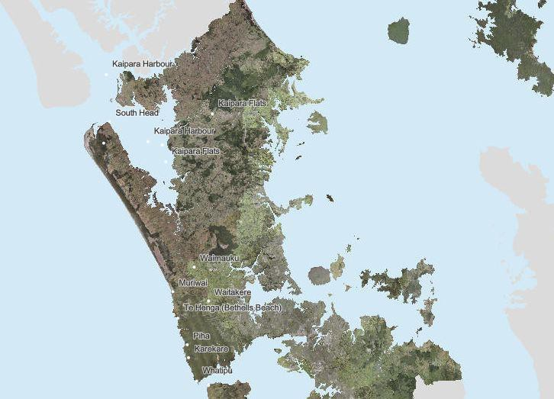

*Figure 1**. Locations of isolated communities*

##### Operation Kanohi Kitea

1. From 7 February, Operation Kanohi Kitea (an Auckland Council community outreach programme) was developed to visit impacted communities, check-in on their welfare and needs, and provide information and advice. The team is also developing a project structure with Records so they can stand up Kanohi Kitea more quickly in future events.
2. The key aim of the programme is to reach affected people who have not had access to information or assistance through existing access points such as the contact centre and Civil Defence Centres.
3. The Kanohi Kitea visited communities in Mount Roskill, Henderson and Māngere from 7 to 10 February. They carried out 782 surveys and spoke to 408 households. Of these, 115 were affected by the flood, and 70 had houses damaged. Where households needed further help, this information was passed to the Emergency Coordination Centre Welfare team to follow up.

#### Building and Land Assessments

1. The Auckland region was designated under Subpart 6 of the Building Act 2004 on 01 February 2023 with the designation scheduled to end on 1 February 2024. While the designation is in place, powers under the Building Act take precedence over CDEM Act powers so where the Group Controller has exercised powers in relation to buildings after 1 February that has generally been done under the Building Act. The same approach applies during a transition period and so the Recovery Manger will also need to be familiar with Subpart 6 of the Building Act.
2. From 28 January, the Auckland Council Rapid Building Assessment and FENZ Urban Search and Rescue teams undertook Rapid Building Assessments. Areas with identified ‘Requests for Service’ via the Council call centre were prioritised, along with areas of known damage and areas known to be susceptible to flooding.
3. Cyclone Gabrielle combined with saturated ground conditions led to further slips, particularly on Auckland’s west coast.
4. Known active slips are still present in Piha, Muriwai and Karekare and many other locations across Auckland from Rodney to Franklin. Access to slip-impacted homes and neighbourhoods is being carefully managed.
5. Geotechnical assessments have been undertaken to support the Rapid Building Assessment process. Additional wider assessments are urgently needed for key communities of Muriwai, Piha and Karekare, and are likely also needed for other areas of Auckland.
6. Preliminary data collection by Auckland Council has commenced, including initial hazard identification from helicopter and drone flyovers, followed by helicopter-based LiDAR and aerial photography, procurement of satellite imagery, and installation of GNSS monitoring (by GNS Science). Further data collection (such as detailed mapping) will be urgently needed and this data will need detailed assessment to produce hazard maps and inform future decision- making.
7. In total, over 7,000 building assessments have taken place (as of 3 March 2023), including residential and commercial properties.
8. Up to 200 Auckland Council Building Inspectors, Geotechnical Engineers and Structural Engineers, and 15 additional inspectors from outside of the Auckland region were in the field for Rapid Building Assessments.
9. Work is also underway to reassess all properties issued a red placard to confirm their status and communicate with the owners. A priority for re-assessment is properties from which people have been displaced, to enable them to return to their homes where possible. Properties can be reassessed by building inspectors and moved between placard levels as remedial actions are completed.
10. There have been reports of people living in red placard dwellings around the Puketāpapa region – some because of pets, and some due to negative stigma attached to government support, and the potential immigration status of some individuals. This suggests numbers of displacements will continue to change.
11. Figure 2 shows the location of flood reports received through Request for Service calls made to the Auckland Council call centre, plus the damage severity from Rapid Building Assessments. (Data is current to 23/02/2023, 7.36am)

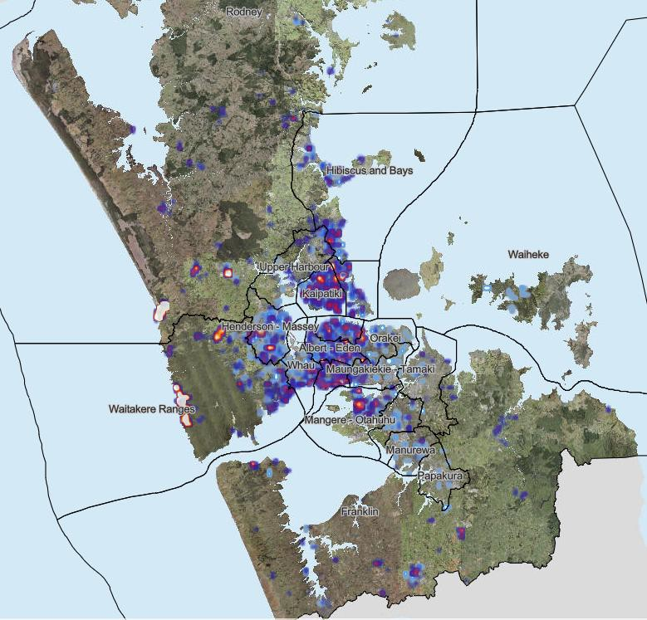

*Figure 2**. Density map representation number of flood reports and Rapid Building Assessment Severity*

#### Waste removal

1. Priority has been given to solid waste collection to assist households and businesses with their initial clean-up of flood damaged materials. This will help reduce public health risk.
2. A Solid Waste Action Plan was developed and operationalised to manage the removal and disposal of flood-damaged household items.
3. New Zealand Response Teams – Civil Volunteers worked alongside New Zealand Defence Force staff to provide targeted assistance to the vulnerable and elderly or those unable to remove waste from their homes and properties of their own accord.
4. From early February, focused efforts were directed at removing waste from kerbside ahead of Cyclone Gabrielle, to reduce the risk of damage from solid waste being flung by strong wind, or being displaced and causing a blockage in the stormwater network. In this period, 10 local suppliers provided essential support at short notice to clear the streets before the cyclone hit.
5. Public information and messages continue to be updated to reflect the evolving situation and approach.
6. Auckland Council provided immediate relief for households with both self-help options through a network of 15 drop-off points and coordinating local contractors to collect, sort and dispose of flood related household solid waste, enabling resource recovery where appropriate and safe. Almost 3,700 requests for assistance with waste have been logged through the council call

centre.

1. Initially nine and then 15 transfer stations were made available across the region for free disposal of event damaged household items. Over 10,000 loads have been delivered, totaling 5,000 tonnes received. Almost half of this has been received through Auckland Council’s Waitākere Refuse Transfer Station.
2. More than 600 skip bins and 250 flexi-bags have been provided for free in the most affected locations, to support residents to dispose of flood-damaged household items.
3. As of 13 February 2023, over 2,300 flood impacted vehicles had been towed, with more pending removal.
4. Mould and mildew are now present on household items and appropriate PPE/N95 masks are required for removal. Masks have been sourced and distributed to Solid Waste removal staff.
5. Ongoing efforts will be required to remove flood-damaged waste from the kerbside.

#### Stormwater response

1. On 27 January, in accordance with forecasts of a normal-range storm, Healthy Waters and Watercare carried out their usual storm preparations, deploying contractors to clean known hot spots and check for hazards.
2. As the storm intensified, Healthy Waters and Watercare deployed staff and contractors to clear blockages and support residents, and worked alongside the Auckland Emergency Management team to coordinate responses and provide technical expertise.
3. Between 27 January 2023 and 13 February 2023, Auckland Council’s Healthy Waters department received 3,117 requests for service.
4. This represents over one third of the annual average volume of requests for service.
5. The majority of the requests were passed onto maintenance teams, who have closed nearly half of the 2,151 requests assigned to them.
6. A further 966 requests have been assigned to engineers. As these requests require more complex investigations, it will take some time to fully investigate and close these out. Additional resources have been enlisted to support this effort.
7. Of the Requests for Service, 106 reported flooded habitable floors. The full number of flooded floors is likely much higher, as some will have been reported to FENZ or not reported.
8. Extensive clean-up of debris and clearing of streams and culverts was undertaken after the flooding event, ahead of Cyclone Gabrielle.

#### Transport response

1. Flooding, landslide, obstructions, and debris caused widespread closures to roads across the regions.
2. There were service disruptions throughout the public transport network, across rail, bus and ferry networks. Up to date information on road closures and service disruptions are provided on the AT website: [https://at.govt.nz/about-us/news-events/service-disruptions/severe-](https://at.govt.nz/about-us/news-events/service-disruptions/severe-weather-impact-across-the-auckland-area/) [weather-impact-across-the-auckland-area/](https://at.govt.nz/about-us/news-events/service-disruptions/severe-weather-impact-across-the-auckland-area/)
3. Immediately following the flood, Auckland Transport had over 500 road maintenance staff assessing the damage to the roading network and working to clear roads as safely and quickly as possible.
4. The Mill Flat Rd bridge in Riverhead was destroyed, isolating a small community. A bailey bridge to provide access is in place.
5. A key focus is identifying and supporting communities that are isolated through the loss of access.

#### Lifeline utilities

1. Strong winds, landslides and flooding caused widespread outages across the power, telecommunications, water and wastewater infrastructure network.
2. The January floods impacted drinking water supplies, particularly in the Waitākere Ranges area with slips and turbidity affecting the Upper Nihotupu Dam, Lower Nihotupu Dam and Lower Huia Dam. Residents in west Auckland were asked to conserve water and tankers were deployed to west Auckland. All potable water supplies were restored prior to Cyclone Gabrielle.
3. Tap water remains safe to drink following the cyclone, and all supplies except Muriwai have been reinstated. The Muriwai pump station is inoperable due to slips and damage, and an interim solution has been set up by Watercare to provide potable water to the community.
4. Ten wastewater pump stations were flooded as a result of the 27 January rain event, however all treatment plants and pump stations were back in operation by 1 February. Wastewater treatment plants are being closely monitored and are stable, and wastewater networks have mostly recovered from the cyclone.
5. Power was restored to more than 35,000 properties between Cyclone Gabrielle and 24 February.
6. Utilities providers continue to work with Auckland Emergency Management on responding to the outages. A key risk is the ability to gain safe access to damaged infrastructure.

#### Public information response

1. Communication on the emergency response was initiated on 27 January and information was published from 8am to 8pm, seven days a week.
2. The public information response operated using a range of social media and digital channels, including:
   * Auckland Emergency Management Facebook page
   * Auckland Emergency Management Twitter account
   * Auckland Emergency Management website
   * Our Auckland website (Auckland Council news website).
3. The response included a daily media stand-up at 1pm, that all media were invited to attend. These were live-streamed on the Auckland Emergency Management Facebook page and also by a number of media outlets. Following each media stand-up, a media advisory was distributed, that was then published on the websites listed above, and shared on social media.
4. A range of public-facing collateral was developed and distributed – to date this has included a ‘seeking help and support’, ‘tips for cleaning up your home after a flood’ and ‘what the coloured stickers on buildings mean’ fact sheets, and a general information flyer. All of the products are being translated into the six languages the Auckland Council regularly uses (Māori, Sāmoan, Tongan, Mandarin, Simplified Chinese and Korean).

## Funding and support

1. An All of Government Fact Sheet which details what support is available and where to get help has been compiled and is available on the Auckland Emergency Management website in multiple languages and formats. Information from this fact sheet has been shared through social media and printed handouts.

[Auckland severe weather – What support is available and where can you get help » National](https://www.civildefence.govt.nz/resources/news-and-events/news-and-events/auckland-severe-weather-what-support-is-available-and-where-can-you-get-help/) [Emergency Management Agency (civildefence.govt.nz)](https://www.civildefence.govt.nz/resources/news-and-events/news-and-events/auckland-severe-weather-what-support-is-available-and-where-can-you-get-help/)

#### Financial support

##### Auckland Council Emergency Relief Fund

1. The Auckland Council Emergency Relief Fund provides one-off financial support to individuals, community groups and marae in Auckland who have been affected by the January 2023 Auckland flooding and landslips. The grants go towards helping to alleviate hardship experienced by individuals and families due to the flooding and landslips.
2. There is also likely to be specific funding made available to support Auckland businesses impacted by the storm, either through this fund or another mechanism.
3. As of 31 January, the Minister of Emergency Management has assigned $1,100,000 to the Auckland Council Emergency Relief Fund, with an additional $100,000 assigned by Auckland Council.

##### Work and Income

1. The Ministry of Social Development provided Civil Defence payments for people impacted to cover food, bedding, clothing, accommodation and loss of income. Between 28 January and 23 February, over $43 million was paid in MSD Civil Defence Payments to over 83,000 clients.
2. Applicants do not have to be on a benefit to qualify for a Civil Defence Payment, and non- residents may be eligible. In most cases it does not matter what the applicants’ income is or what assets they have.
3. Other benefits may be available to cover, food, power bills, repairs or replacing appliances, costs if residents have had to leave their homes and loss of income if they cannot work.

##### Government assistance

1. The Government is providing an interim emergency relief package for regions hit by Cyclone Gabrielle and the January floods, which includes:
   * $250 million to help Waka Kotahi and local councils to assess and fix roads
   * $50 million to deliver interim emergency business and primary sector support
   * Inland Revenue support including interest write-offs, tax concessions for donated trading stock and an extension of R&D Tax Incentive filing deadlines.
2. Enhanced Task Force Green has been activated to help with flood relief efforts. $500,000 has been made available to provide jobs for local people to support farmers, growers and communities by completing clean-up work on their properties. The process for management of the workforce is yet to be determined. Ministry for Primary Industries, Rural Support Trust and Federated Farmers are key agencies in determining the priority of needs.
3. The flooding and storm damage in Northland, Auckland, Waikato, Coromandel and Bay of

Plenty has also been classified as a medium-scale adverse event, which unlocks extra support for farmers and growers. Funding of $200,000 will be allocated to Rural Support Trusts.

1. The Ministry for Primary Industries has announced $25 million in grants to support farmers across the areas affected by Cyclone Gabrielle, including Auckland. This is in addition to an initial $4 million ‘mobilisation fund’ for immediate rural support, taking the total amount of support available so far to $29 million.
2. The Government is also providing $25 million to help businesses in cyclone-affected areas to meet immediate costs, further assist with clean-up and boost business support and advice services.

## Expenditure

#### Expenditure generated during response

1. NEMA will re-imburse repairs for eligible damaged Council infrastructure as per the 60:40 re- imbursement policy.
2. NEMA will re-imburse 100 per cent of CDEM eligible welfare response costs.
3. The exact expenditure generated during the response will be obtained from both Auckland Emergency Management and Logistics and Welfare teams as the transition to recovery takes place, and invoices are received from the goods and services used during the response. Costs may include:
   * welfare costs attributable to displaced persons because of the event
   * open purchase orders generated during response
   * supplies of goods and medicine
   * flights, accommodation and living costs from deployed agencies and surge support
   * other operational costs.

#### Transition to recovery actions

1. Auckland Council will submit an expense claim to NEMA for eligible expenses under Section 33 of the Guide to the National CDEM Plan.
2. Auckland Council Emergency Management to task resources to compile eligible costs for reimbursement claim.
3. NEMA’s reimbursement policy for the welfare support of isolated communities beyond transition to recovery urgently requires clarification.

#### Ongoing costs

1. Ongoing costs for response include:
   * ongoing welfare support to isolated communities
   * waste management and lifeline repairs.

## Response staff

#### Auckland Emergency Coordination Centre

1. The following table sets out the Emergency Coordination Centre functions that were activated.

|  |
| --- |
| **Functions Used** |
| Control |
| Response |
| Intelligence |
| Welfare |
| Planning |
| Logistics |
| Operations |
| Lifeline Utility Coordination |
| Public Information Management (PIM) |
| Iwi Liaison |
| Recovery |

#### Agency and surge support

1. The response was substantial. Multiple agencies supported the Emergency Coordination Centre (ECC) and surge staff supported Auckland Council and Emergency Management within all ECC functions.

## Information management

1. Information gathered during the response is outlined in the table below:

|  |  |  |  |
| --- | --- | --- | --- |
| **Information** | **How has it been gathered** | **Where it is recorded** | **Ongoing information management** |
| Road Closures and restricted access | Direct from: NZTA  Auckland Transport | [Traffic map](https://www.journeys.nzta.govt.nz/traffic/regions/5) nzta.govt.nz  [Road Information of](https://www.gdc.govt.nz/services/roads-and-roadsides/road-information) Auckland Transport [https://at.govt.nz/about-](https://at.govt.nz/about-us/news-events/service-disruptions/severe-weather-impact-across-the-auckland-area/) [us/news-events/service-](https://at.govt.nz/about-us/news-events/service-disruptions/severe-weather-impact-across-the-auckland-area/) [disruptions/severe-weather-](https://at.govt.nz/about-us/news-events/service-disruptions/severe-weather-impact-across-the-auckland-area/) | Updated as required |

|  |  |  |  |
| --- | --- | --- | --- |
| **Information** | **How has it been gathered** | **Where it is recorded** | **Ongoing information management** |
|  |  | [impact-across-the-auckland-](https://at.govt.nz/about-us/news-events/service-disruptions/severe-weather-impact-across-the-auckland-area/) [area/](https://at.govt.nz/about-us/news-events/service-disruptions/severe-weather-impact-across-the-auckland-area/) |  |
| Needs assessment data | Needs assessment gathered through:   * triaging the Auckland Council Request for Service (RFS) logs * staff deployed in the field. | Welfare Tracker spreadsheet currently managed by the Emergency Coordination Centre Welfare and Logistics. | Data collated and managed and will be available as required ensuring privacy protocols. |
| Building assessments data and confirmation of un-inhabitable dwellings | Auckland Council building assessors. | Managed by Auckland Council. | The core SAP system is being adjusted to allow the recording of event- related incidents, with a backup master spreadsheet in the interim. |
| Situation Reports and Action Plans | Gathered information from the Emergency Coordination Centre Intelligence and Planning teams. | Within the Auckland CDEM Microsoft Teams Response site. | This will be archived and is available if requested. |
| AEM Claims Spreadsheet | Collated by Auckland Emergency Management finance. | Auckland Council document management system. | Updated as required. |
| Landslide locations | From public reports, council observations, GNS Science and supplier reports. | NZ Landslides Database. | Auckland Council Resilient Land & Coasts team managing data flow and integrity. |
| Post-event LiDAR, aerial imagery | Multiple sources | Multiple locations | Coherent management approach needed. Key data currently collated informally by Auckland Council Resilient Land & Coasts team. |

# Extraordinary powers

|  |  |  |  |  |  |  |
| --- | --- | --- | --- | --- | --- | --- |
| **Declaration Notice** | **Start date** | **Expiry date** | **Issued by** | **Terminated** | **Area covered** | **Comments (include reason for declaration / notice)** |
| State of Local Emergency | Friday 27 January 2023 | Friday 03 February 2023 | Mayor | Extended | Auckland region | Severe Weather Event |
| Extension of | Friday 03 | Maximum | Mayor | Superseded | Auckland | Severe |
| State of Local | February | of 7 days |  | by National | region | Weather |
| Emergency | 2023 |  |  | State of |  | Event |
|  |  |  |  | Emergency |  |  |
| National State of Emergency | Tuesday 14 February | Maximum of 7 days | Minister | Extended | National | Severe Weather Event |
| Extension of State of National | Monday 20 February 2023 | Maximum of 7 days | Minister | Extended | National | Severe Weather Event |
| Emergency |  |  |  |  |  |  |
| Extension of State of  National | Tuesday 28 February 2023 | Maximum of 7 days | Minister | Expired on 3  March 2023 | National | Severe Weather Event |
| Emergency |  |  |  |  |  |  |
| Notice of  National Transition | Friday 3  March 2023 | Maximum of 90 days | Minister | N/A | National | Severe Weather Event |
| Period |  |  |  |  |  |  |
| Designation of | Wednesday |  | Mayor | Reviewed | Auckland | Severe |
| an Area for | 01 February |  | every 90 | region | Weather |
| Building | 2023 |  | days by |  | Event |
| Management |  |  | Auckland |  |  |
| (subpart 6B of the Building Act 2004) |  |  | Council |  |  |

## Summary of emergency powers exercised

1. Emergency powers used during this response enabled:
   * The NZ Police activated use of the new Puhoi-Warkworth Motorway for emergency vehicles on 31 January 2023. This was in accordance with sections 87 and 90 of the Civil Defence Emergency Management Act 2002
   * The NZ Police to compel the evacuation of people in dangerous situations, or to prevent people returning to unsafe homes – CDEM Act section 86
   * The designation of an area for the emergency management of buildings in accordance with the Building Act 2004, Sub-part 6B, for the demolition of structures necessary for the protection of persons from injury or death:
     + a house in Remuera
     + the Colonial Ammunition Shot Tower in Mt Eden, a Category 1 Historic building, following engineering advice that the tower could collapse suddenly and without warning.
   * The IRD entering into an arrangement to undertake outreach needs assessments on behalf of Auckland Emergency Management – CDEM Act section 85(1)i
   * Healthy Waters using drones to find blockages, landslips and critical assets requiring immediate attention – CDEM Act section 87
   * The NZ Defence Force was activated to provide assistance with response mitigation in the community
   * Works to be carried out where necessary – CDEM Act section 85
   * Welfare measures to be provided, including the provision of emergency food, clothing and shelter – CDEM Act section 85
   * The evacuation of premises or places where necessary to preserve human life – CDEM Act section 86
   * Entry on premises or places where action was considered necessary to carry out urgent measures or to save lives, prevent injuries or rescue endangered persons – CDEM Act section 87
   * The restriction of access to public places or roads to limit the extent of the emergency – CDEM Act section 88
   * Carry out inspections on properties to limit the extent of the emergency – CDEM Act section 92.
2. A transition period notice is considered necessary for this event, as recovery activities may require the use of associated powers under the CDEM Act 2002.

# Impacts

## Welfare and Social Impacts

#### Communities displaced

1. People who were displaced by damaged houses and contents, landslides, or from sustained outages to lifeline utilities required accommodation support.
   * 560 households were placed in Emergency Accommodation, transferred to Temporary Accommodation.
   * An unknown number of evacuees have potentially stayed with friends or family.
2. Outreach and needs assessment efforts are ongoing, the resulting welfare and social impacts is not yet fully known.

#### Impact on people and communities and probable future needs

1. The following table sets out the welfare impacts and potential future needs:

|  |  |  |  |
| --- | --- | --- | --- |
| **Impact** | **Extent** | **Comment** | **Future Needs** |
| Deaths | 6 | Significant impact on whānau and community | Ongoing psychosocial or additional support to be determined |
| Welfare assessments – people in emergency accommodation | Over 4,500 households have requested assistance and been assessed | There are families that voluntarily evacuated their premises, in addition to those who were required to evacuate. However, the numbers are not yet fully known.  The full extent of those displaced is yet to be determined as further inspections and welfare visits are undertaken. | 560 households have been provided emergency accommodation as they are unable to return to their homes.  Needs assessments (and building inspections) are continuing. Further assistance will likely be required as welfare assessments and property inspections continue.  Those who have self-evacuated into unsustainable situations with family and friends may need temporary accommodation.  This will be challenging to provide due to the critical lack of housing / accommodation in the region. |

|  |  |  |  |
| --- | --- | --- | --- |
| **Impact** | **Extent** | **Comment** | **Future Needs** |
| Financial support | MSD have provided financial support | Financial support is available to people for immediate costs and loss of income. | Applications are continuing to be received and will likely be ongoing. |
| Impact on crime and community safety. | Potential issues | Police are acting on reports of people visiting homes impersonating council officers telling residents they need their houses re-assessed. | Monitoring required. Police have increased presence around red stickered areas in the short term. |
| Impact on children and young people | TBD | School attendance has been impacted in the short term due to school closure.  Some children and young people have been displaced from their homes. | Further assessment in recovery required. Displaced children and young people may require additional support. Emergency and Temporary accommodation locations may pose challenges for social networks and school. |
| Impact on older people | TBD | The full impacts on older people are not known to Auckland Council. Two retirement homes were evacuated during the initial flooding response. There have been requests by older people for assistance with cleaning their homes or properties. | Further assessment in recovery required. Continue to promote availability of services to help those affected by the floods. |
| Impact on Māori and marae | TBD | The extent of impact needs to be determined. The number of Māori displaced is not known.  Some marae have had flood damage and may not have insurance or be under-insured.  Commercial assets belonging to iwi may also have been damaged  Potential risks to waterways, taonga species, such as kauri, and damage to waahi tapu. | Continue to promote availability of Māori support services to those affected by the floods.  Fuller assessment to understand impacts for Māori through engagement with iwi mana whenua and mataawaka.  Ongoing involvement of iwi mana whenua as partner in recovery. |

|  |  |  |  |
| --- | --- | --- | --- |
| **Impact** | **Extent** | **Comment** | **Future Needs** |
| Impact on Pasifika community | TBD | Some of the areas most affected (such as Kelston, Onehunga and Māngere) have a high proportion of Pasifika residents. | Continue to promote availability of services to help those affected by the floods.  Ongoing engagement with the Pasifika community in recovery – work with community partners.  Translation services and translated resources may be required. |
| Impact on migrant community | TBD | Some of the areas most affected (such as the Mount Albert/Mount Roskill areas) have a high proportion of migrant residents. | Continue to promote availability of services to help those affected by the floods.  Ongoing engagement with the migrant community in recovery.  Translation services and translated resources may be required. |
| Impact on disability community | TBD | Some disabled people were offered accommodation at evacuation centres. | Continue to promote availability of services to help those affected by the floods.  Ongoing engagement with the Disability Network in recovery. |
| Impact on chronic health community (including mental health and addictions) | To be monitored via agencies | Various people sought medical assistance due to impacts of flooding or landslides.  Potential emerging health risks include:   * risk of outbreak of gastroenteritis due to contamination of homes/property from wastewater * psychosocial impacts, including mental health issues caused by trauma of event and ongoing recovery * family harm, exacerbated by ongoing stress for those displaced and living in unsuitable or crowded accommodation. | Continue to promote availability of services to help those affected by the floods, including assistance for elderly or vulnerable to remove contaminated goods.  Ongoing engagement with the Health Networks in recovery.  Potential for ongoing difficulty in accessing appointments and medical services, particularly mental health support, for some people who have been displaced.  Wrap around support for whānau under stress to prevent family harm. |

|  |  |  |  |
| --- | --- | --- | --- |
| **Impact** | **Extent** | **Comment** | **Future Needs** |
| Impact on foreign nationals, tourists and other visitors to the region. | To be monitored | The full impacts on tourists and foreign nationals are not known. As 7 February 2023 there had been no reports of foreign nationals requiring consular assistance, nor any New Zealand citizens requiring consular assistance to return home.  A number of visitors to Auckland were affected by the cancellation of various major events, such as the Elton John concert, Laneways, and the Lantern Festival. | Ensure the experience of visitors arriving in Auckland for events is not adversely affected.  Manage effects on the city’s reputation as a destination for tourism and recreation.  Ensure successful delivery of FIFA Women’s World Cup in mid-2023 is not impacted. |
| Impact on homeless people | TBD | Homeless people were impacted by the initial flooding. They will also be impacted by the strain on emergency accommodation. | Continue to promote availability of services to help those affected by the floods. Work with City Mission and other partners to support homeless population. |
| Impact on pets | TBD | Properties that have been red or yellow placarded will be considered for support with animals. People in temporary accommodation are sometimes known to return to their properties to feed pets.  Animal welfare issues may also be experienced for pets that were living in damaged homes, who have been abandoned. | There may be further challenges for pet owners who are unable to return home for some time or move into alternate accommodation that are unable to accommodate their pets.  Ongoing support may be needed by MPI and SPCA in recovery. |
| Health and safety issues | TBD | Health and safety issues include:   * Contact with contaminated flood water, or contaminated materials. Te Whatu Ora have issued notifications * Entering/occupying unsafe properties or unstable land/area. | Ongoing communications for public health will be in place.  Ensuring clear information for placarded buildings and active landslide areas. |

#### Impacts on Pasifika community

1. Some of the areas most impacted by the January Flood have a high proportion of Pasifika residents. A community Pacific Response Hub was set up at South Seas Health Care in Māngere from 1 February to 24 February 2023.
2. By 3 February, the hub had supported over 350 families with initial food support over the three days, before transitioning to short-term food support through food parcel delivery. The hub also provided over 1,650 young people with back-to-school support such as stationery and backpacks and provided over 520 families with school-related short-term assistance including fees and uniform support.

#### Impact on disadvantaged communities

1. There have been significant impacts on disadvantaged communities. The map below shows the clustering of damaged buildings as of, overlayed with the deprivation index of Auckland region.
2. Recovery efforts should consider assessing, prioritising and tailoring the response to these communities.
3. The communities of west and south Auckland have been particularly impacted by the weather events. These areas were already facing challenges in regard to socio-economic outcomes and are where there is a concentration of Auckland’s communities of greatest need. There is a risk that the event adds a further barrier to tackling the socio-economic issues being faced in these communities.

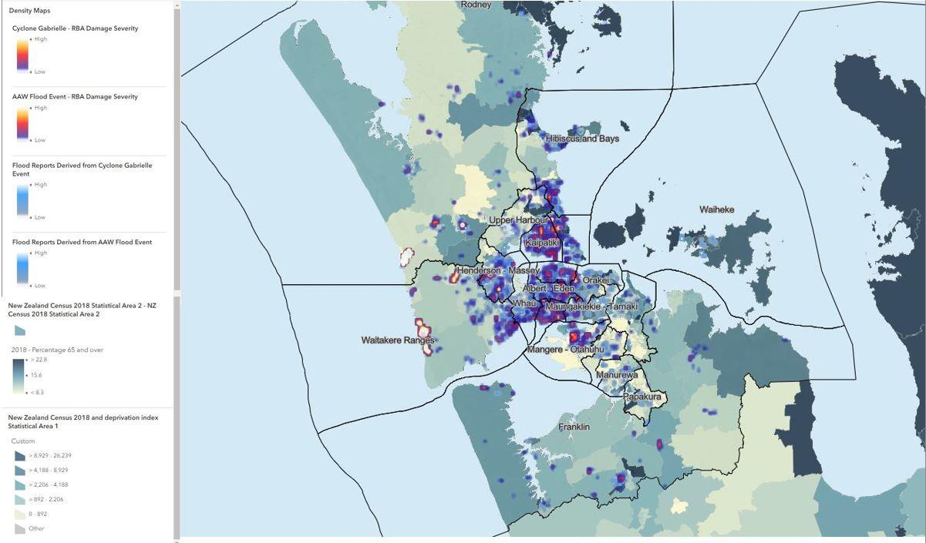

*Figure 3 - Flood report and damaged buildings overlayed with NZ Census 2018 deprivation index*

## Māori Impacts

1. The number of Māori who were displaced by the weather event is not yet known.
2. During the initial response some marae provided accommodation, food and support for those affected by flooding. Marae are continuing to act as information and support hubs for their

communities.

1. Māori Wardens Emergency Response Teams were also activated and Māori Wardens were deployed to Civil Defence Centres.
2. Iwi/Māori liaisons are contacting all marae and iwi in the region to assess their situation. Some needs have been identified through the marae and logistics are working to address them. Priorities are the safety of whānau, and preservation of waahi tapu.
3. Many marae have experienced flood impacts and may not be insured or under-insured.
4. Māori businesses may have been particularly impacted, since they are proportionately more likely to not have insurance or be under-insured.
5. Commercial interests of some iwi may have been impacted, for example, through damage to residential or commercial properties.
6. Iwi mana whenua as kaitiaki of Auckland’s environment are impacted by damage to awa (streams and rivers), repō (wetlands) and moana (sea), ngahere (forest) and native species such as kauri.

## Economic Impacts

#### Employment / Business resumption

1. There were 421 commercial buildings that reported damage in the January floods across Auckland, and 224 of these buildings were in Key Economic Places. These impacts are identified in the map below.

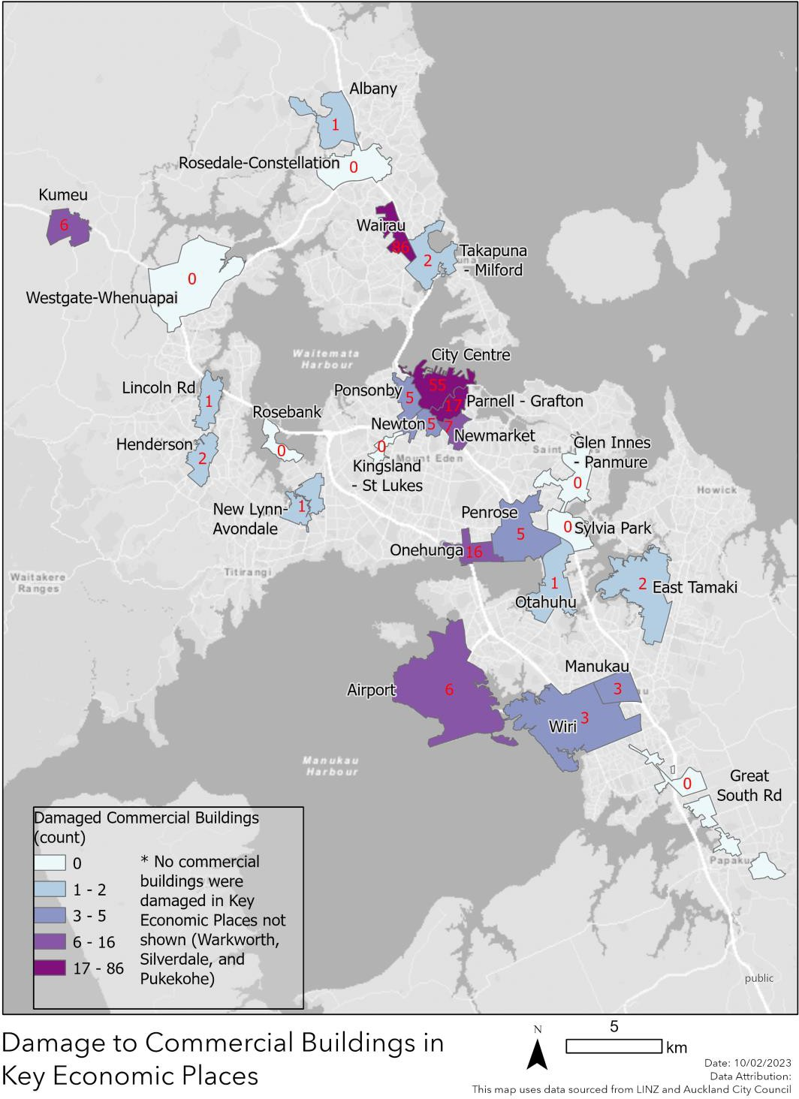

*Figure 4**. Damage to commercial buildings in Key Economic Places*

1. Due to the flood, businesses experienced losses to operational premises, stock, and trading revenues. Businesses have also been impacted by damage to housing, other assets and ability to travel to employment due to transport network closures and flooded roads. The full number of impacted commercial properties is not known.
2. Businesses may find it difficult to resume trade if they do not have comprehensive insurance cover. Delays to insurance pay-outs, inability to source contractors in a timely manner and

disruptions as repairs are undertaken will exacerbate this risk.

1. Timely repair of damaged premise and properties are critical to enable businesses to resume operations. Having sufficient resource allocated and expediting assessment and re- assessment of commercial properties may be helpful. Where applicable some businesses may find temporary locations to operate from through help from insurance or government support.
2. Central government may have a range of financial tools to support businesses ranging from taxation tools and direct support. A business support package has been announced by the government. This includes $5 million for emergency support to help businesses significantly affected by the flooding event in Auckland. The “back to work” grants are administered by the Auckland Business Chamber and provide:
   * up to $5,000 for red/yellow stickered businesses
   * up to $2,000 for other businesses (not red or yellow stickered) who can demonstrate significant need
   * $750 by declaration based on demonstration of a moderate level of need.
3. The Government has announced a further interim emergency relief package for regions hit by Cyclone Gabrielle and the January floods. $2 million has been approved to provide immediate support to businesses in the Auckland region affected by the weather events. The grants for the Auckland region will also be delivered by the Auckland Business Chamber.
4. Further assessment is required to understand the impacts of the recent flooding events on the business areas and sectors affected will help to provide a more robust evidence base to ascertain the economic impact of the flood events on the local economy and the economic places themselves. Key sectors that have reported an impact include retail, agriculture, tourism, manufacturing, construction, hospitality, creative and cultural sector (including a proportion of the music and performing arts businesses).
5. This will help to prioritise the medium and long-term actions that can be undertaken to support these areas to recover from the extreme weather events.

#### Rural environment (primary production)

1. The agriculture sector has been impacted by erosion and damage to farms which has yet to be quantified. This may include fencing, buildings and other facilities that have been damaged.
2. HortNZ have identified severe impacts on crops in South Auckland, especially leafy greens, brassicas, silverbeet, and onions, as well as packhouse damage and silt trap issues.
3. Stock food crop damage has also occurred to corn, maize, silage and grass.
4. These will have a direct impact on food supply, resulting in food price inflation for seasonal vegetables short, medium and long term. There may also be indirect impacts such as business closures, disruptions to the movement of people, disruptions to supply chains.
5. Risks to address in future include a lack of communication/engagement between key local and central government agencies and key sector leaders, major companies, or sector associations on agricultural issues. Key issues to be aware of include the impact on vegetable growers and the dairy industry, with autumn calving and winter feed and pests, and a potential spike in pest incursion anticipated to follow flood and impact crops.
6. The rural sector would benefit from access to clean up services, water pumps, repairs services, electrical, plumbing, building and landscaping. Support is required for farmers to clean up their farms, lodge insurance claims, check for damage, remove debris, reactivate staff and quantify damage and financial impact.

#### Tourism

1. Auckland’s economy is still feeling the effects of the COVID-19 pandemic. A key sector affected was tourism. Following the closure of the international border, visitor numbers and tourism spend plummeted and large parts of the sector went into hibernation. Of those which survived, many only re-emerged this summer and face an environment where labour is incredibly difficult to source, and the cost of inputs have increased.
2. The full impact of the flooding events on this sector are yet to be understood. However, there may have been some reputational damage to the city as a destination along with cancellations of bookings and the risk of future booking cancellations having a negative impact on this sector.
3. In addition, beach and regional park closures over the Waitangi weekend will have impacted businesses in the tourism and hospitality with a direct impact on spend in these sectors.

## Built Environment

#### Housing and Urban Development

1. Auckland Council is leading the collation of Rapid Building Assessment data.
2. Damage has been identified to buildings across much of the Auckland region, with particular impacts in the north shore, the central isthmus, Māngere and west Auckland including the West Coast beaches communities.
3. The management of impacted buildings and property will be via the provisions of the Designation of an Area for Building Management (subpart 6B of Part 2 of the Building Act 2004), which took effect on 1 February 2023.
4. There is a process underway to enable re-assessment of properties that have been placarded to confirm the extent of damage and recommended next steps. This process has transitioned to the Auckland Council Building Compliance teams.
5. More than 7,000 placards have been issued as of 1 March 2023. Of these there have been:
   * 581 red placards (access prohibited)
   * 2266 yellow placards (access restricted)
   * 4,159 white placards (no access restrictions).
6. Figure 6 shows the trend in building assessments completed by placard type.

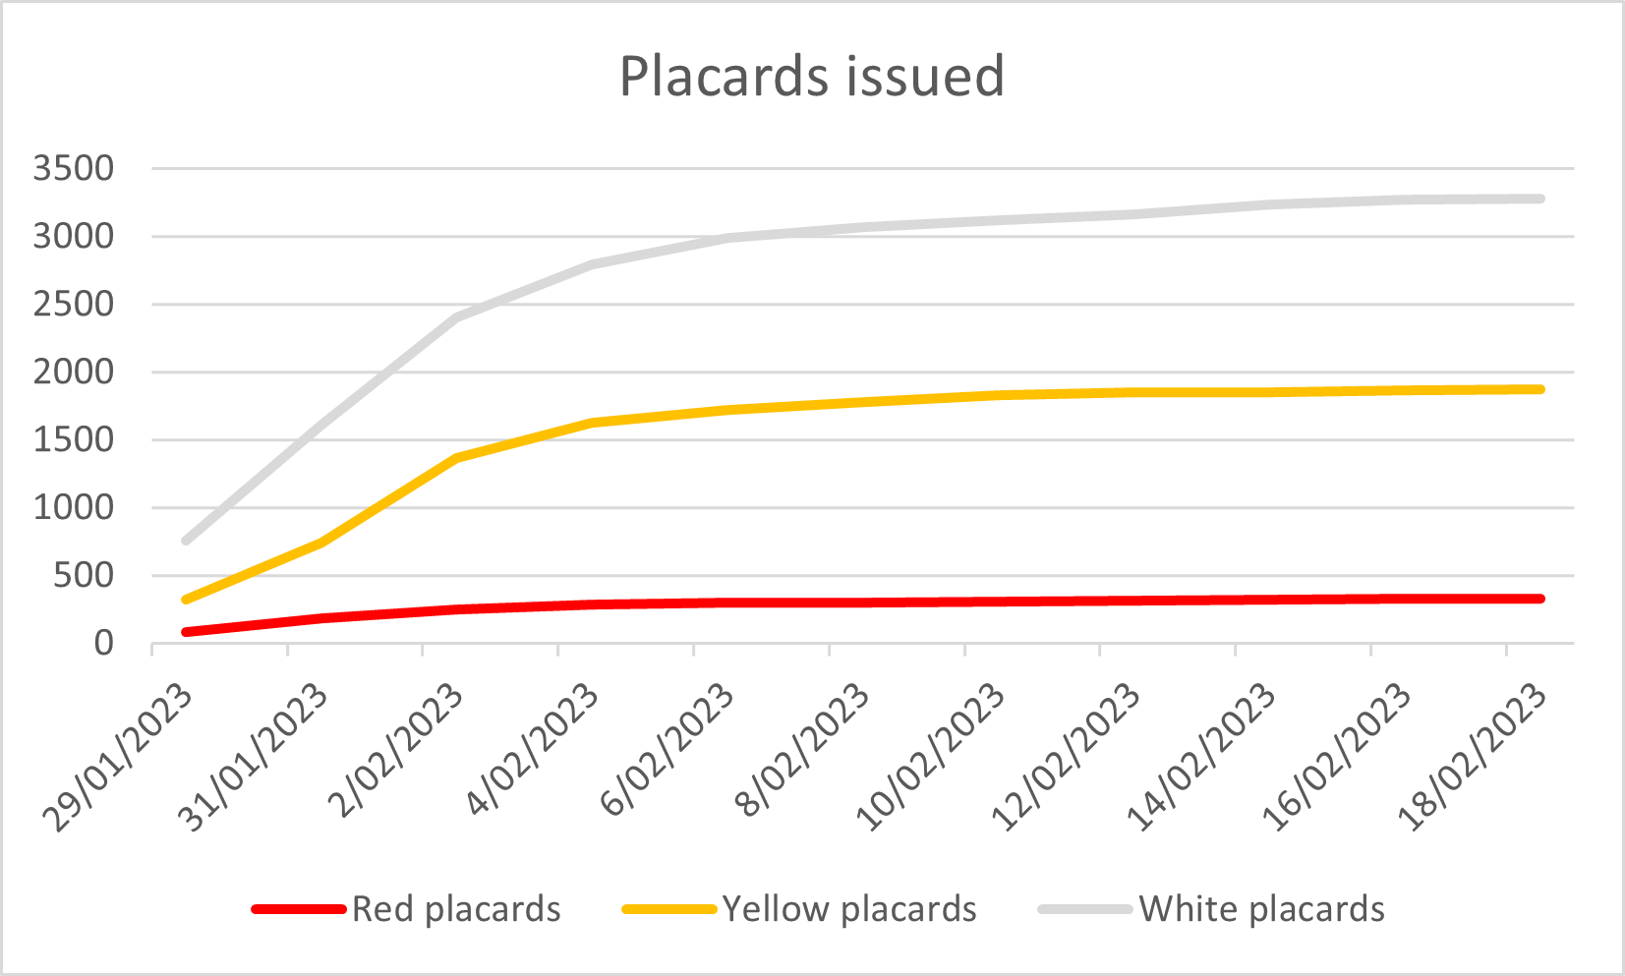

*Figure 5**. Number of properties placarded over time as at 22 February 2023*

1. Properties have been assigned a coloured placard to indicate their extent of damage:
   * red placard - means the building cannot be used and entry is prohibited because it has sustained moderate or heavy damage and poses a significant risk to health or life
   * yellow placard - means the building may have moderate damage and access is restricted. Access may be restricted to some of the building only or may be restricted for short-term entry only
   * white placard - means the building may have suffered little or no damage and can be used. However, it doesn't necessarily mean the building is safe, as there could be unseen damage.

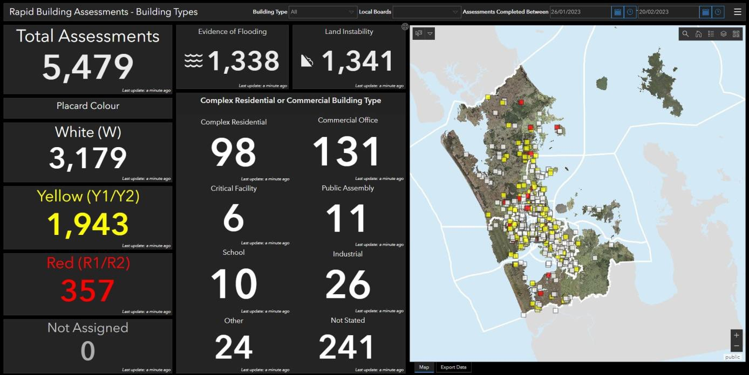

*Figure 6**. Rapid Building Assessments as at 20 February 2023*

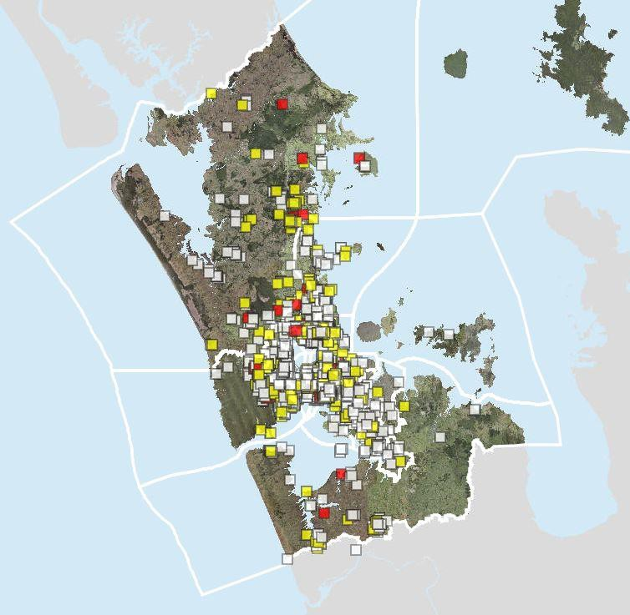

*Figure 7**. Placard status of buildings across Auckland as at 20 February 2023*

#### Parks and community facilities

##### Community assets

1. On Friday 27 January a large number of parks across the region suffered significant surface flooding. In most cases this flooding has subsequently drained away. This was followed by further rain on 1 February and over the weekend of 4-5 February which was an addition to already waterlogged conditions.
2. Although some work on inspections and investigations had begun after the initial 27 January floods, Cyclone Gabrielle (12-15 February) caused further flooding, slips and damage to assets, requiring staff and contractors to restart investigations and inspections across the community asset portfolio.
3. Damage to community assets through the region is evident. Auckland Council’s Parks and Community Facilities department has worked with internal and external customers to assist in ensuring the regional community infrastructure including libraries, pools and halls have been able to open as soon as possible. Most libraries and community buildings were open or partially open after the Cyclone event.
4. Assessment of impact are in progress; however, it may take some time before the full impact of the damage, remediation requirements and costs associated with the reinstatement are understood.
5. An assessment of known impacted facilities, as at 24 February 2023, includes:
   * 148 community facilities, including libraries, aquatic/recreation centres, community buildings, toilets, cemetery buildings etc have been affected by storm damage.
   * 382 affected reserves and parks, including damaged park infrastructure, bridges, boardwalks and playgrounds (25 playgrounds, 198 boardwalks, bridges and tracks, 159 other, for example car parks, park furniture and lighting or fences)
   * This data excludes a significant number of slips across the region, with 291 confirmed on Parks and Community Facilities land.
6. Parnell Baths remains closed to the public based on geotechnical advice that the cliff face is unstable along the boundary of the roadway and carpark.
7. Six regional parks in the north and west of Auckland were closed due to damage and/or access issues. These are Waitākere Ranges Regional Park, Muriwai Regional Park, Atiu Creek Regional Park, Tāwharanui Regional Park, Te Rau Puriri (South Head) and the western side of Hunua Ranges Regional Park, including Hunua Falls. Atiu Creek Regional Park, Tāwharanui Regional Park and Te Rau Puriri reopened on 1 March.
8. Further assessment works will be required, along with follow up with stakeholders, as the response moves into recovery.
9. It is anticipated that the number of affected assets will increase as Auckland Council continues to carry out site inspections and visits.
10. Not all of these assets are insured, which may hamper remediation.

##### Regional facilities

1. There has been significant damage to some of Auckland’s regional facilities. Full assessment of damage and remediation requirements is ongoing, however these are expected to be substantial.
2. The Aotea Centre, Civic Theatre, Auckland Town Hall, Auckland Film Studios and Eventfinder

Stadium (Northshore Events Centre) were all impacted by flooding.

1. All venues were fully operational as of 16 February, except for Western Springs Stadium which remains closed, and some conference facilities at Aotea Centre which are expected to be operational from early March.
2. There was major flooding across the lower portion of Auckland Zoo adjacent to Motions Creek. While remediation works were underway some parts of Auckland Zoo were closed. As of 23 February, most parts of the zoo has reopened to the public.
3. Western Springs Stadium is currently closed due to safety concerns. There are slips and subsidence around the grounds and power to the site has been compromised. Stadium closure is likely to last up to three months. Major events and festivals have been impacted with the Laneways festival cancelled, Speedway and major upcoming concerts are significantly at risk of cancellation.
4. The Ponsonby Rugby clubhouse has been evacuated and closed until further notice. Stadium closure is likely to last up to three months.
5. All other venues were impacted to a lesser extent, but clean-up efforts have ensured that they are all now open to the public. Assessments are in progress, however it may take some time before the full impact of the damage, remediation requirements and costs associated with the reinstatement are understood.
6. Major events cancelled to date included Elton John, Laneways and the Auckland Lantern Festival. Efforts to relocate or assess the viability of upcoming events underway.

##### Department of Conservation assets and facilities

1. Impact from the events include damaged tracks on the Te Henga walkway between Bethells Beach and Muriwai, and the Kaiaraara track on Aotea. Forest Road on Aotea Great Barrier has a significant crack and minor slips.
2. The Department of Conservation are preparing a recovery plan for their Auckland land and assets as part of national level recovery planning in response to cyclone Gabrielle. They will be seeking their own resourcing to deliver their recovery plan.

## Natural Environment

#### Land stability

1. The rainfall event on 27 January triggered an estimated several thousand landslides across the Auckland Region. The bulk of the landslides occurred in a north-south band running along the central spine of Auckland from west of Warkworth through to Waiuku, with the most severe impact north of the Manukau harbour. The landslides occurred in farmland, native and exotic forestry, along waterways, urban inland slopes and on many cliffs.
2. The subsequent cyclone on 14 February produced many more landslides, including very large and devastating landslides which destroyed many homes, roads and infrastructure assets. In this event the worst damage was along the west coast, including Muriwai, Karekare, Piha and across Waitākere. There were numerous other landslides across the region.
3. The distribution of landslides reported by the public is shown in Figure 8 below (from NZ Landslides Database). This is representative, but currently only includes a small percentage of the total number of landslides experienced.
4. The instability has been driven by the saturation of the ground following the extremely wet

January, in combination with the extreme rainfall. Most landslides appear to have formed in areas of overland flow.

1. Following Cyclone Gabrielle there were significant slips on the West Coast of Auckland, particularly at Karekare, Muriwai and Piha, with road access to these communities affected by slips and washouts. Access has been restored to most areas but is limited to residents and emergency/essential services only. As of 23 February, access to Karekare is still extremely limited.
2. Known active slips are still present in Piha, Muriwai and Karekare and many other locations from Rodney to Franklin. Access to slip-impacted homes and neighbourhoods is being carefully managed.

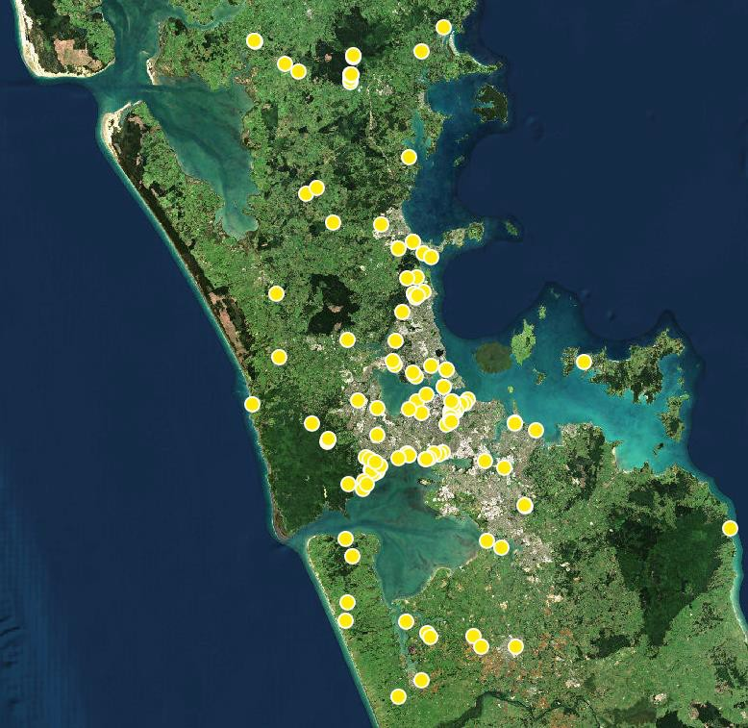

*Figure 8**. General distribution of landslides in Auckland as at 23 February 2023, with significant omissions still to be added (from NZ Landslides Database)*

#### Land contamination

1. Post-storm inspections at Auckland Council owned/managed closed landfills are ongoing. Although landslides have been observed on a few closed landfills, no resultant widespread or large-scale environmental damage have been identified at these sites and at this time.
2. Some of these landslides are impacting other assets such as roads and utilities. This is because many closed landfills have been repurposed to other uses, predominantly parks and reserves. The extent of closed landfill-related damage and recovery requirements are still unknown.
3. The status of privately owned/managed landfills are not known at this stage.
4. Further assessments and understanding any changes to relevant service level expectations are required as part of the recovery plan.

#### Stormwater and hydrology

1. On 27 January Auckland received an average of 307mm of rain. This was Auckland’s ‘wettest’ 24 hours on record. The amount of rainfall was significantly more than forecast, and more than 60 per cent of the urban Auckland area received a greater than 100-year Annual Recurrence Interval amount of rainfall.
2. Areas of the central city above historic lava flows experienced issues with record high groundwater table levels. As a result, springs or ongoing water flows are occurring on private properties or public land.
3. High groundwater levels are likely to be associated with land instability where they occur on slopes. Further rain could exacerbate this effect causing further land instability.
4. The council’s major stormwater capital projects had minor impacts due to flooding, except for the Corban Reserve stormwater project which experienced extensive flooding and will need remediation, to be covered by contract works insurance.
5. Healthy Waters and Watercare will be progressing a Flood Recovery Programme for Three Waters operations, which will coordinate, prioritise and fund three waters activities to recover from the flooding events. The Recovery Programme is expected to incorporate solutions such as naturalisation of streams as part of a range of options to improve resilience to future flooding.

#### Indigenous species and ecosystems

1. The storm events have caused serious, wide-ranging, and complex damaging effects to Auckland’s indigenous ecosystems and natural areas. The most immediately obvious effects are the direct destruction of terrestrial, freshwater, and marine habitats from flooding, landslips, wind, and wave damage. This damage not only reduces indigenous habitats but may have affected threatened species populations.
2. More complex and difficult to detect are the aggravation of biosecurity pressures such as increased spread of pest plants and pest animals (e.g., rats, mustelids) and plant pathogens. There are significant concerns about vulnerable marine and freshwater species, and severe impacts have been observed on threatened seabird species following the Auckland Anniversary storm event. The storms have also disrupted and delayed work programmes and community efforts across the region to protect the natural environment, including plant and animal pest control efforts that are usually intensive at this time of year.
3. Reporting on the location and extent of storm damage in the natural environment is currently very limited. A full picture of the damage and other effects of the storm events on Auckland’s natural environment will take months to emerge, with many consequences remaining unknown unless new resources are provided to identify these.
4. From information available to date, the areas worst affected are forest of the Waitākere Ranges and associated coastal areas, which have been severely affected by landslips and

associated vegetation loss. Coastal pōhutukawa forest and indigenous cliff ecosystems have suffered significant damage and there are concerns for localised threatened plant species on this coast.

1. Coastal vegetation on Auckland’s east coast has also suffered storm damage with numerous slips in coastal forest on steep land, including the loss of large pōhutukawa in numerous locations, and salt spray damage to susceptible native species. East coast sand dunes have been heavily modified by the storms, with dunes cut back to steep scarps with the associated damage to dune vegetation and ecosystems reported from many places, including Te Muri, Wenderholm, Orewa and Long Bay.
2. Masses of the invasive seaweed Caulerpa have been reported from beaches at Aotea/ Great Barrier Island, so this marine pest species is probably now much more widely dispersed following the storms.
3. Landslips within indigenous forest are highly vulnerable to weed invasion and unless this is managed, these sites may never return to native vegetation and will act as weed sources for surrounding areas for decades to come. Indigenous ecosystems throughout much of the Waitākere Ranges and coastal cliffs on Auckland’s east coast are now at acute risk from exacerbated weed impacts.
4. The cost of revegetation and effective management of weeds on numerous slips on public land would likely to be in order of at least hundreds of thousands per annum over an ongoing period. This expenditure is outside of current budgets and needs to be investigated to avoid long term erosion and ecological effects.
5. A rāhui was placed by Ngāti Whātua Ōrākei on the inner Waitematā harbour to ‘acknowledge and address the cultural and environmental impacts’ of the January rain events. The rāhui was lifted on 16 February, with the Waitematā showing signs of regeneration despite the effects of Cyclone Gabrielle.
6. There are impacts to native and mature trees within the Auckland region. As of 24 February, 3,989 tree-related jobs have been received by Auckland Council, with over 1,500 of the these classed as critical. Seventy-three per cent (2,906) of tree-related requests followed Cyclone Gabrielle.

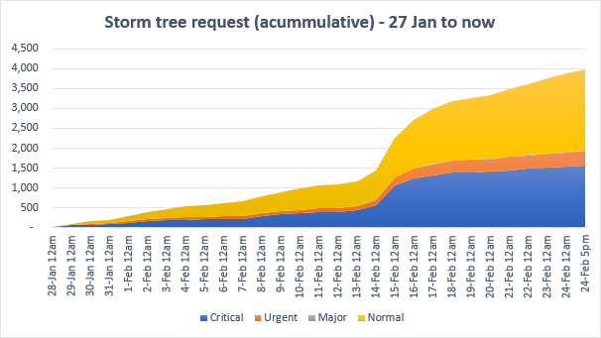

*Figure 9**. Flood-related tree requests – 27 January to 24 February 2023*

##### Kauri dieback disease

1. Landslips and flooding in kauri forest where kauri dieback disease is known to be present risk spreading the disease. Landslip damage is severe and widespread for the west coast and the Waitākere Ranges. Landslips have damaged several tracks in the ranges that have been recently rebuilt to reduce kauri dieback spread.
2. In urban areas affected by landslips (such as Titirangi), clean-up and rehabilitation activities including earthworks and the movement of soil, vegetation and machinery also have the potential to spread kauri dieback disease.
3. The [National PA (*Phytophthora agathidicida*) Pest Management Plan](https://www.kauriprotection.co.nz/national-plan/about-the-plan/) requires that earthworks undertaken within a kauri zone only operate under an approved earthworks risk management plan. This rule does not apply for earthworks that are undertaken *during* an emergency; however, an earthworks risk management plan is required for earthworks in kauri areas after an emergency has passed.

## Lifeline utilities

#### Electricity

1. As of 28 February 2023, there remained approximately 28 properties without power (excluding Muriwai). Power was restored to more than 35,000 properties between Cyclone Gabrielle and 24 February.

#### Water supply

1. Tap water in Auckland remains safe to drink. The water in dams in the Waitākere Ranges has been affected by landslides. The level of sediment makes it harder for the local treatment plants to process. However, water supply has been restored to all areas except Muriwai and all water entering supply continues to meet drinking water standards.
2. Storm and flood damage from 27 January cause some water supply issues which were resolved ahead of Cyclone Gabrielle, including flooding in the Wairau water treatment plant and a slip damaging a watermain on Scenic Drive. Tankers were put in place in areas with interrupted supply until these issues were resolved.
3. The Muriwai water treatment plant has been red placarded due to a slip. A tanker with potable water was set up in Muriwai as an emergency measure. On 24 February Watercare set up a temporary water supply solution for this area using a mobile pump station, allowing Muriwai residents to access potable water from the network.

#### Wastewater

1. Wastewater treatment plants are being closely monitored and are stable. Watercare is working through approximately 15 known wastewater network failures that have arisen due to landslides during the floods.
2. Auckland Council is assisting with the emptying of private septic systems in Piha. This has become an issue due to ongoing power disruption and silting caused by floods and landslips. The council is looking to expand this support to other impacted communities and working with liaisons on the ground to develop plans for this work.
3. The clean-up of beaches and public spaces affected by wastewater overflows during the storm

will take several weeks, due to the scale and spread of the event. Good progress has been made cleaning up private properties where wastewater overflows have occurred.

1. There is a potential health risk for Aucklanders swimming in beaches and waterways due to wastewater contamination and debris – Aucklanders are being encouraged to check [www.safeswim.nz](http://www.safeswim.nz/) before swimming.

#### Telecommunications

1. Eight cell sites are down, mainly due to power-related issues. In some West Coast areas telecommunications have been restored using generators (24/02/2023).

#### Fuel

1. No known restrictions on access to fuel.

#### Transport

##### State Highways and local roads

1. There were extensive road closures due to flooding and land movement. In addition to local and arterial roads, closures included State Highways 1, 26, 16 and 20A.
2. As of 28 February, 32 Auckland roads were closed. An additional number of roads that currently remain open have been damaged and will require resurfacing or remediation. Agencies are working to open roads as swiftly as possible, but remedial works will be ongoing.
3. A temporary bailey bridge to access Riverhead has been installed.

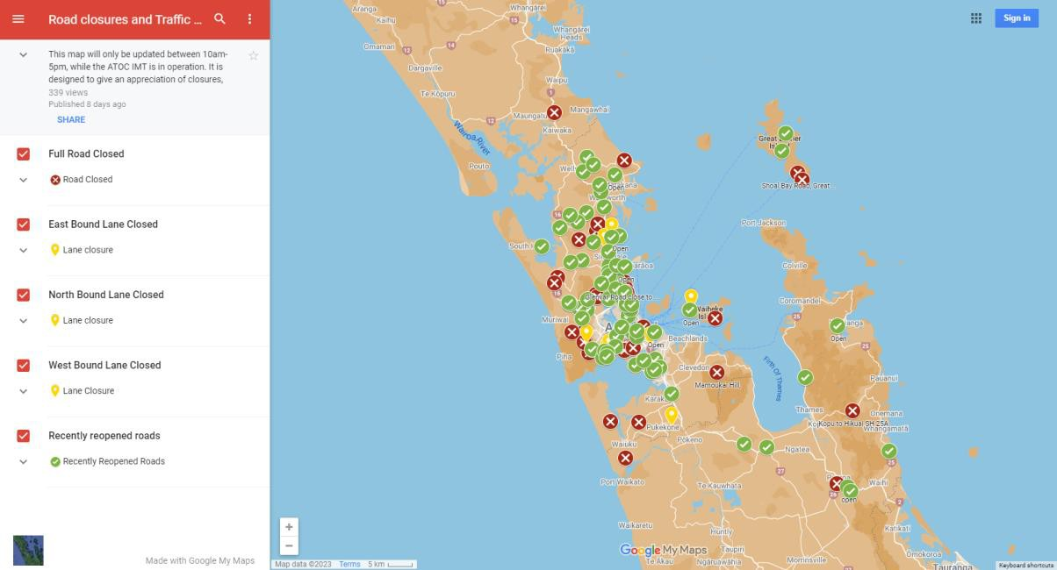

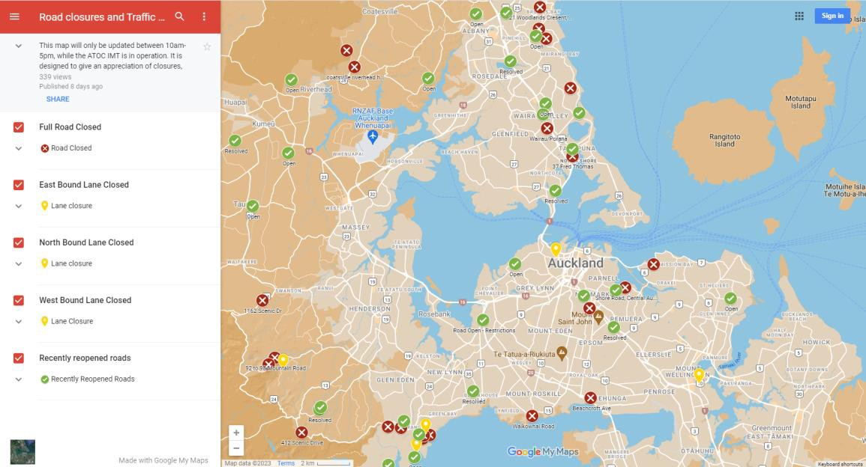

*Figure 10.* *Road closures and traffic light outages across Auckland as at 10 February 10:20am*

##### Public Transport

1. Bus and ferry services have been largely restored, albeit with temporary arrangements in place where needed. Clean-up of cycle and pedestrian infrastructure is underway.
2. There have been multiple slips on Auckland’s train network. KiwiRail are working to carry out urgent repairs in these areas. Reduced rail services are in place. Replacement buses are being used on some of the impacted rail network, with train speed restrictions in place in some areas. Some services are also limited due to the Rail Network Rebuild programme.
3. The bus network is returning to normal schedule. Some diversions and detours continue to operate due to road closures. Auckland Transport worked with operators on school bus routes affected by detours, to ensure readiness for all schools re-opening.

##### Ferries

1. There is debris in and around Auckland harbours requiring removal, with on-going need for assessment. The Harbourmaster has been working with contractors to collect and retrieve debris.
2. Great Barrier Island’s main wharf located at Tryphena where the ferry arrives from Auckland, was cut off by a landslip on Shoal Bay Road. Ferries were temporarily diverted to Whangaparapara Harbour. The wharf has now reopened.

##### Airport

1. Auckland Airport was closed on 27 January (reopening 28 January) and overnight on 14 February (reopening 15 February), in response to the January Flood and Cyclone Gabrielle.
2. Accommodation was provided to approximately 50 airport customers at Trusts Arena overnight on 15 February. People were transferred back to the airport on the morning of 16 February.
3. Auckland International Airport was restored to an operational state on 15 February.

# Nature and extent of consequences (short, medium and long-term)

## Welfare and Social Consequence

#### Condition of community affected by the emergency

1. A large number of Auckland households have contacted Auckland Council seeking support to respond to the flooding. People are currently staying in emergency and temporary accommodation, and an unknown number of people are staying with friends and family.
2. There is an extreme shortage of temporary accommodation in Auckland and the construction industry is already facing significant cost escalations, labour and supply chain constraints. This may lead to significant delays in responding to the demand to repair or replace damaged houses.
3. Impacted people will require practical and psychosocial support to navigate the process of finding more permanent accommodation, lodging an insurance claim (if they are insured) and rebuilding or repairing their home. Their needs should be prioritised in a Recovery Action Plan.

#### Welfare and social consequences of emergency

1. The consequences of this emergency on the social environment may include:
   * existing housing and social needs compounded by impacts of event
   * disruption to day-to-day life
   * impacts on physical and mental wellbeing (stress/anxiety), including those providing support services and the increasing demands and fatigue
   * increase in alcohol and substance use as a coping mechanism
   * increase in family harm due to stress from disruption of normal life
   * limited access to homes/living in temporary housing
   * emergency and temporary housing located in areas that are difficult to access established employment and schools
   * crowded accommodation where households are staying with family/friends
   * no access to usual belongings
   * stress of managing insurance claims/excess
   * no insurance or not enough cover
   * isolation
   * loss of memorabilia
   * loss of personal belongings or property
   * security of unoccupied properties
   * unknown period of displacement
   * logistics and time issues of managing repairs with potential pressures or limitation on builder resources
   * additional financial stressors
   * strain on iwi/marae and community organisations providing support to those impacted
   * short-term increase in fresh food costs, due to damage to crops
   * impacts on mana whenua as kaitiaki, due to damage to natural environment, waterways and waahi tapu.
   * appropriate mātauranga Māori and cultural practices in the removal of taonga.

#### Situations with potential to escalate or exacerbate

1. Areas or situations with the potential to escalate the impacts of the emergency include:
   * further weather events causing more damage
   * further slips putting residential property and key infrastructure at risk dwellings susceptible to future flood events
   * the psychosocial impact of the emergency, including the compounding impacts of the COVID-19 pandemic, inflation pressures, and global economic rebalancing post-covid.
   * the ongoing welfare requirements for those without home and/or contents insurance
   * under or non-insurance for businesses
   * the number of insurance claims means that it may take years for all claims to be processed
   * temporary accommodation insurance has a limited timeframe which is usually less than any timeframe for substantive rebuilds
   * pre-existing Auckland housing/accommodation shortages and limited options for emergency accommodation
   * the collection and disposal of flood affected items from properties and kerbsides
   * the emergence of medium-to-long term health impacts due to the flooding or contamination from sewerage discharge
   * properties left unchecked for damage for long periods of time the building assessment ongoing process and how owners and occupiers are advised of results (or changes from rechecks) as well as next steps
   * ongoing restricted or no access to properties and businesses
   * property owners at risk from slips on or near their properties – pressure to remove slips, distress / anger at a perceived lack of action
   * appropriate mātauranga Māori and cultural practices for the spiritual recovery of impacted waahi tapu, sites and buildings of cultural significance
   * unknown number of residents who are socially isolated, with compromised health and on very low or fixed incomes (superannuation, sickness benefit). They are less likely to seek help than some other residents and may only come to our notice through concerned whānau, local community advocates or neighbours
   * people not feeling adequately supported through recovery
   * state of access and weight limitations on roads
   * impacts on rural production reduce supply of rural produce and inputs into agricultural activities
   * unemployment or loss of income as a result of business impacts.

#### Recovery Considerations

1. There are immediate and ongoing needs for community outreach and welfare assessments. Timelines for support can be determined through a detailed analysis as part of development of the Recovery Plan, but it is likely the community need for support will endure for at least two to three years.
2. The communities of west and south Auckland have been particularly impacted by the weather event. These areas are already facing challenges in regard to social economic outcomes, and are where we see a concentration of Auckland’s communities of greatest need. Recovery efforts should consider assessing, prioritising and tailoring the response to these communities.
3. Emergency and temporary accommodation is a key issue with limitation of accommodation resources. There is a current trend of increasing demand and diminishing supply for emergency accommodation and temporary accommodation.
4. An extensive, coordinated, multi-agency communications and outreach programme is required to connect with the diverse range of ethnicities, ages and varying circumstances within the communities affected.
5. It is strongly recommended that teams of navigators are engaged to assist people with the diverse challenges they will face during the recovery period. These include:
   * insurance (and lack of insurance or underinsurance)
   * accessing financial assistance
   * psycho-social needs
   * temporary accommodation (including if required to vacate premises later to enable repairs)
   * inter-agency support for housing needs.
6. Many people will not have previously experienced events such as this and will be unfamiliar with what to do and how to access the support they need.
7. Peoples’ needs will change over time. Those who may initially be coping may face challenges at later stages, and some affected severely early on may recover well. Others will have complex needs and require support for an extended period.

#### Key Areas of Focus for Recovery

##### Accommodation

###### Emergency Accommodation

1. Emergency accommodation was provided to 560 households. Further requests may emerge through recovery as needs assessments and property inspections continue.
2. There is a concern that elderly people, overstayers and those with disabilities may not be able to seek support for emergency accommodation. This will be addressed through community outreach and welfare visits to areas most impacted.

###### Temporary Accommodation Service (TAS)

1. MBIE activated the Temporary Accommodation Service on 8 February 2023.
2. The Auckland Council will continue to provide numbers of impacted properties through the Rapid Building Assessment (RBA) to assist with accommodating displaced households into accommodation close to their community.
3. The Rapid Building Assessment (RBA) database has also been shared with TAS.

##### Community Support

###### Navigators

1. Owing to the large numbers of impacted people from diverse backgrounds it is strongly recommended that the Recovery Manager consider the establishment of navigators.
2. Navigators have been used in multiple New Zealand events and are resources supporting individuals and families through adverse events.
3. This may be considered for funding by Government subject to a detailed business case being put forward. The functions and business case processes can be found in the latest guide link [content (boprc.govt.nz)](https://atlas.boprc.govt.nz/api/v1/edms/document/A4182361/content).

## Economic Consequence

#### Impact to Auckland’s economic performance

1. Auckland’s scale, gateway status and high concentration of critical industries meant it was more severely impacted by the COVID-19 pandemic than many other parts of New Zealand. This had a direct impact on economic performance, resulting in a $3.5 billion impact on GDP (up to the year ending March 2021) for the region. These emergency events will further delay Auckland’s economic recovery.
2. Auckland’s economic performance will be directly impacted from loss or damage to its asset base owned by households, businesses and the public sector, and include land, infrastructure, buildings, household contents, crops, stock and equipment. The consequence of this could include business closures, inefficiencies and disruptions to the movement of workers and to supply chains/freight.
3. There will have been disruption to some sectors in the immediate aftermath of the flood and cyclone, such as grocery retailers unable to re-stock shelves from road closures and other supply chain disruptions. This will have consequences on prices and households.
4. Emergency events can exacerbate existing socioeconomic inequalities. Households on

floodplains are not only more exposed to flood risk but may also have fewer resources to cope with flood events and their impacts. There could be disproportionate impact on low-income households that tend to be located in flood prone areas due to relatively lower cost housing.

1. Public perception of risk could potentially see property values adjust for land and housing located in flood prone areas. Insurance premiums will eventually adjust to new levels pricing in the risks of future events.
2. Cost to remedy/repair housing could be impacted by an already constrained construction sector. This raises the prospect of repair work being drawn out and limited resources (labour, materials) being diverted from alternate uses, so without any interventions to increase capacity some infrastructure projects could be reprioritised (pushed back or brought forward).
3. Conversely, some types of economic activity will increase in the aftermath, relating to the clean-up, remediation, and replacement of damaged assets. Any post-event lift in GDP may just reflect investment and consumption activity to remediate that damaged asset base.

#### Scale of the cost and implications

1. The situation is still evolving, and information is still being collated. As such, there is considerable uncertainty over the scale of the damage and of the impacts on economic activity. While insurance claims can give a sense of the scale of the damage, not all damaged assets will have been insured and so an insurance perspective undercounts the economic cost.
2. Media reports indicate insurers had received 40,000 insurance claims as at 14 February, with this number being expected to increase. As a point of reference, the flooding in West Auckland in August 2021 led to 2,700 insurance claims. Insured losses of $62 million were spread among house and contents (50%), commercial (41%) and vehicle insurance (8%).
3. The Insurance Council has stated that it is too early to estimate the cost of the damage. Initial estimates of the insurance cost underline the uncertainty, ranging from two to three times that of the 2021 West Auckland flood (i.e. $120-190 million) to up to $1 billion (assuming a fourfold increase in the current number of claims and an average claim amount of $20,000).
4. The damage will lead to some assets being re-priced. The implications for land use policy and infrastructure standards will need to be worked through in a coordinated, evidence-based way.
5. On 9 February 2023 the Planning, Environment and Parks Committee requested a scope of work to ‘investigate the regional and localised impacts of flooding, and the implications for land use planning, regulatory, current plan changes to the Auckland Unitary Plan (including Plan Change 78), infrastructure and other policy settings’ (refer PEPCC/2023/6).

#### Cost escalation and inflation

1. Inflation is at a high level across the economy and has resulted in cost increases to sectors that will be key to the recovery effort, including construction, food and transport.
2. It is possible that in a capacity constrained sector like construction there will be further price rises due to limited supply.
3. The ability for the construction sector to support the increased demand for repair and replacement of building and infrastructure needs to be considered. This sector was experiencing resourcing issues (staff shortfall), supply chain issues and increased materials costs before the emergency event, and these problems will now be exacerbated.
4. Increasing cost of remedial work will increase financial hardship and delays to repair.
5. Large asset owners such as Auckland Council have sustained significant damage to their

infrastructure and facilities, requiring unbudgeted remedial works. Further cost escalation will further exacerbate their ability to progress remedial works.

1. Action may be required to address escalating costs, labour shortages and supply chain constraints in the construction industry. Further assessment is required.

## Natural Environment Consequence

#### Natural Ecosystems

1. There are significant impact to the natural ecosystem as a result of the emergency events, including:
   * impact to native species across the different aquatic and terrestrial environments
   * heightened biosecurity and biodiversity risks
   * potential spreading of kauri dieback disease
   * pest management issues
   * loss of mature trees through damage and slips.
2. The full extent of impact and consequences are currently not known. A comprehensive assessment should be undertaken to understand the extent of impacts on ecosystems, and plans for restorations developed.
3. The ongoing clean-up of beaches and public spaces affected by wastewater overflows during the storm will need to continue in the short term.
4. An earthworks risk management plan is required for earthworks in kauri areas after an emergency has passed.

#### Coastal Hazards

1. Auckland Council’s Resilient Land & Coasts team have completed rapid inspections of most of Auckland’s coastline, with a focus on known coastal ‘hotspots’ and areas with reported damage that are currently accessible to the team.
2. As Cyclone Gabrielle approached Auckland, the very deep low pressure created a storm surge, while strong easterly created significant wave energy. As a result, most of the damage to Auckland’s coastline has focussed on the more exposed, north-east coast.
3. It is anticipated that impacts would have been far greater if the Cyclone had coincided with a higher or king tide event.
4. Immediate actions have focussed on making publicly accessible areas of the coast safe, erecting fencing and signage, where required, and removal of debris material from beaches.
5. Identified works for council land and assets will be prioritised between emergency works and longer-term coastal renewals.
6. Identified emergency works will be the priority for high usage areas and critical infrastructure.
7. Longer term responses will investigate appropriate remediation options for coastal renewals and nature-based solutions including reshaping and dune planting which will guide future costs.

## Built Environment Consequence

#### Damaged buildings remedial and tracking

1. Auckland Council will hold information with respect to placarded buildings from the January Flood and Cyclone Gabrielle, as well as tracking their remedial status over time. Information will be shared with other agencies as appropriate to support the recovery.
2. The Rapid Building Assessment data for the January Flood event was closed on 18 February 2023. The final number of assessments (not placarded buildings) for the January Storm RBA Operation is set at 357 Red, 1,943 Yellow, and 3,179 White.
3. The Rapid Building Assessment for Cyclone Gabrielle is ongoing and a close off date has not been determined at this time stage. A final count of assessments not yet available.
4. Data consolidation is in progress to determine the number of buildings that were issued with placards and what their status is.
5. Information is provided on the [Auckland Emergency Management website](https://www.aucklandemergencymanagement.org.nz/major-incident/flooding-2023#Building) and [Auckland](https://ourauckland.aucklandcouncil.govt.nz/news/2023/01/what-to-expect-from-flood-damaged-building-inspections/)  [Council website,](https://ourauckland.aucklandcouncil.govt.nz/news/2023/01/what-to-expect-from-flood-damaged-building-inspections/) with respect to the Rapid Building Assessment process, building remedial options and approvals, as well as the re-inspection process.
6. Key risks include people continuing to re-enter and occupy damaged buildings, or the inability to fund/undertake repairs in a timely manner.
7. There is an opportunity to consider streamlined consenting process as part of the recovery plan.

##### Insurance

1. A substantial number of insurance claims have been and continue to be made in response to the flood, for home, contents, motor vehicles, business, marine and other claims.
2. Ensuring claims are assessed and resolved as quickly as possible will be crucial for recovery, however there is a risk that more complex claims could take longer.
3. Owing to the large numbers of impacted and diverse peoples, as outlined above it is strongly recommended that the Recovery Manager consider the establishment of a team of navigators to support navigation through the insurance and other processes.
4. The use of MBIE Residential Advisory Services should be considered.
5. Some homeowners do not have insurance, or have inadequate cover. Some landlords also may lack insurance. Exact numbers will need to be assessed and confirmed.
6. Some homeowners who live in flood-stricken areas may also find it difficult to access insurance in future or sell their property. Options for supporting these people should be considered.
7. The full extent of insurance claim is not yet available. Auckland Recovery will include sourcing this data from the Insurance Council and EQC as part of the Recovery Plan.

##### Waste management / debris

1. The clean-up of flood and cyclone damaged household items is underway. A significant amount of waste will need to be disposed of, including commercial and household waste, soil, silt, vegetation and contaminated land.
2. The estimated volume of waste disposed of to date is just over 5000 tonnes. The final amount is likely to far exceed this as it will include a large volume of construction waste from damaged buildings.
3. Waste management contractors are in place to pick up waste from skip bins and kerbside. People are also taking waste directly to transfer stations.
4. Current clean up focus and disposal is for household furniture and chattels only. Construction waste, such as flood damaged wall boards, is starting to be seen and it is anticipated this will increase considerably in the coming weeks and months.
5. There are no emerging issues with capacity at landfills and transfer stations; resource recovery centres and landfills have been able to deal with the volume and types of material received.
6. Only materials, such as metal and wood, that can be recycled safely are being recovered and recycled at the facilities. Fridges are also being collected or separated to ensure degassing, which prevents greenhouse gases from being released into the atmosphere. However, the majority of fridges left on the kerbside to date have had the motors and metals removed, thereby degassing the fridges to the atmosphere in the process.
7. Key risks are:
   * Public health risk from contact with contaminated flood waters and contaminated materials, and from exposure to mould and mildew.
   * Elderly and vulnerable people unable to remove contaminated materials without support. There is currently limited resource to support. Unfamiliar community volunteers entering vulnerable people’s home could cause some anxiety.
   * People undertaking their own building demolition could risk exposure to hazardous building materials, such as asbestos and lead.
   * The capacity to remove waste from kerbside in a timely manner. Piles of waste on kerbside could attract vermin and vandalism, as well as providing a focal point for illegal dumping of general inorganic waste. There is likely to be a long tail of domestic waste needing removal.
   * A large amount of waste going directly to landfill, particularly construction and demolition waste.
8. There will need to be a continued and focused effort on clearing flood damaged household items. Employment of appropriate volunteers/workers to provide support to elderly and vulnerable members of the community to remove waste could be considered.
9. Information should continue to be provided to public, supported by specialist health and safety inspectors, and advisors, as appropriate, to support identification and handling of hazardous building materials and contaminated waste.
10. Residents have been informed not to remove anything that is fixed to the home or business premises such as hard flooring and wall linings as it could contain asbestos containing material (ACM). This should be done by trained contractors.
11. There may be opportunities to salvage some materials from deconstruction of buildings, including options for local salvage and re-use. Examples of this exist from the Piha flood of 2018 where over 58 tonnes of materials were recovered, largely for beneficial use by the local community, from three flood-damaged homes.

#### Hazards – landslides and soil instability

1. Slips or compromised soil stability are the primary hazards because of the flood event.
2. Following Cyclone Gabrielle there were significant slips on the West Coast of Auckland, particularly at Karekare, Muriwai and Piha, with road access to these communities affected by

slips and washouts. Access has been restored to most areas but is limited to residents and emergency/essential services only. As of 24 February 2023, access to Karekare is still extremely limited.

##### Known and emerging risks and issues

1. The scale of the landslide problem is still being assessed. The council is working with assessors on the ground, GNS Science, and other asset owners to try and get a more complete picture. Land stability is the responsibility of the landowner, as a result there is no single source of information for landslides. Auckland Council is leading the effort to create a comprehensive database of landslides to assist with our efforts to coordinate the response and prioritise the recovery.
2. Further bad weather (should it occur while the ground is still saturated and landslides remain un-remediated) is likely to trigger more movement in damaged areas. Landslides may grow in size and affect more properties.
3. High groundwater levels will result in significantly more landslides occurring than would normally be expected, and liquefaction may be more extensive than forecast. In addition, the high groundwater poses a significant risk should Auckland experience an earthquake.
4. There have been numerous instances of sinkholes opening up, normally where water has flowed along pipe backfill and washed out the fine material leaving a void, or where a pipe has collapsed. There is the potential for more of these to occur over the coming weeks.
5. Many landslides cross land ownership boundaries. Where the adjacent landowners have different priorities (for example, residential house adjacent to fields) it can become challenging to agree appropriate remedial options between the parties. Coordination of the remediation efforts between parties can also be difficult where landslides affect multiple asset owners (for example, a road with stormwater and wastewater pipes as well as adjacent private residential property). There may also be challenges relating to expectations where the council is the landowner for part of an area that has had a landslide.

##### Considerations for recovery

1. Short term:
   * Landslide assessments and data gathering will be required
   * Clear communications need to be given to private landowners about the roles and responsibilities of their insurers and of local government
   * Many landslides may need to be monitored at regular intervals, or after bad weather.
2. Medium to long term:
   * Many properties will require similar options for remediation. Opportunities for large bulk of similar consent applications to be processed efficiently
   * Limited geotechnical sector resource.
3. Because landslides are (in most cases) the responsibility of private landowners, it is challenging to get a full picture of the scale of land instability in the region. As a result, our information is sometimes inconsistent, out of date, and recorded in multiple sometimes conflicting locations. Significant effort is required to improve our ability to avoid or mitigate these hazards. This includes the need to create a landslide susceptibility map for the region (project commenced by Resilient Land & Coasts), to create detailed landslide hazard maps of vulnerable communities, and incorporate the results into land use planning and infrastructure decisions.

#### Housing and urban development

1. It is currently known that approximately around 50,000 properties in the region sit in a 100-year flood plain and approximately 55,000 sit in an overland flow path.
2. As a result of the above and the impact of climate change, the risk of future flooding events is likely to occur again.
3. A thorough review should be carried out to understand how the stormwater system responded to the flooding event and which parts require further investment to manage population growth and the impacts of climate change.
4. This review should also inform land use planning, as buildings and paved surfaces such as concrete and asphalt surfaces on roads, carparks, also prevent rainwater from dispersing into the ground, causing water to pool up and surfaces to flood during heavy rain events.
5. Future new developments should engineer overland flow paths away from critical infrastructure.
6. Use of nature-based solutions, such as wetlands, rain gardens, daylighting and naturalising of streams, should also be considered to manage flooding risk.
7. In the long term, the Recovery Plan should work with the local authority to consider the future land-use for highest risk areas.

#### Parks, community and regional facilities

1. Significant damage has been sustained by Auckland’s community and regional assets.
2. Community assets ranging from community buildings such as libraries, pools and recreation centres, to open spaces like our parks, regional parks, sports parks and campgrounds.
3. Assessment of impact are in progress; however, it may take some time before the full impact of the damage, remediation requirements and costs associated with the reinstatement are understood.
4. The costs associated with repairing, rebuilding or demolishing impacted assets are expected to be significant given the number of buildings damaged and tracks and clearing required in response phase. Costs for remedial works are unbudgeted.
5. The short-term focus is on making assets safe or closing them off and responding to the clean up across buildings and parks.
6. Once the full extent of damage across the asset portfolio is known, prioritisation and decisions around whether assets are replaced, repaired and/or demolished based will need to be considered in conjunction with the local boards and the Auckland Council Governing Body. These decisions will be informed by funding available through insurance and other funding sources.
7. Some assets may need to be retired due to being susceptible to further slips or impacts of weather for instance assets that are near the coast.
8. For regional facilities, the biggest risk relates to lack of infrastructure, ownership and control over Motions Creek which runs through the heart of the Zoo and adjacent to Western Springs Stadium. Impact of uncontrolled flooding and contaminated flood waters has had a massive impact on these two key facilities.

## Transport and lifeline utilities infrastructure

1. There has been considerable damage to key infrastructure and utilities assets, including drinking water, wastewater and transport infrastructure.
2. Recovery activities will be led by the respective infrastructure and utilities’ asset owners. However, planning and physical works will need to be coordinated to minimise rework and leverage efficiencies.
3. The immediate focus for recovery is on immediate service restoration, as well as remedial works that are deemed to be significant and of a larger scale.
4. The medium to long term focus will be to undertake a full asset based and system performance assessment and review. Remedial works will be identified and prioritised based on risk.
5. The complexity and scale of works to be undertaken is significant. Prioritisation of assets requiring permanent fixes will be confirmed via asset condition assessments, determination of scope, dedicated contractors and project delivery teams. This is potentially a multi-year programme.
6. A coordinated effort will be required to “build back better”. This will require a strategic approach with clear shared objectives between the many infrastructure owners. Efficiencies and improved outcomes can be achieved by learning lessons from previous events where entities have worked together in an alliance.

# Transition to Recovery

## Response Handover

1. This report forms the basis of the handover brief to the Recovery Manager.

## Recovery Plan

1. This Recovery Transition Report will inform preparation of initial recovery plans and decision- making thereafter.

## Recovery Managers

|  |  |
| --- | --- |
| **Name of Recovery Manager** | |
| Recovery Manager  Deputy Recovery Manager |  |
| National Recovery Manager |  |

## Recovery Structure and Resourcing

1. The recovery structure and resourcing is under development.

## Auckland Emergency Management support in recovery

1. Auckland Emergency Management have allocated the following resources to support the Auckland- led recovery weather and flooding event.

|  |  |
| --- | --- |
| Function | Role |
| Response Manager | Response Manager availability for support/advice of emergency response matters and actions that occurred prior to handover, to t he Recovery Manager on an as required basis. |
| Welfare | Welfare support ongoing through transition and ongoing as required (resourcing TBD) |
| Operations | Operations support for ongoing activities commenced in response, through the transition |
| Logistics | Logsitical support for ongoing welfare and operations activities throuhh the transition |

|  |  |
| --- | --- |
| PIM / Communications | ongoing support to maintain continuity of public messaging, spocils media and media support though the transition |

## Reporting

1. A regular reporting structure for the Auckland Recovery Plan will be developed once the Recovery Manager and structure of the recovery team is confirmed.

## Upcoming Meetings and Forums

1. Recovery Meeting scheduled to be developed and shared.

## Partnership with Mana Whenua for Recovery

1. Partnerships with iwi to support the recovery will be undertaken to recognise and provide a practical commitment to the Treaty of Waitangi.
2. Iwi mana whenua should be involved as partners in responding to impacts on the natural environment from the weather event, including native species and ecosystems.
3. Iwi mana whenua should also be involved as partners in considering changes to land use and stormwater systems to respond to flood impacts and how these can be managed to enhance the mauri of waterways in Tāmaki Makaurau.

## Engagement and communications

1. Auckland Council is a key lead agency engagement and communications regarding the recovery to the weather event. A Communications and Engagement plan will be developed as part of the Recovery Plan.
2. The communications and engagement plan will include a process to transition information from the existing emergency channels onto newly established ‘recovery’ channels, including the Auckland Emergency Management website.
3. There will be an ongoing requirement for information to be provided in plain English and translated into languages that will meet local community needs as the recovery progresses.
4. Community engagement will be undertaken as appropriate. Auckland Recovery will work closely with community partners to reach and support diverse communities impacted by the flooding event. There will be ongoing face-to-face community engagement to support other communications channels.

## Other key stakeholders

1. The following agencies are key stakeholders in the transition to Recovery:
   * National Emergency Management Agency
   * Ministry of Social Development
   * Ministry of Business Innovation and Unemployment
   * Ministry of Business Innovation and Employment
   * Waka Kotahi
   * Auckland Transport
   * Watercare Services Limited
   * Insurance Companies

## Risks and issues

1. Key risks and issues arising because of the emergency and in moving from response to recovery, and actions proposed and underway to reduce the impact are outlined below.

#### Social Environment

|  |  |  |  |  |
| --- | --- | --- | --- | --- |
|  | **Risk/issue** | **Action needed** | **Responsible** | **Result** |
| 1 | Insufficient temporary accommodation to meet demand for displaced households. | MBIE Temporary Accommodation Service (‘TAS’) to assist sourcing.  Impacted people to be identified and linked with agencies.  Provide support to access financial and other help. | MBIE MSD | MBIE will provide temporary accommodation service (TAS).  Adequate temporary accommodation provided to people in need. |
| 2 | Inability to access services for support, by people from diverse backgrounds. | Establishing teams of navigators to assist with accessing services for financial assistance, insurance, accommodation, psychosocial support, etc. | CDEM, Auckland Council, MSD, Te Whatu Ora | Assistance provided to access support. |
| 3 | Complex welfare and psychosocial impacts of those affected. | An extensive, coordinated, multi- agency communications and outreach programme is required to assess needs.  Identify and understand the emerging and ongoing needs of affected communities to  determine their | CDEM, Auckland Council, MSD, Te Whatu Ora | Welfare and psychosocial needs are understood.  Appropriate support is provided. |

|  |  |  |  |  |
| --- | --- | --- | --- | --- |
|  | **Risk/issue** | **Action needed** | **Responsible** | **Result** |
|  |  | specific requirements.  Development of a psychosocial plan. |  |  |
| 4 | Public health resulting from contaminated flood waste, mould and mildew. | Continued and focused effort on clearing contaminated waste from affected homes, including supporting vulnerable and elderly people to remove flood damaged household items. | MSD, Auckland Council, Te Whatu Ora | Public health risks are mitigated. |
| 5 | Increasing financial hardship due to cost- of-living increases, cost of repairs/remedial of impacted homes. | An extensive, coordinated, multi- agency communications and outreach programme is required to assess needs. | MSD | Welfare and psychosocial needs are understood.  Appropriate support is provided. |
| 6 | Increase in crime and community safety, due to damaged homes and displaced communities.  Increased incidents of family harm within impacted communities. | Police to monitor, investigate and respond as appropriate.  Partnership with agencies and community groups. | Police, MSD, Te Whatu Ora | Welfare and psychosocial needs are understood.  Appropriate support is provided. |
| 7 | Health and safety issues for people continuing to re-enter or occupy damaged or unsafe properties. | Police to monitor, investigate and respond as appropriate.  An extensive, coordinated, multi- agency communications and outreach programme is required to assess needs. | Police, MSD, Te Whatu Ora | Health and safety risks are mitigated |
| 8 | Inadequate support for isolated communities. | An isolated communities tasking group has been  activated within the | Auckland Emergency Management | Communities have access to essentials and are  kept up to date on |

|  |  |  |  |  |
| --- | --- | --- | --- | --- |
|  | **Risk/issue** | **Action needed** | **Responsible** | **Result** |
|  |  | Emergency Coordination Centre to manage contact, needs and logistics of access.  Welfare function to be transferred to recover phase. |  | the response. |

## Economic Environment

|  |  |  |  |  |
| --- | --- | --- | --- | --- |
|  | **Risk/issue** | **Action needed** | **Responsible** | **Result** |
| 1 | Business (including the rural sector) insolvency due to losses to operational premises, stock, and trading revenue.  Inability to fund requisite repairs. | Central government business support package.  Support to expedite insurance processing and building repair.  Further assessment is required to understand the impacts of the recent flooding events on the business areas and  sectors affected. | MBIE,  Chamber of Commerce | Minimise business closures as a direct impact to the emergency events. |
| 2 | Damage to agriculture land due to erosion, slips, silt; damage to agriculture facilities. | Central government support for farmers  Support to expedite insurance processing and building repair.  Further assessment is required to understand the impacts of the recent  flooding events. | MPI, MBIE | Agriculture land to return to production as soon as possible. |
| 3 | Widespread negative economic consequences via social, cultural, environmental, and financial impacts to households. | Central government support, insurance industry, local government. | Central Govt, Insurance industry, Auckland Council | Identify long- term solutions to at-risk areas through infrastructure and pricing signals. |

#### Built Environment

|  |  |  |  |  |
| --- | --- | --- | --- | --- |
|  | **Risk/issue** | **Action needed** | **Responsible** | **Result** |
| 1 | Delayed insurance processing could prolong the repair timeframe. | Streamline and expedite insurance claim and payout process..  Establishment of a team of navigators to support navigation  through the insurance and other processes. | MBIE  Insurance Companies | Remedial works are expedited and able to be reoccupied as soon as possible. |
| 2 | Property owners may not have insurance, or inadequate cover. | Exact numbers will need to be assessed to confirmed, to determine the appropriate support required. | MBIE MSD | Appropriate support is provided. |
| 3 | Labour shortage, supply chain constraint and construction cost escalation could prolong  the rebuild timeframe. | Further investigation required to determine what/if intervention may be required. | MBIE | Construction industry can support remedial works effectively |
| 4 | Inability to remove contaminated household and construction waste in a timely manner. | Continued and focused effort on clearing flood damaged household items. Employment of appropriate volunteers/workers to provide support to elderly and vulnerable members of the community to remove waste could be  considered. | Auckland Council MSD | Public health risks are mitigated  Damaged properties are safe to occupy. |
| 5 | Lack of coordination / collaboration between infrastructure owners may result in significant re-work and duplication (e.g. roads repaired then  pipes installed later). | Coordination required between infrastructure and asset owners. | Auckland Council, Central Government | Remedial works are carried out in a coordinated manner, with minimum duplication and  cost. |
| 6 | Land value re-pricing, infrastructure reprioritisation and insurance policy changes to exposed areas. | Ensure data, assumptions, and policy response(s) to support these changes are coordinated across all parties. | Auckland Council, Central Government and Private sector | Better land use outcomes for long-term climate resilience. |

#### Natural Environment

|  |  |  |  |  |
| --- | --- | --- | --- | --- |
|  | **Risk/issue** | **Action needed** | **Responsible** | **Result** |
| 1 | Further landslides in damaged areas.  Landslides may grow in  size and affect more properties. | Continue to monitor high risk areas, and communicate to affected owners. | Auckland Council | Aucklanders informed of risk |
| 2 | Potential risk of the spread of kauri dieback. | A comprehensive assessment should be undertaken to understand the extent of impacts on ecosystems,  and plans for restorations developed. | Auckland Council | Spread of kauri dieback disease are minimised |
| 3 | Increased spread of pest plants and pest animals (e.g., rats, mustelids) and plant pathogens. | A comprehensive assessment should be undertaken to understand the extent of impacts on ecosystems,  and plans for restorations developed. | Auckland Council DOC | Spread of pest plant and animals are minimised |
| 4 | Loss of tree cover, from storm damage and slips. | A comprehensive assessment should be undertaken to understand the extent of impacts on ecosystems, and plans for  restorations developed. | Auckland Council | Loss of native and mature trees minimised |
| 5 | Destruction of terrestrial, freshwater, and marine habitats from flooding, landslips, wind, and wave damage. | A comprehensive assessment should be undertaken to understand the extent of impacts on ecosystems, and plans for  restorations developed. | Auckland Council DOC | Loss or damage to native species habitats minimised |

#### Auckland Recovery

|  |  |  |  |  |
| --- | --- | --- | --- | --- |
|  | **Risk/issue** | **Action needed** | **Responsible** | **Result** |
| 1 | Inadequate resourcing to support Recovery Office. | Build capability and capacity within the Auckland Recovery Team. | Auckland Council | Recovery Team well-resourced and skilled. |

|  |  |  |  |  |
| --- | --- | --- | --- | --- |
|  | **Risk/issue** | **Action needed** | **Responsible** | **Result** |
| 2 | Loss of critical information/data/process in the transition from Response to Recovery, leading to key functions/operations  falling through the gap. | Clear Action planning around handover phase and transition. | Auckland Recovery Team | Ongoing task to mitigate risk. |

# Transition of CDEM Welfare Response to Recovery

1. Recovery in the welfare context involves the continued delivery of welfare services to affected communities following an emergency to bring about the immediate, medium-term, and long- term holistic regeneration of a community following an emergency.
2. This report will support the development of the Auckland Recovery Plan and the Auckland Recovery team.

## Community support information

##### Auckland Emergency Management (AEM)

1. Auckland Emergency Management are assisting communities affected by the severe weather and flood event across the Auckland region. If you need assistance, please contact 0800 22 22 00.

##### Auckland Council Emergency Relief Fund

1. The Auckland Council Emergency Relief Fund supports people who are experiencing hardship due to the flooding and need urgent financial assistance.
2. Applications to the Auckland Council Emergency Relief Fund can be made [online](https://www.aucklandcouncil.govt.nz/grants-community-support-housing/grants/regional-grants/Pages/grant-details.aspx?itemID=102).

##### Transport and water

1. For updates on water supply and wastewater refer to [Watercare](https://www.watercare.co.nz/About-us/News-media).
2. For updates on road closures and transport disruption refer to [Auckland Transport](https://at.govt.nz/about-us/news-events/service-disruptions/severe-weather-impact-across-the-auckland-area/).

##### COVID-19

1. Government guidelines advise, during emergencies where urgent help is needed, emergency services still operate even if a household is isolating. In an emergency, evacuations may be needed. The immediate safety of people takes absolute priority and overrides isolation requirements.
2. Once safe, precautions will then be taken to prevent the spread of the virus such as physical distancing and wearing face masks.
3. Please contact your health provider if you require further health advice.

##### MSD Financial Support

1. Civil Defence payments are available for people who have been affected by the severe weather and flood event across Auckland. These payments are available to anyone affected. Please call 0800 400 100.
2. Assistance may include:
   * Emergency food, clothing, and bedding if they have been damaged or destroyed.
   * Loss of income due to an inability to work caused by the weather event.
   * Payment if you have evacuees staying with you in places such as a private home, marae or community centres.

##### Assistance with other costs

1. There are other ways in which MSD may be able to help with things such as medical costs, rent, power bills, or other essential items. Please contact MSD on 0800 559 009.

##### Houses subject to Section 124 of the Building Act (“red placard”)

1. Houses may receive a red placard if they are deemed uninhabitable. Red placards have been issued when a house or structure has been affected or threatened by events such as flooding or land movement.
2. The effect of a red placard means that until Council is satisfied the threat has been removed, you should not be in your property unless it’s to remove valuable possessions or essential items. Occupants of red stickered houses that are insured should contact insurance providers for alternative accommodation cover.
3. Please contact 0800 22 22 00 if you have questions or concerns about a building assessment.

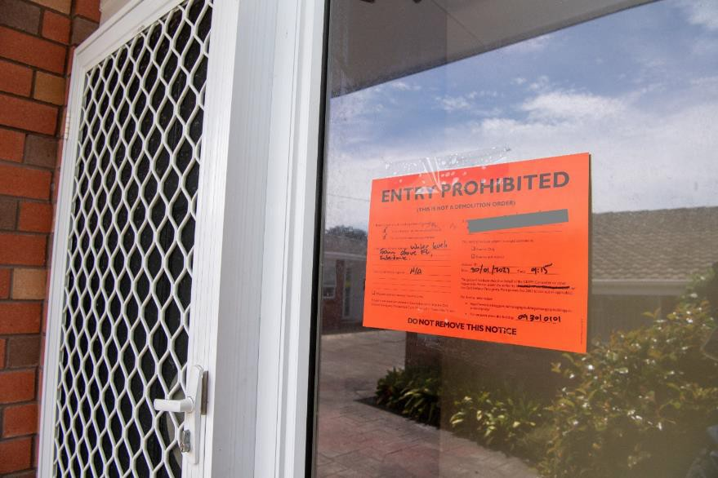

*Figure 11.* *Red placard on a damaged property*

##### Insurance and lodging a claim

1. If you have damage to your home, property or car, please contact your insurance company as soon as possible and they will guide you through the claim process. If you have a residential house claim and need advice to support you through the process, please call the Residential Advisory Service (RAS) on 0800 777 299.
2. [If your home is damaged and uninhabitable, ask your insurance provider if you are eligible for](https://protect-au.mimecast.com/s/23HMCL7EzOhE9p8uB3Gvf?domain=icnz.org.nz) [a temporary accommodation benefit which is included in most home and content policies.](https://protect-au.mimecast.com/s/23HMCL7EzOhE9p8uB3Gvf?domain=icnz.org.nz) Key things to note:
   * Take photos before you remove or repair anything and report it to your insurance company as soon as possible.
   * If you need to make your home safe, sanitary, secure and weather tight, please record the work done, take before and after photos, and keep copies of the bills you have paid.

##### Support for Farmers and Growers

1. Affected farmers and growers can contact:
   * The Rural Support Trust - call 0800 787 254 or visit [www.rural-support.org.nz](https://protect-au.mimecast.com/s/msFwC91WNoT8G31fEgRLX?domain=rural-support.org.nz/).
   * Horticulture New Zealand - fruit and vegetable growers 0508 467 869
   * Federated Farmers
   * Chair of Rural Coordination Group

##### Other Livestock or Feed Related Issues

1. Farmers needing expert feed support to do a feed plan, to source supplementary feed, or assistance with their livestock should contact their levy body or Federated Farmers.
   * Federated Farmers - 0800 327 646
   * Beef + Lamb New Zealand - 0800 233 352
   * DairyNZ - 0800 432 479 69

##### Animal welfare concerns

1. Ministry for Primary Industries (MPI) – email: [awem@mpi.govt.nz](mailto:awem@mpi.govt.nz) or call 0800 008 333
2. Or visit <https://www.mpi.govt.nz/animals/animal-welfare/animals-in-emergencies>

##### Business advice and support

1. Businesses needing advice on how to approach insurance or legal advice can call 0800 300 362 and visit [www.activatecommunity.co.nz](http://www.activatecommunity.co.nz/)
2. For health and well-being advice businesses can visit [www.wellbeing.firststeps.nz](http://www.wellbeing.firststeps.nz/)
3. Businesses can access the $5m government support package of emergency support to help businesses significantly affected by contacting the Auckland Business Chamber or via 0800 005 605.
4. A number of drop-in sessions are also being organized by business groups targeting the areas with the greatest need. These sessions will help connect businesses to the support that is available.
5. Businesses can also contact their banks, as some major banks are offering targeted support to businesses affected by the weather event.
6. The Auckland Business Chamber website [aucklandchamber.co.nz](https://aucklandchamber.co.nz/auckland-floods/?fbclid=IwAR1SsnjlzHeWwKPxDovtOacdQ79GMcYtRNmc6M6o2hRR9PYLvf9JxisBkYc&Mentalhealthandwellbeing) offers a central place for useful information and latest updates in response to the flooding. From finance and banking and insurance claims to emergency plans, weather updates and health/wellbeing resources.
7. The [Pacific Business Trust](https://www.facebook.com/pacificbusinesstrust/posts/627730626028010) are offering support to Pacific businesses. Visit them at the Pacific Response Hub, or phone 0800 287 7526 or email [info@pacificbusiness.co.nz](mailto:info@pacificbusiness.co.nz) between 8.30am and 5.00pm.

##### Health support / advice

1. Healthline - 0800 611 116,
2. Need to talk - text or call 1737

##### Tax payment / financial difficulty

1. Inland Revenue – please send a message in myIR.ird.govt.nz using the key word 'flood' or call us on our disaster line 0800 473 566.

##### Temporary Accommodation Service (TAS)

1. Ministry of Business, Innovation and Employment (MBIE) - 0508 754 163 (Activated in Auckland on 8 February 2023)

##### Tenancy information - landlords and tenants

1. Ministry of Business, Innovation and Employment (MBIE) - 0800 836 262 or visit https/[/www.tenancy.govt.nz/](http://www.tenancy.govt.nz/)

# Appendices

**Appendix I: Powers of a Recovery Manager during Transition1**

###### The amendments to the Civil Deference Emergency Management Act 2002 provides:

* + Group Recovery Managers as a statutory roles
  + Requires a Civil Defence Emergency Management (CDEM) Group to formally appoint a ‘suitably qualified and experienced person’ to be a Group Recovery Manager (s29)
  + Groups may also appoint one or more Local Recovery Managers (s30)
  + provides for Recovery Managers and constables to use powers during transition periods (Part 5B). However, there are differences with the powers of the CDEM Group or Controllers available during a state of emergency. For example, there is no requisitioning power available during a transition period.

Recovery Managers are responsible for directing, co-ordinating the use of personnel, material, information, services and other resources during a local transition period (s30A(1)).

###### Powers during a transition period

Under the Act the Group Recovery Manager – NOT the CDEM Group - has access to the powers contained in Part 5B. The CDEM Group retains overarching responsibility for the conduct of the Group Recovery Manager through their appointment.

Powers **can only be used** if they meet three legal tests. The action must in the Recovery Managers opinion be `in the public interest’, ‘necessary or desirable to ensure a timely and effective recovery’ AND ‘proportionate in the circumstances’ (s94G(3)).

CDEM Groups may appoint one or more Local Recovery Managers and delegate the functions, duties and powers of the Group Recovery Manager to the Local Recovery Managers to exercise in the area that the Group Recovery Manager is appointed (s30(1)).

If during a transition period a Group Recovery Manager needs to direct a Local Recovery Manager then that direction must be followed (s30(2)).

Under s94J the Minister may direct the CDEM Group, the Director of Civil Defence Emergency Management or a person (notably a Recovery Manager or constable) in performing any functions or duties and the exercising of any powers during a transition period.

###### Summary of powers

The list of powers reflects the activities that CDEM Groups, councils and communities may require Recovery Managers to exercise in order to aid recovery, once a state of emergency has ended.

Some of the powers are also available to a constable as defined by the Act and s4 of the Policing Act 2008.

1 Copied from: [https://www.civildefence.govt.nz/cdem-sector/legislation/civil-defence-emergency-management-](https://www.civildefence.govt.nz/cdem-sector/legislation/civil-defence-emergency-management-amendment-act/powers-of-a-recovery-manager-during-transition/#%3A~%3Atext%3DRecovery%20Managers%20are%20responsible%20for%2Cperiod%20(s30A(1))) [amendment-act/powers-of-a-recovery-manager-during-](https://www.civildefence.govt.nz/cdem-sector/legislation/civil-defence-emergency-management-amendment-act/powers-of-a-recovery-manager-during-transition/#%3A~%3Atext%3DRecovery%20Managers%20are%20responsible%20for%2Cperiod%20(s30A(1))) [transition/#:~:text=Recovery%20Managers%20are%20responsible%20for,period%20(s30A(1))](https://www.civildefence.govt.nz/cdem-sector/legislation/civil-defence-emergency-management-amendment-act/powers-of-a-recovery-manager-during-transition/#%3A~%3Atext%3DRecovery%20Managers%20are%20responsible%20for%2Cperiod%20(s30A(1)))., 10 February 2023

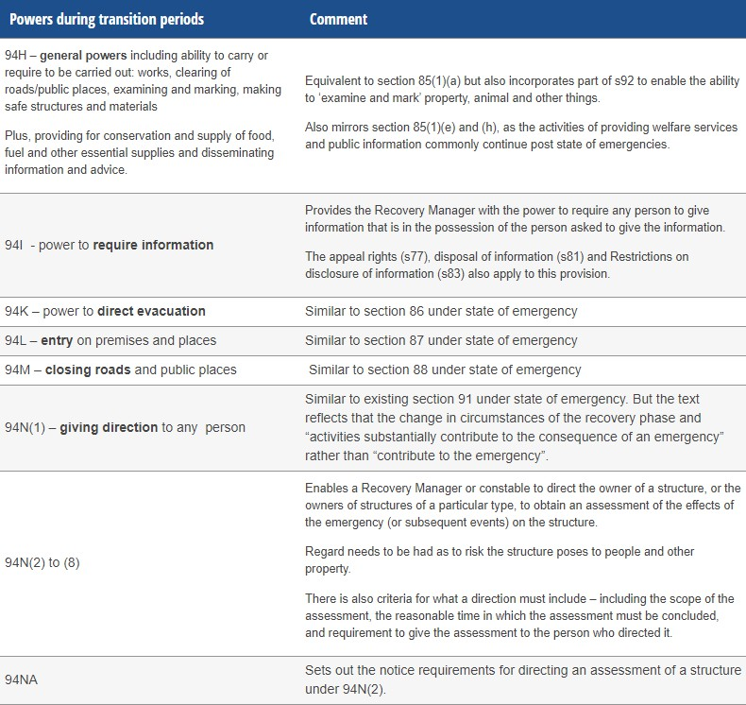

###### Reporting (new section 94P)

Unlike state of emergencies, there are specific reporting requirements if any power is used during transition periods. Reporting requirements include:

* + a written report from the Recovery Manager to the Director of CDEM and a copy to the CDEM Group within seven days of the transition period ending
  + detail on the powers used, by who and the reasons for use
  + making the report public – as the CDEM Group must put it on its website.

It is recommended that Recovery Managers (and those exercising powers) keep an updated record of powers that have been exercised, the reasons for exercising the powers and how the statutory tests in 94G(3) were considered.

###### Application of RMA

Section 330B of the Resource Management Act 1991 has also been amended to clarify that the emergency works provisions also apply to a transition period (s111 CDEM 2002).

###### Delegating functions

A Recovery Manager may authorise another person to perform their functions BUT there are limitations and conditions (new section 30A(3)–(5)).

###### Compensation

The compensation provisions in s108-109 have also been updated to include reference to Recovery Managers.

# List of Figures

Locations of isolated communities 14

Density map representation number of flood reports and Rapid Building Assessment Severity 16

Damage to commercial buildings in Key Economic Places 31

Number of properties placarded over time as at 22 February 2023 34

Rapid Building Assessments as at 20 February 2023 35

Placard status of buildings across Auckland as at 20 February 2023 35

General distribution of landslides in Auckland as at 23 February 2023, with significant omissions still to be added (from NZ Landslides Database) 38

Flood-related tree requests – 27 January to 24 February 2023 40

Road closures and traffic light outages across Auckland as at 10 February 10:20am 43

Red placard on a damaged property 64