
Transition Periods

Transition to Recovery
The transition to recovery is the process of formally ending the Response phase and moving into the Recovery phase. This is a formal process that usually occurs within the first few weeks of an event.
When extraordinary powers are required, this may involve entering a Transition Period. However, it is essential to note that moving to recovery does not have to involve a Transition Period.
Transition Periods
Transition Periods are a legislative mechanism that allow extraordinary powers to be conferred on Recovery Managers to manage, coordinate or direct recovery activities. A Transition Period is only needed when extraordinary powers are required, or are likely to be required, to facilitate a recovery.
As outlined in Part 5A and 5B of the CDEM Act 2002, the authorised person must be satisfied that the transition period is:
- In the public interest; and
- Necessary or desirable to ensure a timely and effective recovery.
The full list of powers is listed in Part 5B of the CDEM Act 2002, but these include:
- General Transition Period powers (s94H) | - Power to Require Information (s94I)  - Evacuation of premises and places (s94k)  - Entry on premises and places (s94L)  - Closing roads and public places (s94M)  - Power to give direction (s94N)
- carry out or require to be carried out all or any of the following:
  - Works
  - Clearing roads and other public places
  - Examining or marking any property, animal, or any other thing
  - Removing or disposing of, or securing or otherwise making safe, dangerous structures and materials wherever they may be
- Provide for the conservation and supply of food, fuel, and other essential supplies
- Disseminate information and advice to the public.

Figure 1: Local vs. National Transition Periods
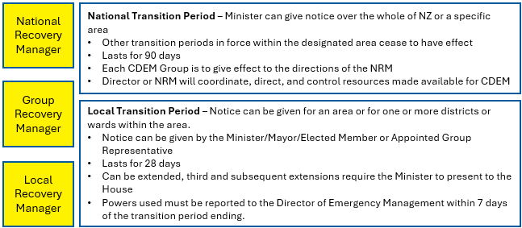
*Regardless of whether a transition period is national or local, Group Recovery Managers and Local Recovery Managers can exercise the powers in Part 5B in respect of the area, district or wards they are responsible for.
Note that the use of any powers must be recorded, and when a Transition Period is terminated or expires, a Report on Powers used is due to the Director Emergency Management, within 7 days.

