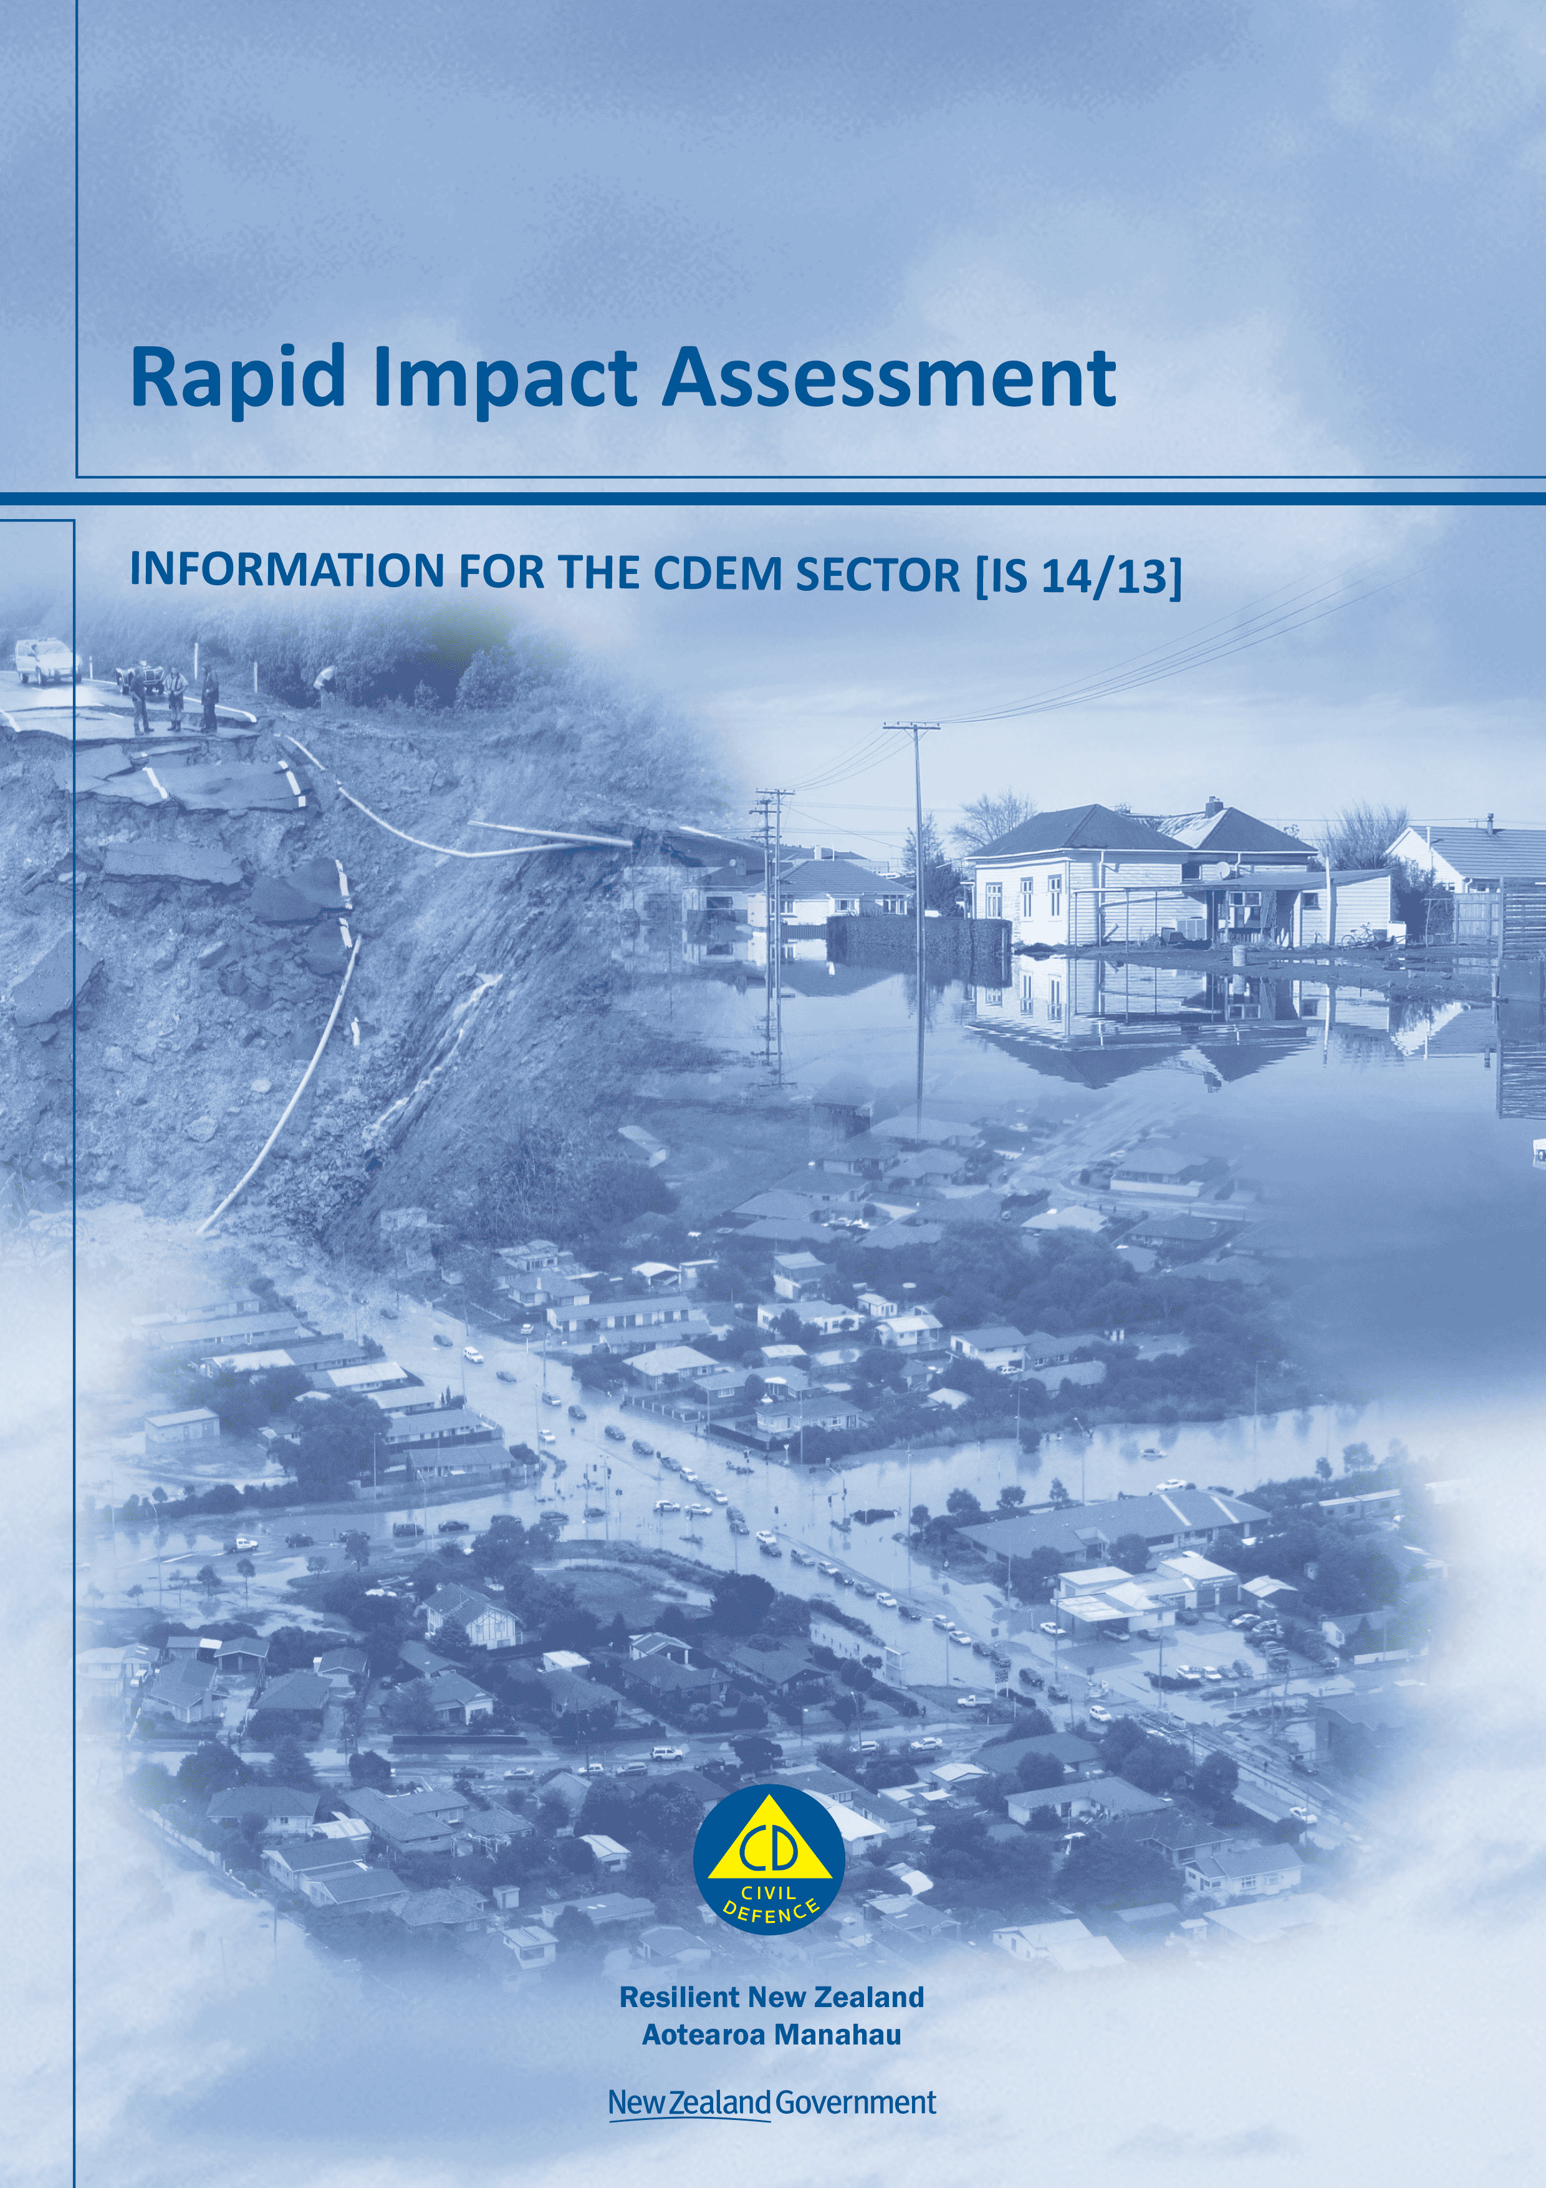

Rapid impact assessment

Information for the CDEM Sector [IS 14/13]

December 2013

ISBN 978-0-478-36807-9

Published by the Ministry of Civil Defence & Emergency Management

This document is not copyright and may be reproduced with acknowledgement. It is available, along with further information about the Ministry, on the MCDEM website [www.civildefence.govt.nz](http://www.civildefence.govt.nz).

Cover images

Clockwise from bottom left: aerial photograph over east Christchurch on 22 Feb 2011 at 17:53hrs, following the Christchurch earthquake of 22 Feb 2011 at 12:51hrs (image RNZAF, product GEOINT NZ 11-0017-U-20"); Bird Hill land slip, 15 December 2011 (image MWH Nelson, for Tasman District Council); flooding in Milton, Otago, 31 July 2007 (image John Lovell, MCDEM).

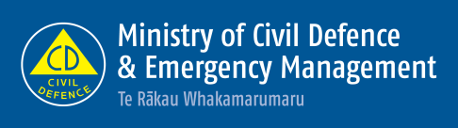

Ministry of Civil Defence & Emergency Management

PO Box 5010

Wellington

New Zealand

Tel: +64 473 7363

Fax: +64 473 7369

Email: [emergency.management@dia.govt.nz](mailto:emergency.management@dia.govt.nz)

Website: [www.civildefence.govt.nz](http://www.civildefence.govt.nz)

Foreword

|  |  |  |
| --- | --- | --- |
|  | We sometimes need reminding that emergencies impact people and their communities. It is the role of those involved in Civil Defence Emergency Management (CDEM) to ensure the consequences are minimised. This Information Series document on rapid impact assessment has been written to support CDEM Groups in working with partner agencies to gather and share information in the initial stages of a response. Rapid impact assessment aims to:   * gather information to provide an early picture of the situation * serve as a first step towards an initial response plan and the more detailed forms of assessment that will take place later in the response and in recovery, and * be used alongside CIMS structures and with EMIS.   All response agencies, including CDEM organisations and the emergency services, need to have plans and procedures in place to conduct rapid impact assessments, and subsequently feed that information to the operations centre coordinating the response. Furthermore, the integration of the plans and procedures of different agencies is critical, to ensure resources available for information gathering are directed in the most effective and efficient way.  This document gives a broad overview of the concept of rapid impact assessment, and its critical role in providing for a swift and accurate initial response to those impacted. It encourages the development of coordinated plans and procedures across the CDEM sector for rapid impact assessment. It will be supported by the New Zealand Fire Service web service application (to be released in 2014) that will facilitate the work of those conducting rapid impact assessments.  This image is a photograph of John Hamiilton, Director of Civil Defence Emergency Management. | |
|  |  |
|  | **John Hamilton**  Director of Civil Defence Emergency Management |

Contents

Section 1 Introduction 1

1.1 About this document 2

Section 2 About rapid impact assessment 5

2.1 Types of rapid impact assessment 5

2.1.1 Initial situation overview 6

2.1.2 Initial damage assessment 7

2.1.3 Products of rapid impact assessment 7

2.2 Rapid impact assessment in readiness and response 8

Section 3 Preparation during readiness 10

3.1 Requirements of a rapid impact assessment plan 10

3.2 Gathering information 12

3.3 Setting up access to forms 12

3.4 Gathering resources 15

3.5 Implementing a planning procedure 16

Section 4 Activation during response 18

Section 5 Appendices 22

Appendix A Initial situation overview form 23

Appendix B Initial damage assessment form 25

Appendix C Impact report form 27

Appendix D Other impact assessments 29

Appendix E About CDEM 30

# Introduction

|  |  |
| --- | --- |
|  | Assessing the impact of an emergency is a vital component of response planning and the subsequent implementation of immediate response activities.  Rapid impact assessment refers to assessments undertaken within the first 8 or 48 hours of an emergency. Their purpose is to obtain a rapid and broad picture of the extent of the damage suffered, to:   * determine initial response activities * direct the initial distribution of resources, and * serve as a precursor or first step to more detailed assessments, such as needs assessments or in-depth structural assessments.   See Section 2 About rapid impact assessment on page 5 for more detail. |
| More detailed assessments | Rapid impact assessments are approached in a logical, structured way and form the basis for more detailed impact assessments, such as:   * a **needs assessment**, which involves the gathering of information from the affected area and community, to address immediate needs and contribute to longer term recovery measures through:   + defining individual and community needs   + determining the resources required for permanent recovery   + estimating the total cost of damage   + acquiring engineering and scientific and insurance data to inform the mitigation process * **building assessments** in an emergency, which involve the collection of information from trained building assessors after an emergency causes widespread structural damage, and * **Urban Search and Rescue/New Zealand Fire Service assessment and building triage** (see USAR levels of assessment on page 6).   Rapid impact assessments are distinct from these more detailed assessments, as they involve a quick overview of the emergency and give those responsible for conducting the more in-depth assessments a common understanding of the situation that will inform further response and recovery activities. |
| Desired outcomes | The desired outcomes for developing plans and processes for rapid impact assessment are:   * all CDEM organisations have a workable, multi-agency plan for conducting rapid impact assessments * response agencies are able to operate collaboratively to enhance the effectiveness of the initial response, and * rapid impact assessments are used to inform response and recovery activities. |

## About this document

|  |  |  |
| --- | --- | --- |
|  | The **purpose** of this document is to provide a broad overview of the concept of rapid impact assessments in a CDEM context. It describes what rapid impact assessment involves, how plans can be developed, and what issues or considerations need to be taken into account. It is intended to encourage a standard, consistent, and robust approach to planning for and conducting rapid impact assessments.  The general information in this document will be supported by a web service application for the Urban Search And Rescue (USAR) function of the New Zealand Fire Service (see The New Zealand Fire Service application on page 15).  The **target audience** of this document is CDEM Groups and other emergency management or response agencies. | |
| Structure | The main sections of this document are:   * Section 1 Introduction – an introduction to rapid impact assessment, a description of the purpose and target audience of this document, and a clarification of terms * Section 2 About rapid impact assessment – an overview of rapid impact assessment * Section 3 Preparation during readiness – how agencies can prepare for the implementation of rapid impact assessments during readiness * Section 4 Activation during response – a description of the phases involved in rapid impact assessment during response * Section 5 Appendices – templates and additional information. | |
| Use of icons | The following icons are used in this document: | |
|  | indicates a template is provided in the appendices. | indicates more information is available in another document or website. |

#### Key terms

|  |  |
| --- | --- |
|  | This section clarifies some of the key terms used in this document. More definitions are given in Appendix E *About CDEM* on page 30. |
| Asset | In this document, ‘asset’ refers to an element of a community or environment that may be affected by an emergency. Assets include:   * buildings and properties (residential, community, or commercial) * infrastructure (roads, rail, bridges, sea ports, and airports), and * other lifeline utilities (power, fuel, water, telecommunications, and sewerage and wastewater). |

|  |  |
| --- | --- |
| CDEM organisation | In this document, ‘CDEM organisation’ refers to any part of a CDEM Group or local authority that has responsibilities in CDEM. |
| ECC and EOC | During and following an emergency, the:   * ECC (Emergency Coordination Centre) is a facility that operates at the CDEM Group level to coordinate and support one or more activated EOCs, and * EOC (Emergency Operations Centre) is a facility that operates at a local level to manage the response. |
| This image provides background colour to the extract from the CDEM Act 2002.Emergency | In this document ‘emergency’ has the same meaning as in the *CDEM Act 2002*:  Extract from the CDEM Act 2002  **emergency** means a situation that -   * 1. is the result of any happening, whether natural or otherwise, including, without limitation, any explosion, earthquake, eruption, tsunami, land movement, flood, storm, tornado, cyclone, serious fire, leakage or spillage of any dangerous gas or substance, technological failure, infestation, plague, epidemic, failure of or disruption to an emergency service or a lifeline utility, or actual or imminent attack or warlike act; and   2. causes or may cause loss of life or injury or illness or distress or in any way endangers the safety of the public or property in New Zealand or any part of New Zealand; and   3. cannot be dealt with by emergency services, or otherwise requires a significant and co-ordinated response under this Act. |
| EMIS | An **Emergency Management Information System (EMIS)** is used to record and store data, and maintain situational awareness during an emergency response. |
| GIS | **Geographic Information Systems (GIS)** are systems designed to capture, store, manipulate, analyse, manage, and present all levels of geographical data. GIS can merge a vast range of data including imagery, topography, property boundaries, and population data and can produce a range of outputs that merge the data available to show relationships, patterns, and trends. |
| Rapid impact assessment and the 4Rs of emergency management | The *National CDEM Plan* describes the **4Rs** of emergency management as being reduction, readiness, response, and recovery. Their definitions are given in Appendix E *About CDEM* on page 30.  Integrating the plans and procedures of response agencies, including CDEM organisations, emergency services, and lifeline utilities, occurs in **readiness**.  Rapid impact assessments are carried out during **response,** and inform **response** and **recovery**. |

|  |  |
| --- | --- |
| Rapid impact assessments and CIMS | The **Coordinated Incident Management System (CIMS)** is a proactive incident management framework, used by New Zealand agencies when responding to incidents.  Information gathered from rapid impact assessments informs responses that are coordinated using the CIMS structure. This document includes the following CIMS-related terms:   * **Controller** – the person in charge of an incident, or an aspect of one (may operate at the site, local, regional, or national levels). The Controller is the person who determines when a rapid impact assessment is to be conducted, and defines the area or location for survey. * **Incident Management Team (IMT)** - consists of the key appointments within a response coordination centre - the Controller and Response Manager; the functional managers (see definition of CIMS functions below); technical experts such as scientific advisors; and key support agency representatives such as the Fire Service, Police, or representatives of hospitals and health services. * **CIMS functions** – include Control, Operations, Logistics, Public Information Management (PIM), Planning, Intelligence, and Welfare. Each function is typically led by a Manager (who in turn may be supported by a team), and is responsible for coordinating a specific aspect of the response.   Each CIMS function has direct input into the rapid impact assessment process. For example, PIM is responsible for monitoring content related to incidents in the media (both news media and social media); sources of information that contribute to rapid impact assessments.  For more information see CIMS on page 34 of Appendix E. |
| Standard operating procedure (SOP) | **Standard Operating Procedure (SOP)** refers to the procedures that different agencies have in place to guide their activities during response. |
| USAR | **Urban Search and Rescue (USAR)** is a function of the New Zealand Fire Service and involves finding and rescuing people trapped in a structural collapse situation. |

# About rapid impact assessment

|  |  |  |
| --- | --- | --- |
|  | Properly conducted, rapid impact assessments enable responding agencies to quickly take stock of the situation, and prioritise and distribute resources appropriately.  During response, information is communicated between many people, organisations, and places. The rapid impact assessment framework provides processes and tools to:   * plan and prioritise areas required for assessment * gather information to assist response activities * rapidly determine the impact of the emergency and identify areas for more in-depth assessment * provide information about the impact of the emergency to responding agencies, emergency services, and local and national government, and * establish a standard process for collection, collation, analysis, and reporting impact-related information. | |
| Recording information | Information from rapid impact assessments must be recorded and stored in an EMIS, and be visible in the lead agency’s EMIS. This enables the assessments to contribute to overall situational awareness, as well as the generation of situation reports (SitReps), Action Plans, and maps. |

## Types of rapid impact assessment

|  |  |
| --- | --- |
|  | This document addresses two types of rapid impact assessment:   * **Initial situation overview**, which involves a rapid survey of the impacted area (either from the ground, the air, or a combination of these), and * **Initial damage assessment**, which involves a more detailed street-by-street assessment. General information is gathered about the initial impact on the social, economic, natural and built environments, which is used to identify areas where more detailed assessment may be needed. |

|  |  |  |  |  |  |  |  |
| --- | --- | --- | --- | --- | --- | --- | --- |
| USAR levels of assessment | The New Zealand Fire Service Urban Search and Rescue (USAR) function has five levels of assessment that are utilised during an emergency response:   * Level 1: Wide area assessment * Level 2: Sector assessment and triage * Level 3: Primary search and rescue; victim extraction * Level 4: Secondary search and rescue * Level 5: International deployment - full coverage search and rescue   The two types of rapid impact assessment described in this document are based on the USAR assessment levels 1 and 2 (see Table 1 below).   |  |  | | --- | --- | | Types of rapid impact assessment | New Zealand Fire Service assessment level | | Initial situation overview | Level 1 – Wide area assessment | | Initial damage assessment | Level 2 – Sector assessment and triage |   Table Comparison of rapid impact assessments and levels of USAR assessment |

### Initial situation overview

|  |  |
| --- | --- |
|  | An initial situation overview is typically carried out **within 8 hours** after an emergency occurs, either by aerial reconnaissance, a drive by if access is possible, a walk by, or a combination of the three.  Assessment personnel gather broad information about the affected population (displacement, injuries, or fatalities), obvious damage to lifeline utilities and critical facilities, and obvious structural damage to building and housing stock.  Information is also gathered from community members, volunteers, emergency service personnel, personnel from responding agencies, or the media (news media or social media) to contribute to an initial situation overview. Some of those contributing information may have only a superficial understanding of the nature and extent of the damage.  The information is quickly collated and used to determine immediate actions and resources necessary to respond to the effects of the emergency. |
| The main phases | The main phases of an initial situation overview are:   * Phase 1 – Prioritise and prepare * Phase 2 – Collect information * Phase 3 – Analyse information * Phase 4 – Disseminate information.   See Section 4 Activation during response on page 18 for a more detailed description of how an initial situation overview may be conducted during a response. |

### Initial damage assessment

|  |  |
| --- | --- |
|  | An initial damage assessment is typically completed **within 48 hours** following a disaster. It is generally a secondary collection of data, but at a more detailed street level following the initial situation overview. Assessment personnel classify and record the extent of initial damage to social, economic, natural, and built environments using pre-defined criteria.  The initial damage assessment is used by authorities at the local, CDEM Group, or national level to determine:   * areas where more in-depth assessment is required, such as building assessments or a welfare needs assessment * requirements for short-term assistance, and * preparation of an initial estimate of the cost of the disaster. |
| The main phases | The main phases of an initial damage assessment reflect those of the initial situation overview, differentiated by **time taken** and **level of detail sought**.  See Section 4 Activation during response on page 18 for more information. |

### Products of rapid impact assessment

|  |  |
| --- | --- |
|  | Information from an initial situation overview or an initial damage assessment contribute to the following products:   * an impact report * an initial situation report (SitRep), and/or * an Action Plan |
| Impact reports | Impact reports are designed to present the information collected during a rapid impact assessment, and are used in the generation of situation reports (SitReps) and Action Plans.  See section 3.3 Setting up access to forms on page 12 for more information on the impact report form and the supporting forms. |
| Situation reports and Action Plans | Situation reports (SitReps) and Action Plans are used to give a brief of an incident at regular intervals, and also to provide a statement of objectives, strategy, and critical functions to be undertaken during the incident. They are used by the Controller, the IMT, and coordinating personnel from other response organisations to update information as it becomes available and to prioritise and manage operational objectives.  More information about these products, the role of Controller, and the IMT is provided in the *Coordinated Incident Management System (CIMS) Manual*, available to view or download at [www.civildefence.govt.nz](http://www.civildefence.govt.nz) on the publications page. |

## Rapid impact assessment in readiness and response

|  |  |
| --- | --- |
|  | The development of impact assessment plans, arrangements, and capabilities occur during **readiness**. However, plans need to be reviewed and refined during **response** to fit the needs of a particular emergency.  The capabilities of all potential contributing agencies and the community need to be included in planning in both readiness and response.  The information gathered from rapid impact assessments during response in turn informs recovery.  Figure 1 on page 9 illustrates the rapid impact assessment cycle, from preparation during readiness to activation during response.  See Section 3 Preparation during readiness on page 10 and Section 4 Activation during response on page 18 for more information. |
| Other impact assessments | There are a number of more detailed impact assessments conducted during response and recovery by CDEM and other agencies.  Appendix D Other impact assessments on page 29 summarises these assessments. |

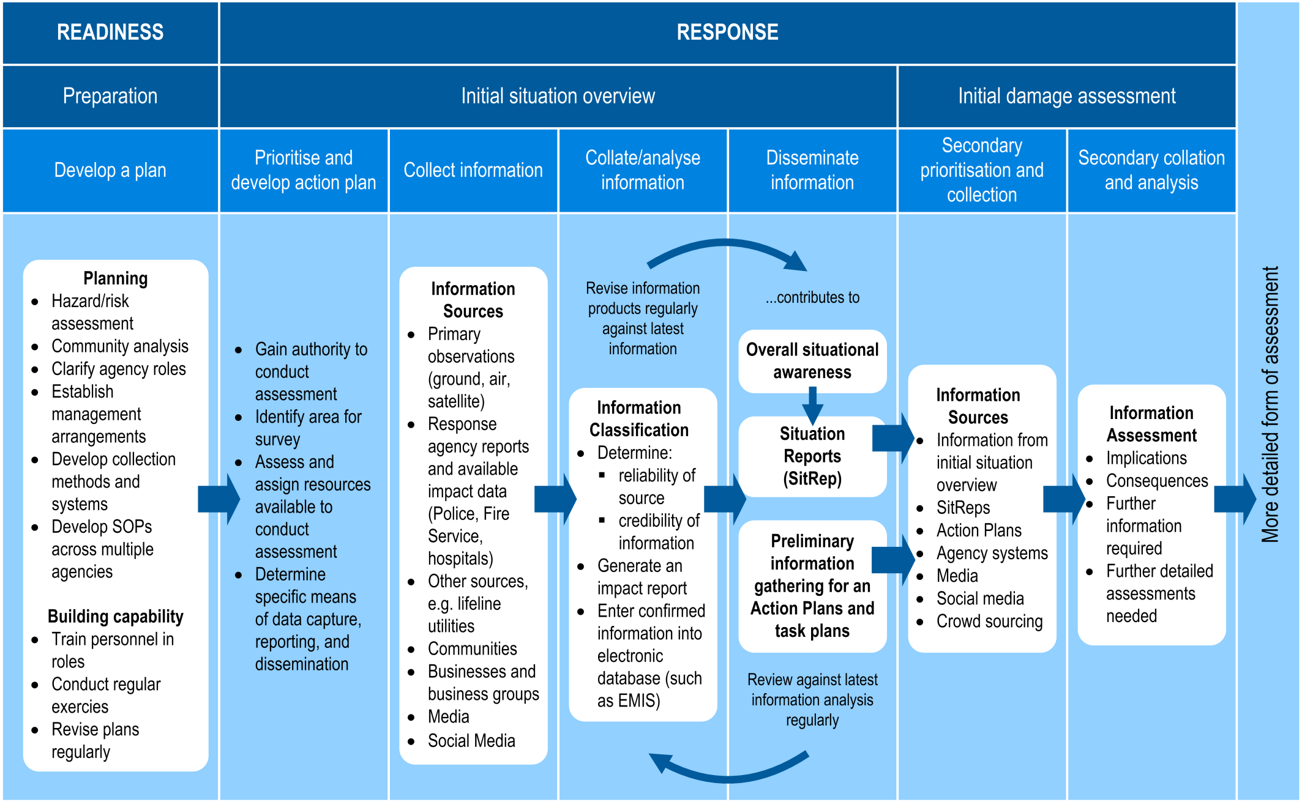

Figure Overview of the two types of rapid impact assessment

# Preparation during readiness

|  |  |
| --- | --- |
|  | This section describes the basic requirements for rapid impact assessment plans.  It also gives an overview of how plans may be developed, including:   * gathering information * setting up access to forms * identifying resources, and * implementing a planning procedure.   The **planning objectives** for a CDEM Group and its member authorities are:   * standard operating procedures (SOPs) for rapid impact assessment across all relevant agencies * capability to effectively carry out the two types of rapid impact assessment, and * all response personnel (including paid emergency management practitioners, volunteers, and community members) can effectively contribute to rapid impact assessments. |

## Requirements of a rapid impact assessment plan

|  |  |
| --- | --- |
|  | Rapid impact assessment plans need to be comprehensive, and include:   * provisions for specific locations or sites, including those that are likely to require more detailed forms of assessment * coordination arrangements for each level and type of emergency, and * clearly defined roles and responsibilities of all agencies and organisations potentially involved in response.   The planning process needs to be collaborative, to ensure that:   * all contributing agencies and organisations have their own SOPs in place * key stakeholders are informed and prepared, and * any deficiencies in resources are identified and addressed. |

|  |  |
| --- | --- |
| CDEM Group level | At a CDEM Group level, a rapid impact assessment plan is a strategic document, which needs to include:   * regional-level community and hazard analysis * authority (who is authorised to order or initiate a rapid impact assessment) * clearly identified and agreed, roles, and responsibilities * a pre-determined list of regionally-critical structures, facilities, and areas to assess * regional logistics, including:   + getting impact assessment personnel and equipment to affected local authorities   + coordinating resources for multi-local authority assessment * regional to local coordination and direction arrangements * systems used to collect, manage, and disseminate data region-wide * capability development, including regionally coordinated training and exercises, and * a process for reviewing rapid impact assessment plans. |
| Local level | At a local level rapid impact assessment plans need to inform and reflect the CDEM Group’s rapid impact assessment plans. They need to include:   * local community and hazard analysis * authority (who is authorised to order or initiate a local rapid impact assessment) * clearly identified and agreed, roles, and responsibilities of agencies or organisations who operate at the local level * the role of local authority contractors in rapid impact assessment * pre-determined list of locally-critical structures, facilities, and areas to assess * capability development, including locally coordinated training and exercises, and * a process for reviewing local level rapid impact assessment plans.   They also need to include standard operating procedures (SOPs) applicable to the local authority, such as:   * personnel responsible for conducting or managing rapid impact assessments * operational logistics, including getting assessment personnel and equipment to affected areas or communities, and * how and by whom information will be collated and analysed. |

## Gathering information

|  |  |
| --- | --- |
|  | An essential part of planning for rapid impact assessment is gathering information about regional and local areas and communities, including background facts and figures, population demographics, hazards, maps, data from previous emergencies, and community response plans.  This information may be gathered from:   * local authorities * CDEM Group and local emergency management offices (GEMOs and EMOs) * CDEM Group partner organisations * community networks and groups * critical infrastructure providers * regionally and locally critical businesses and business groups * research providers, such as universities and Crown Research Institutes (CRI), and * government agencies, such as the Ministry of Education, Work and Income (a branch of the Ministry of Social Development), Statistics New Zealand, and the Department of Internal Affairs. |
| Community engagement | Planning for rapid impact assessment must involve the engagement of local communities, who have detailed knowledge of local people, areas of potential vulnerability during an emergency, and other community members who may need assistance.  See the Best Practise Guide: *Community Engagement in a CDEM context* for information on how to engage with communities.  Welfare Coordination Groups may be able to provide advice about areas or communities that may need to be prioritised during a rapid impact assessment. |

## Setting up access to forms

|  |  |
| --- | --- |
|  | Rapid impact assessments may be carried out by:   * emergency services * local authorities * critical infrastructure providers, and * technical experts.   Using common forms increases operational effectiveness and supports efficient data collation. Access to these needs to be set up during readiness.  The rapid assessment forms in the appendices need to be used during exercises as well as during deployment. The forms are available from the MCDEM website [www.civildefence.govt.nz](http://www.civildefence.govt.nz) under ‘Rapid Impact Assessment’ on the publications page.  GIS capability needs to be used for electronic data capture whenever practicable.  It is recommended that rapid impact assessment forms are integrated into an electronic database or information management system, such as EMIS. |

#### Initial situation overview form

|  |  |
| --- | --- |
|  | The Initial situation overview form on page 23 includes space for the following:   * description of the area to be surveyed (space for a map to be inserted may be included, or may be attached separately if this is more appropriate) * name of emergency * date and (if applicable) duration of the emergency * assessor’s details * the status of people and animals in the survey area, including initial numbers of injuries, fatalities, and major displacements of the population * the status of the assets being assessed, such as obvious structural damage to buildings and infrastructure, and * electronic locations of visual recorded data, such as photographs or videos.   When inserting or sketching a map of the area, the locations of people, animals or assets are indicated using the reference codes on the form, as shown below. |

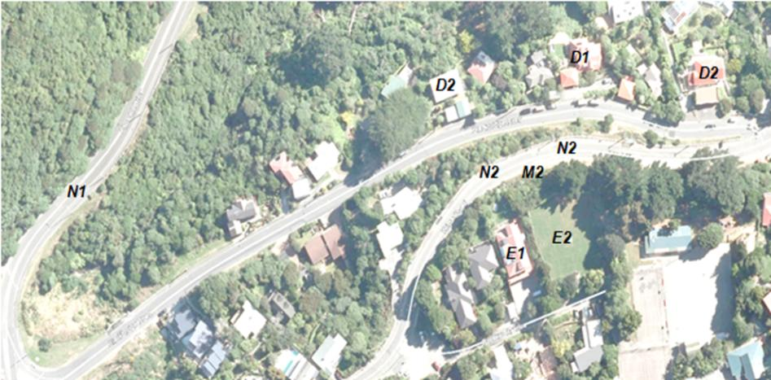

Figure Example of a map marked up with reference codes

|  |  |
| --- | --- |
|  | The *Initial situation overview* form is available from the MCDEM website [www.civildefence.govt.nz](http://www.civildefence.govt.nz) under ‘Rapid Impact Assessment’ on the publications page. |

#### Initial damage assessment form

|  |  |
| --- | --- |
|  | The Initial damage assessment form on page 25 includes space for the following:   * description of the area to be surveyed, usually of a more specific locality, such as a street within a larger affected area (space for a map to be inserted may be included, or may be attached separately if this is more appropriate) * name of emergency * date and (if applicable) duration of the emergency * assessor’s details * more detailed information about the status of people and animals (if any) in the survey area   + injuries or fatalities   + displacement or isolation (for animals, this also includes whether they have escaped usual confinements or been stranded)   + need for more in-depth welfare assessment   + immediate need for the deployment of welfare services * more detailed information about the status of the assets (buildings and infrastructure), and * electronic locations of visual recorded data, such as photographs or videos.   This form is available from the MCDEM website [www.civildefence.govt.nz](http://www.civildefence.govt.nz) under ‘Rapid Impact Assessment’ on the publications page. |

#### Impact report

|  |  |
| --- | --- |
|  | The Impact report form on page 27 includes space for the following:   * name of emergency * report number * date and time of issue * name of agency, function, or team who prepared the report * a description or map of the area assessed (or map can be attached separately, if appropriate) * status of the assets in area assessed (including precise locations and nature of damage observed, if known), and * priority actions, including further assessments and/or resources required.   This form is available from the MCDEM website [www.civildefence.govt.nz](http://www.civildefence.govt.nz) under ‘Rapid Impact Assessment’ on the publications page. |

## Gathering resources

|  |  |
| --- | --- |
|  | CDEM Groups and agencies need to be aware of, understand, and plan how to use all the resources at their disposal when conducting a rapid impact assessment. Resource deficiencies need to be identified and addressed during the planning process.  It is important to consider the size, capacity, and available resources of the CDEM organisation or agency, and develop plans and arrangements accordingly. |
| Types of resources | **Current and accurate maps** are essential for undertaking a rapid impact assessment. There are many categories of information which may be displayed on maps, and several layers of information can be overlaid on the same map.  Thematic datasets using satellite imagery, infrared imagery, or aerial photographs, combined with topographic, cadastral (property boundaries), or rates data can give a picture of the scope of the emergency.  **GIS mapping information** may include:   * known hazard specific inundation areas/impact zones * demographic information * potential community vulnerabilities * critical buildings such as hospitals * lifeline utilities, and * other infrastructure such as bridges, roads.   **GPS units** are an effective tool for capturing accurate point location and tracks. GPS location data to geo-locate information being collected by assessors assists in mapping the collected data.  If GPS units are used, property IDs from council databases need to be included in local datasets so that accurate information is able to be captured.  Despite the importance of electronic assessment tools**, paper-based tools** and **forms** need to be developed and be accessible as well.  CDEM Groups need to ensure that the relevant forms, checklists, and process documents are readily available to response teams, personnel responsible for rapid impact assessment, ECCs, and EOCs prior to an emergency. |
| The New Zealand Fire Service application | As part of its Urban Search and Rescue function, the New Zealand Fire Service is developing a **web service data collection application** based on Geographic Information Systems (GIS). It will be made available to CDEM organisations, emergency services, and other response agencies for use in rapid impact assessments. |

|  |  |
| --- | --- |
| Preparing and equipping personnel | Personnel undertaking rapid impact assessment functions must be suitably equipped for the role. This equipment needs to include:   * standard operating procedures (SOP) and briefing documentation * rapid impact assessment information collection forms * rapid impact assessment information reporting products/tools * personal protection equipment (PPE) appropriate for the emergency * identification (such as a badge or ID card) * a memory stick or card containing electronic versions of the above * a mobile phone * access to food, water, and a medical kit * portable device for electronic capture (if available and appropriate), and * appropriate transport.   Appropriate equipment and information documents need to be established and communicated to agencies that are deploying personnel.  Personnel should be capable of competently carrying out these assessments to the required standard. This may require certification and professional qualifications, depending on the degree of expertise needed to conduct the anticipated assessment. |

## Implementing a planning procedure

|  |  |
| --- | --- |
|  | The procedure outlined in Table 2 (below) may be used as a guide for CDEM organisations and other agencies who engage in rapid impact assessment planning **during readiness**. It may be modified according to the needs and current processes used by each organisation.  **Note**: Planning during response uses a more operationally focused process (see Section 4 Activation during response on page 18). |

| Step | Action | Detail |
| --- | --- | --- |
| 1 | Establish authority to develop plan | The authority to conduct rapid impact assessment planning normally falls to a CDEM Group or local authority. |
| 2 | Review hazard assessment | Different hazards may require different courses of action.  Analyse hazard or risk assessments that have already been conducted for the area. |
| 3 | Community analysis | Collection of statistical and GIS data is an important part of planning for a rapid impact assessment. Important considerations are:   * schools * hospital and aged-care facilities * cultural and linguistically diverse (CALD) communities * people with disabilities * socioeconomic factors * large institutions, such as prisons * infrastructure, and * building and housing stock. |

| Step | Action | Detail |
| --- | --- | --- |
| 4 | Convene planning team | A planning team needs to include senior representatives of agencies that would be involved in conducting a rapid impact assessment (e.g. Fire Service, Police, CDEM organisations, and health organisations, and welfare/social service agencies). |
| 5 | Determine concept of operations for each type of emergency | A concept of operations needs to be developed for each type of potential emergency, informed by:   * size and nature of possible emergency and speed of onset * demographics of the communities affected * geographic areas * key facilities and infrastructure, and * and available resources.   Develop a prioritised list of areas, facilities, and infrastructure to assess in each type of emergency. This list can then be turned into a concept of operations by assigning an assessment area to agencies. |
| 6 | Determine agency roles | Certain agencies have clearly defined responsibilities under existing legislation. Others will have well developed roles and responsibilities which exist due to existing arrangements.  Ensure that all agencies have a clear understanding of their own and others’ responsibilities during a rapid impact assessment. |
| 7 | Establish rapid impact assessment management arrangements | Rapid impact assessment management arrangements must fit within the existing CDEM structure, and must allow for adequate control and coordination during an emergency.  The rapid impact assessment management arrangements must be documented within the final plan.  Consider developing appropriate identification (ID cards) for potential rapid impact assessment personnel. |
| 8 | Document agreed arrangements | The documented plan needs to be in an accessible format that is easy to read and understand. |
| 9 | Review the plan | All agencies involved in rapid impact assessment need to review and sign-off on the documented plan. |
| 10 | Test the plan | All agencies with rapid impact assessment responsibilities need to exercise local rapid impact assessment arrangements. These exercises may be either desk-based or operational.  Train and develop personnel to fulfil roles and responsibilities. |
| 11 | Address plan deficiencies | The evaluation of the plan during exercises may highlight issues which need corrective action.  These issues must be addressed to enhance the workability of the plan and ensure operational success. |

Table Planning procedure

# Activation during response

|  |  |
| --- | --- |
|  | This section provides a more detailed description of each phase of the rapid impact assessment process **during response**. The process may be modified according to the needs and current processes used by each organisation or agency.  The main phases in the process are:   * Phase 1: Prioritise and prepare * Phase 2: Collect information * Phase 3: Analyse information * Phase 4: Disseminate information   The phases can be applied to both types of rapid impact assessment; the differences between the two being **time taken** and **level of detail sought**. |

#### Phase 1: Prioritise and prepare

|  |  |
| --- | --- |
| Establish authority to conduct assessment | The authority to conduct either an initial situation overview or an initial damage assessment falls to a CDEM Group or local Controller. However, in some emergencies (such as a bio- security outbreak) it may be instigated by an agency other than CDEM. |
| Analyse initial information | There is likely to be information already available on the impact, even if it is only a pre-event forecast. Use this information to set the priority of effort, and focus the assessment on the area of greatest need. |
| Generate a rapid impact assessment action plan | A rapid impact assessment action plan should include:   * situation overview, including:   + outline of physical and social context of affected area   + key facilities and infrastructure   + known and estimated impact * rapid impact assessment objectives * safety considerations and actions * limiting factors * prioritised areas, facilities, and infrastructure to be assessed * resources available for immediate deployment/distribution, and * reporting format, recipients and timings. |
| Define area for survey | The person authorising the rapid impact assessment determines the overall priorities for the assessment. The designated manager defines the area and task-objectives for each deployed team to assess.  A map with clearly defined boundaries can be inserted into the initial situation overview and/or initial damage assessment forms as required (see section 3.3 Setting up access to forms on page 12). |

|  |  |
| --- | --- |
| Convene and assign assessment personnel | Impact assessment in any emergency requires input and resources from a wide-range of organisations, as well as the affected communities.  Assessment personnel may be made up of:   * response teams (both formal and community-based) * local authority infrastructure and assets personnel * local authority and associated contractors * Fire Service * Police * infrastructure providers, and * technical experts.   Clarify or establish the reporting lines within the team (for example, the appointment of a Team Leader). Establish where and who Team Leaders report to. |
| Brief assessment personnel | Conduct a briefing outlining the emergency and the areas to be assessed, what is known, and a safety briefing on hazardous areas.  Set a reasonable timeframe for assessment personnel to report back to an agreed location. |
| Equip assessment personnel | Provide assessment personnel with:   * a copy of the relevant SOP outlining use of tools being provided * identification * appropriate personal protective equipment, safety equipment, and a first aid kit * maps and hard copy forms * portable device for electronic capture (if appropriate/available) * camera, video if available * transport/travel arrangements, and * access to food and water. |

#### Phase 2: Collect information

|  |  |
| --- | --- |
|  | Assessment personnel report back to an agreed location (ideally an operating base separate from the ECC or EOC), either:   * by each Team Leader in person (with a completed paper assessment form, supported by an oral report if necessary), or * electronically (by submitting an electronic version of the assessment form).   Consider debriefing all returning assessment personnel. |

|  |  |
| --- | --- |
| Information from other sources | CIMS functions involved in the collection of information include:   * Operations, including:   + in-house infrastructure management   + the Lifeline Utilities Coordinator   + partner response organisations * Intelligence * Planning * Welfare, and * Public Information Management (PIM).   Information from other sources such as the news media, social media, community groups, volunteer teams, and the affected community, is continuously collected and assessed in ECCs and EOCs during response. |

#### Phase 3: Analyse information

|  |  |
| --- | --- |
|  | Gather information from the assessment personnel into a single database.  Pre-emergency vulnerability analysis models relating to the particular hazard are a good means of giving credibility to and verifying information coming from sources other than assessment personnel deployed to undertake a rapid impact assessment.  Information coming from social media or crowd sourcing needs to be checked and confirmed with assessment personnel deployed to survey area(s). |

#### Phase 4: Disseminate information

|  |  |
| --- | --- |
|  | Information is made available through the electronic database to all relevant elements of the response, including:   * the Controller and IMT * coordinating personnel of other response agencies, and * other response coordination facilities and partner agencies. |
| Incorporate information into appropriate products | Analysed information is then used in products including:   * impact reports * situation reports (SitReps) * initial and subsequent Action Plans * Controller briefings, and * PIM outputs to communities and media.   Impact assessment outputs are intended to:   * give the Controller and all components of the response insight into the need for assistance to affected areas * inform response planning and decisions in relation to a declaration of a state of emergency, and * inform initial recovery management planning. |

|  |  |
| --- | --- |
| Use information to inform more detailed assessment | Information from an initial situation overview can be used to determine if/where an initial damage assessment is needed.  Information from an initial damage assessment can be used to determine if/where more detailed forms of assessment (such as building assessments or welfare needs assessments) are needed. |

# Appendices

Appendix A Initial situation overview form 23

Appendix B Initial damage assessment form 25

Appendix C Impact report form 27

Appendix D Other impact assessments 29

Appendix E About CDEM 30

###### Initial situation overview form

Mark the reference indicators (e.g. A1, D2, M2) on the map to indicate the physical locations and status of assets observed.

|  |  |  |  |  |  |  |  |
| --- | --- | --- | --- | --- | --- | --- | --- |
| INITIAL SITUATION OVERVIEW | | | | | | | |
| **Assessment area** *[descriptive title]* | | | |  | | | |
| *[insert or sketch map here]* | | | | | | | |
| Assessor’s details | | | | | | | |
| Name | |  | | | | | |
| Phone number | |  | | | | Date *[yyyy/mm/dd]* |  |
| Organisation/ agency | |  | | | | | |
| People and animals | | | | | | | |
|  | **Status** | | **Reference** | | **Number** | **Notes** | |
| People | Injured | | A1 | |  |  | |
| Uninjured | | A2 | |  |  | |
| Deceased | | A3 | |  |  | |
| Displaced | | A4 | |  |  | |
| Livestock | Injured | | B1 | |  |  | |
| Stranded | | B2 | |  |  | |
| Deceased | | B3 | |  |  | |
| Displaced | | B4 | |  |  | |
| Companion animals | Injured | | C1 | |  |  | |
| Stranded | | C2 | |  |  | |
| Deceased | | C3 | |  |  | |
| Displaced | | C4 | |  |  | |

|  |  |  |  |  |
| --- | --- | --- | --- | --- |
| Assets | | | | |
|  | **Damage** | **Reference** | **Number** | **Notes** |
| Residential buildings or properties | Minor | D1 |  |  |
| Major | D2 |  |  |
| Community buildings or properties (e.g. schools) | Minor | E1 |  |  |
| Major | E2 |  |  |
| Commercial buildings or properties (e.g. shops, offices) | Minor | F1 |  |  |
| Major | F2 |  |  |
| Power | Minor | G1 |  |  |
| Major | G2 |  |  |
| Fuel | Minor | H1 |  |  |
| Major | H2 |  |  |
| Water | Minor | I1 |  |  |
| Major | I2 |  |  |
| Telecommunications | Minor | J1 |  |  |
| Major | J2 |  |  |
| Rail | Minor | K1 |  |  |
| Major | K2 |  |  |
| Bridge | Minor | L1 |  |  |
| Major | L2 |  |  |
| Hazardous materials (sewage, waste, chemicals etc.) | Minor | M1 |  |  |
| Major | M2 |  |  |
| Roads | Minor | N1 |  |  |
| Major | N2 |  |  |

|  |  |  |  |
| --- | --- | --- | --- |
| **Administration** | | | |
| Injured | Yes / No | Date/time confirmed |  |
| Deceased | Yes / No | Assigned to |  |
| Displaced | Yes / No |  |  |

###### Initial damage assessment form

|  |  |  |  |  |  |  |  |  |  |  |  |
| --- | --- | --- | --- | --- | --- | --- | --- | --- | --- | --- | --- |
| INITIAL DAMAGE ASSESSMENT FORM | | | | | | | | | | | |
| **Assessment area** *[descriptive title]* | | | | |  | | | | | | |
| *[Insert or sketch map here]* | | | | | | | | | | | |
| Assessor’s details | | | | | | | | | | | |
| Name | |  | | | | | | | | | |
| Phone number | |  | | | | | | Date *[yyyy/mm/dd]* | | |  |
| Organisation/ agency | |  | | | | | | | | | |
| Address or location of survey area | | | | | | | | | | | |
| Street number |  | | | Street name | |  | | | | | |
| City |  | | | | | | | | Post code |  | |
| Coordinates (if applicable) | X | |  | | | | Y | |  | | |
| Common place name (if applicable) |  | | | | | | | | | | |
| Description of survey area | | | | | | | | | | | |
|  | | | | | | | | | | | |

|  |  |  |
| --- | --- | --- |
| Status of people, animals, and assets in area assessed | *Tick as applicable* | |
|  | People | Animals |
| Well, no assistance required |  |  |
| Well, but some assistance required |  |  |
| Injured |  |  |
| Deceased |  |  |
| Displaced |  |  |
|  | *Tick as applicable* | |
| Immediate deployment of welfare services and/or information is needed in this location | |  |
| More detailed welfare needs assessment is needed in this location | |  |
| Status of assets (infrastructure and buildings) in survey area | *Tick as applicable* | |
| Unknown | |  |
| Fully operational/open | |  |
| Operational (but at capacity) | |  |
| Operational (partially damaged or incapacitated) | |  |
| Destroyed or totally incapacitated | |  |
| Other notes | | |
|  | | |

|  |  |  |  |  |
| --- | --- | --- | --- | --- |
| **Administration only** | | | | |
| Injured | Yes / No | Date/time confirmed | |  |
| Deceased | Yes / No | Assigned to |  | |
| Displaced | Yes / No |  |  | |

###### Impact report form

|  |  |  |  |  |  |  |  |  |
| --- | --- | --- | --- | --- | --- | --- | --- | --- |
| IMPACT REPORT | | | | | | | | |
| **Event name** | |  | | | | | | |
| **Impact Report No** | |  | | **Date/time issued** *[dd/mm/yyyy, 00:00]* | | |  | |
| **Prepared by** *[name of agency/function/team]* | |  | | | | | | |
| Overview | | | | | | | | |
| *[include cause of emergency, geographic location, main impacts and consequences, and whether it is escalating/de-escalating]* | | | | | | | | |
| Extent of area assessed | | | | | | | | |
| *[include description or map (or attach map separately) of area assessed with clearly defined boundaries]* | | | | | | | | |
| Status of people, animals, and assets in area assessed | | | | | | | | |
| **People** | *Insert number* | | | | **Animals** | *Insert number* | | |
| Uninjured |  | | | | Uninjured |  | | |
| Injured |  | | | | Injured |  | | |
| Deceased |  | | | | Deceased |  | | |
| Displaced |  | | | | Displaced |  | | |
|  |  | | | | Stranded |  | | |
| **Residential buildings or properties** | *Insert number* | | **Community buildings or properties** | | *Insert number* | **Commercial buildings or properties** | | *Insert number* |
| Undamaged |  | | Undamaged | |  | Undamaged | |  |
| Minor damage |  | | Minor damage | |  | Minor damage | |  |
| Major damage |  | | Major damage | |  | Major damage | |  |
| Isolated |  | | Isolated | |  | Isolated | |  |
| Contaminated |  | | Contaminated | |  | Contaminated | |  |
| Services interrupted |  | | Services interrupted | |  | Services interrupted | |  |

|  |  |  |  |
| --- | --- | --- | --- |
| **Lifeline utilities** | | *Insert the precise location and nature of damage, if known* | |
| **Roads** | Minor damage |  | |
| Major damage |  | |
| **Rail** | Minor damage |  | |
| Major damage |  | |
| **Bridges** | Minor damage |  | |
| Major damage |  | |
| **Power** | Minor damage |  | |
| Major damage |  | |
| **Fuel** | Minor damage |  | |
| Major damage |  | |
| **Water** | Minor damage |  | |
| Major damage |  | |
| **Telecomms** | Minor damage |  | |
| Major damage |  | |
| **Sewerage/ wastewater** | Minor damage |  | |
| Major damage |  | |
| Priority actions | | | |
| ***Further assessment required*** | | | |
| **Location** *[precise location/area where initial assessment or more detailed assessment is needed]* | | | **Type of assessment required** *[for example, rapid impact, structural, or a welfare needs]* |
|  | | |  |

*Add extra rows with further priority actions as appropriate*

|  |  |
| --- | --- |
| ***Immediate needs*** | |
| **Location** *[precise location of asset or area of immediate need]* | **Type of need** *[for example:*   * *hazard/risk reduction* * *search and rescue* * *medical support* * *evacuation support* * *shelter in place* * *water, sanitation, and hygiene* * *accommodation* * *information and/or community liaison, and* * *security.]* |
|  |  |

*Add extra rows with further priority actions as appropriate*

###### Other impact assessments

The following table summarises the different impact assessments that are carried out by different agencies/personnel (including CDEM) during response and recovery.

|  |  |  |  |  |
| --- | --- | --- | --- | --- |
|  | Name of assessment | Carried out by | Description of assessment | When conducted |
| **Civil Defence Emergency Management (CDEM)** | Rapid impact assessments | Local authority personnel (may include suitably trained volunteers), in conjunction with emergency services and other response organisations and agencies. | Information about initial impact of emergency, gathered rapidly from ground, air, or water.  Analysis is carried out at the respective EOC or ECC. | Response (early and ongoing stages)  Recovery (early stages) |
| Detailed needs assessments | Local authority personnel and trained volunteers, in conjunction with other agencies and organisations involved in response and recovery, particularly welfare agencies. | Detailed needs assessment of social, economic, built, and natural environments to determine response/recovery needs/activities.  Used for community-wide assessment and, where necessary, direction of services to specific cases. | Response (later stages)  Recovery |
| **Building assessments (on behalf of the Controller)** | Rapid building assessments | Personnel trained according to Ministry of Business, Innovation, and Employment (MBIE) models/guidance.  May include:   * local authority staff * local contractors * trained volunteers * MBIE staff | Level 1: Building Usability Triage – assessment from the exterior only all buildings (street by street). This level of assessment distinguishes between ‘entry prohibited’ and ‘usable’ for complex buildings.  Level 2: Building Usability Triage – more detailed evaluation from exterior and interior of buildings identified as priorities, then other buildings street by street. | Response |
| Residential assessments | Personnel trained according to MBIE models/guidance.  May include:   * local authority staff * local contractors * trained volunteers * MBIE staff | Level 1: Building usability assessment from the exterior only, unless can see inside with little additional risk. | Response |
| **New Zealand Fire Service/Urban Search And Rescue** | International Search and Rescue Advisory Group  (INSARAG) assessments | Trained USAR personnel, assisted by NZ Response Teams and other response agencies.  Under control of Local EOC or Group ECC. | Level 1: Wide area assessment.  Level 2: Sector assessment and triage.  Level 3: Primary search and rescue; victim extraction.  Level 4: Secondary search and rescue.  Level 5: International deployment - full coverage search and rescue. | Response |

MBIE also provides guidance to building owners on conducting *Detailed Damage Evaluations* for their properties. These evaluations take place in recovery, and are the responsibility of the building owner.

###### About CDEM

|  |  |
| --- | --- |
|  | This is a brief overview of CDEM intended for people who have not been involved in CDEM before.  More information is available in the *Guide to the National CDEM Plan*, available at [www.civildefence.govt.nz](http://www.civildefence.govt.nz).  **Ministry of Civil Defence & Emergency Management (MCDEM)** is the central government agency responsible for providing leadership, strategic guidance, national coordination, and the facilitation and promotion of various key activities across the 4Rs. It is the lead agency at a national level responsible for coordinating the management of CDEM emergencies. MCDEM may act as a support agency by coordinating the CDEM response to any given emergency managed by another lead agency. MCDEM is responsible for maintaining the National Crisis Management Centre (NCMC) in a state of readiness and for the National Warning System.  **CDEM Groups** are required under the *CDEM Act 2002*. Every unitary authority, and each regional council and every territorial authority within that region, has established a CDEM Group. |
| Business as usual CDEM structure | The general structure of a CDEM Group is shown in Figure E‑1 below. Variations to this structure are discussed in the next paragraph. |
|  | This image is a diagram showing the structure of CDEM organisations during readiness.  Figure ‑ CDEM structure for business as usual |
|  | The **Joint Committee** is made up of representatives of member authorities, such as mayors, chairpersons, or delegates. In CDEM Groups with a unitary authority structure, the Joint Committee is a committee of council.  The **Coordinating Executive Group (CEG)** is made up of chief executives of the local authorities, and representatives of emergency services, health services, and others.  **Group Emergency Management Office (GEMO)** is the CDEM Group’s regionally based emergency management office. CDEM Groups sometimes use different terms for these.  **Emergency Management Office (EMO**) is a CDEM Group’s locally based emergency management office. CDEM Groups sometimes use different terms for these. |

|  |  |
| --- | --- |
| Variations in CDEM Group structure | CDEM structures vary significantly in the different Groups. The CDEM Group Plan will show their particular structure. The main variations in structures are:   * GEMO with no local EMO(s) (includes unitary authorities) * all or some of the EMOs reporting through the GEMO, rather than through the territorial authorities * pooling territorial resources to jointly provide all CDEM functions in the CDEM Group’s region * grouping EMOs under area offices over several local councils, and * the CDEM Group contracting out provision of CDEM to a third party, who report directly to the CEG. |
| CDEM response structure | The structure of a national emergency response is shown in Figure E‑2 below.  This image is a diagram showing the structure of CDEM organisations during response.  Figure ‑ CDEM structure during response  The **Controller** is the person in charge of the response, at the respective level.  The National Crisis Management Centre (NCMC), ECC, and EOC (at national, CDEM Group, and local level respectively) are structured according to the **Coordinated Incident Management System (CIMS)** (see *CIMS* on page 34 for more information).  During and following an emergency, the:   * **ECC (Emergency Coordination Centre)** is a facility that operates at the CDEM Group level to coordinate and support one or more activated EOCs. * **EOC (Emergency Operations Centre)** is a facility that operates at a local level to manage the response. |

* 1. Commonly used CDEM terms

|  |  |
| --- | --- |
| General terms | **A CDEM organisation** is any part of a CDEM Group or local authority that has responsibilities in CDEM.  A **CDEM Group Plan** has been developed and is regularly reviewed by each CDEM Group, required under the *CDEM Act 2002*.  **Agencies** are government agencies (including public service departments, non-public service departments, Crown entities, and Offices of Parliament), non-governmental organisations, andlifeline utilities.  The **lead agency** is the agency that manages a particular emergency. Some agencies are required by law to lead particular types of emergencies; other types of emergencies will have the lead agency determined by expertise.  A **support agency** is any agency that supports the lead agency during an emergency.  **National Crisis Management Centre (NCMC)** can refer to either the secure all-of-government facility maintained in a state of readiness in which the national response to emergencies can be managed, or the team that operates from this facility. |
| The ‘4Rs’ | The ‘4Rs’ of emergency management are:  **Reduction** means identifying and analysing long-term risks to human life and property from natural or non-natural hazards, taking steps to eliminate these risks if practicable, and, if not, reducing the magnitude of their impact and the likelihood of their occurring.  **Readiness** means developing operational systems and capabilities before an emergency happens, including self-help and response programmes for the general public, and specific programmes for emergency services, lifeline utilities, and other agencies.  **Response** means actions taken immediately before, during, or directly after an emergency to save lives and property, and to help communities recover.  **Recovery** means the coordinated efforts and processes used to bring about the immediate, medium-term, and long-term holistic regeneration of a community following an emergency. |
| Terms used in local government | A **territorial authority (TA)** is a city or district council, or unitary authority.  A **regional council** is a region-based council, primarily responsible for environmental management.  A **unitary authority** is a territorial authority with regional council functions and powers.  A **local authority** is any of the above. |

|  |  |
| --- | --- |
| CDEM roles | The **Director of CDEM (the Director)** is the head of MCDEM, who reports to the Minister of Civil Defence. The Director has the role of National Controller during an emergency led by CDEM, unless they choose to delegate.  The **GEMO Manager** is the person who manages the GEMO.  The **Emergency Management Officer (EM Officer)** is the person who manages the EMO.  **Regional Emergency Management Advisors (REMAs)** are MCDEM personnel, based at MCDEM’s regional offices in Auckland, Wellington and Christchurch. They are responsible for providing advice and support to the CDEM Groups in their geographic area.  The **Controller** is the person in charge of an emergency, or an aspect of it. The level of their control is given by the name – National Controller (usually based at the NCMC), Group Controller (usually based at an ECC), and Local Controller (usually based at an EOC).  The **Recovery Manager** is the person in charge of recovery. When emergencies have significant recovery activities, the Controller hands over to the Recovery Manager once most response tasks have been completed. |
| Key CDEM documents | The following documents are available at [www.civildefence.govt.nz](http://www.civildefence.govt.nz) by searching for the document name.  The **Civil Defence Emergency Management Act 2002 (CDEM Act)** describes the legal requirements for CDEM in New Zealand.  **The National CDEM Strategy** describes the intentions of the Crown regarding CDEM provisions.  The **National CDEM Plan (the Plan)** mandates the actions required across the 4Rs (reduction, readiness, response, and recovery) and who is required to carry them out.  **The Guide to the National CDEM Plan (the Guide)** explains the Plan in detail.  **Director’s Guidelines** are documents developed by MCDEM, to provide guidance to CDEM and other agencies regarding CDEM. They are issued by the Director of CDEM under the *CDEM Act*. |
| EMIS | The **emergency management information system (EMIS)** is used by CDEM organisations to record and store data and to maintain situational awareness during an emergency response. EMIS is used to generate situation reports, Action Plans, and maps. |

|  |  |
| --- | --- |
| CIMS | The **Coordinated Incident Management System (CIMS)** is a proactive incident management framework, used by New Zealand agencies when responding to emergencies. It is intended to achieve effective response management and multi-agency coordination for all incidents, regardless of hazard, size, or complexity. It aims to coordinate separate agency operations into a single, unified response.  There are seven CIMS functions:   * **Control** is responsible for the overall direction and management of an emergency, or an aspect of it (see ‘Controller’, under ‘Roles’ on previous page). * **Operations** is responsible for the coordination of the response, detailed task planning, and the implementation of the Action Plan. * **Planning** is responsible for planning operations. * **Intelligence** is responsible for hazard and environmental analysis, and collating information about the response. * **Welfare** is responsible for coordinating and delivering emergency welfare services and resources to affected individuals, families/whānau, and communities. * **Logistics** is responsible for sourcing resources needed to support the response and the affected population, including personnel, equipment, and transportation. * **Public Information management (PIM)** is responsible for releasing information to the public, media liaison, and community liaison. The content of official information (such as warnings) is generated by official processes, and approved by the Controller.   The **Incident Management Team (IMT)** consists of the key appointments within a response coordination centre - the Controller and Response Manager; the functional managers (Operations, Planning, Logistics, Intelligence, PIM, and Welfare); technical experts such as scientific advisors; and key support agency representatives such as the Fire Service, Police, or representatives of hospitals and health services. The exact composition at any time is determined by the Controller.  Naming indicates where it is based, and the agency (if applicable). For example, CDEM ECC IMT means the CDEM IMT based at the ECC, and the Police Wainui IMT is the Police IMT based at Wainui.  Figure E‑3 on page 35 shows the command and control relationships between Response Coordination Centres (RCCs). |

|  |  |
| --- | --- |
| This image shows the CIMS command and control relationships across incident, local, regional, and national levels of a response.  Figure ‑ CIMS command and control relationships | |
|  | More information about CIMS is provided in the *Coordinated Incident Management System (CIMS)* manual, available on the publications page of the MCDEM website [www.civildefence.govt.nz](http://www.civildefence.govt.nz). |

