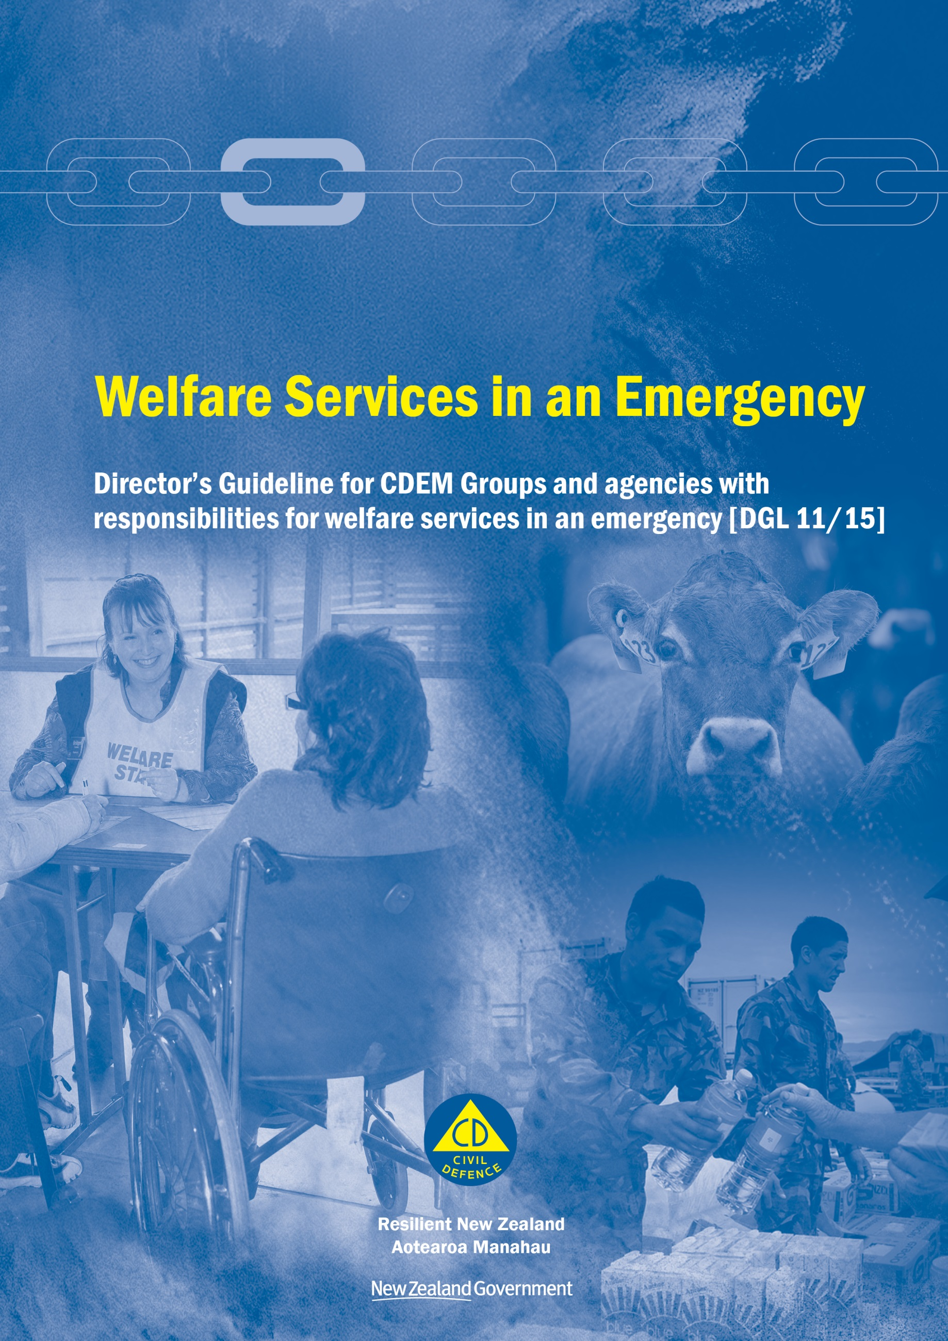

Welfare Services in an Emergency
Director’s Guideline for CDEM Groups and agencies with responsibilities for welfare services in an emergency [DGL 11/15]

October 2015
ISBN 978-0-478-43513-9
Published by the Ministry of Civil Defence & Emergency Management

Authority
This guideline has been issued by the Director of the Ministry of Civil Defence & Emergency Management pursuant to s9(3) of the Civil Defence Emergency Management (CDEM) Act 2002. It provides assistance to CDEM Groups and agencies with responsibilities for welfare services in an emergency to understand and work towards the welfare roles, structures, and responsibilities described in the National Civil Defence Emergency Management Plan 2015.

This document is not copyright and may be reproduced with acknowledgement. It is available, along with further information about the Ministry, on the MCDEM website www.civildefence.govt.nz.

Cover images
Clockwise from left: Welfare volunteer assisting displaced person at Christchurch City Council annual CDC exercise, 13 September 2014 (image courtesy of Christchurch City Council CDEM Team); Cow on Manawatu farm, 4 June 2015 (image courtesy of the Ministry for Primary Industries); NZ Army Engineers distributing water and supplies at New Brighton Beach after Christchurch Earthquake, 26 February 2011 (image courtesy of New Zealand Defence Force).

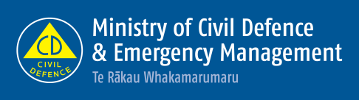

Ministry of Civil Defence & Emergency Management
PO Box 5010
Wellington 6145
New Zealand
Tel: +64 4 817 8555
Fax: +64 4 817 8554
Email: emergency.management@dpmc.govt.nz
Website: www.civildefence.govt.nz

