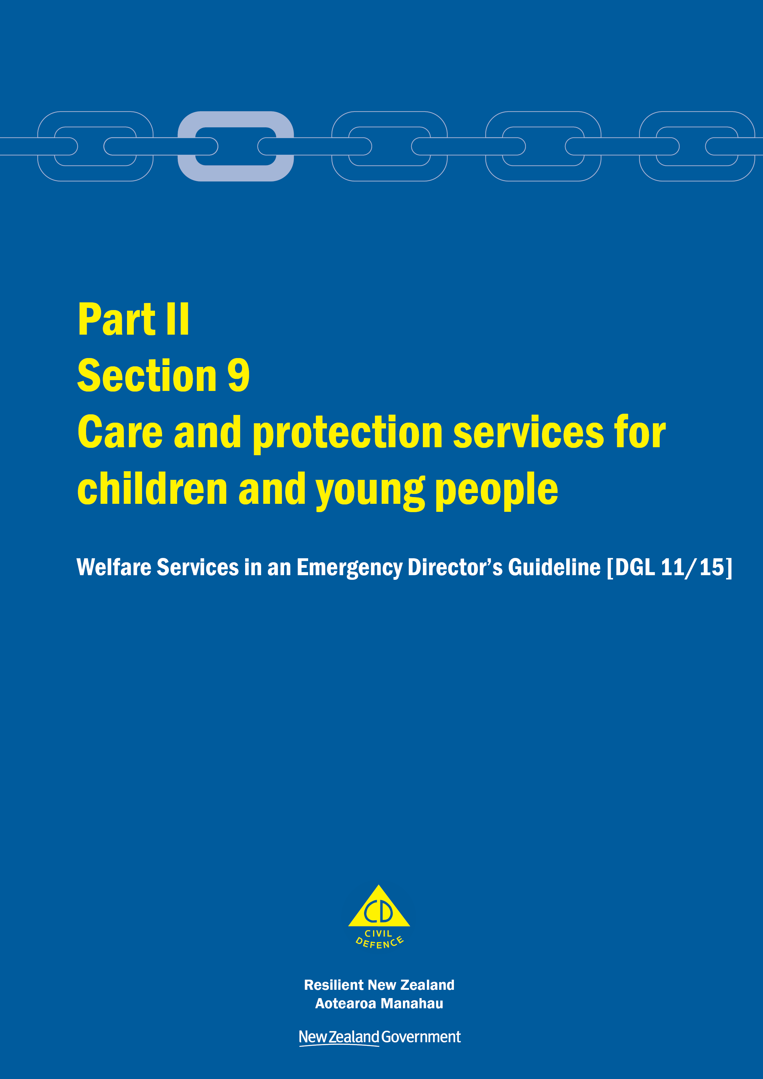
Welfare Services in an Emergency
Director’s Guideline for CDEM Groups and agencies with responsibilities for welfare services in an emergency [DGL 11/15]

October 2015
ISBN 978-0-478-43513-9
Published by the Ministry of Civil Defence & Emergency Management

Authority
This guideline has been issued by the Director of the Ministry of Civil Defence & Emergency Management pursuant to s9(3) of the Civil Defence Emergency Management (CDEM) Act 2002. It provides assistance to CDEM Groups and agencies with responsibilities for welfare services in an emergency to understand and work towards the welfare roles, structures, and responsibilities described in the National Civil Defence Emergency Management Plan 2015.

This document is not copyright and may be reproduced with acknowledgement. It is available, along with further information about the Ministry, on the MCDEM website www.civildefence.govt.nz.

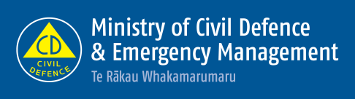

Ministry of Civil Defence & Emergency Management
PO Box 5010
Wellington 6145
New Zealand
Tel: +64 4 817 8555
Fax: +64 4 817 8554
Email: emergency.management@dpmc.govt.nz
Website: www.civildefence.govt.nz

Contents
Section 9 Care and protection services for children and young people 1
9.1 Introduction 1
9.2 Principles 3
9.3 Readiness activities 3
9.4 Response activities 6
9.4.1 Process map for separated children and young people in an emergency 8
9.5 Recovery activities 9
9.6 Psychosocial support for children and young people 9
Appendices 10
Appendix A Information applicable to all welfare services 11
Appendix B Separated children’s identification card 17
Appendix C Emergency supplies for children/young people 18
Appendix D Release form for separated children/ young people 19
Appendix E Activity and planning log 21
Appendix F Status update report 22

Care and protection services for children and young people
This section should be read in conjunction with the other parts and sections in the Welfare Services in an Emergency Director’s Guideline [DGL 11/15].

Introduction
Care and protection services for children and young people deliver and coordinate statutory care and protection to children and young people who have been identified (after registration in the CDEM EMIS Welfare Registration System) as being unaccompanied/separated from their parents, legal guardians, or usual caregivers during an emergency.
The responsibilities of agencies with a role in this welfare services sub-function are articulated in the Welfare Services clauses of the National CDEM Plan 2015.

Agency responsible | At the national and regional levels, the Ministry of Social Development, through Child, Youth and Family, is the agency responsible for planning the delivery and coordination of statutory care and protection services to those children and young people who have been identified (after registration) as being unaccompanied/separated from their parents, legal guardians, or usual caregivers during an emergency.
Definition of child and young person | A child means a person under the age of 14 years.  A young person is someone aged from 14 years, but under 17 years.
Operating assumptions | If an emergency occurs during school hours, children and young people should remain at the school, early childhood centre, or with their usual caregiver.  Education providers have emergency plans and arrangements for looking after children and young people including information to help reunite them with their parents, legal guardians, or approved alternate caregiver in a safe and timely manner.  Most parents/legal guardians will attempt to reunite with their child through making direct contact with the person or education provider that their child was with prior to the emergency.  Due to the timing of the emergency, children and young people could be considered to be temporarily separated from their parent or legal guardian. Attempts to reunite them with their parents, legal guardians, or usual caregivers should be made (while keeping the child/young person safe) before taking steps to refer the child or young person to Child, Youth and Family or Police.
Confidentiality of data | Confidentiality and protection of the data collected on unaccompanied/separated children and young people is critical. Data entry staff must be aware of who has access and is authorised to disclose the information.  See section A.5 Privacy, information sharing, and vetting on page 14.
Support agencies | Support from the agencies shown in Table 1 at both the national and regional levels may be required to provide care and protection services for children and young people.  Note that any agency working with children and young people must meet the approval obligations outlined in the Vulnerable Children Act 2014.
Table 1 Support agencies for the care and protection services for children and young people sub-function
Agency | Support
Ministry of Education | To work with education providers to ensure continuity of care to children and young people at educational facilities during an emergency (a handover of care to Police, or another appropriate agency, will occur for those children and young people who cannot be reunited with their parent, guardian, or other approved person within a reasonable timeframe).
Police | As the agency responsible for a process to coordinate inquiries.  Where inquiries have been made by responding agencies in relation to establishing contact between a child or young person and their family, whānau, or usual caregiver, and have not been successful, and the child’s or young person’s physical or mental wellbeing is, or is likely to be, impaired, Police will exercise their powers under section 48 (unaccompanied children and young persons) of the Children, Young Persons, and Their Families Act 1989.
New Zealand Red Cross | To support and supervise unaccompanied children during emergencies, as required, and to notify Police as soon as practicable.
Te Puni Kōkiri | To provide independent advice nationally/centrally to support iwi, hapū, whānau, and other Māori communities and, through its network of regional offices, work with local government authorities to reconnect tamariki and rangatahi who have become separated from their usual carers during an emergency.

Further support | Table 2 shows the agencies that may offer further support to the care and protection services for children and young people sub-function.  Table 2 Further support for care and protection services for children and young people  Agency Support  CDEM Groups/local authorities To register unaccompanied children and young people in the CDEM EMIS Welfare Registration System.
 | Note: There are other agencies and organisations that can contribute to this welfare services sub-function at a local and regional level.

Expectations for participating agencies | All contributing agencies to this welfare services sub-function are expected to have plans and arrangements in place to support their effective contribution to collective planning and coordinated delivery arrangements:  This includes agencies:  - having business continuity arrangements to ensure they can continue to deliver their essential services and critical functions  - providing ongoing care and protection to children and young people in their business as usual capacity  - ensuring their plans integrate and align with welfare arrangements, and  - leveraging off their business as usual relationships with providers and agencies to maximise response capability.

Principles
The following principles underpin the delivery and coordination of services to children and young people separated from their parents, legal guardians, or usual caregivers in an emergency:
- Children are kept safe and cared for.
- Children should be reunited with their parent, legal guardian or usual caregiver as soon as possible.
- All reasonable steps are taken to reunite children with their parent, legal guardian or usual caregiver before referring to Police.
- Delivery of welfare services relies on having strong relationships with community organisations and a clear understanding of welfare needs of individuals, families, and whānau.
- Any response needs to recognise the diverse and dynamic nature of emergencies and their consequences on children and young people.

Readiness activities
 | Readiness activities should be undertaken to support the effective delivery of welfare services for children and young people separated from their parents, legal guardians, or usual caregivers.
Planning | Agencies involved in this sub-function should develop and maintain plans, which outline how the agencies will collectively ensure that the needs of children and young people are met.
Building relationships | Agencies involved in this sub-function need to build relationships with each other during readiness. This involves:  - participating in activities that build relationships and response capability  - ensuring agency representatives know their agency’s role and responsibilities, their capacity and capability at local, regional, and national levels, and how they can contribute to planning and response activities  - establishing communication and reporting lines with local, regional, national agencies, and  - engaging in discussion on various scenarios that they may be faced with and potential options for responding.
Building capacity and capability | Building capacity and capability involves:  - understanding activation and response processes and expectations  - developing capacity and capability relevant to roles  - building awareness of psychosocial support and resources available to support children and young people affected by an emergency  - building awareness of the needs of separated children and young people requiring shelter and accommodation, and  - planning and participating in testing and exercising activities.
Identifying approved people or organisations | There is an expectation that people involved in the provision of care and protection services for children and young people separated in an emergency are safety checked according to legislative requirements under the Vulnerable Children Act 2014.  From 1 July 2015, new government safety checking regulations under the Vulnerable Children Act 2014 require all paid employees and contractors who work with children for state-funded organisations to be safety checked.  It is considered best practice that any person who will be working with children and young people under this welfare services sub-function (including volunteers) is safety checked by the organisation they report to.  A list of people who have been safety checked should be developed and maintained by agencies during readiness. This includes identifying approved caregivers and care service organisations that may have capacity to care for separated children and young people in the short term.  Safety checking involves:  - identity verification – proof people are who they say they are, including former identities  - information requirement:  - reliable data about history and behaviour, and  - Police vetting  - risk assessment – judgement-based assessment, and  - periodic re-assessment – information should be updated and reassessed every three years.
 | The Vulnerable Children Act 2014 is available at the New Zealand Legislation website: www.legislation.govt.nz. For more information, refer to the Children’s Action Plan website: www.childrensactionplan.govt.nz.

Response activities
Activation | All agencies know and understand what to do on becoming aware of an emergency and can:  - undertake first response actions (i.e. confirm point of contact, availability)  - confirm and maintain the safety and wellbeing of any children and young people in their care at the time  - confirm contact list and communication lines:  - within and across support agencies  - with the CDEM sector  - make recommendations on a range of communication activities  - contribute consistent messaging to the Public Information Management function  - coordinate response activities and participate in the development of the welfare component of the Action Plan, and  - complete status update reports.
Building situational awareness | Situational awareness informs and guides delivery and coordination of activities following an emergency. It involves:  - assessing the impact on children and young people separated from their parents, legal guardians, or usual caregivers  - identifying children who may be particularly vulnerable because of their health condition (including disability)  - identifying key response priorities  - identifying strategies and actions to support coordination of services  - identifying what additional resources might be required, in what timeframe and options for their delivery, and  - participating in the planning and implementation process.  Points to consider include:  - how many children or young people have been separated by the emergency, where are they located, and who is currently responsible for them  - identifying priorities and gaps  - whether the basic needs of children and young people are being met (food, water, warmth, medication, comfort to those exhibiting fear or other stress related needs), and  - strategies and interventions to ensure the response is integrated and aligned across relevant agencies.
Taking reasonable steps to locate parents or guardians | All reasonable steps should be taken to locate parents, legal guardians, or usual caregivers before referring children or young people on to Child, Youth and Family, or Police.  This includes collecting all relevant information to facilitate family reunification (child or young person’s name and age; their parent’s name, address, place of work; and/or grandparent’s or other relative’s address).  This may also include checking relevant locations if possible (homes, or parents’ workplaces).
Unification of children and young people with their parents or legal guardians. | It is important that any person that a child or young person is released to is:  - able to satisfactorily identify themselves as the parent, legal guardian, or usual caregiver, and  - in a fit state to care for the child or young person.  If unsure about whether to release a child or young person back to their parent, legal guardian, or usual caregiver because of concerns for their immediate health and safety, Police must be contacted in the first instance.
Using relevant databases | The following databases/sources may hold emergency contact details and other information relevant to the reunification of children and young people temporarily separated from their parent, legal guardian, or usual caregiver:  - education database  - CDEM EMIS Welfare Registration System (parents/guardians may have registered or inquired with local CDEM about their child/young person)  - Child, Youth and Family database, and  - Police Inquiry process.
Ensuring integrated service delivery | Working together to deliver accessible and responsive service requires:  - agencies to maintain situation awareness to ensure the needs of those affected are identified and met  - ongoing liaison with Local/CDEM Group/National Welfare Manager  - deploying people and resources to assist  - completing status update reports, and  - ongoing monitoring of activities and maintaining communication links with response teams.
More information | Refer to Part I Appendix G Civil Defence Centre toolkit of the Welfare Services in an Emergency Director’s Guideline for more information on children and young people in a Civil Defence Centre (CDC).  This toolkit is available at www.civildefence.govt.nz.

Process map for separated children and young people in an emergency
Figure 1 shows the process for providing continuing care to children and young people separated from their parents, legal guardians, or usual caregivers in an emergency.
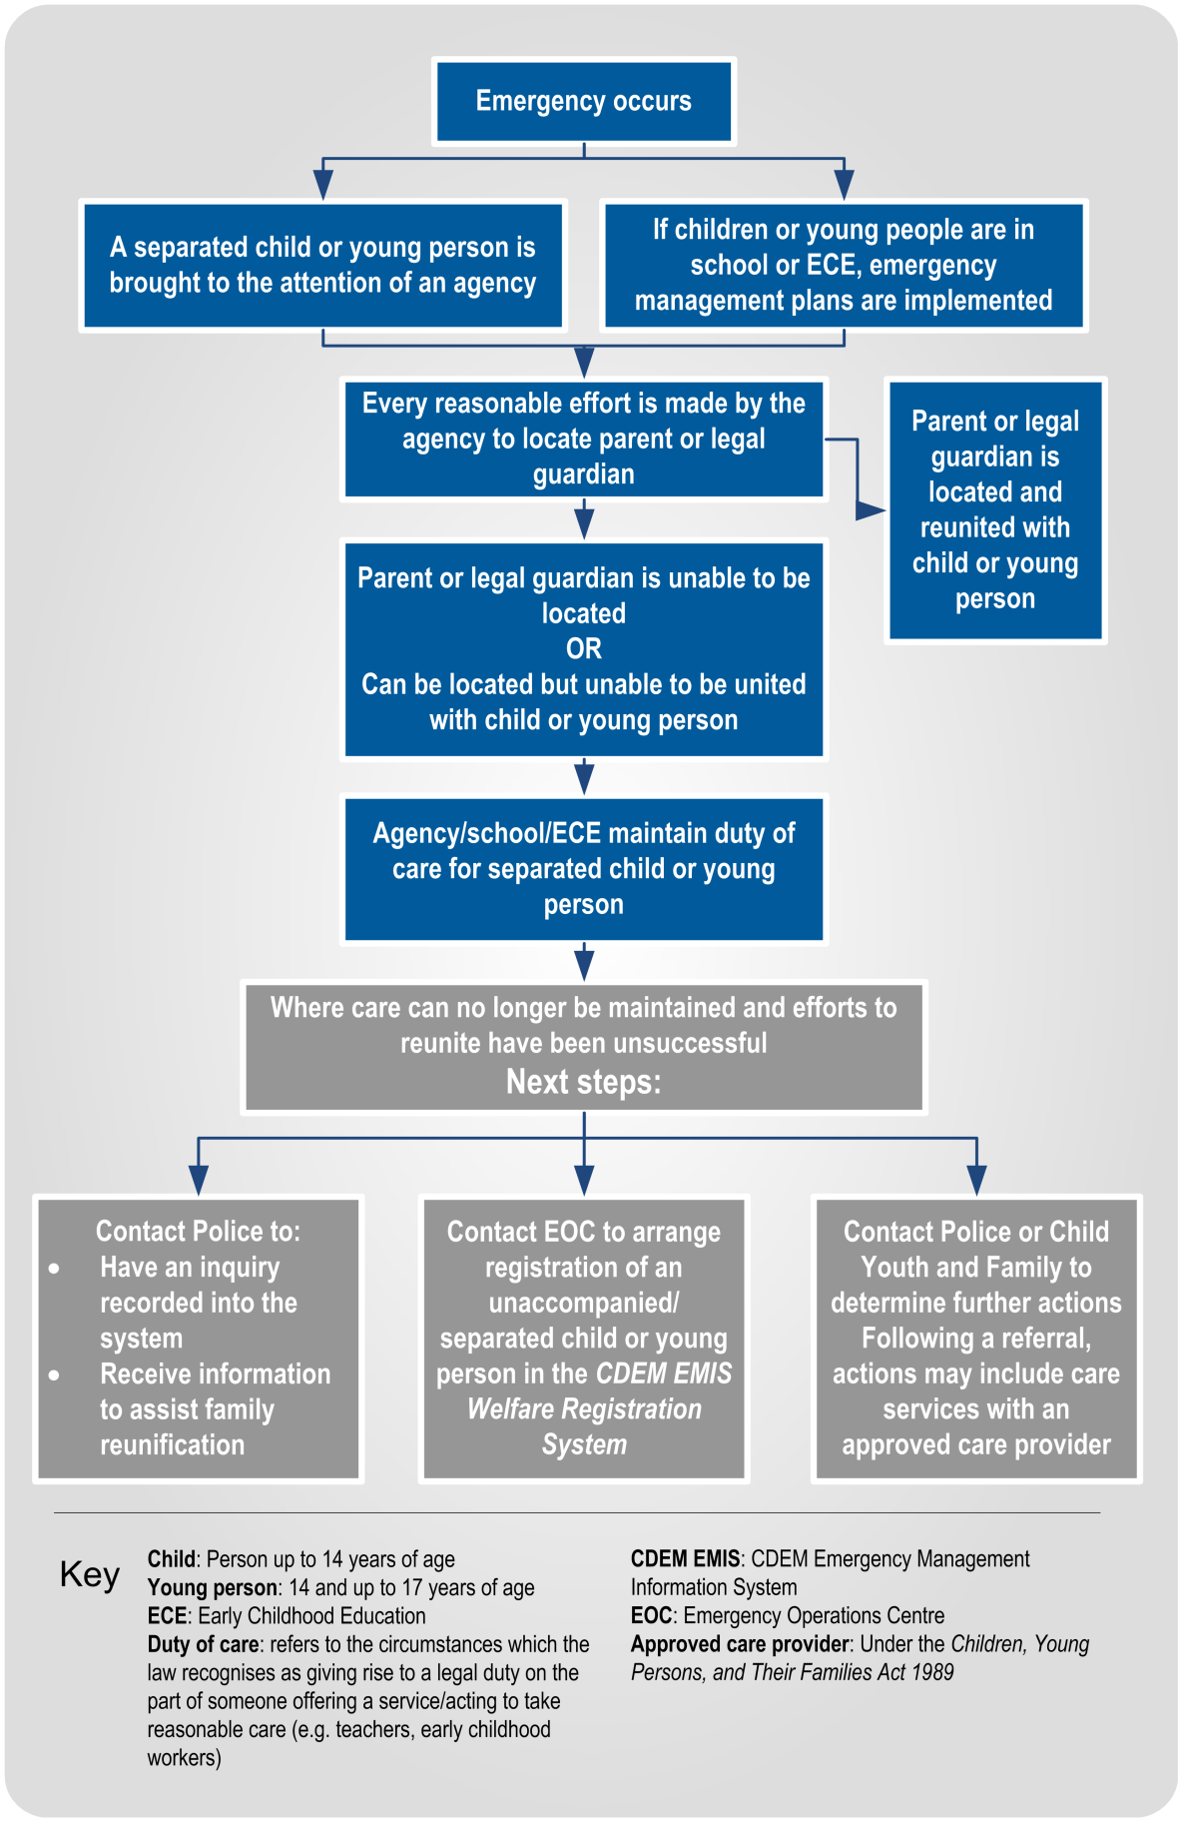
Figure 1 Process map for separated children and young people in an emergency

Recovery activities
During recovery, agencies will work together to prioritise ongoing needs. This requires agencies to:
- evaluate ongoing needs of affected children and young people
- ensure ongoing linkage of children, young people and their families to community and support agencies, including psychosocial support
- undertake recovery planning, and
- participate in post-emergency debriefs and undertaking corrective action planning.

Psychosocial support for children and young people
 | While most children and young people will experience normal reactions as a result of an emergency (such as sadness, irritability, and lack of concentration) it is important that appropriate psychosocial support is given consideration in planning arrangements.
Information and resources | The Ministry of Health has a range of information and resources to assist in alleviating stress and anxiety in children and young people. It is important that in planning for the delivery of psychosocial support that there is clarity on how services work together to meet the needs of children and young people.  - Helping children: Children have their own ways of dealing with trauma according to their stage of development.  - Helping adolescents: Adolescents involved in crisis and traumatic events may not always show their distress outwardly. As a result, adults may misunderstand adolescents’ needs or find them unwilling to accept help.  - Families and disasters: People are usually surprised by how much a crisis or trauma affects them. It frequently changes the way they think, their values, habits, feelings, and behaviour. It influences most aspects of their life.  - When someone you know has been through a traumatic experience: Traumatic experiences are distressing and threatening, and may be so intense as to temporarily disrupt a person’s ability to come to terms with them.  The resources above are available at the Ministry of Health website www.health.govt.nz (search for ‘managing stress in an emergency’).

Appendices
Appendix A Information applicable to all welfare services 11
A.1 Welfare services agency representation 11
A.2 Human rights 11
A.3 Working with communities 12
A.4 Minimum standards in the Sphere Handbook 13
A.5 Privacy, information sharing, and vetting 14
Appendix B Separated children’s identification card 17
Appendix C Emergency supplies for children/young people 18
Appendix D Release form for separated children/ young people 19
Appendix E Activity and planning log 21
Appendix F Status update report 22

Information applicable to all welfare services
This section provides overarching information applicable to all welfare services.

Welfare services agency representation
Some government agencies responsible for the coordination of the welfare services sub-functions do not have a presence in all communities.
Where agencies are not represented at the regional or local level, those agencies need to identify how they will fulfil their responsibilities. This may include:
- identifying alternative agencies or organisations to coordinate or support the delivery of the welfare services sub-function, or
- deploying personnel into the region or local area.
Agencies should work with the CDEM Group/local authority to identify alternative agencies/organisations present in the local community. These organisations may be non-government, community-based, or voluntary.
See the National CDEM Plan 2015, the Guide to the National CDEM Plan 2015, and the sections in Part II Welfare services of this guideline for details of the agencies responsible for, and who support the welfare services sub-functions.

Human rights
New Zealand’s human rights commitments | The provision of welfare services to people affected by an emergency, either via a CDC or in a community setting, must contribute to ensuring that New Zealand meets its national and international human rights commitments.  See the Human Rights Commission website www.hrc.co.nz under the ‘Your rights’ tab for more information.
Age, people with disabilities, and people from CALD communities | Consideration must be given to providing access to welfare services to people of any age, people with disabilities, and people from culturally and linguistically diverse (CALD) communities. For example, people with disabilities require welfare services to be delivered in a disability-inclusive way, and will work with CDEM to achieve this. CALD community members often have specific requirements around social interaction, food, prayer, or gender which must be considered when planning for the delivery of welfare services.
More information | For more information and a list of relevant statutory documents, refer to the MCDEM publications:  - Including people with disabilities: Information for the CDEM Sector [IS 13/13]  - Including culturally and linguistically diverse (CALD) communities: Information for the CDEM Sector [IS12/13].  Along with the resources listed above, see Part I of the Welfare Services in an Emergency Director’s Guideline [DGL 11/15] (Appendix H Accessibility).  These are available at www.civildefence.govt.nz (search for the document name).

Working with communities
An inclusive approach | An emergency can be a stressful and emotional experience, which may impact or compound any existing difficulties or issues that people are facing. At the local and regional levels, consideration must be given to vulnerable and hard to reach communities, acknowledging that they may have:  - specific challenges to address  - skills and strengths that may contribute to welfare services delivery.
Considerations | Consider when planning:  - age  - gender  - children and young people  - people living alone  - elderly  - health and disability issues  - mental health and general health issues  - drug or alcohol dependency  - cultural requirements  - ethnicity and language  - socio-economic status  - people with companion animals  - isolation, and  - people with unreliable or no internet access or mobile phone coverage.
Utilising community networks | Opportunities should be taken wherever possible to build links with existing community networks. These networks should be utilised to reach people requiring support in an emergency, with resulting arrangements formalised in local plans.
Culturally and linguistically diverse (CALD) communities | CALD communities have many strengths, including skills, experience, and language capabilities.  CALD community networks are often well developed, with strong connections both within their own community and between communities. Partnering with CALD community leaders can enable appropriate and effective engagement and communication with community members.
People with disabilities | Working with people with disabilities and their wider networks of family/whānau, friends, and supporters provides an opportunity to gain an understanding of both the requirements and strengths of these members of the community.  People with disabilities and disabled people’s organisations provide expertise on the impact of disability. Disability service providers have technical and professional expertise, and may also have resources that can be drawn upon in an emergency.

Minimum standards in the Sphere Handbook
CDEM Groups/local authorities should take The Sphere Handbook: Humanitarian Charter and Minimum Standards in Humanitarian Response into account when planning for, setting up, and delivering welfare services.
The Sphere Handbook is one of the most internationally recognised sets of common principles and universal minimum standards in life-saving areas of humanitarian response.
The Minimum Standards include recommendations in water supply, sanitation, hygiene promotion, food security and nutrition, shelter, settlement, and non-food Items.
The Sphere Handbook is available at www.spherehandbook.org.

Key considerations | Some of the key requirements (taken from the Sphere Handbook) to be considered when planning for people affected by an emergency are shown in Table 3.  Table 3 Key considerations for planning for people affected by an emergency  Rights Key requirements  Protection from Poor health, disease and wellbeing  Environment, weather, heat or cold  Violence, crime or abuse  Dangerous structures  Nutrition Clean drinking water  Food, baby food and pet food  Cooking facilities, utensils and fuel  Water and Sanitation, Hygiene (W.A.S.H) Clean water for washing  Waste water, solid waste  Hygiene, nappies, soap and disinfectant

Privacy, information sharing, and vetting
Information about welfare registrants, including personal information, will be shared with agencies contributing to the coordination and delivery of welfare services.
A privacy statement features as the first step in the registration process, and this must be understood and agreed to by all potential registrants. The privacy statement can be displayed by way of posters, hand-outs or on-screen if people are waiting to be registered (e.g. in a CDC).
Welfare registrars need to be trained in and must understand and abide by the provisions of the Privacy Act 1993. This Act controls how agencies collect, use, disclose and give access to personal information. Note that people have the right to request any information gathered about them under this Act.
See section 6 in Part 2 of the Privacy Act 1993 which features 12 Information privacy principles.
The Privacy Act 1993 is available at the New Zealand Legislation website: www.legislation.govt.nz or for more information refer to the Privacy Commissioner’s website: www.privacy.org.nz .

Civil Defence National Emergencies (Information Sharing) Code 2013 | The Civil Defence National Emergencies (Information Sharing) Code 2013 (the Information Sharing Code) is a regulation issued by the Privacy Commissioner, and applies to a state of national emergency only.  The Information Sharing Code provides agencies with the authority to collect, use, and disclose personal information relating to an individual, in relation to an emergency.  The Information Sharing Code applies as follows:  - To assist with the effective management of the response to a national emergency, this code applies in relation to any emergency in respect of which a state of national emergency is in force.  - To assist with the recovery from a national emergency, this code continues to apply in relation to such an emergency for a further 20 working days after the date on which a state of national emergency expires or is terminated.  Specific criteria apply to the Information Sharing Code. For full details, refer to the Civil Defence National Emergencies (Information Sharing) Code 2013 on the Privacy Commissioner’s website: www.privacy.org.nz.  As stated above, the Information Sharing Code applies only to a state of national emergency. The Privacy Act 1993 applies at all times including during and following any emergency.
Police Vetting Service | The New Zealand Police Vetting Service offers an online process for approved organisations to check the criminal records of potential or existing personnel, including volunteers.  Vetting requests cannot be made by individuals, and organisations must register in order to ask for Police vetting. To become an approved organisation, agencies must show that their personnel provide services or care for children, older people, people with special needs or other vulnerable members of society.  Vetting can only be carried out with the signed consent of the person being vetted. Organisations are expected to ensure the person being vetted is aware of the vetting process.  The standard turnaround time for completing a Police vetting process is 20 working days.  Police recommend that vetting of existing personnel including volunteers, is carried out on a regular basis, i.e. every two to three years.  An organisation must have information security procedures in place to protect the confidential information and any Police material they hold as a result of the vetting process.  More information about Police vetting is available at www.police.govt.nz.
Safety checking for the children’s workforce | The Vulnerable Children Act 2014 introduces new requirements for organisations funded by the government that employ people to work with children. Safety checking requirements are being phased in over several years.  Any agency working with children and young people must meet the approval obligations outlined in the Vulnerable Children Act 2014.  The Vulnerable Children Act 2014 is available at the New Zealand Legislation website: www.legislation.govt.nz or for more information refer to the Children’s Action Plan website: www.childrensactionplan.govt.nz.
Screening CDEM-trained volunteers | For information about screening processes for CDEM-trained volunteers, refer to the Volunteer Coordination in CDEM Director’s Guideline for CDEM Groups [DGL 15/13] available at www.civildefence.govt.nz (search for ‘volunteer coordination DGL’).

Separated children’s identification card
This template is available to download at www.civildefence.govt.nz
This template may be:
- used before children and young people are relocated from their usual place of care e.g. school, childcare centre, and
- intended to ensure each child has an identification card attached to their clothing before they leave their current location.

ID CARD
Current location: | Relocating to (name and address):
Name
Medical and/or physical requirements
Name of parent/legal guardian (authorised to uplift child/young person) and cell phone number
Name of parent/legal guardian (authorised to uplift child/young person) and cell phone number
Home address
Home phone number/s
Name of relative or friend and phone number (local and out of area)

Emergency supplies for children/young people
This template is available to download at www.civildefence.govt.nz
This template can be used to ensure that basic needs are met to support separated children and young people (and their carers) in an emergency.

 | Short Term Emergency |  | 72 Hour Emergency
Basic supplies | Evacuation pack (per person) |  | Evacuation pack (per person) | 
Important papers | Emergency information on each child or child identification card |  | Emergency information attached to each child
 |  |  | Emergency Transport
Water (for drinking, cooking and washing) | 3 litres of drinking water per day |  | 3 litres of drinking water for each child/adult per day
Food | Non-perishable food items |  | Non-perishable food items such as canned fruit
 | Formula and feeding equipment/food for infants |  | Appropriate eating utensils
 |  |  | Formula and feeding equipment/food for infants
 | Disposable cups |  | Non electric can opener
Clothing & bedding | Blankets |  | Change of clothes per- person (include extra socks)
 | Change of clothes for babies |  | Extra bedding and blankets
First Aid | Small first aid kit |  | First Aid kit
 | Any needed medications |  | Any needed medications
Sanitation | Nappies, wipes, and disposable bags |  | Additional nappies, wipes, and disposable bags
 | Toilet paper |  | Additional toilet paper
 |  |  | Hand soap and paper towels
 |  |  | Plastic bags
 | Hand sanitizer |  | Feminine hygiene supplies
Comfort and Safety | Age appropriate activity |  | Age appropriate play activities
 | Torch and batteries |  | Torch and batteries
 | Pencils |  | Pencils
 | Notebook |  | Notebook
Communication | Radio and batteries |  | Radio and batteries
 | Charged cell phone |  | Charged cell phone
 | Calling card |  | Calling card

Release form for separated children/ young people
This template is available to download at www.civildefence.govt.nz
This template is intended to ensure safe reunification between separated children and their parents, legal guardians, or usual caregivers, and is used:
- when separated children and young people are sheltered in a Civil Defence Centre (CDC) or other location
- by CDC staff before they release a separated child or young person back into the care of their parents, legal guardians, or usual caregivers.

To be completed by CDC staff member
Name of CDC Staff member: | Date:
Location (CDC/care provider):
Child/children’s name(s):
Are you happy to release this child/ren to their parent, legal guardian, or usual caregiver? |  | Yes/No
If NO, have you contacted Police? |  | Yes/No
To be completed by parents, legal guardians, or usual caregivers, or the person the child or young person is being released to
Name: | Signature:
Contact Details: | Relationship to child or young person:
Copy provided of proof of identification (photo required e.g. Driver licence):
Time: | Destination address:

A separated child or young person must not be released to a person that is ‘not an approved person’ to have access to that child/young person (i.e. check that the parent, legal guardian, or usual caregiver has been stated on the Separated Child/ren’s Identification Card).
If this hasn’t occurred, check that there are no protection (or other) orders in place preventing access to the child or young person by checking:
- the Separated Child/ren’s Identification Card
- with Police, or
- with a Child, Youth and Family social worker.

Before releasing the child or young person, check with the police or Child, Youth and Family that the child or young person has not been placed into the care of Child, Youth and Family by the Police in the interim under a Section 48 “unaccompanied Child or Young Person” of the Children, Young Persons, and their Families Act 1989.
If there are any concerns about the immediate safety of the child or young person if they were to be released to their parent, legal guardian, or usual caregiver, contact Police.

Activity and planning log
This template is available to download at www.civildefence.govt.nz
This template is used to:
- record actions taken and required
- identify and provide a record of actions undertaken, and the current status
[Grey text] is an example only, and is replaced with required information. Brown text can be deleted.
Activity & Planning Log
Record of Actions Required and Taken
Care and protection services for children and young people
EMERGENCY: [insert]
DATE: [insert]
Ref: | Date | Time | Description | Actions Required | Responsibility | Priority  Low  Med  High | Actions undertaken | Status | Open/  Closed
Add rows as required

Status update report
This template is available to download at www.civildefence.govt.nz
This template is completed by the named support agencies for care and protection services for children and young people, and is sent to Child, Youth and Family (the agency responsible for coordinating this sub-function). It is used to:
- provide an information summary on the impact of the emergency on separated children or young people
- identify further support required
- highlight any potential risks
- ensure that the coordinated provision of care and protection services for children and young people is taking place, and that there is good oversight of arrangements.
[Grey text] is replaced with required information. Brown text can be deleted.
STATUS UPDATE REPORT
Care and protection services for children and young people separated from their parents, legal guardians, or usual caregivers during an emergency
[Name of emergency]
To: |  |  | Date
CC: |  |  | Time
From (name) |  |  | Agency
Point of contact
Name:  Email: |  | Phone:  Mobile number:

Current situation
Separated children and young people
-impact
-number
Response required
Wider support required
(Potential) Risks and Issues
Resources required | What additional resources may be required, in what timeframe and options for their delivery
Once completed, please email this report to: Coordinator of care and protection services for separated children and young people

