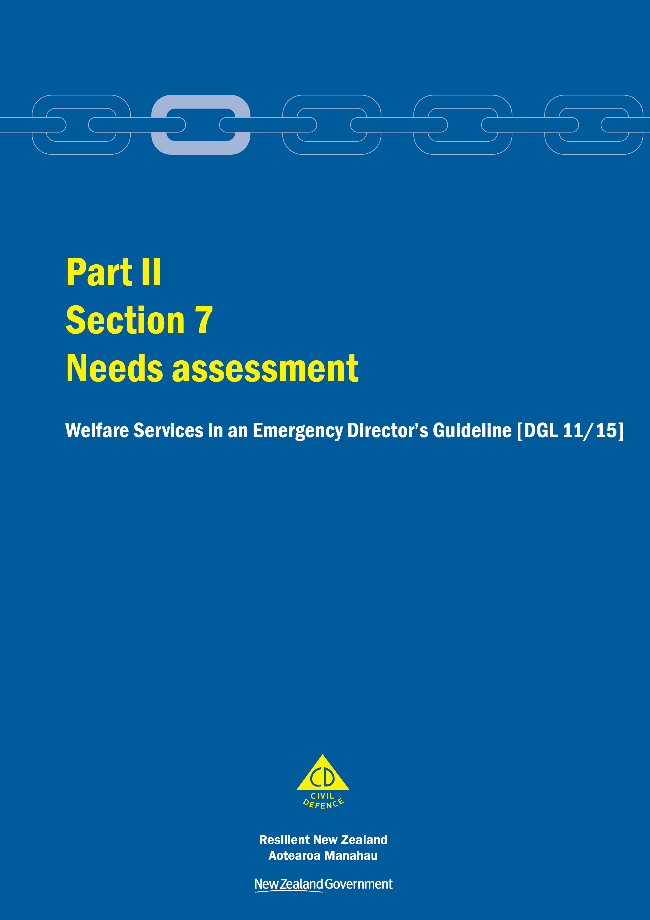
Welfare Services in an Emergency
Director’s Guideline for CDEM Groups and agencies with responsibilities for welfare services in an emergency [DGL 11/15]

October 2015
ISBN 978-0-478-43513-9
Published by the Ministry of Civil Defence & Emergency Management

Authority
This guideline has been issued by the Director of the Ministry of Civil Defence & Emergency Management pursuant to s9(3) of the Civil Defence Emergency Management (CDEM) Act 2002. It provides assistance to CDEM Groups and agencies with responsibilities for welfare services in an emergency to understand and work towards the welfare roles, structures, and responsibilities described in the National Civil Defence Emergency Management Plan 2015.

This document is not copyright and may be reproduced with acknowledgement. It is available, along with further information about the Ministry, on the MCDEM website www.civildefence.govt.nz.

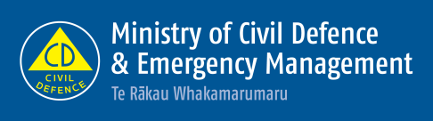

Ministry of Civil Defence & Emergency Management
PO Box 5010
Wellington 6145
New Zealand
Tel: +64 4 817 8555
Fax: +64 4 817 8554
Email: emergency.management@dpmc.govt.nz
Website: www.civildefence.govt.nz

Contents
Section 7 Needs assessment 1
7.1 Introduction 1
7.2 Needs assessment framework 3
7.3 Principles 4
7.4 Readiness 5
7.5 The welfare needs assessment process 6
7.5.1 Develop initial awareness and activate the Welfare Manager and team 8
7.5.2 Confirm capacity and plan for needs assessment 8
7.5.3 Undertake welfare needs assessments 9
7.5.4 Information collection 11
7.5.5 Identifying and addressing immediate needs 12
7.5.6 Collating information and building a picture of needs 12
7.5.7 Planning and delivery of welfare services 13
7.5.8 Coordination and reporting 14
7.6 Needs assessment phases 16
7.6.1 Rapid (initial response) 16
7.6.2 Response 17
7.6.3 Recovery 18
Appendix A Information applicable to all welfare services 19

Needs assessment
This section should be read in conjunction with the other parts and sections in the Welfare Services in an Emergency Director’s Guideline [DGL 11/15].

Introduction
Needs assessment is the process of understanding the needs of people affected by an emergency. It provides the basis for welfare service delivery.
Needs assessment includes the provision of a system to assist with meeting the immediate and ongoing welfare needs, and coordinating the actions required to meet those needs, in an integrated and flexible way.
Needs assessment provides the means of identifying and coordinating welfare services during emergencies, and is therefore of direct benefit to people affected by emergencies and agencies with welfare service delivery responsibilities.

Agency responsible | MCDEM and CDEM Groups (including local authorities) are the responsible agencies for coordinating the needs assessment sub-function.  At the national level, MCDEM provides a system to facilitate the collection of data to inform the assessment of immediate and ongoing welfare needs.  At the CDEM Group level, CDEM Groups are responsible for:  - collating and analysing identified welfare needs, and  - working with support agencies, including community-based organisations and networks, to identify and deliver appropriately integrated services and information to address welfare needs.
Support agencies | Table 1 lists agencies that may be required to provide support at both national and CDEM Group levels.

Table 1 Support agencies for the needs assessment sub-function
Agency | Level | Support
Ministry of Foreign Affairs and Trade | National | Coordinate with Foreign Diplomatic and Consular missions to provide information and advice on foreign nationals.
Ministry of Health | National | To coordinate a national health service response, including health personnel, and to provide advice on specific health and disability issues, including provision of psychosocial support.
District Health Boards (DHBs) | Regional | To coordinate a regional health service response, including health personnel and the assessment of health and disability requirements and psychosocial support services.

Agency | Level | Support
St John | National | To coordinate the provision of ambulance personnel to support the Ministry of Health response to welfare services.
 | Regional | To coordinate the provision of ambulance personnel to support the regional health response to welfare needs, in consultation with Ministry of Health and DHBs.
Ministry for Primary Industries (MPI) | National | To coordinate information provided by Rural Support Trusts and other primary producer stakeholder networks about identified needs on farms and in rural communities.  To coordinate information on animal welfare.
 | Regional | To identify needs on farms and in rural communities through Rural Support Trusts and other stakeholder networks.  To identify animal welfare needs.
Ministry of Social Development | National and regional | To determine eligibility for:  - financial assistance  - temporary accommodation for displaced persons.
Police | National and regional | To coordinate inquiries and provide information.
The Office for Disability Issues | National | To provide information and advice in support of the coordination of assistance to people with disabilities.
Te Puni Kōkiri | National and regional | To work with other government agencies and CDEM Groups to facilitate and coordinate support to Māori who require assistance, and to engage with iwi, hapū, whānau, and Māori communities to ensure that their needs are met.
New Zealand Red Cross | National | To coordinate the provision of trained New Zealand Red Cross personnel to support community-based needs assessment and outreach.
 | Regional | To provide trained New Zealand Red Cross personnel to support community-based needs assessment and outreach.
Salvation Army | National | (With other faith-based organisations) To coordinate the provision of their trained personnel to support community-based needs assessment and outreach.
 | Regional | (With other faith-based organisations) To provide trained personnel to support community-based needs assessment and outreach.
Victim Support | National | To coordinate the provision of trained support workers and personnel to support community-based needs assessment and outreach.
 | Regional | To provide trained personnel to support community-based needs assessment and outreach.

Further support | Support may also be provided by any other government agency or non-government organisation that can provide relevant advice or information (see examples in Table 2 on the next page).

Table 2 Examples of further support
Agency | Support
Ministry of Pacific Island Affairs | At the national level, to work with other government and non-government agencies to ensure that the needs of Pacific communities are met, by:  - providing advice and information on Pacific communities  - engaging with Pacific peoples  - identifying Pacific community leadership.  At the regional level, to work with CDEM Groups as possible through regional offices, to provide this support (the Ministry of Pacific Island Affairs has offices based in Auckland, Wellington and Christchurch).
Office of Ethnic Communities | At the national level, to work with other government and non-government agencies to ensure that the needs of ethnic communities are met, by:  - providing advice and information on ethnic communities  - engaging with ethnic groups  - identifying ethnic community leadership  - facilitating access to Language Line.  At the regional level, to work with CDEM Groups as possible through regional offices, to provide this support (the Office of Ethnic Communities has offices based in Auckland, Hamilton, Wellington and Christchurch).

Needs assessment framework
Effective needs assessment requires work during readiness, and a flexible response process that can be adapted to any emergency.
The key components of welfare needs assessment are outlined in Figure 1, and described in sections 7.3 to 7.6.
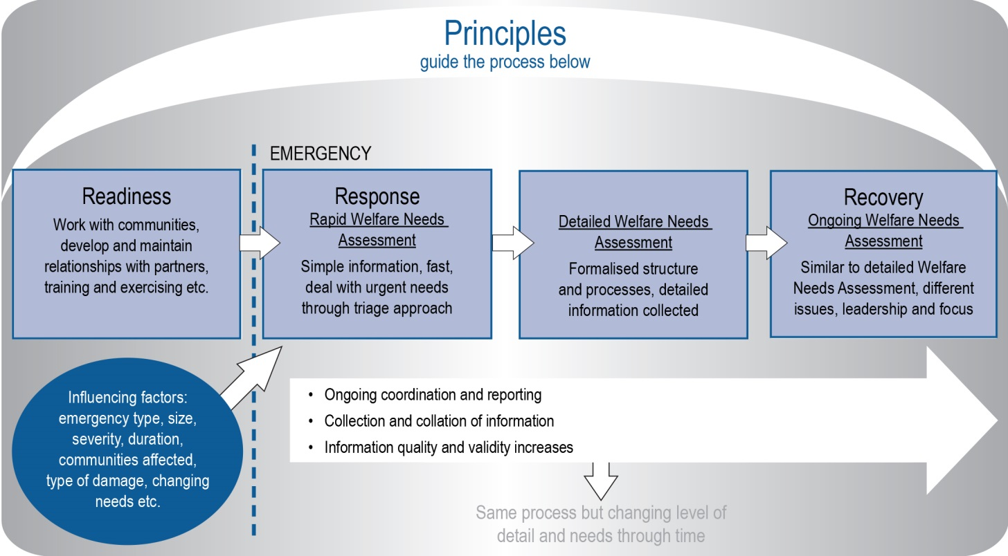
Figure 1 Welfare needs assessment framework

Principles
The following principles guide the welfare needs assessment process:
- Plan for welfare needs assessment as part of readiness activities.
- The Welfare Manager leadership role is critical – ensure the right skills and training are provided.
- Keep needs assessments streamlined and efficient.
- Identify ‘hidden’ needs and focus on vulnerable people.
- Ensure needs assessment is done with empathy and is people-focused.
- Assess first, then confirm resources, then plan, and then deploy.
- Use experienced people best suited to the situation.
- Maintain a flexible approach, as needs and information requirements change through time.
- Encourage community-led assessments, and use all available community networks.
- Work alongside communities to assess needs and deliver what is required.
- Maintain regular communication with partners and communities.
- Ensure information management processes and applications are integrated throughout the assessment process:
  - each assessment builds on existing data
  - only the data required for decision-making is collected
  - quality of information is ensured – coordination centre functions and partners must verify to the extent possible.
- Collate information to build a common picture of needs – who is affected, where they are and what their needs are.
- Agencies must liaise closely with other sub-function agencies to ensure that where multiple needs are identified, the individual and/or family receives a wrap-around service to meet those needs.
- Distinguish between and link welfare needs assessment, welfare service delivery, and follow-up/monitoring.
- Assessments should adequately address factors such as age, gender, and diversity.
- Ensure the privacy of personal information is safeguarded in accordance with privacy legislation.

Readiness
 | The following CDEM readiness activities underpin effective welfare needs assessment during an emergency.
Communities and response planning | CDEM Groups/local authorities should work with communities on response planning, and support community resilience. Community response plans can contribute to welfare service delivery by identifying community arrangements in place. The process of community response planning builds relationships, and can identify potential needs during an emergency.  Understanding the nature of communities and local networks, and establishing communications links between the community and the coordination centre, are important parts of community response planning.
Other readiness- activities | Other readiness activities of particular relevance to needs assessment include:  - clarifying roles and responsibilities for needs assessment, relationship management, training and exercising, and clarifying agency capability and capacity for needs assessment (see Part I of the Welfare Services in and Emergency Director’s Guideline – Section 3, Readiness)  - developing staff experience  - ensuring the Welfare Coordination Group (WCG) or local welfare committee is functional and engaged  - pre-planning and development of Standard Operating Procedures (SOPs)  - learning from agency and collective reviews/debriefs, and updating plans, procedures and training  - establishing strong links to the Coordinating Executive Group (CEG), and  - determining potential safety and security requirements for undertaking welfare needs assessment.
Privacy and information sharing | See Appendix A Information applicable to all welfare services on page 19 for information on privacy legislation, the Police Vetting Service, safety checking for the children’s workforce, and screening CDEM-trained volunteers.

The welfare needs assessment process
The welfare needs assessment process has three phases through response and recovery:
- rapid (initial response)
- response, and
- recovery.
The process remains the same throughout each phase, but the speed, level of formality, and detail of information will change through time.
During rapid welfare needs assessment, processes are fast, information collected is simple, and structures may be informal. Generally, as time progresses, the level of information collected becomes more detailed and structures and processes become formalised.
During recovery, the focus of welfare needs assessment often changes towards long-term community regeneration needs.
The differences between the three phases are outlined in more detail in section 7.6 Needs assessment phases on page 16.

Immediate needs | It is important that, alongside the needs assessment process, immediate needs are met as soon as practicable. The needs assessment process supports the ongoing identification and delivery of welfare services.
Information management | Information management occurs throughout the needs assessment process. Information management comprises collection, collation, analysis, and evaluation of information to build a picture of current, emerging, and diminishing needs.  See the following sections for more information:  - 7.5.4 Information collection on page 11  - 7.5.6 Collating information and building a picture of needs on page 12.
Process diagram | The welfare needs assessment process is outlined in Figure 2 on the next page.
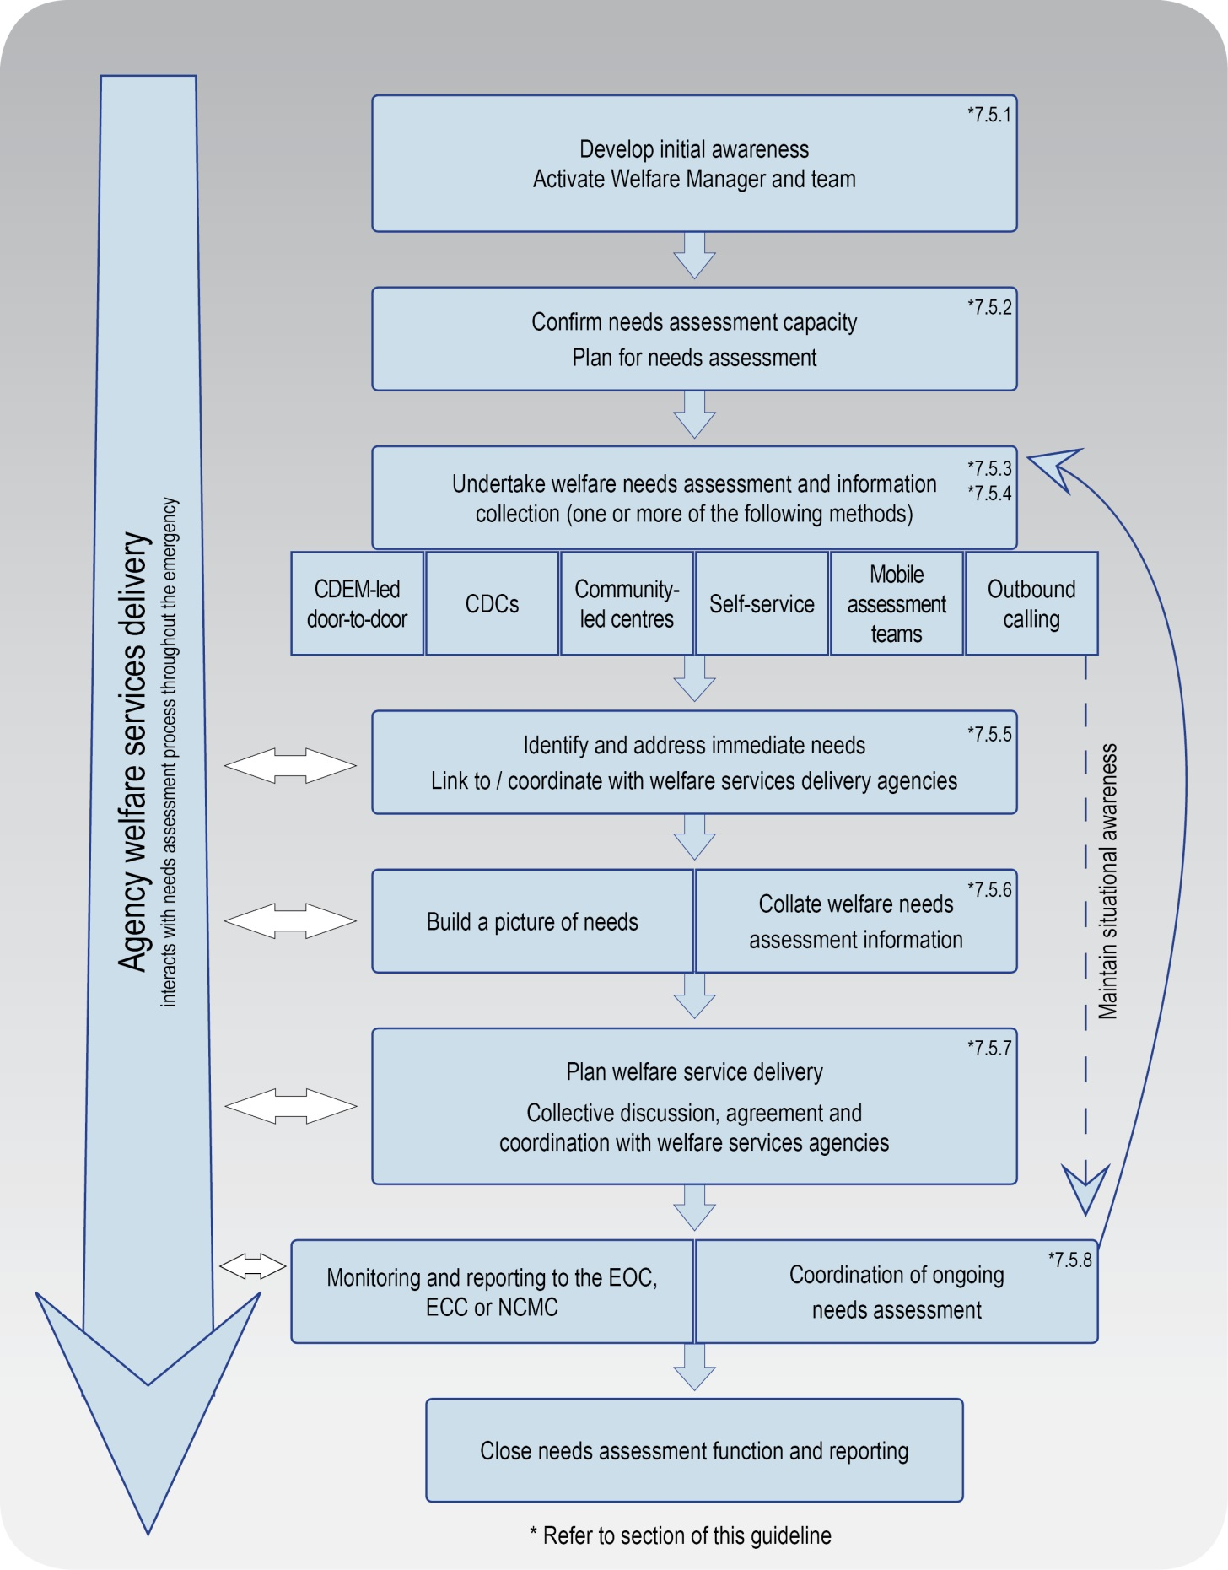
Figure 2 Needs Assessment Process

Develop initial awareness and activate the Welfare Manager and team
The initial actions of the rapid needs assessment process are:
- develop initial awareness, and
- activate the Welfare Manager and team.

Develop initial awareness | An initial awareness of needs in affected communities are developed using information from a variety of sources, including:  - coordination centre Operations and Intelligence functions  - emergency services  - results from Rapid Impact Assessments  - local communities  - volunteer organisations  - contractors, and  - inbound calls to the coordination centre.  Matters of interest include the areas impacted, the type of impacts, and the likely development of the emergency.
Activate Welfare Manager and team | The CDEM Group Welfare Manager or Local Welfare Manager will be activated using established coordination centre response processes.  Once activated, the Welfare Manager makes initial contact with relevant support agencies, and activates Welfare team members (including needs assessment teams).

Confirm capacity and plan for needs assessment
Needs assessments may be conducted in a number of ways depending on the size and scale of the emergency.
Before needs assessment personnel are dispatched:
- confirm the resources and partner agencies available to support needs assessment
- decide how to collect information, based on the nature of the emergency (size, extent, severity, communities affected) and preliminary information received
- develop a simple plan, which may include:
  - a brief situation report
  - definition of the coverage area for needs assessment
  - level of information required and how it will be collected, collated, and reported
  - resourcing and logistics requirements, and
  - emerging issues and plan review.

Undertake welfare needs assessments
Welfare needs assessment (both rapid and detailed) can be carried out in a number of contexts, including:
- door-to-door
- in Civil Defence Centres (CDCs)
- in community-led centres
- self-service (e.g. 0800 numbers, online)
- mobile assessment units, or
- outbound calling.
An overview of methods commonly used in each context is provided below.

Door to door
 | CDEM-led door to door needs assessments (supported by welfare services agencies) are typically carried out when people are sheltering in place.
In an urban setting | In the urban setting, the most common needs assessment method is to deploy teams of two to four, comprising:  - a Welfare practitioner  - a building inspector, and  - others, as appropriate.  Welfare practitioners are commonly local authority personnel, but could be other welfare services agency representatives.  Teams may be added to with trained staff and volunteers from local authorities, New Zealand Red Cross, the Salvation Army, volunteer agencies, and other technical specialists as required.
In a rural setting | In the rural setting, Rural Support Trusts often play a key role in their communities in smaller scale, local emergencies. During emergencies, the rural environment can pose challenges in terms of distance to be covered and a lack of accessibility. The most common needs assessment method is as follows:  - In large-scale emergencies, needs assessments are led by CDEM Groups/local authorities, with support from MPI, Rural Support Trusts, and local farming sector staff (often those who are already well known within the community, such as catchment management and biosecurity staff, primary industry organisation staff, Rural Women New Zealand, and local iwi) and linked back to the coordination centre.  - Where needs assessment is led by the coordination centre, Rural Support Trusts play an important supporting role, providing local knowledge, rural networks, and advice.
In urban and rural areas | The following applies to both urban and rural areas:  - For large-scale emergencies use maps, break down into sectors, and use a sampling/estimates method. This can be extrapolated across the affected area, and used to inform a triage approach.  - Use hand outs with key contact information, and leave these at properties whether contact is made or not.  - Assessments must be coordinated – confirm who is doing what, when, and where. Collective morning briefings are commonly used prior to daily needs assessment activities.  - Use the most experienced people available and people who are known to the community.

In a CDC
CDCs are opened as required in affected communities to inform people where to come for assistance, and what assistance is available (Public Information Management).
In larger urban areas it may be more appropriate to establish a CDC than to provide door to door services.

Personnel | Staff CDCs with a trained CDC Supervisor and support agency personnel initially, adding trained volunteers as required. Add support agencies as needs and numbers demand. Ensure capacity and skills for welfare needs assessment are maintained.
Immediate needs | Identify immediate needs such as for food, clothing, and shelter, including immediate psychosocial support requirements. Deal with immediate needs either onsite via relevant agencies, or flag to the coordination centre for follow up.  Identify hidden needs and/or quiet people – walk the queue lines looking for immediate needs, and double check no one requiring immediate assistance is overlooked.

In community-led centres
Community-led centres may be set up by community-based organisations or Community Response Groups (normally these groups have prepared Response Plans, but may be spontaneously activated).
Local people talk to local people, rapidly determining who is affected and what the needs are, and may report to the Welfare Manager or a contact in the coordination centre. There is a high reliance on local knowledge and contacts.
This method is likely to be a highly effective approach where the community is fully engaged in community response planning during readiness.
Support from the coordination centre | A coordination centre – usually an Emergency Operations Centre (EOC) – can support local community-led centre leaders or organisers through liaison.  This relies on pre-planning, mainly clarifying roles and responsibilities, identification of community leaders and community response preparation.

Self-service (phone and online)
Self-service requires the establishment of self-service options, and continuous messaging via Public Information Management. It involves encouraging the public to make direct contact with call centres (normally a council helpline), or other online options such as email or web based contact.
Calls may be forwarded to the coordination centre Welfare function as required. Needs may also be communicated via email.

Mobile assessment teams
Mobile assessment teams may be used if there are areas of severe impact. A team usually comprises highly trained professionals, depending upon the skills required.
Teams report back to the CDEM Group or Local Welfare Manager via telephone or radio.

Outbound calling
CDEM and support agencies use information available to them to contact pre-identified vulnerable groups and/or those most affected, to identify needs and inform welfare service delivery. This requires intact telecommunications.

Information collection
Collection methods depend upon the influencing factors – particularly size and extent of the emergency (see Figure 1 on page 3). Sufficient information for decision making must be collected.
Information collection may be paper-based or electronic.

Paper-based | Paper-based information collection involves using:  - customised CDEM Group/local authority forms, or  - printed CDEM EMIS Welfare Registration and/or Needs Assessment forms.  Forms are usually between one to two pages.  Paper-based forms may be more practical, particularly for door-to-door assessments due to unreliable power supply, lack of internet availability, weather conditions, and the ‘human element’ (mobile digital devices may be perceived as getting in the way). Paper-based forms may also be used in CDCs.
Electronic | Electronic information collection involves the use of CDEM EMIS at CDCs and call centres, or via mobile digital devices during door-to-door assessments (if viable).  Electronic collection methods may also involve using other systems, including spreadsheets and/or databases.

Identifying and addressing immediate needs
The identification of immediate needs and addressing these as soon as possible should occur during the initial response and throughout the ongoing emergency.
Common methods include:
- using a triage approach, particularly for large scale emergencies
- using instant communication tools (particularly radio or phones) to contact the coordination centre Welfare function (all types of needs assessment)
- CDCs facilitating delivery of welfare services onsite via agencies responsible for the activated sub-functions, and
- community-led centres identifying immediate needs and informing the coordination centre when support is required to address those needs.
The Welfare Manager or team should follow up with agencies to ensure needs are being addressed and to collate needs assessment data via status update reports. Collated information is reported to the coordination centre by the Welfare Manager.

Collating information and building a picture of needs
Collation of information | Electronic collation of information is required to build a picture of needs. Collation may be done by spreadsheet for small-scale emergencies, CDEM EMIS, databases and or other systems such as Customer Relationship Management (CRM) systems. Collation of information for large-scale emergencies may require dedicated teams of data entry and management personnel.
Building a picture of needs | It is important to build a common operating picture of needs prior to planning and delivery of welfare services. Building a common operating picture of needs includes:  - identifying how many people are affected/have needs, and where they are  - identify what needs people have  - where the requirements are and how significant they are, and  - emerging pressure points.  A person’s need may be as simple as interaction with others at a community-led centre, or complex (requiring professional help).

Planning and delivery of welfare services
Planning | Welfare service delivery should be planned for and confirmed in coordination with partner agencies. Planning is led by the Welfare Manager and WCG or local welfare committee, and is supported by the Welfare team and the coordination centre Planning function.  It is important to record and confirm how welfare services will be delivered via the agencies responsible and their support agencies; this is the crux of welfare action planning.  Information on coordinated needs assessment informs planning for the other welfare services sub-functions, as well as wider coordination centre action planning.
Beginning welfare service delivery | Welfare service delivery can begin once:  - needs are assessed and understood  - there is collective agreement on which agency will deliver services to meet those needs, and  - there is collective agreement how welfare services will be delivered.  Collective discussion and agreement should occur via coordination (see section 7.5.8 Coordination and reporting on page 14), led by the Welfare Manager.
Detailed needs assessment within other welfare services sub-functions | As a part of welfare service delivery, detailed needs assessment may be required to address needs within each welfare services sub-function. This is normally the role of the agency responsible for each sub-function. While undertaking welfare service delivery, agencies will use their own client information systems for managing client needs.  When further needs are identified during welfare service delivery, these may be referred to other agencies, and should be reported to the Welfare Manager.  Agencies should provide high-level reports on service delivery status and arising needs to the Welfare Manager on an agreed reporting cycle.

Coordinating ongoing needs assessment and welfare service delivery
Regular follow up with agencies on welfare service delivery is carried out by the Welfare team or the coordination centre.
Further needs that develop with time, and gaps in needs assessment (such as those properties where people could not be contacted via door-to-door assessment), should be flagged.
The coordination of needs assessment and follow up of welfare service delivery should continue over time. Welfare Managers are responsible for maintaining high-level oversight of how agencies are progressing with meeting needs identified during the needs assessment process throughout all phases of the emergency.

End of the needs assessment process | The needs assessment process usually ends when:  - all needs are being managed by welfare service delivery agencies  - there is no need for ongoing coordinated assessments, and/or  - when CDEM involvement and responsibility for the response or recovery phase ends.

Coordination and reporting
Coordination and reporting are fundamental to ongoing processes throughout all phases of needs assessment.

Coordination
 | Teleconferences and face to face meetings are the preferred coordination methods. For either method, only agencies who are actively involved in welfare service delivery should be included (continuously review agency involvement as needs evolve).
Teleconferencing | Agencies may prefer to work from their own offices depending on the circumstances. Agencies will determine this for themselves.  During the rapid welfare needs assessment phase, teleconferencing may be 2-3 times daily, lessening in frequency with time.  A teleconference may be facilitated by the Welfare Manager or Recovery Manager, and include all Welfare Managers, the Controller (when relevant), and support agencies directly involved in needs assessment and welfare service delivery (some of whom will likely be WCG or local welfare committee members).  Teleconferences will likely include the WCG in large-scale emergencies (depending on whether WCG has an operational role or not).
Following a process | A common procedure used for both teleconferencing and face to face meetings is:  - Provide a brief overview of the situation (numbers of people affected, welfare facilities established).  - Collectively identify needs/issues arising.  - Assign welfare service delivery to responsible agencies.  - Fill gaps in delivery capacity.  Detailed delivery discussions between agencies are flagged, but taken offline to resolve. The primary outcomes sought are:  - agencies understanding what is needed  - delivery of immediate needs, and  - the Welfare Manager and other coordination centre functions understanding what the issues are, and what services are being delivered.  Record-keeping should include minute-taking with action points noted. Minutes are to be communicated to participants as soon as possible.
Situational awareness | Good coordination of needs assessment is dependent upon Welfare Managers:  - having an overview of the collection of information, interpretation, reporting and follow-up  - developing a strategic view of issues across the CDEM Group or local area, and  - liaising with the Controller or Recovery Manager, the coordination centre Welfare team, the WCG or local welfare committee, and the National Welfare Manager (if required).  There is a need to maintain constant communication between welfare services agencies, and a requirement to move quickly to case management by agencies.

Reporting
 | Agencies are responsible for reporting on welfare service delivery, while CDEM Group and Local Welfare Managers are responsible for ensuring that reporting takes place.
Welfare Manager responsibilities | Welfare Managers need to ensure that:  - regular verbal updates are provided to Controllers/Recovery Managers (e.g. at Controller team meetings) on issues, resourcing, risks, priorities, and planning  - regular input into coordination centre Situation Reports is provided as required, and  - needs assessment summary information is provided to other Welfare Managers, the WCG or local welfare committees, and/or the National Welfare Manager as required.
Reporting to the coordination centre | Reporting to the coordination centre primarily involves:  - reports from door-to-door needs assessment teams, in addition to communication of immediate issues (normally via phone or radio)  - regular CDC status reports  - periodic community response group reporting via phone or radio from community-led centres, and  - regular reports to and from all activated Welfare Managers (Local, CDEM Group, or National).

Needs assessment phases
While the needs assessment process stays the same through response and recovery, there are differences between the phases – rapid (initial response), response, and recovery.

Rapid (initial response)
Rapid needs assessment occurs immediately following an emergency, and is designed to gain a quick understanding of the impact on communities, so that immediate needs can be addressed. Typically, rapid welfare needs assessment:
- is a quick and simple process
- involves rapid decision-making on methods and resourcing
- collects high-level information on impacts to people and welfare needs
- occurs with limited information and an incomplete understanding of impacts, and
- occurs alongside and is coordinated with rapid impact assessments and intelligence gathering processes.
The rapid needs assessment process may be compressed or modified as required.

Response
As a response progresses, it is often necessary to understand welfare needs in greater detail.
Detailed welfare needs assessments during response identify additional and changing needs, and help to inform likely future needs.

Changes from the rapid process | Activities carried out in the rapid needs assessment process become more involved for a detailed needs assessment. For example:  - more detailed planning is required  - formalisation, expansion, or re-supply of rapid needs assessment teams  - adjustments to how needs assessment is carried out (processes should remain simple if possible; aim especially to keep the interview process streamlined), and  - a higher level of detail may need to be collected, while ensuring that the right amount of information is gathered (only the information required for decision making).
Use of CDEM EMIS | CDEM EMIS is the official tool of CDEM for needs assessment; however, CDEM EMIS will not replace other agencies’ own systems for recording needs assessment information, especially in regards to those people with whom agencies will need to follow up. Welfare services agencies may collect further information as required to deliver the services they are responsible for.  It is recommended that, where possible, CDEM EMIS is used as the core information tool for all agencies (noting data entry and administrator support requirements).
Role of the Welfare Manager | The Welfare Manager (CDEM Group or Local) has an ongoing coordination, monitoring, and reporting role. To maintain high-level oversight, the Welfare Manager should follow up with agencies or organisations as they work to meet identified needs.  Needs assessment information, as well as feedback from welfare services agencies, is collected by the Welfare Manager. This is vital, as any additional services required must be communicated to other agencies.

Recovery
As response transitions into recovery, it is necessary to continue to collect detailed information to understand changing welfare needs.
During recovery:
- the nature of needs and assessment requirements changes over time towards regeneration and community development (support for psychosocial needs will have high ongoing importance)
- local authorities assume a coordination role via Recovery Managers, who work closely with Welfare Managers, WCGs, and local welfare committees
- agency welfare service delivery systems and processes may become predominant for welfare needs assessment, and
- needs assessment tasks and follow up responsibilities are assigned to recovery task groups as required, who report to Recovery Managers.

Information applicable to all welfare services
This section provides overarching information applicable to all welfare services.

Welfare services agency representation
Some government agencies responsible for the coordination of the welfare services sub-functions do not have a presence in all communities.
Where agencies are not represented at the regional or local level, those agencies need to identify how they will fulfil their responsibilities. This may include:
- identifying alternative agencies or organisations to coordinate or support the delivery of the welfare services sub-function, or
- deploying personnel into the region or local area.
Agencies should work with the CDEM Group/local authority to identify alternative agencies/organisations present in the local community. These organisations may be non-government, community-based, or voluntary.
See the National CDEM Plan 2015, the Guide to the National CDEM Plan 2015, and the sections in Part II Welfare services of this guideline for details of the agencies responsible for, and who support the welfare services sub-functions.

Human rights
New Zealand’s human rights commitments | The provision of welfare services to people affected by an emergency, either via a CDC or in a community setting, must contribute to ensuring that New Zealand meets its national and international human rights commitments.  See the Human Rights Commission website www.hrc.co.nz under the ‘Your rights’ tab for more information.
Age, people with disabilities, and people from CALD communities | Consideration must be given to providing access to welfare services to people of any age, people with disabilities, and people from culturally and linguistically diverse (CALD) communities. For example, people with disabilities require welfare services to be delivered in a disability-inclusive way, and will work with CDEM to achieve this. CALD community members often have specific requirements around social interaction, food, prayer, or gender which must be considered when planning for the delivery of welfare services.
More information | For more information and a list of relevant statutory documents, refer to the MCDEM publications:  - Including people with disabilities: Information for the CDEM Sector [IS 13/13]  - Including culturally and linguistically diverse (CALD) communities: Information for the CDEM Sector [IS12/13].  Along with the resources listed above, see Part I of the Welfare Services in an Emergency Director’s Guideline [DGL 1/15] (Appendix H Accessibility).  These are available at www.civildefence.govt.nz (search for the document name).

Working with communities
An inclusive approach | An emergency can be a stressful and emotional experience, which may impact or compound any existing difficulties or issues that people are facing. At the local and regional levels, consideration must be given to vulnerable and hard to reach communities, acknowledging that they may have:  - specific challenges to address  - skills and strengths that may contribute to welfare services delivery.
Considerations | Consider when planning:  - age  - gender  - children and young people  - people living alone  - elderly  - health and disability issues  - mental health and general health issues  - drug or alcohol dependency  - cultural requirements  - ethnicity and language  - socio-economic status  - people with companion animals  - isolation, and  - people with unreliable or no internet access or mobile phone coverage.
Utilising community networks | Opportunities should be taken wherever possible to build links with existing community networks. These networks should be utilised to reach people requiring support in an emergency, with resulting arrangements formalised in local plans.
Culturally and linguistically diverse (CALD) communities | CALD communities have many strengths, including skills, experience, and language capabilities.  CALD community networks are often well developed, with strong connections both within their own community and between communities. Partnering with CALD community leaders can enable appropriate and effective engagement and communication with community members.
People with disabilities | Working with people with disabilities and their wider networks of family/whānau, friends, and supporters provides an opportunity to gain an understanding of both the requirements and strengths of these members of the community.  People with disabilities and disabled people’s organisations provide expertise on the impact of disability. Disability service providers have technical and professional expertise, and may also have resources that can be drawn upon in an emergency.

Minimum standards in the Sphere Handbook
CDEM Groups/local authorities should take The Sphere Handbook: Humanitarian Charter and Minimum Standards in Humanitarian Response into account when planning for, setting up, and delivering welfare services.
The Sphere Handbook is one of the most internationally recognised sets of common principles and universal minimum standards in life-saving areas of humanitarian response.
The Minimum Standards include recommendations in water supply, sanitation, hygiene promotion, food security and nutrition, shelter, settlement, and non-food Items.
The Sphere Handbook is available at www.spherehandbook.org.

Key considerations | Some of the key requirements (taken from the Sphere Handbook) to be considered when planning for people affected by an emergency are shown in Table 3.  Table 3 Key considerations for planning for people affected by an emergency  Rights Key requirements  Protection from Poor health, disease and wellbeing  Environment, weather, heat or cold  Violence, crime or abuse  Dangerous structures  Nutrition Clean drinking water  Food, baby food and pet food  Cooking facilities, utensils and fuel  Water and Sanitation, Hygiene (W.A.S.H) Clean water for washing  Waste water, solid waste  Hygiene, nappies, soap and disinfectant

Privacy, information sharing, and vetting
Information about welfare registrants, including personal information, will be shared with agencies contributing to the coordination and delivery of welfare services.
A privacy statement features as the first step in the registration process, and this must be understood and agreed to by all potential registrants. The privacy statement can be displayed by way of posters, hand-outs or on-screen if people are waiting to be registered (e.g. in a CDC).
Welfare registrars need to be trained in and must understand and abide by the provisions of the Privacy Act 1993. This Act controls how agencies collect, use, disclose and give access to personal information. Note that people have the right to request any information gathered about them under this Act.
See section 6 in Part 2 of the Privacy Act 1993 which features 12 Information privacy principles.
The Privacy Act 1993 is available at the New Zealand Legislation website: www.legislation.govt.nz or for more information refer to the Privacy Commissioner’s website: www.privacy.org.nz .

Civil Defence National Emergencies (Information Sharing) Code 2013 | The Civil Defence National Emergencies (Information Sharing) Code 2013 (the Information Sharing Code) is a regulation issued by the Privacy Commissioner, and applies to a state of national emergency only.  The Information Sharing Code provides agencies with the authority to collect, use, and disclose personal information relating to an individual, in relation to an emergency.  The Information Sharing Code applies as follows:  - To assist with the effective management of the response to a national emergency, this code applies in relation to any emergency in respect of which a state of national emergency is in force.  - To assist with the recovery from a national emergency, this code continues to apply in relation to such an emergency for a further 20 working days after the date on which a state of national emergency expires or is terminated.  Specific criteria apply to the Information Sharing Code. For full details, refer to the Civil Defence National Emergencies (Information Sharing) Code 2013 on the Privacy Commissioner’s website: www.privacy.org.nz.  As stated above, the Information Sharing Code applies only to a state of national emergency. The Privacy Act 1993 applies at all times including during and following any emergency.
Police Vetting Service | The New Zealand Police Vetting Service offers an online process for approved organisations to check the criminal records of potential or existing personnel, including volunteers.  Vetting requests cannot be made by individuals, and organisations must register in order to ask for Police vetting. To become an approved organisation, agencies must show that their personnel provide services or care for children, older people, people with special needs or other vulnerable members of society.  Vetting can only be carried out with the signed consent of the person being vetted. Organisations are expected to ensure the person being vetted is aware of the vetting process.  The standard turnaround time for completing a Police vetting process is 20 working days.  Police recommend that vetting of existing personnel including volunteers, is carried out on a regular basis, i.e. every two to three years.  An organisation must have information security procedures in place to protect the confidential information and any Police material they hold as a result of the vetting process.  More information about Police vetting is available at www.police.govt.nz.
Safety checking for the children’s workforce | The Vulnerable Children Act 2014 introduces new requirements for organisations funded by the government that employ people to work with children. Safety checking requirements are being phased in over several years.  Any agency working with children and young people must meet the approval obligations outlined in the Vulnerable Children Act 2014.  The Vulnerable Children Act 2014 is available at the New Zealand Legislation website: www.legislation.govt.nz or for more information refer to the Children’s Action Plan website: www.childrensactionplan.govt.nz.
Screening CDEM-trained volunteers | For information about screening processes for CDEM-trained volunteers, refer to the Volunteer Coordination in CDEM Director’s Guideline for CDEM Groups [DGL 15/13] available at www.civildefence.govt.nz (search for ‘volunteer coordination DGL’).

