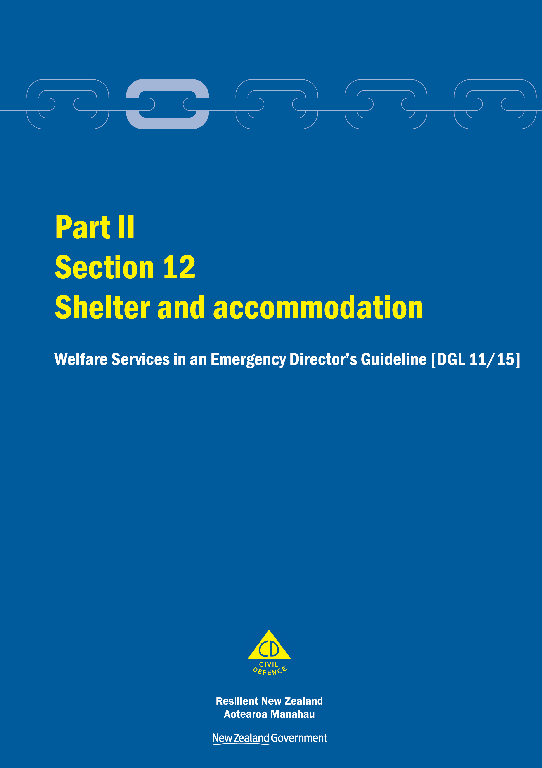
Welfare Services in an Emergency
Director’s Guideline for CDEM Groups and agencies with responsibilities for welfare services in an emergency [DGL 11/15]

October 2015
ISBN 978-0-478-43513-9
Published by the Ministry of Civil Defence & Emergency Management

Authority
This guideline has been issued by the Director of the Ministry of Civil Defence & Emergency Management pursuant to s9(3) of the Civil Defence Emergency Management (CDEM) Act 2002. It provides assistance to CDEM Groups and agencies with responsibilities for welfare services in an emergency to understand and work towards the welfare roles, structures, and responsibilities described in the National Civil Defence Emergency Management Plan 2015.

This document is not copyright and may be reproduced with acknowledgement. It is available, along with further information about the Ministry, on the MCDEM website www.civildefence.govt.nz.

Ministry of Civil Defence & Emergency Management
PO Box 5010
Wellington 6145
New Zealand
Tel: +64 4 817 8555
Fax: +64 4 817 8554
Email: emergency.management@dpmc.govt.nz
Website: www.civildefence.govt.nz

Contents
Section 12 Shelter and accommodation 1
12.1 Introduction 1
12.1.1 Categories 1
12.1.2 Agencies responsible 2
12.1.3 Roles and responsibilities of agencies responsible 2
12.1.4 Support agencies 5
12.1.5 Roles and responsibilities of support agencies 6
12.2 Principles 7
12.3 Shelter and accommodation options 8
12.3.1 Sheltering people in place in their home 9
12.3.2 Displaced people 9
12.3.3 Support to displaced people, or people sheltering in place 11
12.4 Reduction 11
12.5 Readiness 12
12.5.1 Clarifying and building relationships 12
12.5.2 Collaborative planning considerations 13
12.5.3 Identifying possible shelter and accommodation facilities 14
12.6 Response 15
12.6.1 Confirming pre-identified facilities are safe 16
12.6.2 Record keeping 17
12.6.3 Companion animals 17
12.7 Recovery 18
12.7.1 Transition to temporary accommodation 18
12.7.2 Returning home or moving to new residence 18
Appendix A Information applicable to all welfare services 19

Shelter and accommodation
This section should be read in conjunction with the other parts and sections in the Welfare Services in an Emergency Director’s Guideline [DGL 11/15].

Introduction
The provision of shelter and accommodation is for people who have to leave their homes as a result of an emergency (displaced people).
Sheltering in place (remaining in usual place of residence or home), when possible and safe to do so, is best practice, and the preferred option when providing this welfare service.
People affected by an emergency should only be sheltered or accommodated elsewhere when it is impractical or unsafe for them to remain in their own home.

Categories
The shelter and accommodation sub-function is divided into the following categories:
- shelter
- emergency accommodation, and
- temporary accommodation.
Shelter | Shelter is provided, usually in a communal facility – possibly but not necessarily a pre-designated Civil Defence Centre (CDC) – for a few hours to only a few days, to protect displaced people from the elements and danger (some basic welfare services may be provided at this facility).
Emergency accommodation | Emergency accommodation is provided to displaced people who cannot return to their homes for short periods, generally a few days and no more than about two weeks.
Temporary accommodation | Temporary accommodation is provided to displaced people who cannot return to their homes for a prolonged period (generally several weeks, months, or possibly, years).
Timing | Shelter and emergency accommodation address the more immediate needs of people affected by the emergency. Temporary accommodation addresses ongoing need, and may not be required at all, or until the later part of response. Temporary accommodation may continue into recovery.

Agencies responsible
 | MCDEM and the Ministry of Business, Innovation and Employment (MBIE) co-lead the shelter and accommodation sub-function.
Shelter and emergency accommodation | At the national level, MCDEM is the agency responsible agency for providing advice and coordinating the provision of shelter and emergency accommodation.  CDEM Groups (including local authorities) are responsible for planning and coordinating the provision of shelter and emergency accommodation at the CDEM Group or local level. CDEM Groups/local authorities are to:  - assess, within their area, the need for shelter and emergency accommodation for displaced people, including displaced people from another region  - coordinate the provision of shelter and emergency accommodation within their area for displaced people, including displaced people from another region, and  - provide MBIE with advice, information and access to council- controlled temporary accommodation facility options.
Temporary accommodation | MBIE is the agency responsible for the coordination of the provision of temporary accommodation, in particular:  - planning in advance for service delivery and technical support systems  - gathering and analysing information promptly to ascertain the likely level of temporary accommodation demand, and the most appropriate supply options for the affected populations, and  - encouraging operational partnerships at both national and CDEM Group level for successful implementation of temporary accommodation plans.

Roles and responsibilities of agencies responsible
The agencies responsible for the shelter and accommodation sub-function (MCDEM, CDEM Groups, and MBIE) have numerous roles and responsibilities across the 4Rs.

MCDEM’s responsibilities | MCDEM’s principal role is to provide advice and coordinate the provision of shelter and emergency accommodation at the national level. To achieve this, MCDEM will:  - establish an adaptable and scalable plan that is ready to activate that describes what MCDEM will do to meet its obligation  - determine in the plan where accountabilities will reside within MCDEM’s organisation structure, and who the key personnel will be to approve, deliver, and operationalise the plan  - ensure (through collaborative planning and relationship development) that all agencies understand their roles and responsibilities and the interdependencies with other welfare services sub-functions, enabling cohesive service delivery, and  - ensure there is a pre-prepared communications strategy that explains the support the agency provides.
CDEM Group responsibilities | The principle role of CDEM Groups is to provide advice and coordinate the provision of shelter and emergency accommodation at the CDEM Group level. To achieve this, CDEM Groups will:  - establish an adaptable and scalable plan that is ready to activate that describes what the CDEM Group will do to meet its obligation  - determine in the plan where accountabilities will reside within the CDEM Group organisation structure, and who the key personnel will be to approve, deliver, and operationalise the plan  - develop relationships with agencies with responsibilities in the National CDEM Plan 2015, which will allow pre-emergency collaborative planning and forward thinking partnership development so that prescribed roles are coordinated and delivered in a cohesive manner  - develop shelter and emergency accommodation solutions suitable for deployment under varying scales of an emergencies, during an emergency suitable to the region’s geography  - understand the hazards and risks specific to the region that might displace people, and  - establish a communication strategy to enable preparation of advice, information, and education collateral for displaced people and key stakeholders.  Note: Some costs associated with shelter and emergency accommodation are likely to be recoverable under the reimbursement process for response costs.  Costs for the care of displaced people may be recoverable by local authorities. Refer to the National CDEM Plan 2015 and the Logistics in CDEM Director’s Guideline for CDEM Groups [DGL 17/15] regarding the reimbursement process and a description of appropriate costs.
MBIE’s responsibilities | MBIE’s principal role is to coordinate the provision of temporary accommodation at both the national and CDEM Group levels. To achieve this, MBIE will:  - establish a plan that is ready to activate and that describes what MBIE will do to meet its obligation  - ensure the plan takes account of key legislation  - determine in the plan where accountabilities will reside within the MBIE organisation structure, and who the key personnel will be to approve, deliver, and operationalise the plan  - establish a communication strategy in conjunction with MCDEM to enable preparation of advice, information and education collateral for displaced people and key stakeholders  - establish what enterprise technology is required to manage displaced household data and, effectively case manage, track, and report on displaced household status’ between arrival into the service and outcomes into temporary accommodation  - develop temporary accommodation solutions suitable for deployment in varying scales of emergency, and in different geographical locations  - ensure the plan is adaptable and scalable  - establish a process that describes how MBIE will secure funding to allow the plan to be activated should an emergency require it  - understand the hazards and risks identified by CDEM Groups that might displace people in their regions  - understand population demographics and the differences between regions  - understand temporary accommodation best practice taking examples from on and off shore  - develop relationships with agencies with responsibilities in the National CDEM Plan 2015, which will allow pre-emergency collaborative planning and forward thinking partnership development so that prescribed roles are coordinated and delivered in a cohesive manner  - work closely with the Ministry of Social Development (MSD) who provide the assessment service which will enable fast, accurate, secure dissemination of displaced persons data between agencies, and  - agree with the MSD on what data MBIE requires for collation  - establish a clear activation and termination strategy for the contingency plan.

Support agencies
Table 1 lists the agencies who support the shelter and accommodation sub-function, and the kinds of support they provide.
Table 1 Support agencies for the shelter and accommodation sub-function
Agency | Support
CDEM Groups | See previous section.
Local authorities | To provide access to buildings, land and other infrastructure and/or expediting regulatory approvals to ensure timely delivery of temporary accommodation solutions.  To deliver shelter and emergency accommodation services.
Housing New Zealand Corporation | To provide MBIE with advice, information and access to Housing New Zealand Corporation temporary accommodation options (buildings and landholdings).
Ministry of Education | To link CDEM Groups/local authorities to appropriate school boards of trustees for advice, information and access to shelter or emergency accommodation options (buildings and landholdings).
Ministry of Health | To link CDEM Groups or MBIE or both to DHBs (through the Public Health Units) for advice and information to manage any environmental health or communicable disease risks to public health associated with shelter, emergency accommodation, and temporary accommodation facilities.
Ministry of Social Development | To determine eligibility for temporary accommodation for displaced persons.
New Zealand Defence Force | To provide MCDEM, CDEM Groups, local authorities, and MBIE with advice, information and access to shelter, emergency accommodation and temporary accommodation options (buildings and landholdings) in accordance with section 9 of the Defence Act 1990.
Te Puni Kōkiri | National and regional offices to provide:  - advice and assistance to CDEM Groups/local authorities to link to marae that can assist with shelter and emergency accommodation and manaakitanga (care and support)  - advice to the Ministry of Social Development so that appropriate assessments of needs are undertaken for temporary accommodation for displaced Māori  - advice to MBIE so that appropriate matching and placement case management for temporary accommodation for displaced Māori are undertaken, and  - advice and assist MBIE to link with marae and appropriate marae trustees for advice, information and access to marae temporary accommodation options (buildings and landholdings).
The Salvation Army | To provide CDEM Groups/local authorities with advice, information and access to Salvation Army shelter and emergency accommodation, and to support displaced people living in shelter or emergency accommodation.
Commercial providers | Providing temporary accommodation solutions, e.g. hotel/motel operators, building and construction, and property management services

Agency | Support
Community-based organisations | Assisting with the provision of pastoral care and recovery support services for displaced people seeking or occupying temporary accommodation.

Further support | Support may also be provided by any other government agency or non-government or community-based organisation or business that can provide relevant advice, information, or services.

Roles and responsibilities of support agencies
All agencies that support this sub-function should:
- establish a plan that is ready to activate that describes the actions required to meet the agency’s obligations under the National CDEM Plan 2015
- determine in the plan where accountabilities will reside within the agency organisation structure and who the key personnel will be to approve, deliver and operationalise the plan
- ensure the plan is adaptable and scalable
- develop relationships with agencies with responsibilities in the National CDEM Plan 2015, which will allow pre-emergency collaborative planning and forward thinking partnership development so that prescribed roles are coordinated and delivered in a cohesive manner
- ensure the integrated public information management plan established by the lead agency is followed, and
- ensure funding is available to allow the plan to be activated.

Shelter and accommodation subgroup | MCDEM and MBIE will establish and co-convene a subgroup with membership including all support agencies for the Shelter and accommodation sub-function.  The subgroup will convene regularly to plan and undertake other readiness tasks including training, exercising, and monitoring and reviewing.  Collaborative planning and forward thinking partnership development between agencies will enable prescribed roles to be understood, and ensure a state of readiness and coordinated and cohesive response and recovery.  Similar arrangements may be made at the CDEM Group and local levels.

Principles
The effectiveness of emergency sheltering operations is contingent on realistic pre-emergency planning that involves evaluating community sheltering needs, facilities and resources, as well as capacity development, based on emergency management guidance. Proper planning should also take account of the diverse needs of members of the community based on their age, gender, religion, ethnicity and other factors, including the needs of people with disabilities.
The following principles should be followed when planning for and providing shelter and accommodation:
- Maintain family and community connections, including:
  - keeping families together
  - keeping communities together (where possible)
  - accommodating people as close as possible to their home/community
  - develop measures to avoid moving people numerous times.
- Consider the needs of displaced people beyond shelter, emergency accommodation or temporary accommodation. Referrals to support agencies should be expected. Support mechanisms may include:
  - school/early childhood education centre/play centre/kindergarten
  - healthcare and advice – doctor/dentist
  - animal welfare
  - Plunket/parent groups
  - sport/exercise/interest groups
  - place of worship/faith-based networks
  - cultural groups
  - seeking financial assistance.
- Consider the varying degrees of vulnerability (for example interpreters may be needed to assist with language difficulties) of displaced people.
- Avoid moving displaced people multiple times. Where possible, move people directly into permanent housing.
- Ensure that all shelter and accommodation is safe, secure, and as accessible as possible.
Human rights and minimum standards | All shelter and accommodation solutions for displaced people are required to meet New Zealand’s national and international human rights commitments. They and are also recommended to meet The Sphere Project minimum standards (see section 12.5.2 Collaborative planning considerations on page 13 for more information).

Shelter and accommodation options
People affected by emergencies may:
- be able to shelter in place, e.g. in their homes or workplaces or other locations, such as hotels (if they are visitors to the area), or
- be displaced.
Note that sheltering people in place is best practice. Whether sheltering in place or displaced, people may:
- support themselves, or draw on the support of communities, or
- require support from agencies.
Figure 1 shows some of the options affected people may take, resulting in either displacement or sheltering in place.
Note: Pathways may not be linear and will depend on the circumstances of the emergency.
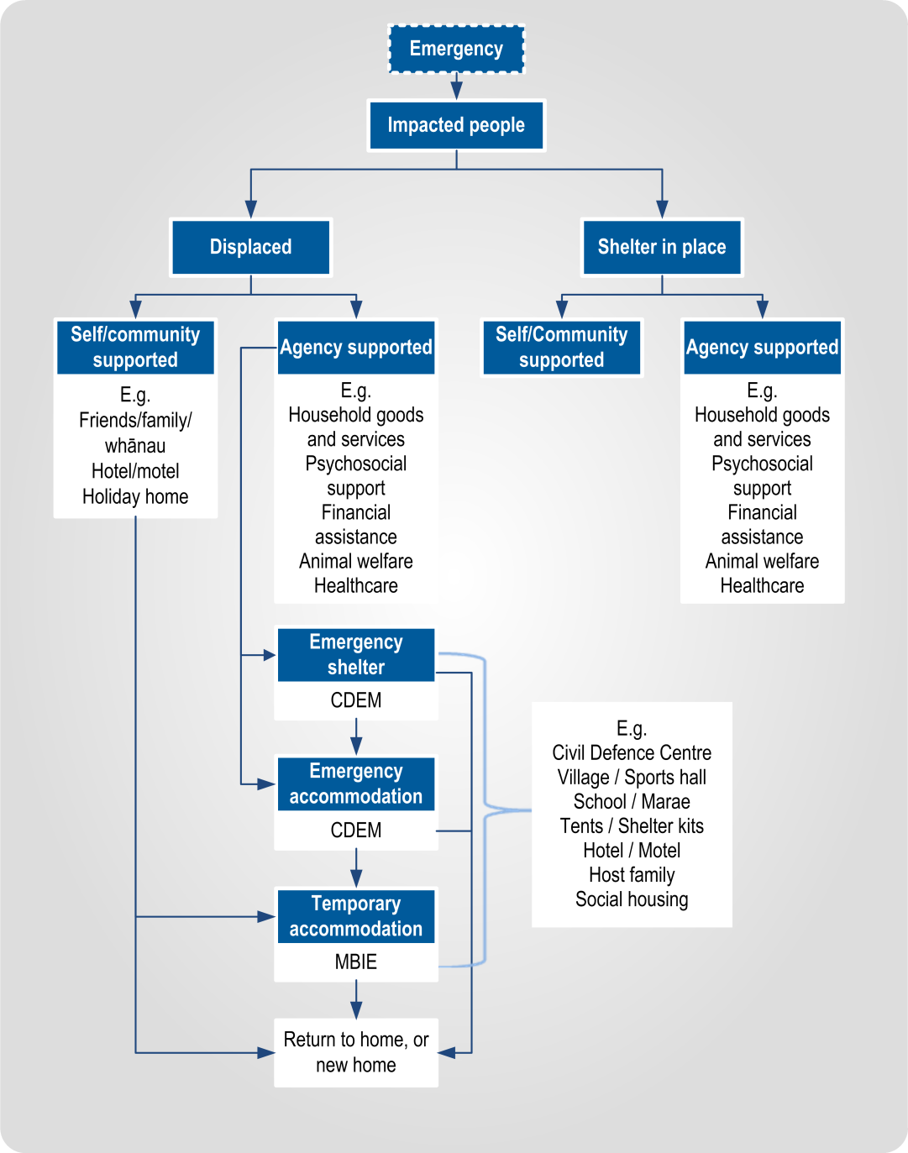
Figure 1 Shelter and accommodation options

Sheltering people in place in their home
People affected by an emergency may choose to (or may be required to) shelter in place in their own homes following an emergency.
People may shelter in place with or without the support of the community, or with agency support if welfare services are required.
Pandemic | People may be required to shelter in place in their homes during a pandemic. Welfare provision in a pandemic will follow the same guidelines as for any other response and involves supporting people sheltering in place. Refer to the following documents more information:  - Ministry of Health document: NZ Influenza Pandemic Action Plan – Information for CDEM Groups (available at www.health.govt.nz – search for ‘influenza pandemic plan’)  - MCDEM document: Administrative arrangements for welfare support during an influenza pandemic (April 2010) (available at www.civildefence.govt.nz).

Displaced people
The nature of the emergency may lead people to self-evacuate, or people may be ordered to evacuate their location. Both situations will result in people becoming ‘displaced’.
People who have been displaced will need to access emergency shelter. Some will transition into emergency accommodation, and possibly temporary accommodation. See section 12.7.1 Transition to temporary accommodation on page 18 for more information.

Location | People may become displaced from any number of locations in an emergency, depending on their activity at the time. These locations may include their home, place of work, vehicle (if travelling), or a hotel/holiday accommodation.

Emergency shelter
An emergency shelter is a place of safety for displaced people. This is a very short-term situation where a displaced person may be located for a few hours (e.g. to shelter safely from a nearby chemical spill or fire) but not longer than a few days.
A CDC may provide emergency shelter. Emergency shelter may also be set up at:
- village, sports or church hall
- community centre
- school
- marae
- club rooms, or
- any facility run by the community.
People may transition from emergency shelter to emergency accommodation.

Emergency accommodation
Emergency accommodation is where displaced people may be accommodated for a short period of time during an emergency. Emergency accommodation should be provided for only a few days, to about two weeks. Emergency accommodation may include:
- tents or shelter kits
- marae
- commercial accommodation (hotel or motel)
- campground cabins
- host family
- social housing, and
- educational facilities (hostels, etc).

Temporary accommodation
People may transition from emergency accommodation to temporary accommodation.
Temporary accommodation is where displaced people are accommodated for a prolonged period of time. Temporary accommodation could involve the use of existing accommodation options not impacted by the emergency, relocatable accommodation, or built solutions.

Support to displaced people, or people sheltering in place
People affected by an emergency, whether displaced or sheltering in place, should be encouraged to register and have their needs assessed so they can receive the support they need. This support may include:
- psychosocial support
- household goods and services
- financial assistance, and
- animal welfare.
Refer to the relevant sections of Part II of the Welfare Services in an Emergency Director’s Guideline (available at www.civildefence.govt.nz).

Logistics | Procurement and transport and may be required to deliver this support/these services. The Logistics function will assist with this.  Refer to the Logistics in CDEM Director’s Guideline for CDEM Groups [DGL 17/15] for more information on procurement and transport. This is available at www.civildefence.govt.nz (search for ‘logistics in CDEM DGL’).
Evacuation | See the Mass Evacuation Planning Director’s Guideline for CDEM Groups [DGL 07/08] for more information about the decision to shelter in place or evacuate. This is available at www.civildefence.govt.nz (search for ‘mass evacuation planning’).

Reduction
In the shelter and accommodation context, reduction describes measures taken to reduce the chance of people being displaced from residences, and requiring emergency shelter or accommodation.
Reduction is made possible through understanding of natural hazards and their consequences as part of the risk management process.

Consequences that include potential displacement of people | Hazard and risk assessments should identify consequences of hazards in CDEM Group areas that need to be managed. Where these consequences include the potential displacement of people affected by an emergency, a good understanding should be available of the:  - nature of the hazard that may cause people to be displaced and the implications of the hazard on site selection for sheltering/accommodating the affected community  - locations/areas from where people are likely to be displaced and nearby potential shelter/accommodation facilities  - numbers of people likely to be affected by an emergency  - demographics of the population and any likely requirements regarding shelter/accommodation, and  - high risk facilities located in the area that are likely to be affected by an emergency (e.g. rest homes, hospitals, schools, prisons).
Considering measures to reduce risk | Once risk assessment has been undertaken to determine potential shelter and accommodation needs, the potential for measures to reduce risks can then be considered.

Readiness
The MCDEM and CDEM Group/local authority shelter and emergency accommodation responsibility is essentially a response function, while the MBIE temporary accommodation responsibility is essentially a recovery function.
Regardless, MCDEM, CDEM Groups/local authorities, and MBIE are required to maintain a state of readiness through effective relationships, and regular testing and review of their plans. Effective implementation of their plans will help to reduce the consequences of emergencies on displaced people by supporting focused, timely, and expedited response and recovery.

Clarifying and building relationships
MBIE representation at regional and local level | Relationships with key operational personnel at the national, regional, or local level will need to be established and maintained. Regularity of contact is important for preparedness, and includes:  - participation, as appropriate, in the activities of the National Welfare Coordination Group (NWCG) or Welfare Coordination Group (WCG),  - organising and running exercises with key support agencies to test aspects of their plans and reviewing and updating plans in light of exercise outcomes, and  - the use of electronic communication methods (e.g. telephone, email, video and telephone conferencing) for remote representation.
Maintaining key contacts | MCDEM, CDEM Groups/local authorities, and MBIE are required to maintain up-to-date lists of key contacts at the national, CDEM Group, and local levels and provide information about their plans on a regular basis – either through written communications, attending meetings and/or participation in CDEM exercise activities.
Collaborative decision making and agreement | MCDEM, CDEM Groups/local authorities, and MBIE are expected to assist with:  - decision-making around which shelter, emergency accommodation, and temporary accommodation options are best in each CDEM Group area  - identifying available and suitable land and buildings to be used for shelter, emergency accommodation and temporary accommodation  - adopting or adapting bylaws or rules to facilitate shelter, emergency accommodation and temporary accommodation provision, and  - ensuring the availability of local services for residents throughout their stays in shelter, emergency accommodation and temporary accommodation.

Collaborative planning considerations
All CDEM Group and local welfare plans (or documented arrangements) should include planning for emergency shelter and emergency accommodation. Plans must include considerations for:
- the visitor sector/tourists; at the national level the MBIE-chaired Visitor Sector Emergency Advisory Group may be able to advise
- understand vulnerabilities and contingencies in place for times when region’s accommodation may be at capacity (e.g. concerts and sporting events), and
- working with marae; CDEM Groups and local authorities should build relationships and work with local marae.

Planning for displaced people | Planning must also address the complex needs of displaced people and connect to a broad range of community based services. The following considerations are examples of planning requirements and should be read in addition to the shelter and accommodation principles:  - nature and magnitude of the emergency (scale of impact on built residential environment)  - number of people affected, displaced or sheltering in place  - community or regional characteristics  - complexity of individual and household needs, including specific requirements (e.g. people with disabilities, and culturally and linguistically diverse community members)  - registration of affected people requiring emergency accommodation  - probable duration of displacement  - availability and functionality (e.g. lifeline utility services) of shelter/emergency accommodation facilities  - use of commercial or non-commercial facilities, large scale accommodation versus family unit accommodation  - shelter and accommodation options for companion animals, and other animal welfare needs  - distance of displacement from usual place of residence/community e.g. to another district/region  - integration with and access to other welfare services  - public information including the location of operating CDCs and/or access to other welfare services, and  - transport.
Interdependencies with other welfare services | Interdependencies with all other welfare services sub-functions need to be considered in planning.

Identifying possible shelter and accommodation facilities
CDEM Groups/local authorities can work with MBIE to identify the types of facilities in a community that might be suitable for shelter and accommodation.
An assessment of identified facilities will determine suitability for shelter, emergency accommodation or temporary accommodation.
Some facilities may also be identified as suitable for designated CDCs.

Other agencies’ facilities | School boards of trustees, the NZ Defence Force, Te Puni Kōkiri, and The Salvation Army may be able to advise on the availability of their buildings and landholdings, and to make connections with local marae.
Environmental health | CDEM Groups/local authorities and MBIE should work with DHBs (via their Public Health Units) to assess potential facilities regarding any environmental or public health issues.
More information | Refer to Part I Appendix G Civil Defence Centre toolkit of the Welfare Services in an Emergency Director’s Guideline for checklists, considerations, and other information that applies to identifying possible shelter and accommodation facilities.  This toolkit is available at www.civildefence.govt.nz.

Response
In response, shelter and emergency accommodation:
- are coordinated by the coordination centre (National Crisis Management Centre (NCMC), Emergency Coordination Centre (ECC), or Emergency Operations Centre (EOC)) Welfare function, and
- are delivered by CDEM Groups/local authorities at the local level.
Temporary accommodation:
- is coordinated by MBIE at the national level (as required) and may include a deployed temporary accommodation team in the coordination centre, who may be deployed to a CDEM Group area as required, and
- is delivered (under the direction of MBIE) at the local level.

Integration | The extent of the services provided at shelters or emergency accommodation should be planned and integrated by the coordination centre Welfare function, and resourced accordingly.  Refer to Part II Section 7 Needs assessment of the Welfare Services in an Emergency Director’s Guideline, available at www.civildefence.govt.nz.
Activation | The need for shelter and emergency accommodation services may be determined by the needs assessment process, identified by community members or community based organisations, or when evacuation is required.  The decision to activate a shelter and emergency accommodation facility is made by the National Controller, CDEM Group Controller, or Local Controller, upon the advice of the Welfare Manager (at all levels).  Once the relevant Controller authorises the sub-function’s activation, the Welfare Manager (at all levels as appropriate) is to inform MBIE (and all agencies that support the shelter and accommodation sub-function):  - if the sub-function is likely to be activated (standby)  - when the sub-function is activated (confirmation).  The Welfare Manager should continue to liaise with MBIE who will advise on accommodation options.  Note: This should be included in the welfare component of the Action Plan.
Community response | Another avenue of shelter and accommodation activation could be via a decision by local CDEM contacts in a community, where local response plans state that in the absence of any means to contact the CDEM Group or local authority, the community response may set up a centre to receive evacuated persons from within that community.

Confirming pre-identified facilities are safe
If establishing emergency shelters or accommodation is required, pre-identified facilities must be assessed and deemed safe and habitable before they are used.
Refer to Part I Appendix G Civil Defence Centre toolkit of the Welfare Services in an Emergency Director’s Guideline for checklists, considerations, and other information that may be used to perform a safety and suitability check on shelter and accommodation facilities during response.
This toolkit is available at www.civildefence.govt.nz.

Commercial accommodation
If utilising commercial accommodation, ensure that contractual arrangements are in place with the property owner/operator and a clear understanding of inclusions, exclusions and other rules, for example:
- meals allowance
- toll calls (landline telephone)
- use of internet
- mini-bar (recommend to remove this from room), and
- property damage or theft.
Arranging commercial accommodation | Commercial accommodation arrangements should be made by the coordination centre Logistics function, using appropriate means of accountability such as purchase orders, quotes, and invoices.  MBIE may be able to advise and provide information on commercial accommodation options.  Commercial accommodation arrangements may be made:  - by investigating bed availability and making bookings directly with providers  - via a duty hotelier/motelier system, or  - via a travel agent/booking agent.  Block bookings for accommodation may be made by the Logistics function. Accommodation may then be allocated to affected people as needs are identified, e.g. by CDC staff.

Record keeping
Accurate accommodation records must be kept by any agency or organisation that is sheltering or accommodating displaced people. These records include:
- names of the people being accommodated
- address (usual place of residence)
- contact details
- duration of stay
- cost of any accommodation
- cost of any meals provided, and
- cost of any other services (e.g. landline phone calls).
These details should be recorded via the registration and needs assessment processes.
Accurate and detailed data will be required by any local authority in order to claim for reimbursement of costs.
Costs for the care of displaced people may be recoverable by local authorities. Refer to the National CDEM Plan 2015 and the Logistics in CDEM Director’s Guideline for CDEM Groups [DGL 17/15] regarding the reimbursement process and a description of appropriate costs.

Companion animals
Refer to Part II Section 14 Animal welfare of the Welfare Services in an Emergency Director’s Guideline (available at www.civildefence.govt.nz) for more information on the management of companion animals, including Disability Assist Dogs at shelters and emergency accommodation.

Recovery
Recovery involves the longer term provision of accommodation services to people who have been displaced by an emergency; i.e. temporary accommodation.

Transition to temporary accommodation
In the same way that people may need to move from shelter to emergency accommodation, there may be a requirement for affected people to transition from emergency accommodation to temporary accommodation.
This transition is managed by the coordination centre Welfare function, in conjunction with MBIE (the agency responsible for the coordination of the provision of temporary accommodation).
During response, engagement between the agencies responsible for the shelter and accommodation sub-function (and support agencies) is required to enable early and effective transition planning. In addition, collaborative planning for transition stems from pre-emergency relationship development outlined in sections 12.1.3 on page 2, and 12.1.4 on page 5.
During recovery, key operational personnel from MBIE liaise with either MCDEM or the CDEM Group/local authority contacts and support agencies (or vice versa) in finalising the transition from emergency accommodation to temporary accommodation.

Returning home or moving to new residence
When an emergency has passed and if safe to do so, temporarily displaced people may be able to return home. Conversely, if their home is assessed to be permanently unliveable, then they may move to a new place of residence.
Before people return to their home, ensure:
- their home and the surrounding area are safe and accessible
- the journey is safe
- lifeline utility services are functioning or alternatives are provided (see to Part II Section 14 Household goods and services of the Welfare Services in an Emergency Director’s Guideline, available at www.civildefence.govt.nz), and
- follow up via the needs assessment sub-function is arranged (ongoing needs are documented and monitored and the relevant agencies are engaged to provide services as required).
Transport may be arranged via the coordination centre Logistics function if required.

Information applicable to all welfare services
This section provides overarching information applicable to all welfare services.

Welfare services agency representation
Some government agencies responsible for the coordination of the welfare services sub-functions do not have a presence in all communities.
Where agencies are not represented at the regional or local level, those agencies need to identify how they will fulfil their responsibilities. This may include:
- identifying alternative agencies or organisations to coordinate or support the delivery of the welfare services sub-function, or
- deploying personnel into the region or local area.
Agencies should work with the CDEM Group/local authority to identify alternative agencies/organisations present in the local community. These organisations may be non-government, community-based, or voluntary.
See the National CDEM Plan 2015, the Guide to the National CDEM Plan 2015, and the sections in Part II Welfare services of this guideline for details of the agencies responsible for, and who support the welfare services sub-functions.

Human rights
New Zealand’s human rights commitments | The provision of welfare services to people affected by an emergency, either via a CDC or in a community setting, must contribute to ensuring that New Zealand meets its national and international human rights commitments.  See the Human Rights Commission website www.hrc.co.nz under the ‘Your rights’ tab for more information.
Age, people with disabilities, and people from CALD communities | Consideration must be given to providing access to welfare services to people of any age, people with disabilities, and people from culturally and linguistically diverse (CALD) communities. For example, people with disabilities require welfare services to be delivered in a disability-inclusive way, and will work with CDEM to achieve this. CALD community members often have specific requirements around social interaction, food, prayer, or gender which must be considered when planning for the delivery of welfare services.
More information | For more information and a list of relevant statutory documents, refer to the MCDEM publications:  - Including people with disabilities: Information for the CDEM Sector [IS 13/13]  - Including culturally and linguistically diverse (CALD) communities: Information for the CDEM Sector [IS12/13].  Along with the resources listed above, see Part I of the Welfare Services in an Emergency Director’s Guideline [DGL 1/15] (Appendix H Accessibility).  These are available at www.civildefence.govt.nz (search for the document name).

Working with communities
An inclusive approach | An emergency can be a stressful and emotional experience, which may impact or compound any existing difficulties or issues that people are facing. At the local and regional levels, consideration must be given to vulnerable and hard to reach communities, acknowledging that they may have:  - specific challenges to address  - skills and strengths that may contribute to welfare services delivery.
Considerations | Consider when planning:  - age  - gender  - children and young people  - people living alone  - elderly  - health and disability issues  - mental health and general health issues  - drug or alcohol dependency  - cultural requirements  - ethnicity and language  - socio-economic status  - people with companion animals  - isolation, and  - people with unreliable or no internet access or mobile phone coverage.
Utilising community networks | Opportunities should be taken wherever possible to build links with existing community networks. These networks should be utilised to reach people requiring support in an emergency, with resulting arrangements formalised in local plans.
Culturally and linguistically diverse (CALD) communities | CALD communities have many strengths, including skills, experience, and language capabilities.  CALD community networks are often well developed, with strong connections both within their own community and between communities. Partnering with CALD community leaders can enable appropriate and effective engagement and communication with community members.
People with disabilities | Working with people with disabilities and their wider networks of family/whānau, friends, and supporters provides an opportunity to gain an understanding of both the requirements and strengths of these members of the community.  People with disabilities and disabled people’s organisations provide expertise on the impact of disability. Disability service providers have technical and professional expertise, and may also have resources that can be drawn upon in an emergency.

Minimum standards in the Sphere Handbook
CDEM Groups/local authorities should take The Sphere Handbook: Humanitarian Charter and Minimum Standards in Humanitarian Response into account when planning for, setting up, and delivering welfare services.
The Sphere Handbook is one of the most internationally recognised sets of common principles and universal minimum standards in life-saving areas of humanitarian response.
The Minimum Standards include recommendations in water supply, sanitation, hygiene promotion, food security and nutrition, shelter, settlement, and non-food Items.
The Sphere Handbook is available at www.spherehandbook.org.

Key considerations | Some of the key requirements (taken from the Sphere Handbook) to be considered when planning for people affected by an emergency are shown in Table 2.  Table 2 Key considerations for planning for people affected by an emergency  Rights Key requirements  Protection from Poor health, disease and wellbeing  Environment, weather, heat or cold  Violence, crime or abuse  Dangerous structures  Nutrition Clean drinking water  Food, baby food and pet food  Cooking facilities, utensils and fuel  Water and Sanitation, Hygiene (W.A.S.H) Clean water for washing  Waste water, solid waste  Hygiene, nappies, soap and disinfectant

Privacy, information sharing, and vetting
Information about welfare registrants, including personal information, will be shared with agencies contributing to the coordination and delivery of welfare services.
A privacy statement features as the first step in the registration process, and this must be understood and agreed to by all potential registrants. The privacy statement can be displayed by way of posters, hand-outs or on-screen if people are waiting to be registered (e.g. in a CDC).
Welfare registrars need to be trained in and must understand and abide by the provisions of the Privacy Act 1993. This Act controls how agencies collect, use, disclose and give access to personal information. Note that people have the right to request any information gathered about them under this Act.
See section 6 in Part 2 of the Privacy Act 1993 which features 12 Information privacy principles.
The Privacy Act 1993 is available at the New Zealand Legislation website: www.legislation.govt.nz or for more information refer to the Privacy Commissioner’s website: www.privacy.org.nz .

Civil Defence National Emergencies (Information Sharing) Code 2013 | The Civil Defence National Emergencies (Information Sharing) Code 2013 (the Information Sharing Code) is a regulation issued by the Privacy Commissioner, and applies to a state of national emergency only.  The Information Sharing Code provides agencies with the authority to collect, use, and disclose personal information relating to an individual, in relation to an emergency.  The Information Sharing Code applies as follows:  - To assist with the effective management of the response to a national emergency, this code applies in relation to any emergency in respect of which a state of national emergency is in force.  - To assist with the recovery from a national emergency, this code continues to apply in relation to such an emergency for a further 20 working days after the date on which a state of national emergency expires or is terminated.  Specific criteria apply to the Information Sharing Code. For full details, refer to the Civil Defence National Emergencies (Information Sharing) Code 2013 on the Privacy Commissioner’s website: www.privacy.org.nz.  As stated above, the Information Sharing Code applies only to a state of national emergency. The Privacy Act 1993 applies at all times including during and following any emergency.
Police Vetting Service | The New Zealand Police Vetting Service offers an online process for approved organisations to check the criminal records of potential or existing personnel, including volunteers.  Vetting requests cannot be made by individuals, and organisations must register in order to ask for Police vetting. To become an approved organisation, agencies must show that their personnel provide services or care for children, older people, people with special needs or other vulnerable members of society.  Vetting can only be carried out with the signed consent of the person being vetted. Organisations are expected to ensure the person being vetted is aware of the vetting process.  The standard turnaround time for completing a Police vetting process is 20 working days.  Police recommend that vetting of existing personnel including volunteers, is carried out on a regular basis, i.e. every two to three years.  An organisation must have information security procedures in place to protect the confidential information and any Police material they hold as a result of the vetting process.  More information about Police vetting is available at www.police.govt.nz.
Safety checking for the children’s workforce | The Vulnerable Children Act 2014 introduces new requirements for organisations funded by the government that employ people to work with children. Safety checking requirements are being phased in over several years.  Any agency working with children and young people must meet the approval obligations outlined in the Vulnerable Children Act 2014.  The Vulnerable Children Act 2014 is available at the New Zealand Legislation website: www.legislation.govt.nz or for more information refer to the Children’s Action Plan website: www.childrensactionplan.govt.nz.
Screening CDEM-trained volunteers | For information about screening processes for CDEM-trained volunteers, refer to the Volunteer Coordination in CDEM Director’s Guideline for CDEM Groups [DGL 15/13] available at www.civildefence.govt.nz (search for ‘volunteer coordination DGL’).

