Post | FB | Twitter | Graphics
Mon 31 Oct  World Tsunami Day | Saturday 5 November is World Tsunami Day. It’s a chance for us to prepare for, and learn more about, our tsunami risk  All of New Zealand’s coastline is at risk of tsunami. Know what to do and where to go. #TsunamiDay2016  www.happens.nz/types-of-emergencies/#tsunami | Saturday 5 November is World Tsunami Day.  All of New Zealand’s coastline is at risk of tsunami  #TsunamiDay2016 www.happens.nz/types-of-emergencies/#tsunami | 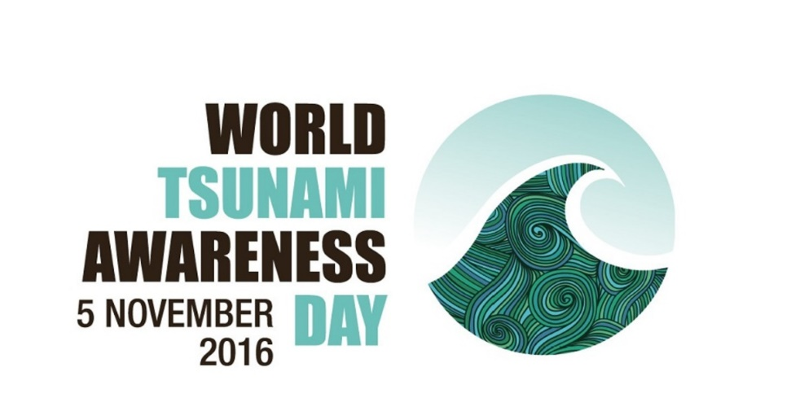
Tues 1 Nov | Saturday 5 November is World Tsunami Day. There are three ‘types’ of tsunami – local, regional and distant. In a local source tsunami we may only have a few minutes warning. Early warning saves lives. Know what to do and where to go. Share this post and help save lives. www.happens.nz/types-of-emergencies/#tsunami  www.happens.nz/types-of-emergencies/#tsunami | In a local source tsunami we may only have a few minutes warning. Know what to do and where to go. #TsunamiDay2016  www.happens.nz/types-of-emergencies/#tsunami | Social media image - Where do tsunami come from?  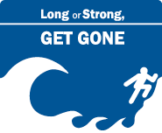
Weds 2 Nov | Saturday 5 November is World Tsunami Day.  All of New Zealand’s coast line is at risk of tsunami. A tsunami wave can grow to become a fast moving wall of water.  Know the natural warning signs.  www.happens.nz/types-of-emergencies/#tsunami | Early warning saves lives. Know what to do and where to go in a tsunami. Share this post and help save lives. #TsunamiDay2016 | 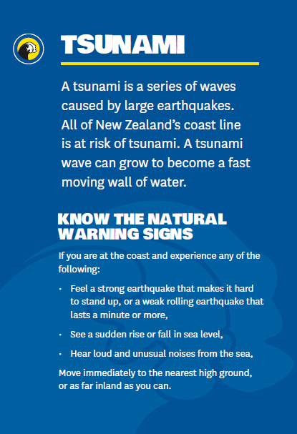
Thurs 3 Nov | Saturday 5 November is World Tsunami Day. Do you know how a tsunami wave is caused and why they do what they do?  www.happens.nz/types-of-emergencies/#tsunami | Tsunami – what’s the big deal? #TsunamiDay2016  www.happens.nz/types-of-emergencies/#tsunami | Social media image - what is a tsunami  Social media image - What’s the big deal?  Social media image - How a tsunami happens
Friday 4 Nov | Saturday 5 November is World Tsunami Day.  During a tsunami warning, some houses, streets and neighbourhoods may not be safe to stay in and you may  have to leave home in a hurry.  https://www.happens.nz/make-a-plan/ | If your street was evacuated where would you go?  #TsunamiDay2016  https://www.happens.nz/make-a-plan/ | 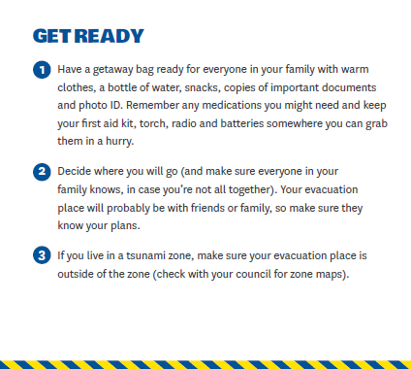
Saturday 5 Nov | Today is World Tsunami Day. All of NZ’s coastline is at risk from tsunami. Take some time today to make a plan with your family. If your street was evacuated where would you go? What would you take?  What about pets? Do you have neighbours who might need your help?  www.happens.nz | Today is World Tsunami Day. If your street was evacuated where would you go? What would you take?  What about pets? Do you have neighbours who might need your help?  #TsunamiDay2016 | 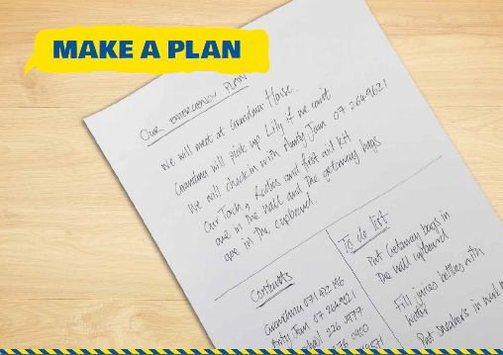
Saturday 5 Nov | Today is World Tsunami Day. In the last 200 years, there have been at least 3 tsunami that were more than 10 metres high at the NZ coast. Māori mythology also speaks of large tsunami. Some were caused by distant earthquakes some by underwater quakes not far off the coast. For the close ones, there’s very little warning before they arrive. Do you have a plan for if it happens? www.happens.nz/types-of-emergencies/#tsunami | In the last 200 years, there have been at least 3 #tsunami over 10 metres high at the NZ coast. What would you do? #TsunamiDay2016 www.happens.nz/types-of-emergencies/#tsunami | Social media image - It happens here….
Saturday 5 Nov | Today is World Tsunami Day. In a local source tsunami we may only have a few minutes warning. If you feel a long or strong earthquake, move immediately to higher ground or as far inland as you can. Early warning saves lives. Know what to do and where to go. Share this post and help save lives. www.happens.nz/types-of-emergencies/#tsunami | If you feel a long or strong earthquake, move immediately to higher ground or as far inland as you can #TsunamiDay2016  www.happens.nz/types-of-emergencies/#tsunami
Weds 2 Nov | Saturday 5 November is World Tsunami Day.  All of New Zealand’s coast line is at risk of tsunami.. Know what to do and where to go in a tsunami. Share this post and help save lives. #TsunamiDay2016  www.happens.nz/types-of-emergencies/#tsunami | Know what to do and where to go in a tsunami. Retweet save lives. #TsunamiDay2016
Sunday 6 Nov | All of NZ’s coastline is at risk from tsunami. Do you know what to do before, during and after a tsunami?  www.happens.nz/types-of-emergencies/#tsunami | Do you know what to do before, during and after a tsunami? #TsunamiDay2016  www.happens.nz/types-of-emergencies/#tsunami | Social media image - Tsunami survival before a tsunami  Social media image - Tsunami survival during a tsunami  Social media image - Tsunami survival after a tsunami
Types of tsunami warning natural | For a local source tsunami there may only be a few minutes warning? Luckily there are natural warning signs you can keep an eye out for. Unusual noises, a sudden rise or fall in see level or a long or strong earthquake could all be signs a tsunami is on its way. www.happens.nz/types-of-emergencies/#tsunami | For a local source tsunami there may only be a few minutes warning. #TsunamiDay2016 www.happens.nz/types-of-emergencies/#tsunami
Types of tsunami warning official | Tsunami warnings can come in different forms: from friends, civil defence and emergency management groups by text, sirens, radio, website, or from natural warning signs.  Contact your local council to find out about the warning systems in your area. www.happens.nz/types-of-emergencies/#tsunami | Tsunami warnings come in many forms – formal, informal and natural. #TsunamiDay2016 www.happens.nz/types-of-emergencies/#tsunami | Social media image - official tsunami warnings  Social media image - informal tsunami warnings

