Public Education Programme Strategy 2016-2019
Moving from “She’ll be right” to “We’re ready”

Contents
Introduction 3
Scope 3
Working together 4
Context 5
National CDEM Strategy 5
CDEM Group’s responsibilities under the CDEM Act 2002 5
Public education programme 2006-2016 6
Redeveloping our programme 7
Changing environments 7
Vulnerable audiences identified 7
Research and collaboration 7
Mission 8
Vision 8
Programme objectives 8
Approach 9
Change the way people think about preparedness 9
2016-19 Campaign 10
National campaign 10
Reactive advertising 10
Community-based education 10
Redeveloping our schools programme 10
Appendix 1 12
Public education implementation plan 2016/17 12
Redeveloped strategy and plan overview 13
Appendix 2 15
Summary of differences in 2006 and 2016 programmes 15

Introduction
Our previous public education programme was developed in 2006, and included television advertising, print advertising in the Yellow Pages and (initially) radio advertising, along with teaching resources for schools and additional materials to promote the campaign through other channels, including Civil Defence Emergency Management (CDEM) Groups.
While the programme was appropriate for the time, and proved effective at increasing preparedness among some groups, the campaign took a one-size-fits-all approach.
Our latest research shows that less than a third of the country is prepared for an emergency. Reasons range from complacency to lack of time or motivation and not expecting an event to happen. Our least prepared, and therefore most vulnerable, people are family with lower incomes, non-English speakers, new migrants and people aged between 18 and 30.
MCDEM has a statutory and moral responsibility to reach out to those people who are most at risk. We provide leadership, resources and support for 16 Civil Defence regional groups (CDEM Groups) to deliver public education in their regions, while delivering our own national campaign.
The partnership between the Ministry of Civil Defence & Emergency Management (MCDEM) and the wider CDEM sector is shown in the way the public education programme has been developed and implemented. It is based on the experience and agreed messages of the wider sector, and developed as an “umbrella” campaign allowing CDEM Groups to maximise the impact of their own, local, initiatives.
A public education implementation plan, which will be updated annually, is included as an appendix to this document to provide greater clarity on specific activities to be undertaken to implement the strategy.

Scope
Based on research findings and knowledge about the preparedness of different demographics MCDEM has identified as a priority reaching out to those people who are most at risk, the programme will seek to do this while also servicing existing levels of awareness among more well prepared audiences. A new campaign will reach those key audiences, and will link in with the established Get Ready Get Thru branding.
The Public Education Programme consists of:
- a national campaign targeted at priority audiences
- an implementation plan with supporting resources for CDEM groups to use in their public education activity
- a refresh of the national schools programme – What’s The Plan Stan?
- a community-based social marketing programme, which will seek to change specific behaviours
- additional actions by MCDEM and CDEM Groups to support or build on the programme.

Working together
The redeveloped national public education programme has been developed by MCDEM to meet commitments to Government, in consultation with public education representatives from CDEM Groups.
The success of the programme will be largely dependent on the commitment and actions of CDEM Groups, using their own public education programmes and networks to deliver the programme to their regions, and sharing the resources they develop with other Groups. MCDEM is committed to providing resources, assistance and advice to the Groups to help support their delivery of the programme.
The involvement of partner agencies, emergency services, lifeline utilities and other organisations will also be critical to the success of the programme.
Thank you to everyone who has contributed to the development of this framework. I look forward to working with you to move Kiwis from “She’ll be right” to “We’re ready”.

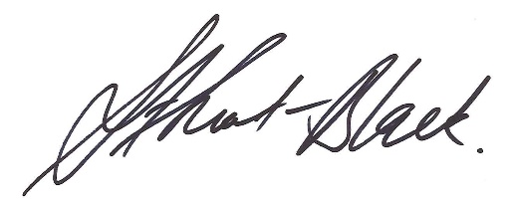
Sarah Stuart-Black
Director of Civil Defence
July 2016

Context
‘Sometimes it does us a power of good to remind ourselves that we live … where two tectonic plates meet, in a somewhat lonely stretch of windswept ocean just above the roaring forties. If you want drama – you’ve come to the right place,’ Sir Geoffrey Palmer.
Because of our location and environment, New Zealand faces many natural hazards. In some cases, such as a weather related or volcanic disaster, there may be time for a warning.
But an earthquake or a tsunami close to land could strike without warning. All hazards have the potential to cause disruption, damage property and take lives.

National CDEM Strategy
The strategic goals of the National CDEM Strategy are developed to enable an effective response to these hazards, and are supported by the Public Education programme. The goals of the National CDEM Strategy are:
- to increase community awareness, understanding, and participation in civil defence emergency management
- to reduce the risks from hazards to New Zealand
- to enhance New Zealand’s capability to manage emergencies
- to enhance New Zealand’s capability to recover from disasters.

CDEM Group’s responsibilities under the CDEM Act 2002
Section 17 of the Act establishes clear local responsibility for public education:
17 Functions of Civil Defence Emergency Management Groups
(1) The functions of a Civil Defence Emergency Management Group, and of each member, are to:
(a) in relation to relevant hazards and risks:
(ii)consult and communicate about risks:
(c) take all steps necessary on an ongoing basis to maintain and provide, or to arrange the provision of, or otherwise to make available … information, …for effective civil defence emergency management in its area:
(g) within its area, promote and raise public awareness of, and compliance with, this Act and legislative provisions relevant to the purpose of this Act:
(k) promote civil defence emergency management in its area that is consistent with the purpose of this Act.

Public education programme 2006-2016
In 2006 a national programme was developed. It was targeted at individuals and communities to improve awareness of New Zealand hazards, with the aim of converting that awareness to action to be better prepared. Initiatives included:
- The development of a long-term strategy for the National CDEM Public Education Programme to 2015 (The Way Forward).
- Targeted media campaigns reinforced by printed and online resources that provide detailed information on what to do
- The development of teaching resources for schools aimed at getting the message into homes through children at school (What’s the Plan Stan).
- The establishment of a website containing all agreed messages about individual and family preparation for disaster (translated into Te Reo Māori, simplified Chinese, traditional Chinese, Samoan, Hindi, Korean, Tongan and Arabic).
- Continued promotion through news media, events such as the annual Get Ready Week and other opportunities of the need to be aware of hazards and to prepare.

Redeveloping our programme

Changing environments
Our research shows that 97% of people believe it’s their responsibility to look after their family in a natural disaster and 98% believe it’s important to be prepared for a natural disaster, but only 14% are fully prepared for a natural disaster and only 47% have taken steps to prepare in last 12 months.
Since the 2006 programme was launched, there have been significant changes in the demographics and behaviours of New Zealanders, including an increase in migrants, and the way we communicate and receive information (increased use of social media, less engagement with television advertising).
Other complicating factors include a reduced level of ‘neighbourliness’, confusion about what assistance people will receive during and after a disaster, and language/cultural barriers.
MCDEM annual research continues to suggest that individuals and communities are not as prepared as they need to be to deal with, and recover from these disasters when they happen.

Vulnerable audiences identified
Our research has continued to identify the following groups as being least prepared and, therefore, most at risk:
- Families with lower incomes
- Millennials (18-30 year olds)
- New migrants
- Non-English speakers
Auckland residents are also less likely than average to be prepared, largely because the region includes a large percentage of the above groups.

Research and collaboration
In January 2016 we commissioned qualitative research to look at barriers and motivators for our most vulnerable audiences. This research, combined with our annual Colmar Brunton research, showed the main barriers for most people are:
- “It’s not going to happen to me”
  - Decrease in awareness of types of events (90% -82%) and their effect (87% 82%)
  - Recency of Canterbury quakes is diminishing
  - 1 in 4 don’t expect a disaster to happen (up from 18% - 25%)
  - Increase in people saying ‘preparing is not a priority’ (up from 3% - 13%)
- “Preparing feels too hard right now”
  - 97% believe it’s important but only 15% are fully prepared
  - 84% have emergency survival items at home, but only 26% have a comprehensive plan
  - Someone else will look after me - 77% say emergency services will help
  - 13% say they don’t have enough money to prepare
In February 2016 we met with public education representatives from across the Civil Defence groups and agreed that our redeveloped programme should empower people to take responsibility for their own preparedness and make preparedness part of everyday life. To do this, we need to change how we talk to people about being prepared.
Our research and collaboration work has included working closely with the sector and academics to ensure our approach is evidence-based, capturing the latest research and global best practice.

Mission
To empower Kiwis to take responsibility for their emergency preparedness

Vision
Emergency preparedness is part of everyday life.

Programme objectives
The following objectives will be used to measure the effectiveness of the redeveloped programme over the next three years
- More people are aware of why they need to be prepared
- More people understand how to prepare
- More people have taken steps to be more prepared.
- More people are fully prepared (have made plans, stored/checked and updated emergency supplies).

Approach
The redeveloped programme will take a staged, targeted, evidence-based approach, with resources developed and adapted to suit different channels, with a particular focus on reaching our most vulnerable audiences.
In the past we have focused on moving people from unawareness/apathetic awareness to total preparedness, resilience, self-responsibility and community responsibility. While this ‘one size fits all’ approach has worked for some people, we know that many New Zealanders are unaware of the need to prepare and are not motivated to take any steps to preparedness.
Our previous programme also focused on talking about the types of disasters likely to occur in New Zealand and providing prescriptive advice on the actions people need to take to get prepared.
Research indicates that advocating highly prescriptive preparation measures – such as extensive survival kits and detailed plans – can be counterproductive in improving preparation because it seems too onerous.
There is an assumption held by many New Zealanders, particularly in our target groups, that the impacts of major emergencies are unlikely to affect them. When advocating for preparation, focusing on specific disasters – such as earthquakes – can fuel complacency, as areas such as Auckland seldom experience such hazards, and reinforce fatalism (the belief that “there’s nothing I can do about it”).

Change the way people think about preparedness
Our approach will change the way people think about preparedness by:
- Reframing the conversation: Focusing more on impacts than hazards (e.g. no power, no water, no transport) and getting people to imagine themselves (and their families) in various situations. It is more effective to focus on specific impacts, such as power cuts and transport outages, as these are common across all significant emergencies, and are relatable for almost all people.
- Encouraging ownership: Getting people to think about what they need to do now to get their families through and prompting them to have conversations with their loved ones
- Making preparedness relevant and easy: Encouraging people to take small steps to be more prepared and protect the things they love, in a way that works for their family.
- Being positive and empowering: We will employ an approachable, positive and empowering approach, with greater use of humour and active engagement through channels such as social media.

2016-19 Campaign

National campaign
A national campaign, adopting a positive, slightly light-hearted tone, will make disaster preparation more approachable to those who have previously not warmed to the idea. An over-earnest or alarmist tone can make people feel disempowered or fatalistic, reducing the chances of them getting prepared. An authoritarian tone can reinforce the misconception that there is an army of people ready and able to help everyone.
The campaign will use social media paid promotion, and will capitalise on existing channels throughout councils, government agencies and other groups, without relying on television advertising (at this stage).

Reactive advertising
Event-specific messaging is still appropriate when advising what action to take during and after an event. Our Colmar Brunton survey results tell us that people are six times more likely to be prompted into preparedness by actual events (eg floods, earthquakes occurring) than by advertising alone. As such, our advertising is likely to be far more effective if it is closely linked to such events. Our campaign will therefore employ reactive advertising during and immediately after actual events – for example, advertising to accompany online news stories about floods, or through banner ads on social media sites.

Community-based education
While national resources can help to ‘start the conversation’ and act as a springboard for the campaign, more targeted, community-based interventions are likely to drive behaviour change and provide better value for money by enabling the adaption, targeting and distribution of resources at a local level, using targeted media and key influencers to spread the word.
Using the channels and networks that already exist within CDEM groups, other agencies and partners will be a key component in the success of the programme. This will require continued consultation and engagement to ensure that CDEM Groups and key stakeholders
- Are regularly kept informed of PEP developments, and contribute to these
- Are encouraged to develop and share new resources (Contestable fund?)
- Are updated on PEP progress and feedback (including research programme)
- Are involved in coordinated consistency of messaging and planned activity (national and regional)
- Work with MCDEM and other groups to create the level of individual and community preparation that is needed

Redeveloping our schools programme
What’s the Plan Stan?, our schools programme, is being redeveloped, in partnership with EQC. This involves revising the content and bringing it into line with the current curriculum, creating additional resources for years 1 to 3, and moving the content to an engaging, online platform. A “take home” resource will also be developed to ensure that the message being taught in schools is shared with families, using children as educators and channels for encouraging preparedness. The new resource will be launched during Get Ready Week, in October.

Appendix 1

Public education implementation plan 2016/17

The redeveloped public education programme will be rolled out using a staged approach over the three next three years. This will allow us to test the new campaign material and resources before we build on them.

The new programme will begin in July 2016 and will include a national campaign that makes preparedness real and relevant, including:
- Short online videos showing how simple it is to prepare for a range of different impacts.
- A campaign website that provides information about the major impacts of emergencies and how to prepare for them.
- Reactive advertising elements to be used during and immediately after actual events (eg banner ads on social media sites).
- Brand guidelines for new campaign identifier, with templates for posters, social media posts, video, etc.
- New preparedness booklet with plan.

The first six months of the campaign will focus on framing preparedness as inexpensive, quick, easy and something families can do together. Resources will include:
- A “voice of others” (VOO) media campaign, using influencers relevant to the target audience to generate conversation about awareness
- “Voice of experience” (VOE) resources, using people from the target audience who have experienced one or more of the impacts during an emergency, what it meant to them and what they do now as a result.
- Six months of impact-based resources for CDEM Groups, partners and other organisations to use, focusing on a different impact each month (see calendar below).
The second six month period will focus on producing relevant resources for millennials (18 to 30 year olds), with new migrants and non-English speakers being the focus for 2017/18.
Civil Defence Groups and other partner organisations will be encouraged to build on the campaign, following the brand guidelines, to develop their own resources. A contestable fund will be made available during the year for Groups who develop resources that fit the campaign and can be shared across the regions, in particular, developing the “Voice of Experience” resources.

Redeveloped strategy and plan overview
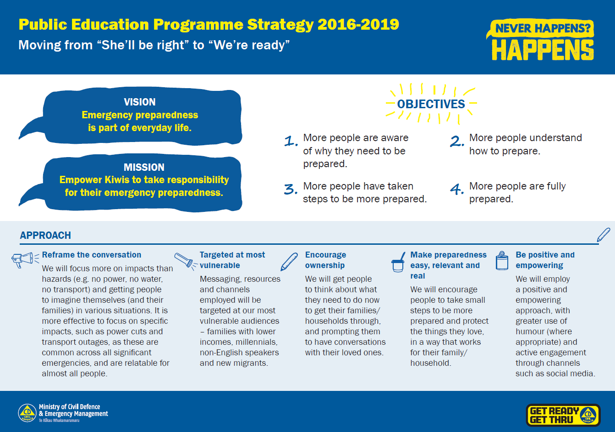
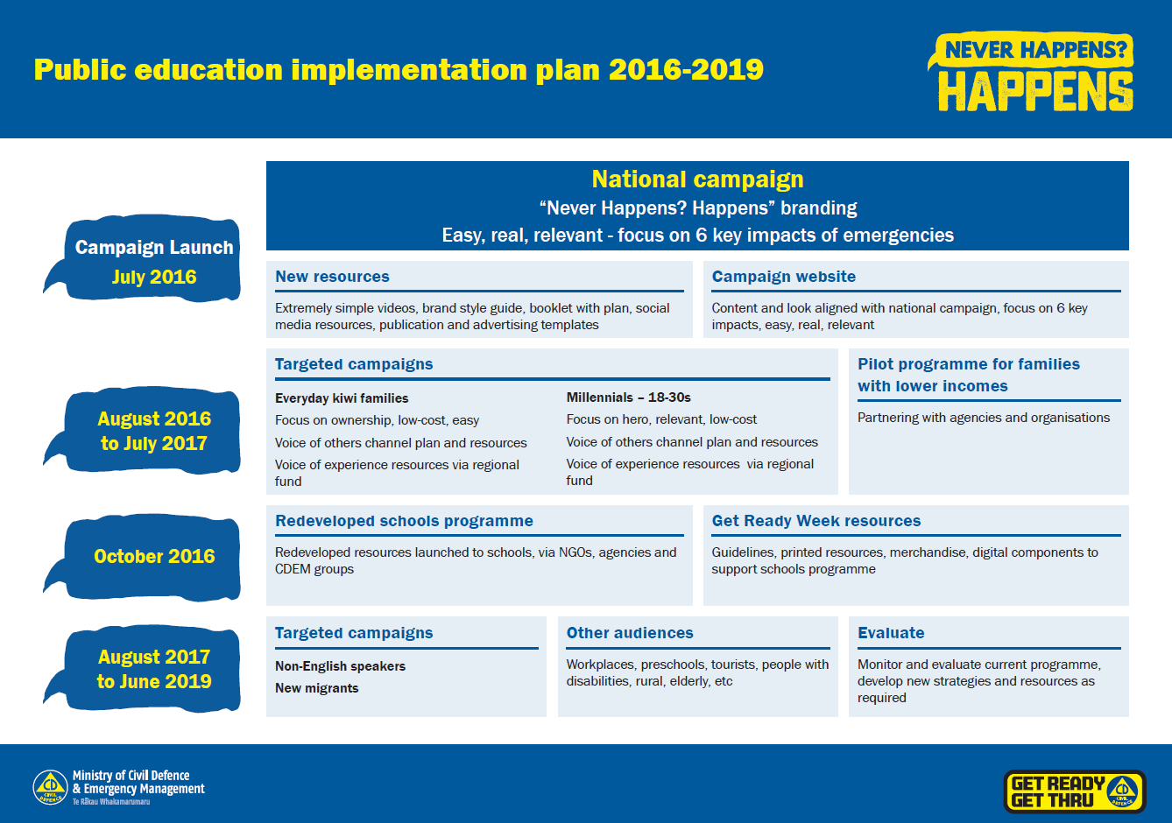

Appendix 2

Summary of differences in 2006 and 2016 programmes
The following table outlines how our redeveloped approach differs from our previous programme:

2006-2016 campaign | 2016-19 campaign
‘Above the line’ (mass media) approach primarily using television and Yellow Pages advertising and some supporting collateral. | Targeted campaign, with community resources developed for adaptation and distribution through CDEM groups and other agencies/NGOs. Supported by some high-profile national campaign material, such as online videos.
Strong focus on specific disasters, such as earthquakes. | Strong focus on preparing for impacts of disasters and emergencies, such as power outage, transport disruption, no water.
‘One size fits all’ approach aimed at all NZers. | Targeted, multiphase approach aimed at those groups identified as having low levels of preparedness, with the ability to capture wider audiences in the slipstream.
Campaign hinged strongly on Peter Elliot as spokesperson | Reduced focus on a ‘spokesperson’, but rather resources with the ability to feature ‘real’ people, adaptable at a local level and for particular target audiences. Some use of talent for national material to engage public.
Serious, methodical tone. | A more approachable, positive and empowering approach, with greater use of humour and active engagement through channels such as social media.
Get Ready Get Thru website, supported by Facebook and Twitter | New campaign website, with the entire Get Thru website to be redeveloped over the 16/17 financial year. New materials and approaches to better engage public on social media.
Prescriptive approach, advocating for detailed plans and survival kits | Less prescriptive and onerous approach, encouraging people to think for themselves and take personal ownership about how they would deal with easily relatable impacts.
Hard copy school resources, with limited adaptation for the school curriculum, supported by “What’s the Plan Stan’ website. | Interactive online school resources specially adapted for the school curriculum, in partnership with EQC; redeveloped What’s the Plan Stan website

