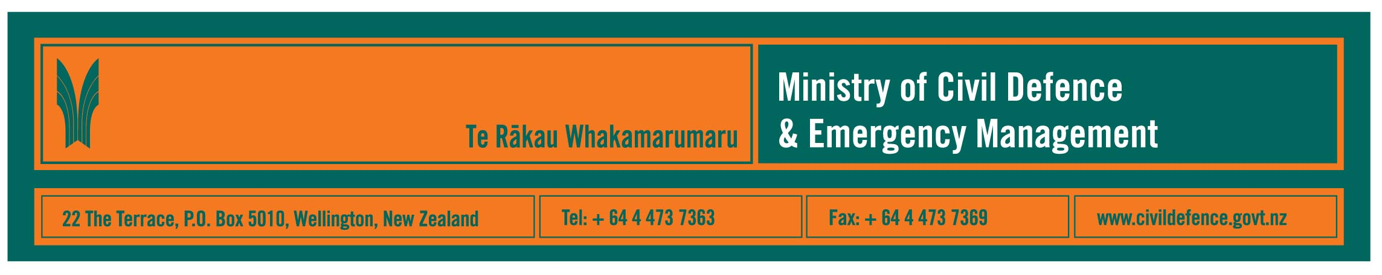

Media Release 30 July 2009

Landslides, tornadoes, flooding and earthquakes;
So, how prepared are we?

In the last few weeks Waihi Village was evacuated because of a threatened landslide, Wellington rail and road links were closed by slips, tornadoes struck Kaitaia and Opunake, heavy rain caused flooding in Gisborne district and a large earthquake, followed by aftershocks, occurred in Fiordland.

So, how prepared are our households for disasters?

The Director of the Ministry of Civil Defence & Emergency Management, John Hamilton, said that the Ministry carries out an annual survey to gauge how aware New Zealanders are of possible disasters and how well prepared we are should a disaster occur.

“This year’s survey shows that more people are thinking about what they should do in a disaster and are talking more to family and friends about preparing but they also show that we need to do more to actually be prepared,” Mr Hamilton said.

“For our survey ‘being prepared’ means having emergency items and water to last at lest three days, an emergency plan and regularly updating them.”

Survey results included:
- 76 % of New Zealanders said they know what they need to do to be prepared for a disaster
- 40% have taken some steps in the last year to prepare
- 23% are well prepared at home
- 10% are well prepared at home and at work.

“It is important that people understand that we all have to be prepared because we are our own first line of response,” Mr Hamilton said. “The first people to be hit by a disaster will always be those who are right there at home, at work, at school, wherever we are when it happens.

“Our advice is that households, workplaces and communities should prepare for at least three days of limited or no access to utilities and emergency services.

“Local, regional, national and, if necessary, international, support is available but will take at least some time to deploy and reach everyone who needs it, particularly when infrastructure like roads, bridges, railway lines and telecommunications systems are damaged.

“That is when we will be at our most vulnerable and must be ready to look after ourselves, our loved ones and our communities.”

Survey summary

- 79% of New Zealanders have at least some of:
- sufficient stored water (3 litres per person per day)
- food supply for three days
- supply of emergency personal items, e.g. necessary medicines, baby needs
- emergency plan
- the percentage prepared at home has fluctuated between 21% in 2006, 26% last year and 23% this year
- the percentage fully prepared (i.e. water, emergency items and a plan at home and work) has slowly increased from 7% in 2006 to 10% in 2009
- people who are fully prepared tend to be older and to have either been born in New Zealand or have lived here for 10 years or more
- 80% of people who have seen the “Get Ready Get Thru” television advertisements have been prompted to think or take action to prepare for a disaster (up from 74% in 2008).

A report on the survey results, including regional information, is available on the Ministry’s website:
- Links to full report (PDF 1MB) or (Powerpoint 5MB)
- Links summary of research (PDF 117kB) or (doc 157kB).

Media contact

Public Information Manager, Vince Cholewa
Telephone: Mobile 027 276 7587, Office: 04 495 6835
E-mail: vince.cholewa@dia.govt.nz



People can find practical information, including, a household emergency plan and checklist, about what they can do to help themselves prepare for an emergency on the Ministry’s “Get Ready Get Thru” website www.getthru.govt.nz

