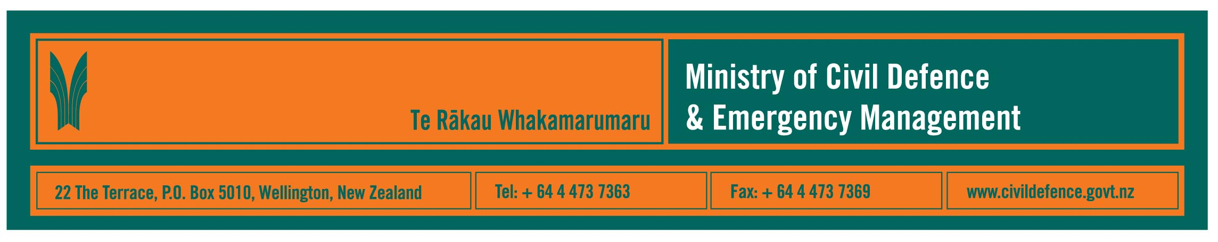

Media Release 27 July 2009

Next step towards purchase of management information system for National Crisis Management Centre

The purchase of an electronic emergency management information system (EMIS) for the National Crisis Management Centre (NCMC) has come a step closer today with the issuing of registration of interest (ROI) documentation.

The Director of the Ministry of Civil Defence & Emergency Management, John Hamilton, said that the ROI is available on the Government Electronic Tendering website and media can also obtain copies by contacting the Ministry.

Mr Hamilton said that EMIS will be used during emergencies when the NCMC is activated. Its attributes will include:

- managing all data received through various channels, including voice, fax and e-mail
- workflow management
- reporting
- resource management
- mapping.

The EMIS will be an off the shelf software application, or a package of off the shelf applications, that Ministry staff will be able to access when they are working in the NCMC and remotely.

The successful vendor will be required to provide training, system documentation, and on-going support and maintenance.

Vendors have until 11August 2009 to respond to the ROI. Their responses will be evaluated and those short-listed will be invited to take part in a more detailed request for proposal (RFP). A contract is expected to be signed by November 2009. The implementation timetable will outlined during contract negotiations.

The EMIS ROI is part of a wider information management programme for the NCMC. The programme includes three work streams comprising the EMIS, alternate communications, and video conferencing.

This ROI is for the EMIS only and the other work streams will have their own separate acquisition processes.

.

Media contact

Public Information Manager, Vince Cholewa
Telephone: 04 495 6835, Mobile 027 276 7587
E-mail: vince.cholewa@dia.govt.nz



People can find practical information about what they can do to help themselves prepare for an emergency on the Ministry’s “Get Ready Get Thru” website www.getthru.govt.nz

