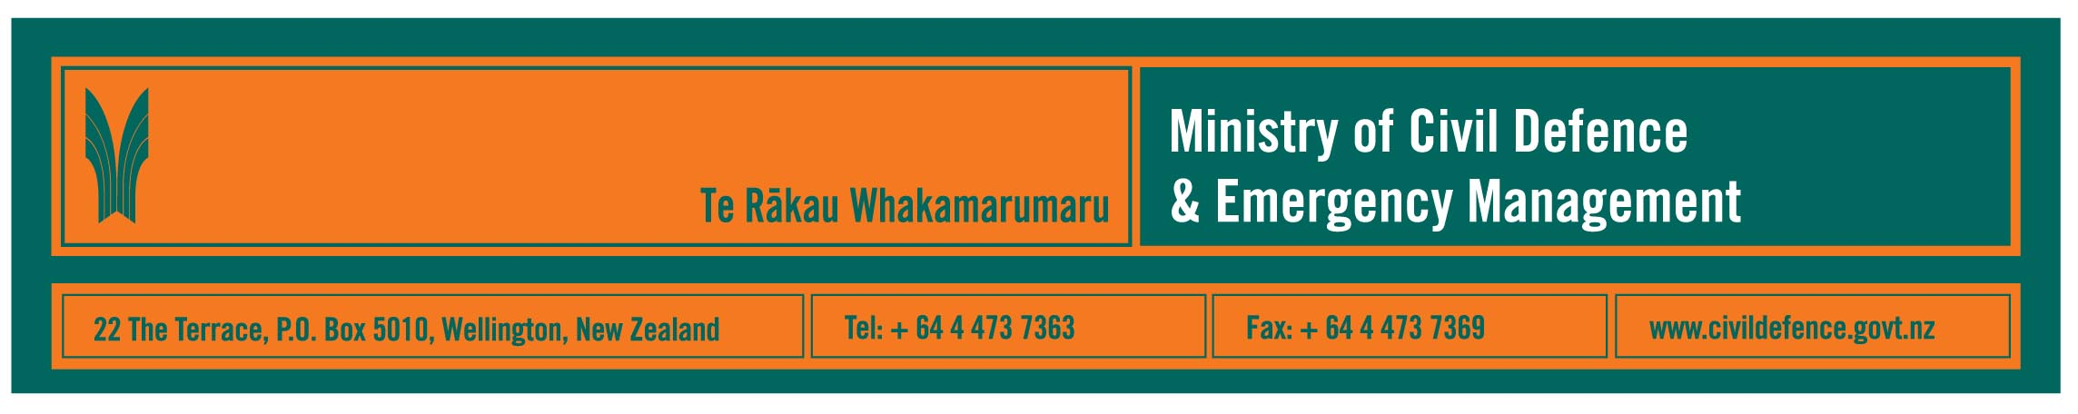

Media Release 21 May 2009

Closer links between New Zealand and Australian
national emergency management agencies

A formal “Administrative Arrangement” between the Ministry of Civil Defence & Emergency Management and the Attorney-General’s Department of Australia has helped create better links between New Zealand’s and Australia’s national emergency management agencies.

The Ministry’s Director, John Hamilton, said that few, if any, countries in the world can respond on their own to a national disaster.

“Given our hazards and geographic isolation it is important that we have strong relationships that will help us manage risks and disasters,” Mr Hamilton said.

“Australia is our nearest neighbour and we have always offered each other assistance whenever it has been needed. The Arrangement formalises the ad-hoc processes we have previously used. The key is having a strong, working relationship and specified processes so that if we do need to contact each other at any time of day or night we can, we can immediately share information about an emergency and, if necessary, start arrangements to provide staff or resources.”

In summary, the Arrangement includes New Zealand and Australia:

- maintaining 24/7 points of contact to ensure continuity of dialogue and, when required, co-ordination of effort, and to carry out communications exercises
- developing formal arrangements to allow quick entry of staff and materials during response to and recovery from an emergency
- deploying observers during emergencies
- sharing lessons identified from emergencies and exercises
- exchanging information about emergencies in other countries
- inviting participants to conferences, workshops and exercises
- exchanging information about best practice
- considering opportunities for joint research.
The Arrangement is part of the Ministry’s priority of having strong international links for civil defence emergency management in New Zealand. The aims of international engagement are to:

- ensure that, should it be required, New Zealand would receive international support quickly
- be a good global citizen by supporting other countries facing a disaster, particularly our neighbours in the Asia Pacific region
- increase our own ability to respond in New Zealand by learning from international experience and exercises.

The Ministry also works closely with other nations through a variety of international forums, including the United Nations, South Pacific Forum, APEC and ASEAN.

Media contact:
Public Information Manager, Vince Cholewa
Telephone: Mobile 027 276 7587, Office: 04 495 6835
E-mail: vince.cholewa@dia.govt.nz

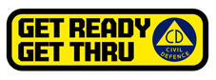

People can find practical information about what the can do to help themselves prepare for an emergency on the Ministry’s “Get Ready Get Thru” website www.getthru.govt.nz

Emergency management is one of the functions carried out by the Attorney-General’s Department.

