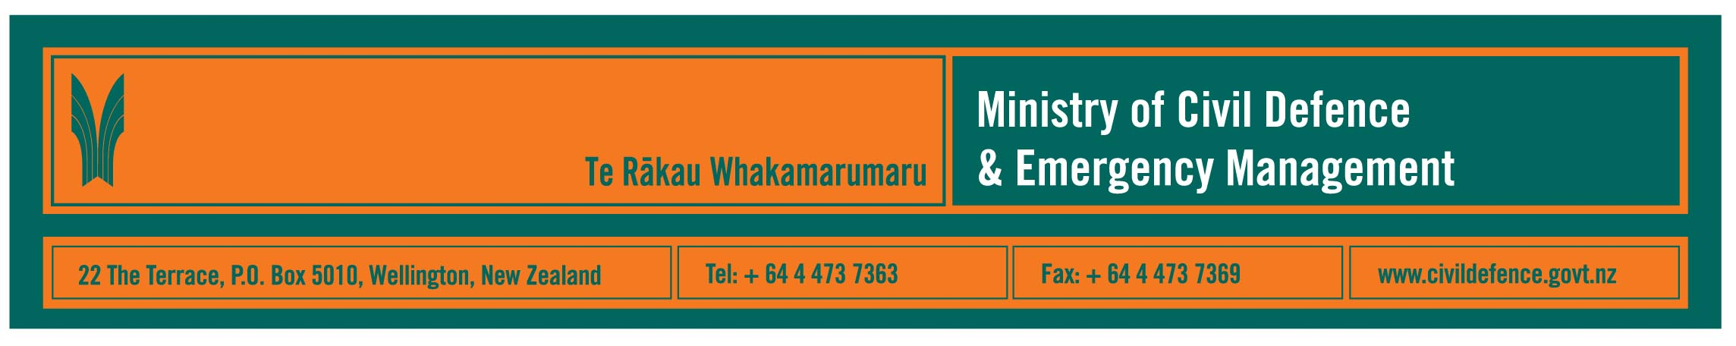

Media Release 11 May 2009

6.28pm Tuesday May 12, 1st anniversary of Wenchuan earthquake, China

A lesson learned: Earthquake engineering saves lives,

New Zealand technology being used to rebuild in China

The first anniversary of the Wenchuan earthquake, which claimed more than 70,000 lives and displaced 5 million people, will be marked at a New Zealand Society for Earthquake Engineering (NZSEE) presentation at Victoria University at the exact time of the earthquake on Tuesday May 12.

NZSEE President, Graeme Beattie, said that the five-member NZSEE team that went to China will be presenting about lessons for New Zealand. In summary, these are:

Observations from China | Lessons for New Zealand
Earthquake engineering works - well engineered buildings, bridges and dams performed well and saved lives. | Building codes and building consent processes (including compliance regimes) are crucial to ensuring resilience and public safety.
Earthquake prone buildings must be managed carefully. Such buildings suffered extensive damage and many collapsed, causing many injuries and deaths. | Local authorities need to look closely at how older buildings are managed in our towns and cities.
Earthquake induced land slides had catastrophic impacts, destroying buildings and probably causing more deaths and displacement of people than damage done directly by the earthquake. | Much of New Zealand has similar landscapes to Wenchuan County but with lower population densities. Land use planning must include allowance for effects of hazards. That includes understanding that an event like an earthquake can trigger a range of additional hazards, like landslides and river diversions, as well as severe ground shaking. Likewise emergency plans must allow for these additional consequences.

Observations from China | Lessons for New Zealand
The response was a colossal effort involving government agencies, non-government organisations and businesses at local, regional, national and international levels. Leadership came from the President and was well resourced. | Hundreds of agencies will be involved in the response to a major emergency. Political and operational leadership, co-ordination of agencies, and planning are crucial for the response to be effective at all levels.
The Chinese government is meeting its targets for recovery. Its recovery plan aims to provide better and safer facilities and communities than those destroyed or damaged. All 5 million displaced people were in temporary housing quickly. The regional building code was reviewed and upgraded within one month of the earthquake. Building work on all reconstruction projects (including permanent housing for 5 million people, schools, hospitals, factories, dams, roads, bridges, utilities etc.) was underway in less than one year. Larger, heavy public buildings, including a hospital, schools and a kindergarten, are being built on New Zealand invented base isolators. (Base isolators are so named because they “isolate” large buildings from severe ground shaking. They are already used in hundreds of new Chinese buildings and elsewhere in the world, including New Zealand). | Recovery must be pre-planned, prompt and draw on lessons from the emergency. Recovery could involve rebuilding suburbs or towns in different places. If recovery focuses on restoring what was there before the emergency, then it leaves the community still exposed to the same risks.

Link to earthquake safety fact sheet:
Drop cover and hold is still the best advice

Guests at the function will include representatives from the Embassy of the People’s Republic of China, the Minister of Civil Defence, John Carter, the Director of the Ministry of Civil Defence & Emergency Management, John Hamilton.

“We are expecting a lot of interest from local authorities, engineering firms, academics who teach engineering and architecture, and the civil defence emergency management sector,” Mr Beattie said.

Wellington is the last stop for the NZSEE team, which has been giving its presentation in Auckland, Napier, Christchurch and Queenstown during the last two weeks. Details if media wish to attend:

Tuesday 12 May 2009, 6pm to 8pm
Victoria University of Wellington, Lecture Theatre LT1
Rutherford House, Bunny Street, Wellington.

Media contacts:

New Zealand Society for Earthquake Engineering
President, Graeme Beattie
Telephone: 04 238 1347
E-mail: graeme.beattie@branz.co.nz

Ministry of Civil Defence & Emergency Management
Public Information Manager, Vince Cholewa
Telephone: Mobile 027 276 7587, Office: 04 495 6835
E-mail: vince.cholewa@dia.govt.nz

Useful websites:

- Ministry of Civil Defence & Emergency Management www.civildefence.govt.nz
- New Zealand Society for Earthquake Engineering www.nzsee.org.nz
- Earthquake Commission www.eqc.govt.nz
- GNS Science’s GeoNet project, earthquake recording www.geonet.org.nz/earthquake/



People can find practical information about what the can do to help themselves prepare for an emergency on the Ministry’s “Get Ready Get Thru” website www.getthru.govt.nz

