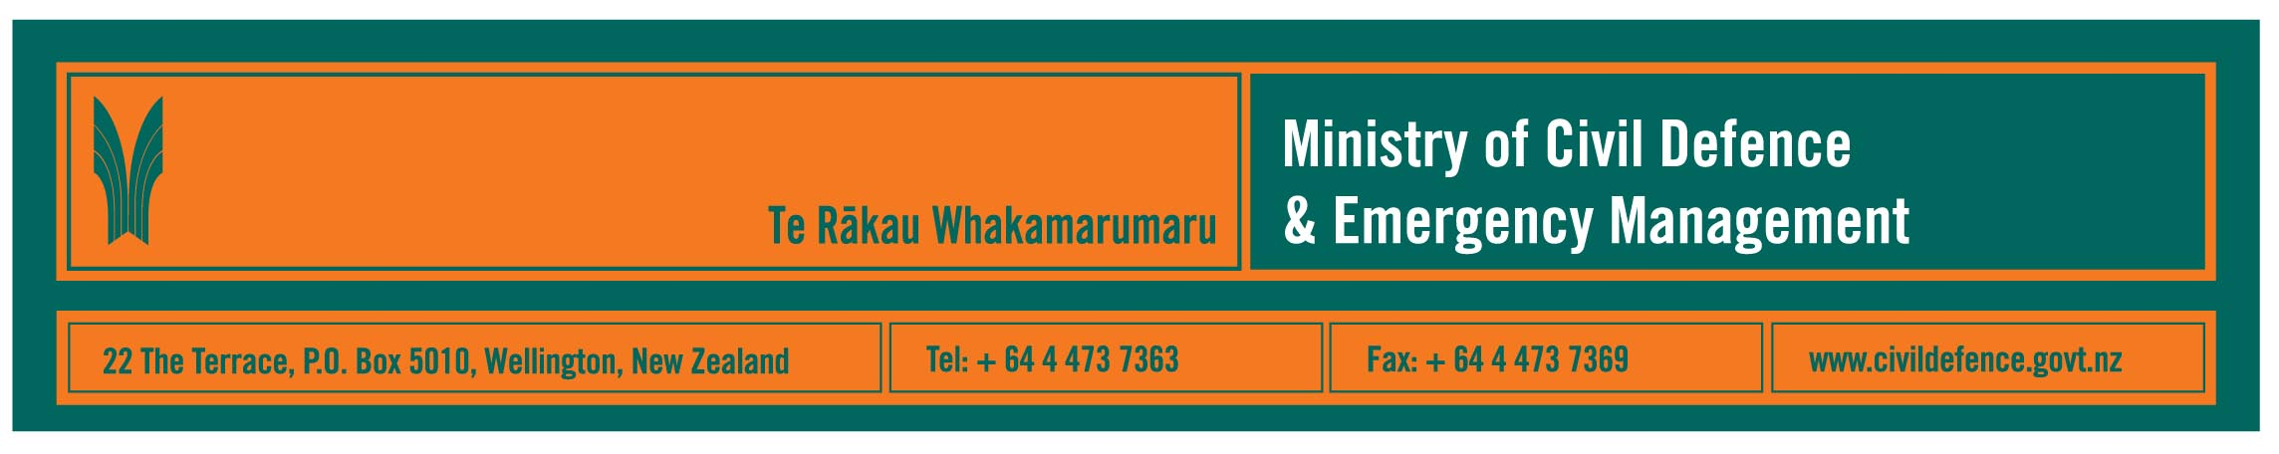

Media backgrounder 7 April 2009

Italian earthquake a tragic reminder for New Zealand of the need to be prepared

The earthquake that has struck the Abruzzo region of Italy is a tragic reminder that New Zealanders need to be prepared for earthquakes here.

The Director of the Ministry of Civil Defence & Emergency Management, John Hamilton, said that yesterday three quakes measuring 4.1, 4.2 and 4.4 occurred around Gisborne and Napier, and many thousands of earthquakes occur in New Zealand each year.

“A large, damaging earthquake could occur in New Zealand at any time and cannot be predicted,” Mr Hamilton said.

“In a severe earthquake it is absolutely vital that people respond immediately. To be able to do that we need to be prepared and know what to do - confusion and delay can result in people getting seriously injured or killed.”

The following information is from the Ministry’s “Get Ready Get Thru” public website.

Before an earthquake
- Develop a Household emergency plan and prepare an emergency survival kit so that you can cope with being on your own for up to three days or more.
- Identify safe places within your home, school or workplace. A safe place is:
- under a strong table, remember to hold onto the legs
- next to an interior wall
- somewhere close to you, no more than a few steps, or two metres away, to avoid injury from flying debris.
- Check your household insurance policy for cover and amount.
- Seek qualified advice to make sure your house is secured to its foundations. Also check with your local council that any renovations comply with the building code.
- Secure heavy items of furniture to the floor or wall. Click here to go to the EQC website and find out how to quake-safe your home.

During an earthquake
- If you are inside a building, move no more than a few steps, drop, cover and hold.
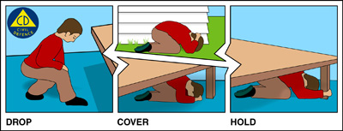
- If you are outside, move no more than a few steps, then drop, cover and hold.
- If you are driving, pull over and stop.
- If you are at the beach or near the coast, drop, cover and hold, then move to higher ground immediately in case a tsunami follows the quake.
- Link to earthquake safety fact sheet.

After an earthquake
- You should expect to feel aftershocks.
- Help those around you if you can.
- If you are in a damaged building, try to get outside and find a safe, open place.
- Do not go sightseeing to look at the damage the earthquake has caused.
- If you smell gas, try and turn off the gas main outside the building if it is safe to do so.
- If you see sparks, broken wires or evidence of electrical system damage, turn off the electricity at the main fuse box if it is safe to do so.
- If your property is damaged, take notes and photographs for insurance purposes.
- Listen to the radio for information and advice.

Media contact

Public Information Manager, Vince Cholewa
Telephone: work 04 495 6835, cellular 027 276 7587
E-mail: vince.cholewa@dia.govt.nz

Useful websites include:

Ministry of Civil Defence & Emergency Management www.civildefence.govt.nz
Earthquake Commission www.eqc.govt.nz
GNS Science www.gns.cri.nz and www.geonet.org.nz
New Zealand Society for Earthquake Engineering www.nzsee.org.nz
People might also wish to contact their regional, city or district council for information about regional local civil defence arrangements. Contact details are on the Ministry’s website.



People can find practical information about what the can do to help themselves prepare for an emergency on the website of the Ministry’s “Get Ready Get Thru public education campaign.

www.getthru.govt.nz

