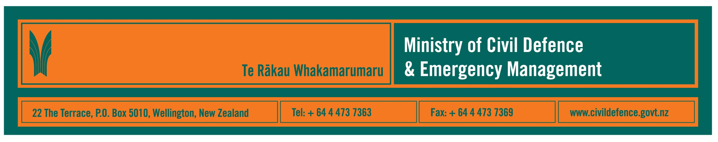

Media release 22 January 2009

How safe is that building?
Comment encouraged on draft safety evaluation guidelines

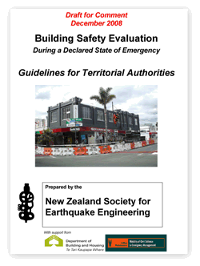
The Ministry of Civil Defence & Emergency Management is encouraging local authorities and other organisations to comment on draft Building Safety Evaluation Guidelines.

The Ministry’s Director, John Hamilton, said that the guidelines would be used to assist local authorities to prepare to quickly evaluate the safety of buildings when a state of emergency has been declared after an earthquake or other emergency.

The draft guidelines have been prepared by the New Zealand Society for Earthquake Engineering with support from the Ministry and the Department of Building and Housing.

The draft guidelines have been circulated widely for comment, including to all city and district council chief executives and the 16 regional civil defence emergency management (CDEM) groups. Comment should be made to the Society’s project leader, Dave Brunsdon, by e-mailing db@kestrel.co.nz

The Gisborne earthquake of 20 December 2007 provided a reminder that it is crucial to quickly evaluate the safety of buildings and decide if they should be occupied again. The Gisborne District Council’s actions in response to the earthquake reduced anxiety amongst owners, tenants and the public by providing rapid and authoritative decisions on the safety of their buildings.

The Society has updated its 1998 document on post-earthquake building safety evaluations, drawing upon the experiences from Gisborne. Changes have been suggested to: how buildings are classified, who directs the evaluations, and references to relevant legislation.

The guidelines would result in a "triage" or "traffic light" system:
- Green: inspected, apparently okay, no restrictions on use or entry.
- Yellow: restricted use, safety concerns, parts may be off limits, entry only on urgent business, leave as soon as possible, detailed engineering evaluation required before unrestricted use.
- Red: clearly unsafe, do not enter, detailed engineering evaluation required before any use.

It is intended that local authorities, engineers and others who might be involved in building evaluation would use the guidelines before emergencies occurred to help prepare them for the work they would have to do after an emergency.

Media contacts

New Zealand Society for Earthquake Engineering

President, Graeme Beattie

Telephone 04 238 1347

E-mail: graemebeattie@branz.co.nz

Ministry of Civil Defence & Emergency Management

Public Information Manager, Vince Cholewa
Telephone: cellular 027 268 8463, work 04 495 6835
E-mail: vince.cholewa@dia.govt.nz



People can find practical information about what the can do to help themselves prepare for an emergency on the Ministry’s “Get Ready Get Thru” website www.getthru.govt.nz

