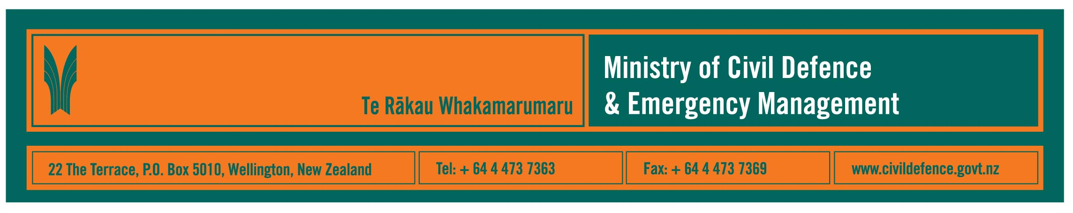

Media release 22 December 2008

Strong international links necessary for civil defence emergency management

Maintaining strong international links is, necessarily, a priority for civil defence emergency management in New Zealand.

The December issue of the Ministry of Civil Defence & Emergency Management’s quarterly magazine, Impact, highlights some of our international links at central and local government levels.

The Ministry’s Director, John Hamilton, said that few, and probably no, countries in the world can respond on their own to a national disaster.

Mr Hamilton said that the Ministry’s international aims are to:
- ensure that, should New Zealand ever need it, we would receive international support quickly
- be a good global citizen by supporting other countries facing a disaster, particularly our neighbours in the Asia Pacific region
- increase our own ability to respond in New Zealand by learning from international experience and exercises.

The December issue of Impact includes articles about:
- at the anniversary of the Gisborne earthquake, the Gisborne District Council and the New Zealand Society for Earthquake Engineering looking at earthquake lessons from China
- the Ministry working through Asia Pacific Economic Cooperation (APEC) to learn lessons from Taiwanese emergency preparedness
- a high level Indonesian delegation visiting many agencies in New Zealand, including the Greater Wellington Regional Council, to establish closer links between the our countries, including establishing a National Geosciences Centre and Local Government Network for disaster risk management at the University of Gadjah Mada, Yogyakarta
- the Auckland Regional Civil Defence Emergency Management Group observing an earthquake drill involving 5.5 million people in California.

Other information in Impact includes:
- a message from the new Minister of Civil Defence, John Carter
- public education highlights
- Tsunami Evacuation Zone Guidelines published
- Auckland training
- tornado in Cambridge
- Taranaki weather research
- Golden Bay “Even paradise needs a plan”
- Canterbury training and public competition
- introducing the Ministry’s operations unit
- services available to the sector from the Ministry’s CDEM Specialist Services unit.

Media contact

Public Information Manager, Vince Cholewa
Telephone: cellular 027 268 8463, work 04 495 6835
E-mail: vince.cholewa@dia.govt.nz
www.civildefence.govt.nz



People can find practical information about what they can do to help themselves prepare for an emergency on the Ministry’s “Get Ready Get Thru website www.getthru.govt.nz

- ENDS -

