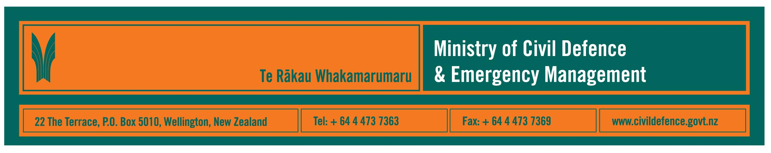

Media Release 28 October 2008

“Pacific Wave 08”: International tsunami exercise

UNESCO led tsunami exercise, “Pacific Wave 2008” is an opportunity for the Ministry of Civil Defence & Emergency Management to train staff and test its response to Pacific tsunami bulletins.

The Ministry’s National Operations Manager, David Coetzee, said Ministry duty teams will tomorrow (Wednesday 29 October 2008) train in the National Crisis Management Centre (NCMC) beneath the Beehive.

“The duty teams will be responding as if an earthquake had occurred off the coast of Japan and had potentially caused a tsunami,” Mr Coetzee said. “Exercise bulletins will be issued from Japan, Alaska and Hawaii.

“We will have to react to the information in the bulletins by using the decision making procedures that we recently reviewed, and deciding to issue either a national warning or an advisory depending on the risk to New Zealand.

“Our expectation is that if a national warning is required, we would issue it within 15 minutes of information being received.”

Tsunami risk management in New Zealand

The Ministry maintains a 24/7 monitoring and warning system for all hazards, including tsunami. There is a team in the New Zealand Fire Service’s Northern Communication Centre in Auckland whose role is to, 24-hours-a-day, receive national and international information about possible civil defence emergencies and issue immediate warnings or advisories when the information exceeds stated criteria.

In Wellington, the Ministry has duty teams on call 24-hours-a-day. Their roles include, when necessary, activating the NCMC and immediately focusing on national response activities and working with regional civil defence emergency management (CDEM) agencies. They are also available to advise Northern Communication Centre staff whenever required.

If, for any reason, the North Communications Centre cannot carry out its CDEM monitoring and warning roles the Wellington-based duty teams take on those tasks.

Other recent, and continuing, tsunami risk management work includes:

- a nationwide series of tsunami preparedness seminars aimed at the 16 regional CDEM groups, and local authority planners, consultants and advisers involved in long term community planning and consent processes
- release of the National Tsunami Advisory and Warning Plan
- publication of Mass Evacuation Planning Guidelines
- gazetting of a national standard for tsunami warning and information signage
- research by GNS Science into sources of tsunami and possible impacts on different parts of New Zealand
- GNS Science and LINZ installing sea-level gauges at various locations around the coast
- research into public alerting mechanisms
- ensuring close links between New Zealand and international science agencies that monitor earthquakes and tsunami
- a wide range of mapping, alerting systems and evacuation planning within each of the 16 regional CDEM groups.

WARNING: No formal warning possible for local tsunami

It is important that people understand that while formal warnings can be issued for tsunami coming from elsewhere in the Pacific, there is unlikely to be enough time to issue a formal warning if a tsunami was caused by an earthquake near the coast of New Zealand.

This is true all around the world. If a local undersea earthquake caused a tsunami, the tsunami could arrive within minutes. No warning system anywhere in the world can react that quickly.

People should know and heed natural warnings. If you are at the coast and you:
- feel a strong earthquake (it is hard to stand up)
- feel a weak earthquake that lasts for a minute or more
- see strange sea behaviour, such as the sea level suddenly rising or falling
- hear the sea making loud or unusual noise or roaring like a jet engine

then get to high ground or go inland. Do not wait for an official warning.

Immediately after the Gisborne earthquake last year many people self-evacuated from the town. More recently a fisherman near Christchurch saw the sea behaving in an unusual way and urged people away from the coast.

“They did exactly the right thing,” Mr Coetzee said. “Thankfully in neither case was a tsunami generated. The next time there might be and people must be prepared.”

Media contact:

Public Information Manager, Vince Cholewa
Telephone: Mobile 027 268 8463, Office: 04 495 6835
E-mail: vince.cholewa@dia.govt.nz

Websites with more information about tsunami

Ministry of Civil Defence & Emergency Management
GNS Science


Get Ready Get Thru public education campaign

