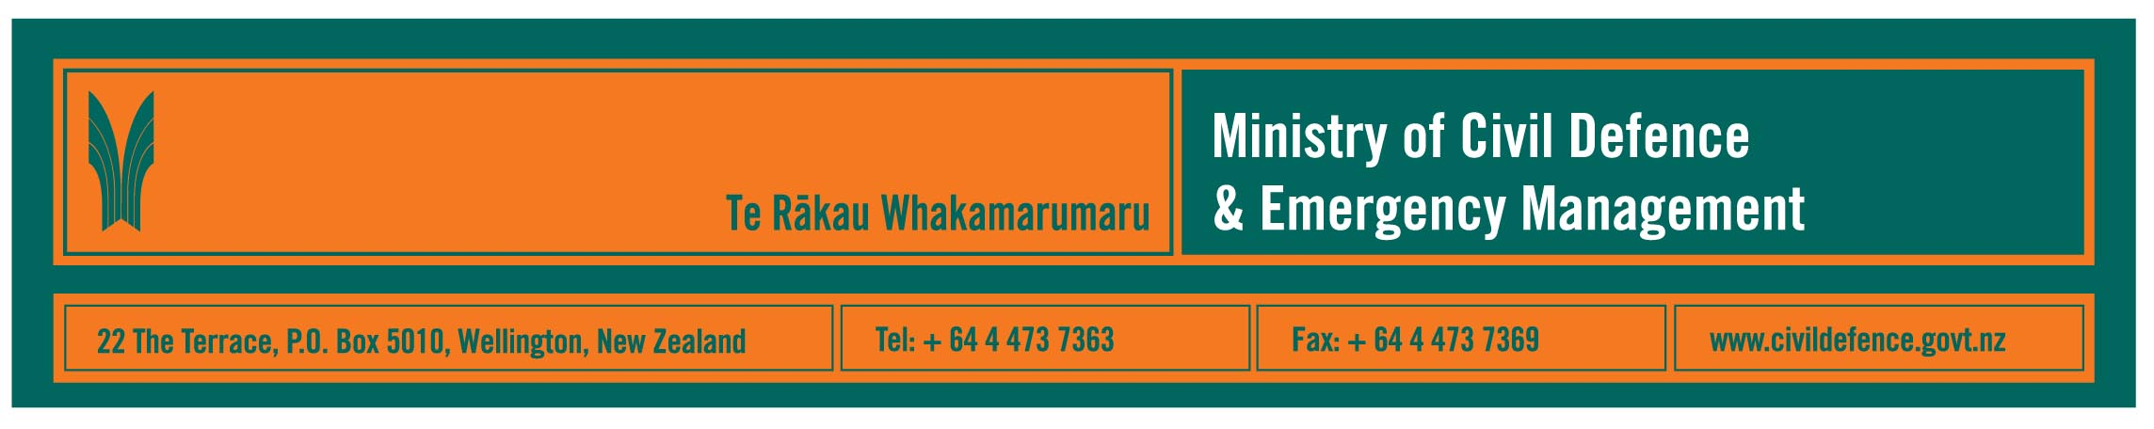

Media release 7 October 2008

Warning about Aftershock TV show

A warning to people channel surfing tomorrow night or starting to watch Aftershock on TV3 part way through after its 8.30pm start. The programme includes acted “news bulletins” and “interviews” that help it give a realistic portrayal of what might happen after a major earthquake hits Wellington. Do not be confused; it is dramatisation of events but is not the real thing!

The Director of the Ministry of Civil Defence & Emergency Management, John Hamilton, said that while Aftershock is set in Wellington, it has important messages for all New Zealanders about any major civil defence emergency.

“Immediately after a major emergency most local services will not be functioning initially and additional support could take days to get through because of damaged roads, railways, bridges, harbours or airports,” Mr Hamilton said.

“In those first days people in the affected area will be at their most vulnerable and they will have to rely on each other and the preparations they had made before hand.

“Those preparations include having enough food and, crucially, water for three days and emergency plans for households and work places. Some people will need to include critical personal items like medicines, glasses or batteries for a hearing aid. Plans should include how to help family or others you know who will need special support.

“Battery-powered radios and torches could be life-savers. With power out, battery radios would be the only practical way of receiving public information messages. Torches are not a fire risk but candles can be.”

On Thursday on TV3 at 9.30pm Aftershock – Would You Survive? looks at how a real Wellington family coped when put through a simulation of surviving on their emergency supplies for three days after an earthquake.

Tomorrow is the United Nations International Day for Disaster Reduction. Each year New Zealand holds a Disaster Awareness Week around that day.

The Ministry has been broadcasting its Get Ready Get Thru television and radio advertisements from Sunday 5 October.

The website that supports the campaign, www.getthru.govt.nz, provides information in nine languages and has been updated to make it easier to find information and quicker to update.

City, district and regional councils are also holding local and regional events to highlight the need for all of us to take care of ourselves and our loved ones, and be prepared for emergencies.

Activities planned include: testing of warning systems, erecting tsunami signs and publicising tsunami risks, articles and advertising in local newspapers, a school holiday programme, community displays and demonstrations, exercises, working with local shops to get messages across to their communities.

Information about some of the local and regional events is on the Ministry’s website, http://www.civildefence.govt.nz/memwebsite.nsf/wpg_URL/For-the-CDEM-Sector-Public-Education-Disaster-Awareness-Week-2008?OpenDocument
and people can also contact their district, city or regional council for more information about their local area.

Media contact

Public Information Manager, Vince Cholewa
Telephone: work 04 495 6835, cellular 027 268 8463
e-mail: vince.cholewa@dia.govt.nz
www.civildevence.govt.nz

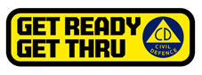

People can find practical information about what they can do to help themselves prepare for an emergency on the Ministry’s “Get Ready Get Thru website www.getthru.govt.nz

