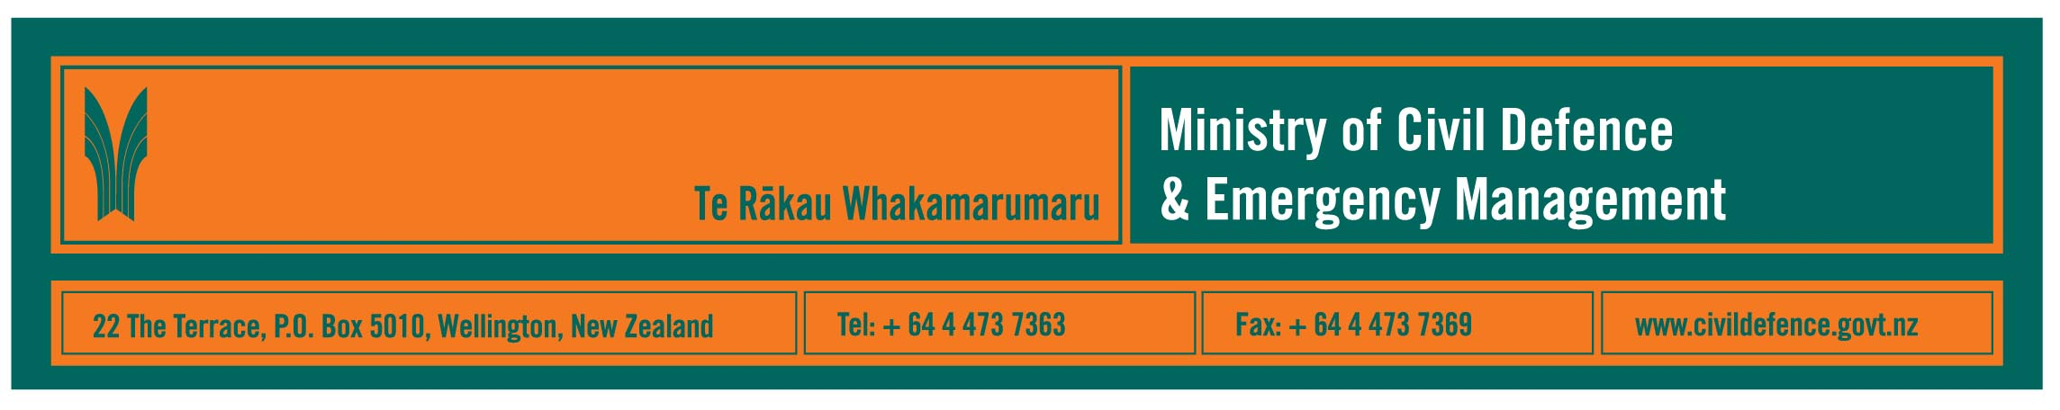

Media release 2 September 2008

If you had to leave in a hurry, what would you do?

Seeing New Orleans being evacuated ahead of Hurricane Gustav, it is timely to consider what New Zealanders would be able to do if we had to leave home in a hurry.

The Director of the Ministry of Civil Defence & Emergency Management, John Hamilton, said the reality for many parts of New Zealand is that it can happen here. It may not be a hurricane. It could be the threat of a tsunami or volcanic eruption or even fire.

“In the last few weeks people in Northland, Auckland, Waikato, Marlborough and Canterbury have been evacuated because of flooding, slips and storm damage,” Mr Hamilton said.

“We have guidelines for planning evacuations and many organisations have carried out local evacuations, but what has been shown here and overseas is that when households and families are better prepared, evacuations are faster and safer for all.

“This is why we ask people to make sure they know how to check information, have emergency supplies and a plan for what the family or household will do. If you have someone at home who is sick, elderly or has special needs you will need to consider and plan for them should they need to be evacuated. Other things to consider might include, who would fetch your children from school and if you cannot take your pets, what will you do for them?

“Talk to your neighbours. They can help you and you can help them. Kiwis have a reputation for initiative, community self-help and assisting their neighbours.

“And do keep in mind that an emergency is not a hopeless situation. While local resources are likely to be stretched at first, additional assistance from outside the region and the local community is available from central and local government, the emergency services, welfare organisations, utilities like power, telephone, gas and transport networks and many others. They are ready to help when required but it could take some time to have them deployed. Hence the message that people and communities must be prepared to cope on their own initially.”

Emergency information

During an emergency your local civil defence contact is at your district or city council. Find the number before you need it.

Emergency information would be broadcast on local radio stations. Local councils and regional civil defence emergency management groups also make specific provision for providing information to their local people.

If people have time to prepare for an evacuation, they will be able to take more items with them, including food. However, if they have to evacuate quickly, they should only take essential items. What is essential depends on the person, hence the need for some planning, but could include:
- medication
- glasses, hearing aids etc and the right-sized batteries
- personal sanitary and hygiene items, such as toothbrush and toothpaste, toilet paper, soap, a towel etc
- important family documents.

Media contact

Public Information Manager, Vince Cholewa
Telephone: work 04 495 6835, cellular 027 268 8463, e-mail: vince.cholewa@dia.govt.nz

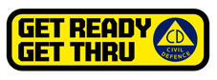

People can find practical information about what they can do to help themselves prepare for an emergency on the Ministry’s “Get Ready Get Thru website www.getthru.govt.nz

