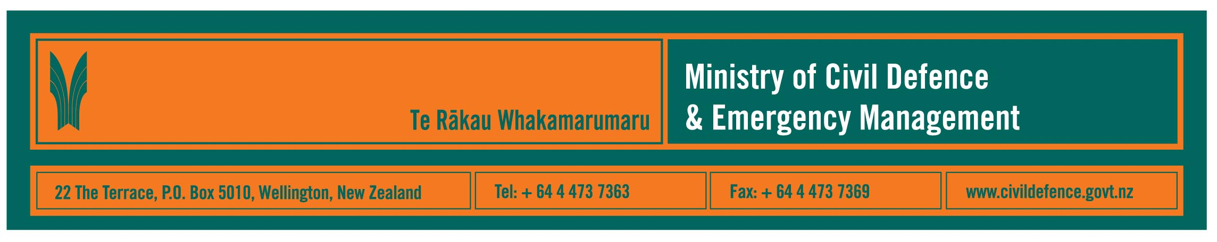

Media release 23 July 2008

Coming to a disaster near you? The big “Green Rig”

One of the “star attractions” at the National Civil Defence Emergency Management Forum at Parliament tomorrow will be big, green and mobile.

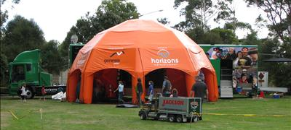
It is Horizons Regional Council’s mobile education facility and emergency operations centre (EOC), the “Green Rig” (right). It will be set up in the forecourt at Parliament tomorrow.

The best time for photographs and interviews will be at 11.10am. Link to “tyre-kicker” info about the Green Rig.

The Director of the Ministry of Civil Defence & Emergency Management, John Hamilton, said that the Green Rig is an articulated truck and trailer equipped for education and emergency management purposes.

“If an existing EOC is damaged, or there isn’t one close enough to the scene of an emergency, the Green Rig can drive there and then power its EOC from mains electricity, solar panels or its on-board generator.

“It is fully equipped with computer and office equipment, and communications systems, including telephone PABX, satellite links, radio telephones and mobile telephone network connections.

“The Green Rig also brings a bright orange inflatable dome that can be used for shelter, more office space or to provide accommodation for welfare services like first aid and catering.

“It’s a great initiative and I am delighted that Horizons Regional Council will be showing it off tomorrow,” Mr Hamilton said.

When the Green Rig is not needed as an EOC, it is used by the Regional Council as a mobile information centre to reach its communities and schools. It is used to provide information and education, and to support community consultation, about the whole range of council work, and is not limited to civil defence emergency management promotion.

The Forum

The National Civil Defence Emergency Management Forum will be hosted by the Minister of Civil Defence, Rick Barker, in the Beehive from 10am to 4pm, Thursday July 24.

The keynote speaker is United States Federal Emergency Management Agency (FEMA) Region Administrator, Susan Reinertson. Ms Reinertson is responsible for FEMA involvement in emergencies in Alaska, Idaho, Oregon and Washington.

The Forum will be attended by senior representatives from the 16 regional civil defence emergency management (CDEM) groups that cover New Zealand.

“It is an important opportunity to focus on local, regional and national leadership during civil defence emergencies, to learn from each other and to help co-ordinate our efforts and preparedness,” Mr Barker said.

Media contacts

Horizon’s Regional Council
Manager Emergency Management Office, Shane Bayley
Telephone: 06 952 2901, cellular 01 227 7183
E-mail: shane.bayley@horizons.govt.nz

Ministry of Civil Defence & Emergency Management

Public Information Manager, Vince Cholewa
Telephone: 04 495 6835, cellular 027 268 8463
E-mail: vince.cholewa@dia.govt.nz



People can find practical information about what the can do to help themselves prepare for an emergency on the website of the Ministry’s “Get Ready Get Thru public education campaign.

www.getthru.govt.nz

