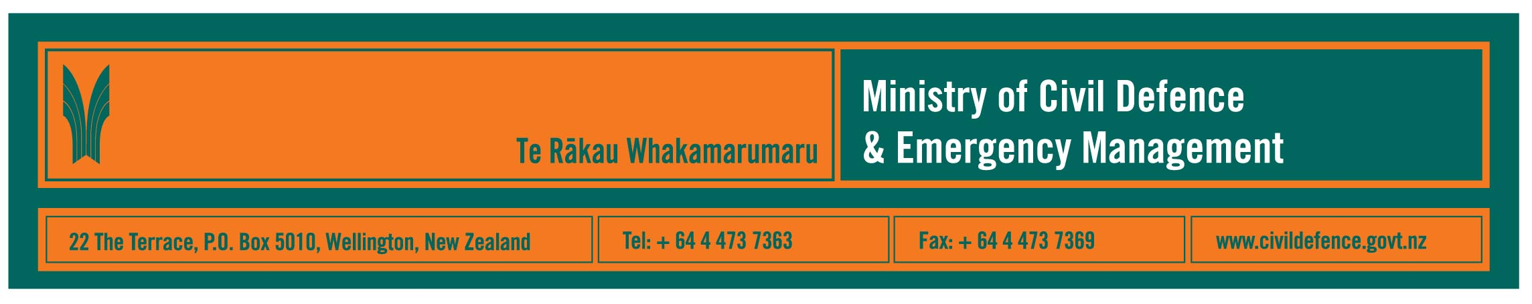

Media release 23 June 2008

Nationwide tsunami seminars

Starting tomorrow, the Ministry of Civil Defence & Emergency Management is hosting a nationwide series of tsunami preparedness seminars.

Preliminary information about the seminars is included in the June 2008 issue of the Ministry’s quarterly journal Impact www.civildefence.govt.nz/memwebsite.NSF/wpg_URL/For-the-CDEM-Sector-Publications-Impact?OpenDocument

The Ministry’s Director, John Hamilton, said that the seminars are aimed at:
- the country’s 16 regional civil defence emergency management (CDEM) groups, which are made up of the local authorities, welfare agencies, emergency services, utility companies (e.g. power, gas, water etc) and others involved in preparing for and responding to emergencies
- local authority planners, consultants and advisers involved in long term community planning and consent processes.

“Our aim is to inform the groups and council planners of all the work that is being done nationally and around the country and support them with their regional and local planning,” Mr Hamilton said.

A lot of work has already been done within each of the groups’ regions. The seminars will help groups and planners learn from and work with each other, get the most up-to-date scientific information and be informed of national policies. They will be able to use that information as they consult and work with their local communities to develop local plans.

Seminar programmes include:
- overview of the tsunami risk management programme
- introduction to the just released national tsunami advisory and warning plan
- information from GNS Science about tsunami research and assessment
- public alerting, evacuation zones and signage
- mass evacuation planning guidelines
- good examples and practice already used in New Zealand
- support available from the Ministry and other national agencies.

Seminars will be held at:
- Auckland, June 24
- Rotorua, June 25
- Palmerston North, June 26
- Nelson, July 8
- Christchurch, July 9
- Balclutha, July 10.

Other information in the June 2008 issue of Impact includes:
- progress towards an electronic information management system for the National Crisis Management Centre beneath the Beehive
- new weather radar at New Plymouth
- an oil spill exercise in Tauranga
- a new regional CDEM facility in Auckland
- Palmerston North tertiary providers developing CDEM education to PhD level
- improving community resilience in Wellington
- marae-based emergency planning in Wairoa
- announcement of a Te Reo Maori version of the teachers’ resource, What’s the Plan Stan
- supporting Tokelau
- new publications, training provided by the Ministry.

Media contact

Public Information Manager, Vince Cholewa
Telephone: work 04 495 6835, cellular 027 268 8463
E-mail: vince.cholewa@dia.govt.nz



People can find practical information about what the can do to help themselves prepare for an emergency on the website of the Ministry’s “Get Ready Get Thru public education campaign.

www.getthru.govt.nz

