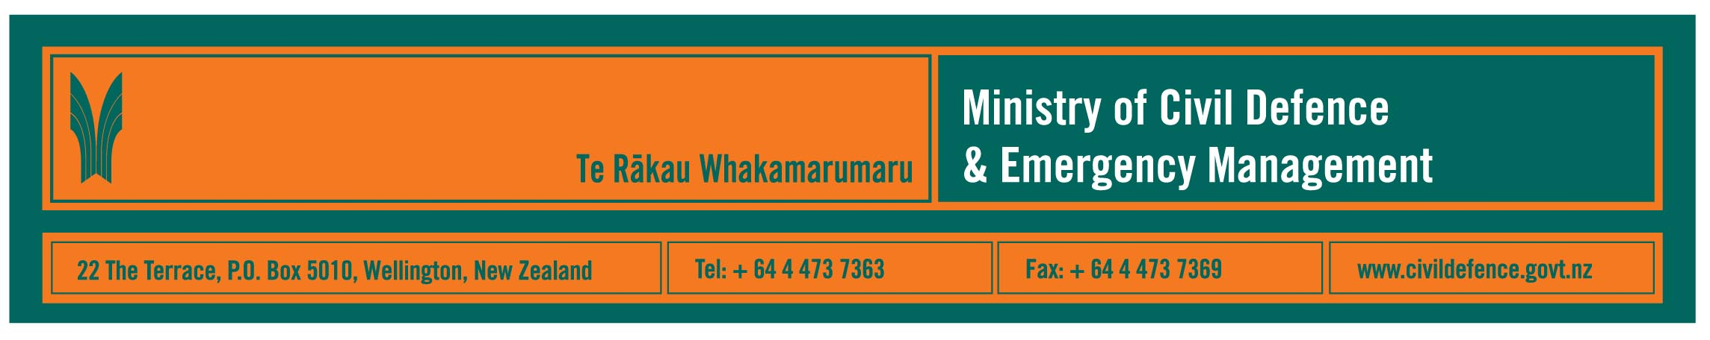

Media release 5 June 2008

Discredited earthquake safety advice circulated in NZ

New Zealand agencies involved in promoting earthquake safety are concerned that advice from a source discredited overseas is being circulated by e-mail in New Zealand.

The Ministry of Civil Defence & Emergency Management, the New Zealand Society for Earthquake Engineering, the Earthquake Commission (EQC) and GNS Science have spoken out against the
e-mail, sometimes known as the “triangle of life”. They have done so because the e-mail discourages people from taking what is usually the safest option, covering under desks, in doorways etc.

“When an earthquake starts, the best advice is still to ‘drop, cover and hold’,” the Ministry’s Director, John Hamilton said.

A link to the earthquake fact sheet on the Ministry’s website, http://www.civildefence.govt.nz, is attached. The fact sheet is the agreed New Zealand advice about what to do during an earthquake. It is based on international best practice.

We have had queries from Members of Parliament, schools, Citizens’ Advice Bureaus, media and members of the public about the misleading advice, which includes the dangerous statement that “people who get under objects, like desks or cars, are crushed”.

Mr Hamilton said that the drill practised by schoolchildren will protect people in most earthquakes. That drill is to drop, take cover under a sturdy piece of furniture, and hold on, or shelter against an interior wall away from windows, bookcases etc.

“In a severe earthquake it is absolutely vital that people respond immediately. Confusion about what to do can result in people getting seriously injured or killed,” Mr Hamilton said.

“Our advice is to identify safe places in your home, office or school before an earthquake so that when the shaking starts you can respond quickly.

An immediate response to move to the safe place can save lives. And that safe place should be within a few steps – no more than two metres – to avoid injury from flying debris.”

Media contact

Public Information Manager, Vince Cholewa
Telephone: work 04 495 6835, cellular 027 268 8463
E-mail: vince.cholewa@dia.govt.nz

Useful websites include:

www.civildefence.govt.nz

www.gns.cri.nz

www.nzsee.org.nz

www.eqc.govt.nz



People can find practical information about what the can do to help themselves prepare for an emergency on the website of the Ministry’s “Get Ready Get Thru public education campaign.

www.getthru.govt.nz

