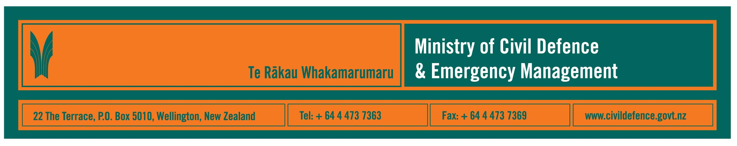

Media release 16 April 2008

204 civil defence emergency management events in first quarter:
earthquakes and weather warnings most common

The Ministry of Civil Defence & Emergency Management announced today that it recorded 204 weather and geological events in the first quarter of the year, 1 January 2008 to 31 March 2008.

The Ministry’s Director, John Hamilton, said that the breakdown of events highlights what we should expect in New Zealand – almost half the events were earthquakes and about a quarter were heavy rain warnings.

“We live on a group of isolated islands, in the roaring forties on the edge of tectonic plates,” Mr Hamilton said. “That means we are likely to get rain and wind, and earthquakes and volcanoes.”

Historically, flooding is by far the most common emergency in New Zealand, while earthquakes, most too small to be felt, occur every day.

The Ministry works with science agencies in New Zealand and overseas. That includes GNS Science, NIWA, MetService, universities and the Pacific Tsunami Warning Centre.

Event | January - March 2008 | October - December 2007
Earthquakes¹ | 97 | 123
Tsunami bulletins | 9 | 14
Volcanic bulletins | 2 | 2
Heavy rain warnings | 55 | 78
Strong wind warnings | 11 | 49
Sea swell warnings | 25 | 21
Severe thunderstorm watch (now included in weather warnings) | - | 6
Cyclone alerts | 5 | 0
Totals | 204 | 293
- Most earthquakes recorded by GNS Science are not reported to the Ministry as they are detected by measuring instruments but not felt by people.

Most of the information received, and analysis provided, is about events that do not become emergencies. They are monitored as a precaution, and when exceeding specific thresholds or deemed necessary, information is provided to the 16 regional civil defence emergency management (CDEM) groups, national agencies and the media. The groups are made up of regional, city and district councils, emergency services, health, lifeline utilities and other organisations that might be involved if a response was necessary.

Strong links across all the organisations that make up the CDEM sector are crucial for a response to be effective. The Ministry’s role is to provide national strategy and co-ordination for the hundreds of organisations that could be involved in a response, and to provide national public education.

No matter how well co-ordinated responding agencies are, the first people on the scene of an emergency will always be those who are right there, at home, at school, at work, wherever the emergency is.

Local resources are likely to be stretched at first during an emergency. Additional support from outside the local community and region is available but could take some time to deploy, especially if there is damage to roads and other transport systems and to telecommunications. Hence the public education messages that people and communities must be prepared to cope on their own initially.

Recent CDEM activities included:

- Review of the National Civil Defence Emergency Management Strategy completed and a revised strategy published.
- Upgraded communication systems to issue faster warnings and advisories to CDEM agencies.
- Better and faster access to science information through a memorandum of understanding (MOU) between the Ministry and GNS Science.
- Through an MOU between the Ministry and the New Zealand Fire Service, the Fire Service provides 24/7 monitoring and, in predetermined situations, issues initial warnings and advisories, from its Northern Communication Centre to support the Ministry’s on-call duty team.
- Closer links with local government organisations to include management of hazards and risk in immediate and long-term plans.
- The conclusion of Exercise Ruaumoko, a national exercise led by the Auckland CDEM group and based on the led up to an eruption in the Auckland volcanic field. More than 1,000 people from more 100 organisations were involved.
- Mass evacuation planning guidelines drafted and distributed for public comment.

Recent CDEM activities continued:

- Preparing and delivering the next round of courses for controllers, recovery managers and public information managers.
- Preliminary scoping work undertaken to create a “CDEM competencies framework” to describe the tasks, skills and knowledge of different CDEM roles. The framework would help provide national consistency and standardisation for CDEM professional development.
- Public education activity included “Get Ready Get Thru” advertising over the Christmas and New Year holidays and during the final week of Exercise Ruaumoko, revising the school’s programme “What’s the Plan Stan”, in line with the new schools’ curriculum and the nearly completed translation of “What’s the Plan Stan” into Maori.

Media contact

Public Information Manager, Vince Cholewa
Telephone: cellular 027 268 8463, work 04 495 6835
E-mail: vince.cholewa@dia.govt.nz

www.civildefence.govt.nz

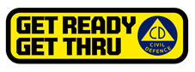

People can find practical information about what the can do to help themselves prepare for an emergency on the website of the Ministry’s “Get Ready Get Thru public education campaign.

www.getthru.govt.nz

