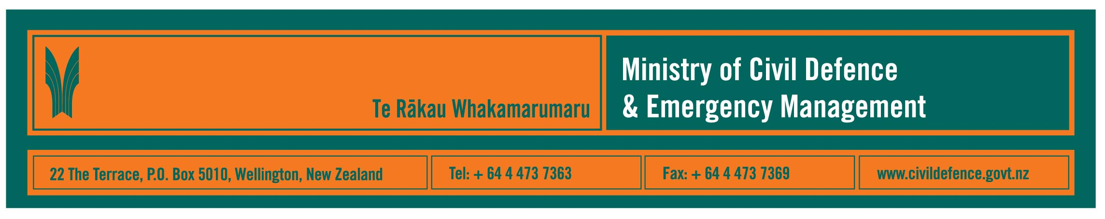

Media Release 3 April 2008

How do you evacuate 300,000 people? Mass evacuation planning guidelines developed and myths dispelled

The Ministry of Civil Defence & Emergency Management today distributed draft guidelines for planning mass evacuations.

The Ministry’s Acting Director, Alan Walker, said that many organisations in the civil defence emergency management (CDEM) sector (local authorities, Police, New Zealand Fire Service, welfare agencies etc.) have planned and carried out local evacuations.

“However, as a country we have never had to evacuate hundreds of thousands of people from one of our cities,” Mr Walker said. “Should we have to, the level of planning and organisation is very different to what we have done in the past.”

The draft planning guidelines were developed by the CDEM sector. They draw from what has and has not worked overseas, and include lessons from some New Zealand civil defence exercises. That includes work done in Auckland for the volcanic exercise, Exercise Ruaumoko, that ended last month.

“Some of the lessons from overseas are contrary to popular myths about how people behave in emergencies,” Mr Walker said. “For example, few individuals panic during an evacuation, mass panic has not happened, and people help each other.

“Those are important and useful social behaviours to know about and make use of in evacuation plans. The message is that we should not underestimate our communities, and we should make use of their willingness and ability to do the right things to support each other in an emergency.

“What communities need most is to know what to do and to have confidence in the people providing the information.”

How an evacuation plan is developed can be just as important as the final written plan. Involving a wide range of CDEM sector organisations and community representatives is vital in ensuring that as many elements as possible have been considered and there is maximum knowledge of, and “buy-in” to, the final plan.

Areas of particular concern are dissemination of warnings and information, the physical movement of people and providing welfare support to people who have been evacuated.

Copies of the draft planning guidelines have been circulated to the CDEM sector for comment and are available from the Ministry’s website. Comment is due by 15 May 2008.

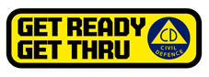
People can find important practical information about what they can do to help themselves prepare for an emergency on the website of the Ministry’s “Get Ready Get Thru” public education campaign, www.getthru.govt.nz Information includes:

- Emergency Survival Items
- First Aid
- Getaway Kit
- Household Emergency Plan
- Radio stations to listen to
- Caring for sick or vulnerable people
- Caring for pets and livestock
- Storing water
- If you are in your car
- Get your business ready
- Checklist

Media contact:

Ministry of Civil Defence & Emergency Management

Public Information Manager, Vince Cholewa
Telephone: work 04 495 6835
cellular 027 268 8463
E-mail: vince.cholewa@dia.govt.nz

www.civildefence.govt.nz

