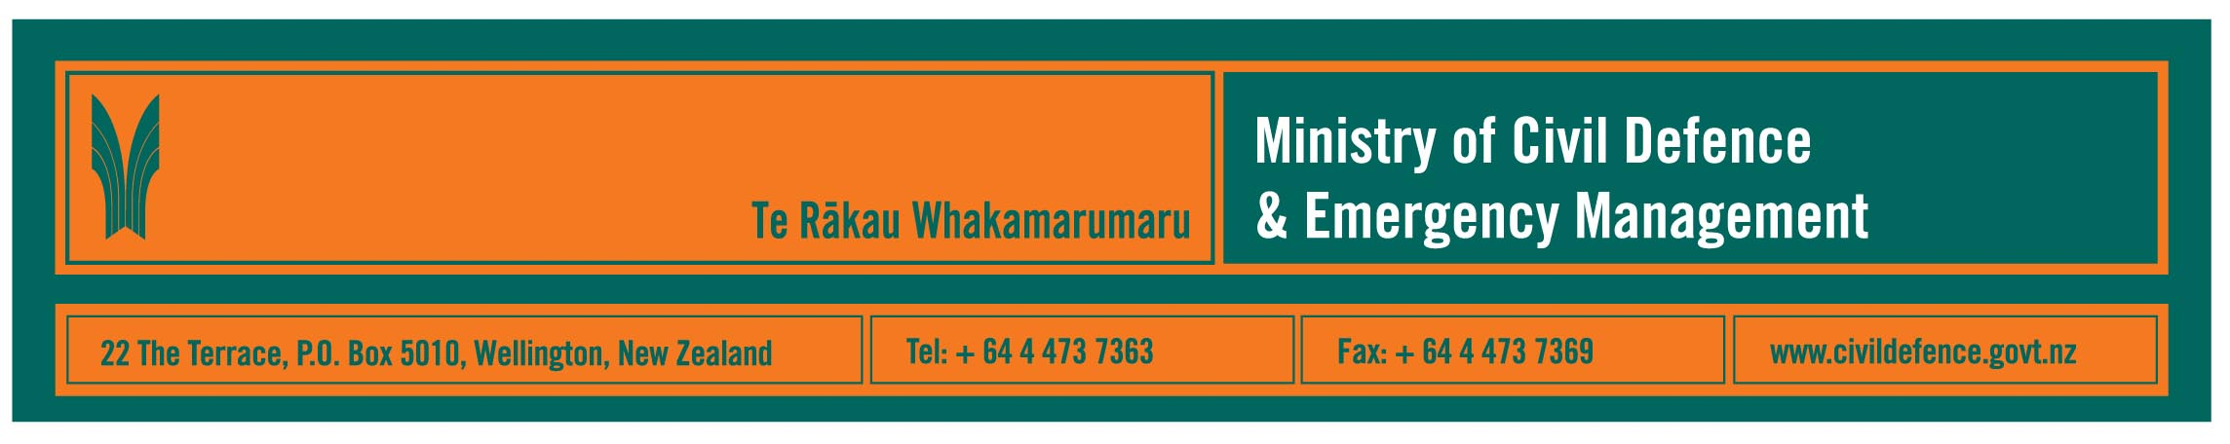

Media release 30 March 2008

Better, faster science information for
civil defence emergency management

Civil defence emergency management (CDEM) organisations will have better and faster access to science information through a memorandum of understanding (MOU) between the Ministry of Civil Defence & Emergency Management and GNS Science.

The Ministry’s Director, John Hamilton, and GNS Science Chief Executive, Dr Alex Malahoff, said that the MOU benefits both the CDEM sector and the science community. Emergency response agencies can make better informed decisions during an emergency when they have better access to scientific data, and to interpretation of data. Meanwhile, scientists will get better access to the information that they need for research and to build a better understanding of the hazards facing New Zealand.

The MOU is announced in the March 2008 issue of the Ministry’s quarterly journal, Impact http://www.civildefence.govt.nz/memwebsite.NSF/wpg_URL/For-the-CDEM-Sector-Publications-Impact?OpenDocument

“The MOU will help during a response, in planning to reduce risks from and improve responses to future emergencies and will provide data for broader scientific research,” Mr Hamilton and Dr Malahoff said.

The Ministry will make space for GNS Science staff in the National Crisis Management Centre (NCMC), which is beneath the Beehive, when the NCMC is activated.

GNS Science staff will, where possible, have access to the scenes of emergencies.

For “business as usual”, i.e. when there is not an emergency, the MOU formalises the existing links between the Ministry and GNS Science, including immediate contact between their 24 hour-a-day seven-day-a-week duty teams and working together on information sharing, research and exercises.

Background information

The Ministry provides national strategy and co-ordination for the hundreds of organisations that make up the CDEM sector (www.civildefence.govt.nz). It also runs a national public education programme (www.getthru.govt.nz).

GNS Science is a government-owned research and consultancy organisation that operates the GeoNet Project which provides real-time monitoring of, and long-term research into, earthquakes, volcanoes, landslides, and tsunami. GeoNet is fully funded by the Earthquake Commission. www.gns.cri.nz www.geonet.org.nz

Other information in Impact illustrates some of the wide range of work being done across the country by regional CDEM groups, city and district council CDEM offices, and other agencies. This includes work in:
- Taranaki
- Hawkes Bay, Napier and Hastings
- Auckland
- NCMC
- North Shore, Hamilton and Sri Lanka
- Chatham Islands
- Southland
- specialist services available from the Ministry for the sector.

Media contacts

Ministry of Civil Defence & Emergency Management  Public Information Manager, Vince Cholewa  Telephone: 04 495 6835  Cellular 027 268 8463  E-mail: vince.cholewa@dia.govt.nz | GNS Science  Communications Manager, John Callan  Telephone: 04 570 4732  Cellular: 027 440 2571  E-mail: j.callan@gns.cri.nz



