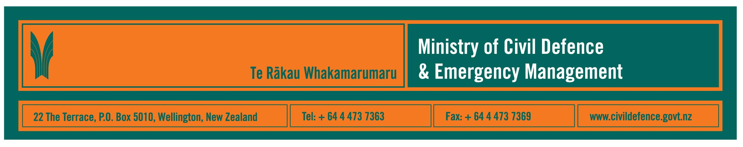

Media release 10 January 2008

900 civil defence events recorded in 2007: earthquakes, severe weather, tornadoes, floods, and an eruption

The Ministry of Civil Defence & Emergency Management announced today that it recorded 900 weather and geological events or emergencies last year.

“It has been a year of earthquakes, severe weather, tornadoes, floods, a lahar, an eruption, and tsunamis that threatened parts of the Pacific but, fortunately, did not impact New Zealand ,” the Ministry’s Director, John Hamilton, said. “The spread of events gives an important message.

“Northland was hit by flooding and severe weather, Southland and the lower South Island were shaken by earthquakes, Taranaki was hit by tornadoes, part of Otago flooded, Mt Ruapehu produced a lahar and an eruption and just before Christmas Gisborne suffered from an earthquake – the list goes on and covers pretty well the whole country.”

During 2007 civil defence emergencies were declared four times, in Northland, Otago, Taranaki and Gisborne. Again, these emergencies span the country north and south, east and west and it follows a historical pattern. In the last five years there have been 14 declarations, 12 because of flooding, which is by far the most common emergency.

“Clearly, nowhere in New Zealand is hazard-free. The challenge is to know what hazards different parts of the country face, to know what to do about them, and to be prepared,” Mr Hamilton said.

Emergency management organisations and researchers around the world have found that when people understand the hazards that they face and realise they can do things that will help their families and friends in an emergency, then the response to the issue is much better and communities recover faster.
“The first people to respond to an emergency will always be those who are right there at home, at work, at school, wherever we are when it happens,” Mr Hamilton said. “The recent Gisborne earthquake is an example. The first response was made by the people of Gisborne using the preparation, plans and resources that were immediately available.

“Kiwis have a reputation for initiative, community self-help and assisting their neighbours. The Gisborne response provides an excellent example of this trait. Those strengths become very important during emergencies, when New Zealanders have repeatedly shown that they will help each other.

“An emergency is not a hopeless situation. While local resources are likely to be stretched at first in an emergency, additional assistance from outside the region and local community is available and could include support from central and local government, the emergency services, welfare organisations, utilities like power, telephone, gas and transport networks and many others. They are ready to help when required but it could take some time to have them deployed. Hence the message that people and communities must be prepared to cope on their own initially.

“We cannot tell where or when the next crisis will strike. Civil defence is about everyone playing their part including being prepared and responding in an emergency. It involves individuals and family, households, workplaces and local communities as well as the organisations that have a responsibility to respond to an emergency.”

Civil defence emergency management (CDEM) activities in 2007 included:

- Continuously receiving and assessing information from New Zealand and international science organisations in case action is needed. The vast majority of the events recorded were public weather and sea swell warnings from the MetService and notifications of earthquakes by GNS Science (there are about 15,000 earthquakes a year in and around New Zealand, most too small or too deep to be felt). In most cases knowing that the science organisation has issued that information publicly is all that is necessary and the Ministry and CDEM sector does not need to take any further action.
- The Department of Prime Minister and Cabinet published the country’s first National Hazardscape Report to give a comprehensive description of the geological, meteorological, biological, technological and social hazards facing us.
- Starting the reviews of what is, in effect, the CDEM sector’s operations manual, The Guide to the National Civil Defence Emergency Management Plan, and also of the 16 regional CDEM plans.
- Local, regional, national and international exercises and training. These included United Nations led training and exercises involving 24 countries and international agencies; Exercise Pandora, the largest CDEM exercise in the South Island for many years; the start of Exercise Ruaumoko in Auckland, which will develop into the country’s biggest CDEM exercise to date; and many exercises and training courses for people with CDEM roles in various organisations.
- The national public education campaign, Get Ready Get Thru, continued with national radio and television advertising and its website was translated into eight languages.
- The schools’ programme, What’s the Plan Stan, was expanded and a Te Reo version is being developed.
- Redevelopment of the Ministry’s website to ensure easier and quicker access to public information for families and businesses and to specialist or technical information for the CDEM sector.

Media contact

Public Information Manager, Vince Cholewa
Telephone: cellular 027 268 8463, work 04 495 6835
E-mail: vince.cholewa@dia.govt.nz

www.civildefence.govt.nz

