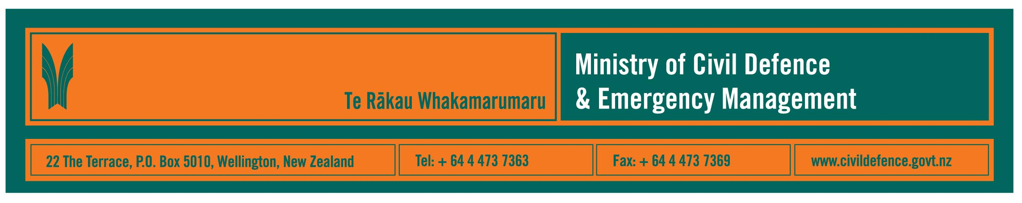

Media release 20 December 2007

Strong international links set as priority for Ministry

Maintaining strong international links has been set as a priority for the Ministry of Civil Defence & Emergency Management.

The Ministry’s Director, John Hamilton, said that few, and probably no, countries in the world can respond on their own to a major, national disaster.

“International engagement” was set as a Ministry priority in September this year, and the December issue of the Ministry’s quarterly journal, Impact, looks at how that is being done. Copies of Impact are available on the Ministry’s website http://www.civildefence.govt.nz/memwebsite.NSF/wpg_URL/For-the-CDEM-Sector-Publications-Impact?OpenDocument and from its Wellington office.

Mr Hamilton said that the Ministry’s international aims are to:
- ensure that, should New Zealand ever need it, we would receive international support quickly
- be a good global citizen by supporting other countries facing a major disaster, particularly our neighbours in the Pacific and Asia
- increase our own ability to respond in New Zealand by learning lessons from other countries and international exercises.

Since September, New Zealand’s contribution to international engagement has included:

United Nations Disaster Assessment and Co-ordination (UNDAC)
Upon request from a disaster-hit country, an UNDAC team would be deployed within hours. New Zealand contributes staff to teams being deployed from a pool of eight accredited members. New Zealand has hosted a training course and a full-scale deployment exercise for 24 countries and international organisations, which were jointly funded by the New Zealand and Australian governments.

International Search and Rescue Advisory Group (INSARAG)
INSARAG comprises countries and international groups that provide urban search and rescue (USAR) teams to international emergency responses. MCDEM and the New Zealand Fire Service have been involved in training and exercises in Asia and the Pacific, are leading the development of international training methods and guidelines, and will chair regional and international forums in 2008.
France, Australia and New Zealand arrangement (FRANZ)
France, Australia and New Zealand work together to plan how they would share information and resources in response to disasters in the Pacific. The Ministry contributed to a two-day exercise in Wellington, based on Cyclone Heta, which was a category 5 cyclone that devastated Niue and also hit Tonga and Samoa in 2004.
Memorandum of Understanding to support Pacific countries
MCDEM has signed an MOU with the New Zealand Agency for International Development so that MCDEM will continue to work closely with the Cook Islands, Tokelau, Niue, Tonga and Samoa as part of the New Zealand government’s aid funding. Activities to date have included exercises and training; and assessment, review and, where necessary, development of national disaster management plans.

Other information in Impact includes:
- major improvements and training in Auckland
- a new Yellow Pages agreement
- work with The Salvation Army and Volunteering NZ
- new and updated publications
- public education activity
- people in the civil defence emergency management sector
- faster messages to the sector
- specialist services available from the Ministry for the sector.

Media contact

Public Information Manager, Vince Cholewa
Telephone: cellular 027 268 8463, work 04 495 6835
E-mail: vince.cholewa@dia.govt.nz

www.civildefence.govt.nz

