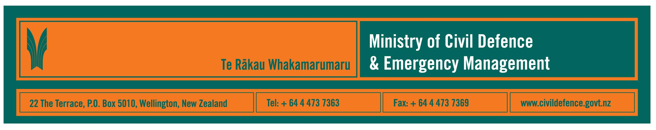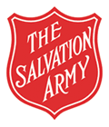

Media Release 4 December 2007

Ministry and Salvation Army strengthen emergency welfare

New Zealand’s ability to respond to civil defence emergency management (CDEM) events was strengthened today after the Ministry of Civil Defence & Emergency Management and The Salvation Army signed a memorandum of understanding (MOU) about welfare services.

The Director of the Ministry of Civil Defence & Emergency Management, John Hamilton, said that the MOU expands and formalises the Salvation Army’s long-standing involvement in response to civil defence emergencies.

Under the MOU The Salvation Army will, where possible, assist in planning for and recovering from a significant emergency by providing:
- stand alone catering units
- pastoral welfare support units
- welfare needs assessment units (clothing, furniture)
- meet and greet, reception
- trained critical incident stress support teams
- other welfare units as skills are identified.

The Salvation Army will be represented on the National Welfare Recovery Co-ordination Group and on each of the 16 regional CDEM Welfare Action Groups.

Salvation Army Territorial Commander, Commissioner Garth McKenzie, said that The Salvation Army appreciates the relationship that has developed with the Ministry over a number of years.

“Salvation Army Emergency Services staff and volunteers around the country stand ready to organise vital help such as catering, welfare support, emergency accommodation, and post-disaster counselling when needed. They also work closely with government departments such as the Ministry, local and regional authorities, and a range of non-government agencies,” Commissioner McKenzie said.

“By working together and understanding our roles we are better able to help people during their time of need.

“The Salvation Army has a proud history of providing practical help to emergency workers, victims and their families in time of crisis such as the Far North floods earlier this year.”

Media contacts:
Ministry of Civil Defence & Emergency Management
Public Information Manager, Vince Cholewa
Telephone: (04) 495 6835, cellular 027 268 8463
E-mail: vince.cholewa@dia.govt.nz

The Salvation Army
Territorial Media Officer / Communications Writer, David Youngmeyer
Telephone: (04) 802 6269 Extn 8250, cellular 027 200 5366
Email: david_youngmeyer@nzf.salvationarmy.org

