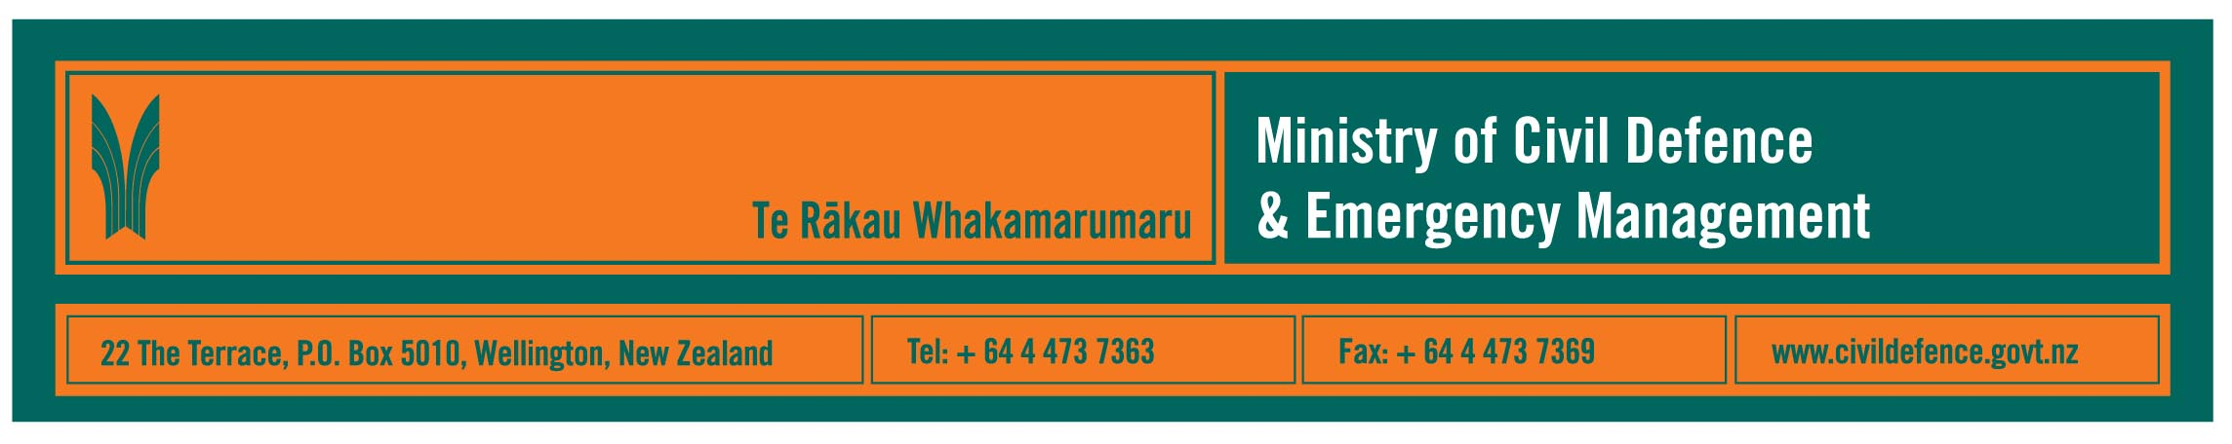

Media Release 8 October 2007

New on-line initiatives for public and
civil defence emergency management sector

As international Disaster Awareness Week gets underway, three on-line initiatives to help provide better information to the civil defence emergency management (CDEM) sector and the public have been announced.

The Director of the Ministry of Civil Defence & Emergency Management, John Hamilton, said that:

today, the Ministry launched its overhauled website www.civildefence.govt.nz
- the Ministry’s primary school teaching resource, “What’s the Plan Stan”, has been nominated for a Telecommunications Users’ Association of New Zealand (TUANZ) innovation award – the award winners are to be announced on Wednesday this week www.whatstheplanstan.govt.nz
- the website for the Ministry’s public education campaign, “Get Ready Get Thru”, has been translated into eight languages, making it one of the most extensively translated public education websites in New Zealand www.getthru.govt.nz .

The Ministry’s website has been overhauled to make access to information easier and quicker. It is now clearly divided into sections for:
- the latest information, which is the section that would be frequently updated during an emergency
- information for families, businesses and schools to use to prepare themselves, for teaching, and to be able to contact their local council’s CDEM staff
- specialist or technical information for the CDEM sector.

“What’s the Plan Stan” includes a website, CD-ROM, audio CD, children’s story book, activity cards, poster and teacher’s resource book.

“Teachers from throughout the country and experts from the CDEM sector developed the resource,” Mr Hamilton said. “It was released in April late year, updated with additional information in July this year and has been well received by schools.”

The website used with the “Get Ready Get Thru” campaign has been translated into Māori, Arabic, traditional and simplified Chinese script, Hindi, Korean, Samoan and Tongan.

These languages were chosen because they are the most requested by callers to the Department of Internal Affairs’ telephone service, “Language Line”, several communities read Arabic while speaking other languages, and the government is committed to continuing the promotion of Māori as an official language.

“Almost a quarter of New Zealanders were born in other countries,” Mr Hamilton said, “and we also have one of the highest levels of Internet use in the world.

“Making information easily available on line for the community and the sector is an important part of providing the information that people need to help them prepare, respond and recover.”

Media contact:

Public Information Manager, Vince Cholewa
Telephone: cellular 027 268 8463, work 04 495 6835

