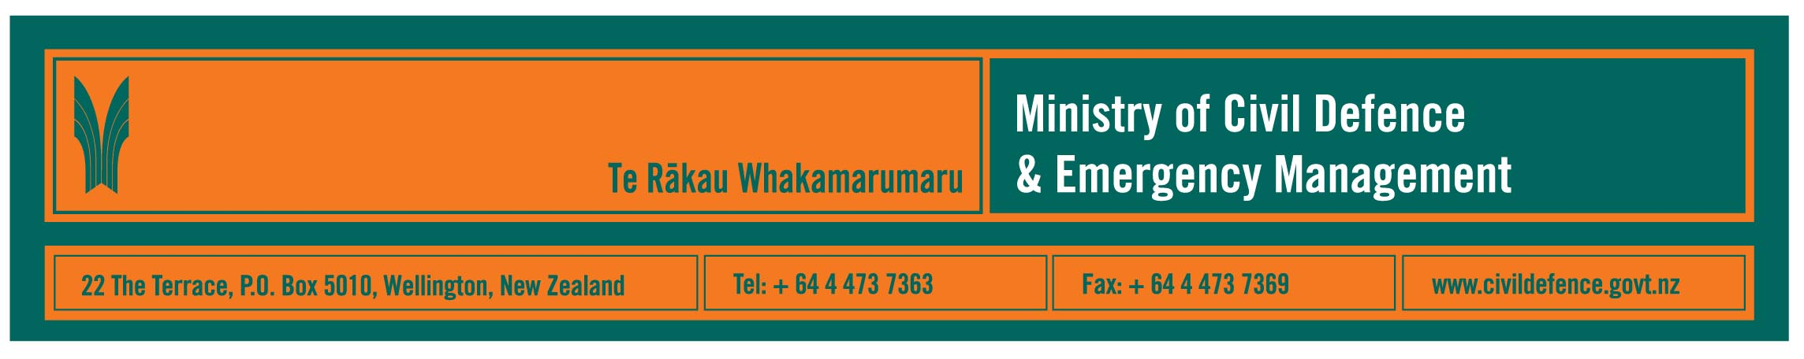

Media Release 4 October 2007

Volcanoes, earthquakes, tsunami, storms, floods, tornadoes: are you ready?

It’s Disaster Awareness Week next week and New Zealand has again shown us how unpredictable our country can be and why we need to get ready and be prepared.

“In the last week we have had a volcanic eruption, significant earthquakes and a tsunami advisory,” the Director of the Ministry of Civil Defence & Emergency Management, John Hamilton said. “Through the year we have had storms, floods and tornadoes. It’s time more people got ready.

“This week we started broadcasting the next round of our national ‘Get ready get thru’ advertising campaign.

“Publicity steps up next week during international Disaster Awareness Week. There will be national and regional advertising, and many local events organised by regional, district and city councils.

“I urge everyone to take a few simple steps to get ready. Have a plan for your family or household and a stock of emergency supplies.

“We know that while many people have food, they have not stored water. You should have a minimum of three litres per person per day.

“Some New Zealanders think that if they don’t think about it, it won’t happen. What I can tell them is that if they do get some water and food stored they will feel a lot better about facing an emergency.

“Any event affects the people who staff emergency services as well and can cut roads, power lines and phone links. Everyone in every house and business should be prepared to be on their own for three days. Have the basics – water, food, torch and radio.

“In a disaster, the first person to be there for you and your family will be you.”

Disaster Awareness events will be run in all regions – contact your local Civil Defence Emergency Management Group through your local council.

Go to www.getthru.govt.nz for more information and a checklist of the things you need to get ready.

See www.whatstheplanstan.govt.nz for the schools’ programme.

Visit http://www.civildefence.govt.nz/memwebsite.nsf/wpg_URL/For-the-CDEM-Sector-Public-Education-Disaster-Awareness-Week-2007?OpenDocument for information for the civil defence emergency management sector.

Media contact:

Public Information Manager, Vince Cholewa
Telephone: cellular 027 268 8463, work 04 495 6835

