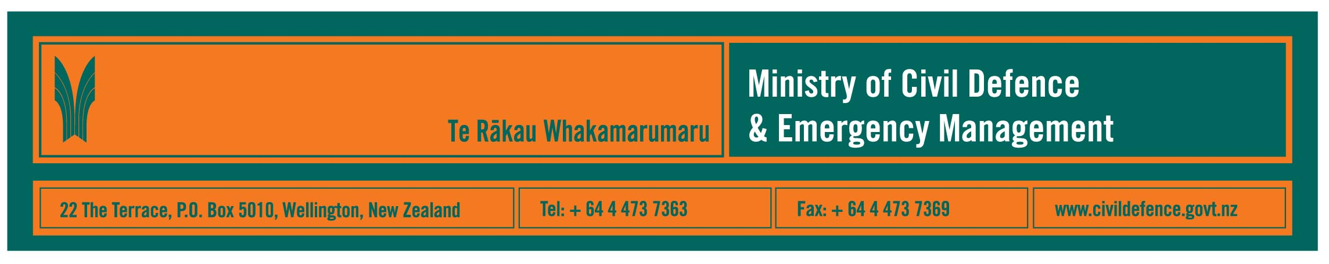

Media Release 3 October 2007

What Impact do hazards and risks have on N.Z.?

Impact is the Ministry of Civil Defence & Emergency Management’s quarterly journal.

The current issue includes:

- A summary of the National Hazardscape Report, published by the Officials Committee for Domestic and External Security Co-ordination. This is the first nationwide report to give a comprehensive description of the hazards facing our country. This is not solely the hazards usually associated with Civil Defence Emergency Management (CDEM) but also includes terrorism, biological, technological and social hazards. It is intended to inform policy makers from national to local levels. Hard copies are available from the Ministry and electronic copies will be available from its website www.civildefence.govt.nz from next week.
- Relevant points for New Zealand CDEM from the recent Peruvian earthquake. A New Zealand delegation visited Peru after the magnitude 8.0 earthquake caused extensive damage to the towns of Pisco, Ica, Chincha and Paracas.
- What would happen if there was a volcanic eruption in Auckland? A preview of the national-level Exercise Ruaumoko, which is due to start in November.
- Biggest ever South Island-wide CDEM exercise – a major earthquake on the main alpine fault.
- Review of the National Civil Defence Emergency Management Plan.
- New emergency operations centres for Kapiti Coast and Waitakere City.
- Training in Canterbury, Palmerston North and Wellington.
- A memorandum of understanding between the Ministry and Volunteering NZ to develop Internet-based support for emergency volunteers.
- Specialist services available to the CDEM sector from the Ministry.
- And, of course, storms, flooding and tornadoes.

Impact is aimed predominantly at the CDEM sector but also contains much of interest to a general audience. Copies are on http://www.civildefence.govt.nz/memwebsite.nsf/wpg_URL/For-the-CDEM-Sector-Publications-Impact?OpenDocument

Media contact:

Public Information Manager, Vince Cholewa

Telephone: 04 495 6835, cellular 027 268 8463

