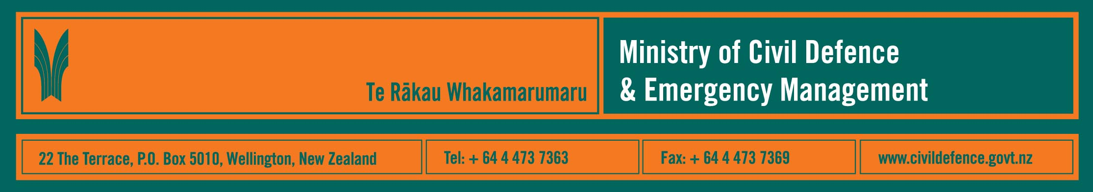

National Civil Defence Emergency Management Plan supported

Date: 15/05/06

The Ministry of Civil Defence and Emergency Management has assured citizens of Canterbury that the National Civil Defence Emergency Management (CDEM) Plan has been properly developed under the law. It is robust in dealing with major disasters from whatever cause.

The Plan is based on the principle that every agency with a role in managing disasters is expected to understand, plan for, and fufil that role.

The role of the Ministry is to direct the coordination needed to support communities and make the response to any disaster successful. The National Plan sets out the roles and arrangements in a complete and rigorous manner and without ambiguity.

The Canterbury CDEM group has criticised some parts of the plan and released a lengthy legal opinion from Wellington lawyers it has hired for the purpose.

But the Director of the Ministry of Civil Defence and Emergency Management, John Norton, says there are 16 CDEM groups around the country and the Plan has wide support among the other groups.

“Not everyone agrees with everything, but almost everyone agrees that we have a robust and workable plan. Even CDEM Canterbury has said it agrees with 85% of it. CDEM Canterbury’s concerns are primarily highly technical criticisms about the definition of words. For example, it is concerned that there is no definition of the term “lead agency”, although it is obvious to everyone what is meant.

“No person or property would be significantly safer if what CDEM Canterbury wants was to be implemented in its entirety. All CDEM groups have been involved in developing the National CDEM Plan and the Ministry has engaged in wide-ranging and detailed consultation.

“The Canterbury CDEM group is not responsible for the National
CDEM Plan. The Ministry is. It has been properly developed, provides what is needed, and does what the law requires. It is a significant step forward in developing Civil Defence preparedness in New Zealand. At some point everyone has to accept that we have a Plan, and just get on with it. There are many pressing issues in Civil Defence Emergency management. Highly technical litigation about definitions will not improve New Zealand’s preparedness.

“We are happy to listen, and have undertaken to look further into what CDEM Canterbury is saying, but we also have to listen to other CDEM groups, which want far more practical action.

“The law and the plan provide a framework for action. They are not themselves a solution. We concentrate on finding real solutions to real problems,” said Mr Norton.

For more information contact: John Norton 04 4956815 or Colin Feslier (Communications) 04 495 9460 0274 575 676

