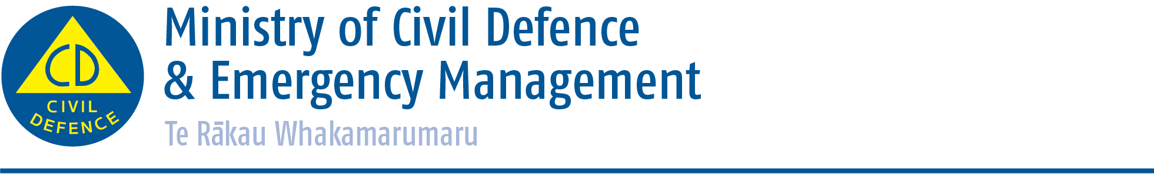

Media release

Sunday 21 June 2015
Update on regions affected by flooding
The Ministry of Civil Defence and Emergency Management has activated the National Crisis Management Centre this morning to be ready to support regions affected by flooding.

States of local emergency that were declared on 20 June in Wanganui, Rangitikei and Taranaki are still in place.

Director of Civil Defence Emergency Management, Sarah Stuart-Black, said rain has eased but some rivers are only expected to start receding by early afternoon today.

“We remain in contact with Civil Defence Emergency Management Groups throughout the event. People are advised to watch council websites for detailed updates on the situation, as well as the NZTA website for the latest information on the status of state highways.”

Wanganui
In Wanganui the weather has improved and is expected to be settled for the next 48 hours. Water levels are expected to start receding early afternoon today, therefore assessment of properties along the river have to be delayed.

Between 200 and 250 people have been evacuated by Civil Defence, but many more people have self-evacuated. About 100 homes have been affected on ANZAC Parade and may be inaccessible until Tuesday.

Slips are also present on ANZAC Parade and need to be assessed by geotechnical professionals before the road can re-open. City bridges are also closed and will not re-open until there have been structural assessments. The New Zealand Defence Force is assisting with the cordoning of areas at high risk.

Civil Defence Centres are open at Wanganui Gils College and at St Johns.

Power in the region is intermittent, but water is generally available.

Rangitikei
Assessments are underway in the Rangitikei region. Commercial and residential homes were flooded in Marton and 25 people were accommodated in the Civil Defence Centre overnight.

In Koitiata there is no cellphone coverage and landlines are working intermittently. A helicopter was sent to the area this morning.

Manawatu
Assessment of infrastructure has commenced in Manawatu. There was a late surge last night with the southern end of the Manawatu river spilled over, and up to eight people needed to be evacuated.
Water contamination is expected due to power loss to sewage pumps. People across the region are advised to save water and limit flushing of toilets to avoid contamination.
Palmerston North
There are some slips and surface flooding in and around the Palmerston North area, but in general the district has coped well.

Horowhenua
In Levin there were a number of evacuations overnight and transient travelers had to be assisted. There were also some evacuations in Foxton.

More rain is expected between 6pm and midnight tonight in Horowhenua; the situation will be closely monitored. Water and waste water may become an issue.
ENDS

Media contact
Ministry of Civil Defence & Emergency Management
Public Information Duty Officer
24/7 media phone: 04 494 6951
E-mail: pim@ncmc.govt.nz

- Follow the Ministry on Twitter or subscribe to our RSS feed
-  If a disaster happened now, would you be ready? www.getthru.govt.nz

