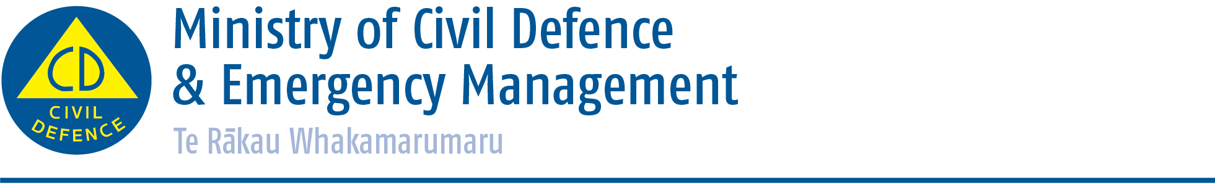

Media release 12 June 2015
Logistics guideline published

The Ministry of Civil Defence & Emergency Management today published Logistics in CDEM: Director's Guidelines for Civil Defence Emergency Management Groups. This will complete another recommendation from the Review of the CDEM Response to the 22 February 2011 Christchurch Earthquake.
Director of Civil Defence Emergency Management Sarah Stuart-Black says the new Civil Defence Emergency Management (CDEM) Logistics Guideline will help lay the foundation for more effective and efficient emergency response.
The guideline provides logistics staff, controllers, and others working closely with the logistics function with consistent guidance on providing logistics support during response or recovery.
Mrs Stuart-Black said that logistics was a key part of a successful response to any emergency.
“It means that the right resources are provided at the right time, in the right place, in the right quantities, and in the right condition,” she said.
“Without the right resources, responders may not be able to operate effectively. Logistics is key to enabling emergency response agencies to meet the needs of the community.”
The guideline will serve as a key reference for training and professional development for logistics staff. It will provide a thorough overview of the logistics function, how it is applied in a CDEM context, and include a number of templates and suggested processes to make this information more accessible.
Logistics in CDEM: Director’s Guidelines for Civil Defence Emergency Management Groups is available to download from the Ministry’s website at www.civildefence.govt.nz/cdem-sector/cdem-framework/guidelines
Media contact
Public Information Manager
Ministry of Civil Defence & Emergency Management
24/7 media phone: 04 494 6951
E-mail: pim@ncmc.govt.nz

Twitter https://twitter.com/nzcivildefence; https://twitter.com/nzgetthru
Facebook https://www.facebook.com/NzGetThru?fref=ts
If a disaster happened now, would you be ready? www.getthru.govt.nz

