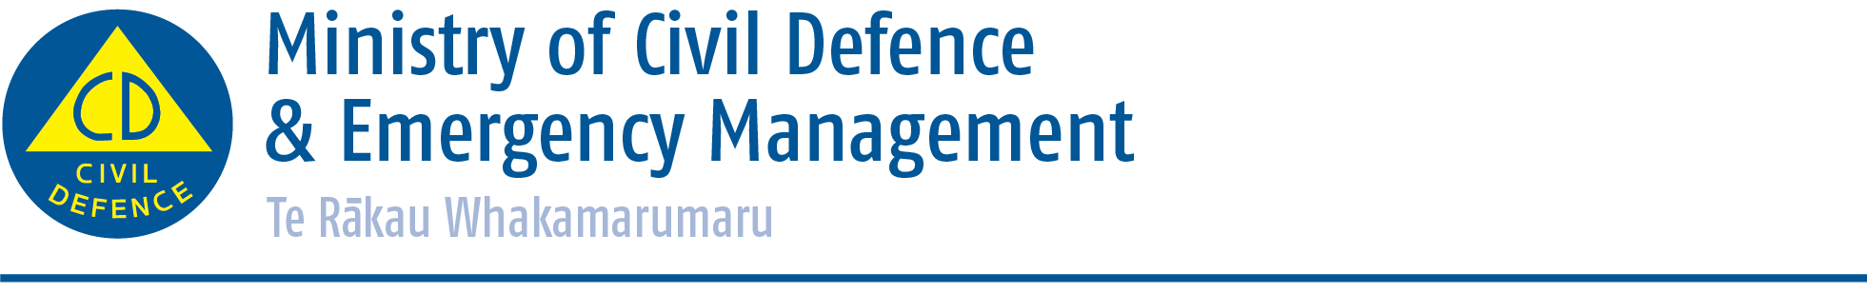

Media release

1 October 2014
Changes to Pacific Tsunami Warning Centre messages
The Ministry of Civil Defence & Emergency Management advises that while changes to Pacific Tsunami Warning Centre messages come into effect from today (Wednesday 1 October), the Ministry has been, and remains, the authoritative voice for tsunami advice in New Zealand.

Based in Hawaii, the Pacific Tsunami Warning Centre (PTWC) provides information on all earthquakes in the Pacific which could have a tsunami impact in the Pacific Rim countries and island states. This information is based on data from over 400 seismic stations.

From today, the PTWC will start issuing new, enhanced tsunami messages with some changes to terminology.

The terms ‘Warning’ or ‘Watch’ will no longer be used in PTWC messages. Instead, they will now provide ‘Threat forecast levels’ along coastlines. This change has been made as individual countries are responsible for the safety of their own populations, and therefore the designation of a warning status will be the sole responsibility of the national tsunami warning centre in each country (which is the Ministry of Civil Defence & Emergency Management in New Zealand).

PTWC will also no longer issue ‘Tsunami Cancellations’. Instead a ‘Final Threat Message’ will be issued and it will again be the sole responsibility of individual countries to cancel their own warning status if they had designated such a status.

Director of Civil Defence Emergency Management John Hamilton said it was important to note that even before these changes, only messages issued by the Ministry represented the official tsunami warning/advisory status for New Zealand. This authority remains under the changes to the PTWC system.

“The PTWC messages are a trigger to start a New Zealand response if one is needed,” Mr Hamilton said. “The Ministry uses that information as well as additional assessment by GNS Science to decide the threat status for New Zealand, and our warnings and advisories will continue to be in the same format. It is only the information the media and others may receive from PTWC that will look different.”

Mr Hamilton said the Ministry also wished to remind the public that an official warning was only possible for distant (more than three hours warning time) and regional source (one to three hours warning time) tsunamis.

“For a tsunami generated very close to New Zealand there simply won’t be time for an official warning,” he said. “It is therefore important to prepare before a tsunami and be able to recognise the natural warning signs so you can act quickly.”

If you are at the coast and experience any of the following, then move immediately to the nearest high ground, or as far inland as possible:

- Feel a strong earthquake that makes it hard to stand up, or a weak rolling earthquake that lasts a minute or more;
- See a sudden rise or fall in sea level;
- Hear loud and unusual noises from the sea

More information on how to prepare for tsunamis is available online at www.getthru.govt.nz/disasters/tsunami or from your local council.

ENDS

Media contact
Ministry of Civil Defence & Emergency Management
Public Information Duty Officer
24/7 media phone: 04 494 6951
E-mail: pim@ncmc.govt.nz

- Follow the Ministry on Twitter or subscribe to our RSS feed
-  If a disaster happened now, would you be ready? www.getthru.govt.nz

