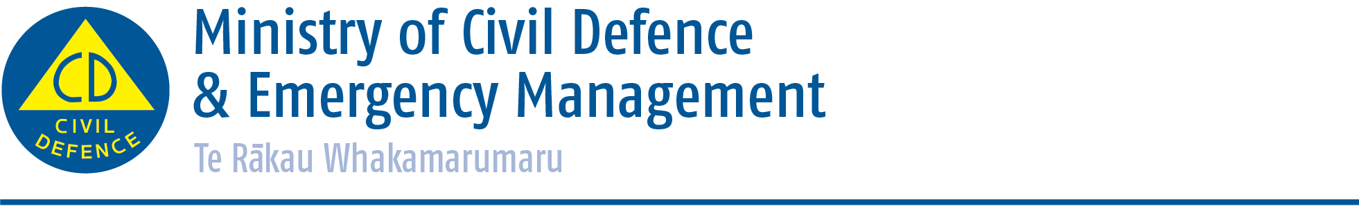

Media release Thursday 8 October 2015
Seven Day Countdown to ShakeOut earthquake drill
With just seven days to go until New Zealand’s national ShakeOut earthquake drill, a challenge is going out to every business and family in the country to sign up now to help them ‘get ready and get thru’ if there is a disaster.

So far 1.136 million people are registered to do the ‘drop, cover and hold’ drill for ShakeOut next Thursday at 9.15am.

Young people through their schools or educational organisation are leading the way with around:
- 90,000 preschool students registered
- 566,000 school students registered
- 121,000 tertiary students registered
- And another 1300 or so other young people registered.

Tens of thousands of people working at businesses around the country will also take part next Thursday with almost 130,000 staff at businesses registered for ShakeOut.

“The ShakeOut national drill gives each and every one of us the chance to think about our plans if there is an emergency, and to drop, cover and hold with our workmates, schoolmates, friends, family members and customers,” says David Coetzee, Acting Director, Ministry of Civil Defence & Emergency Management.

“If you haven’t signed up yet do it today, then think about and plan what you will do before, during and after the drill takes place.”

Registration and getting information about what to do is easy. Just go to www.shakeout.govt.nz/index.html

“While it’s a serious message we are getting out to people, there are a lot of people doing interesting and unique things to prepare for the ShakeOut drill and for doing it on the day,” says Mr Coetzee.

Check out some of the videos
Thunderbirds are go for Shakeout https://www.youtube.com/watch?feature=player_detailpage&v=zriayC6NDcs&list=PLkRilRMAiBueBIXGZY1_VqSJRGnEMQPVP
Peter Jackson and Richard Taylor preparing for ShakeOut
https://www.youtube.com/watch?v=jQ3AMx9a5jU&index=1&list=PLkRilRMAiBueBIXGZY1_VqSJRGnEMQPVP
Taika Waititi on ShakeOut
https://www.youtube.com/watch?v=rhwRJWiNMek&index=7&list=PLkRilRMAiBueBIXGZY1_VqSJRGnEMQPVP

Airports, hospitals, universities, banks, power companies and Parliament are amongst those organisations taking part. Go to the Get Thru Facebook page which shows what some people are doing.

Media contact
Ministry of Civil Defence & Emergency Management
Public Information Duty Officer
24/7 media phone: 04 494 6951
E-mail: pim@ncmc.govt.nz

- Follow the Ministry on Twitter or subscribe to our RSS feed
-  If a disaster happened now, would you be ready? www.getthru.govt.nz

