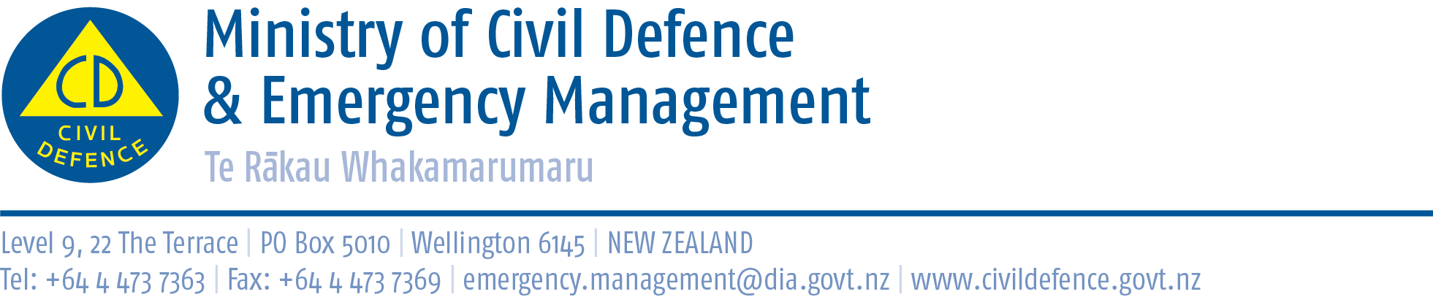

Media release 13 February 2014
Civil Defence welcomes Statistics NZ preparedness data
Statistics New Zealand survey results released today confirm the trend of more and more households being prepared for emergencies but, overall, the total is still low.
The Director of Civil Defence Emergency Management, John Hamilton, said the Ministry’s annual preparedness survey carried out since 2006 shows the same pattern. The Ministry’s 2013 survey showed, nation-wide, 17 per cent of households were fully prepared (2006, 7 per cent).
The measures of preparedness and sampling methods used in the two surveys are similar but not identical. However, importantly, they show the same trend of slowly increasing preparedness over time.
“The message is we are getting improvements but we cannot be complacent, as the Canterbury, Cook Strait and Eketahuna earthquakes showed us.
“Importantly, it is not just earthquakes. Winter is coming, and not just on the TV show Game of Thrones! We will have storms, slips and floods, just like we do every year. They can cut roads, power, water and other services.
“Being fully prepared with enough stored food and water for three days or more, and having a plan for what we will do when some of us are at home and others at work, school or elsewhere helps in all civil defence emergencies.
“Being prepared means we and our loved ones will get thru better and recover faster.”
The percentage of people with emergency supplies at home is high, 85 per cent in the Ministry’s 2013 survey. It is people not having plans for what to do, especially when they are not at home, that drops the percentage described as fully prepared.
The Ministry, the regional Civil Defence Emergency Management Groups, and councils are continuing the national public education programme. This includes the Get Ready Get Thru campaign, What’s the Plan Stan? schools programme, Yellow pages advertising, and regional and local events and promotions.
To find out how to prepare and what to do before, during and after emergencies go to www.getthru.govt.nz

Media contact
Ministry of Civil Defence & Emergency Management
Public Information Duty Officer
24/7 media phone: 04 494 6951
E-mail: pim@ncmc.govt.nz

- Follow the Ministry on Twitter or subscribe to our RSS feed
-  If a disaster happened now, would you be ready? www.getthru.govt.nz

