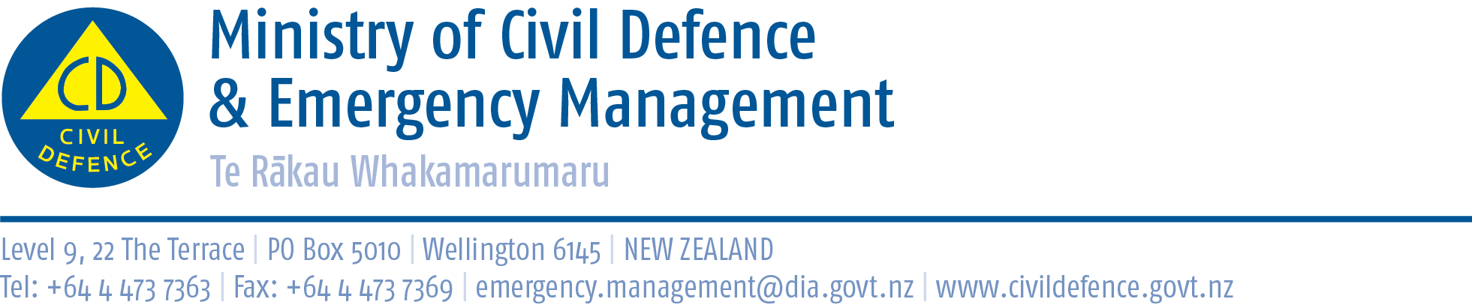

Media release 18 December 2013

Rapid Impact Assessment guidelines published
Ministry of Civil Defence & Emergency Management Rapid Impact Assessment was published today as new guidance to be used by staff carrying out rapid impact assessments.
The Director of Civil Defence Emergency Management, John Hamilton, said a rapid impact assessment is carried out in the first hours after an emergency. It quickly provides a broad picture of the scale and location of the damage and impact, and is used to guide what the initial response should be, direct the initial deployment of resources, and identify where more detailed assessments are needed.
The new publication will give all civil defence emergency management organisations a consistent approach for how they carry out a multi-agency rapid impact assessment, leading to better cooperation, a fast response and better recovery. It includes information on:
- gathering information
- rapidly determining the impact of the emergency and identifying where more in-depth assessment is needed
- establishing a standard process for collection, collation, analysis and reporting impact-related information
- planning and prioritising
- providing information to responding agencies, emergency services, and local and central government
It is set out in sections explaining rapid impact assessment, preparation before an emergency, and activation during an emergency, and includes template forms that can be copied and used as required.
Copies of Rapid Impact Assessment have been sent to civil defence emergency management agencies and emergency services, and are available from the Ministry’s website at http://www.civildefence.govt.nz/memwebsite.nsf/wpg_URL/For-the-CDEM-Sector-Publications-Rapid-Impact-Assessment-Information-for-the-CDEM-sector

Media contact
Ministry of Civil Defence & Emergency Management
Public Information Duty Officer,
Telephone: 04 494 6951
E-mail: pim@ncmc.govt.nz

Follow the Ministry on Twitter or subscribe to our RSS feed

 If a disaster happened now, would you be ready? www.getthru.govt.nz

