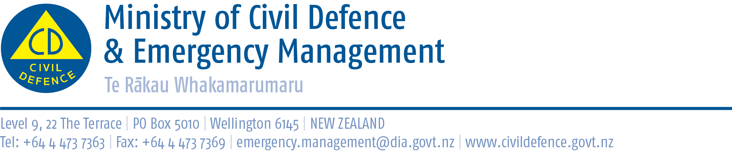

Media release 30 September 2013

Tsunami review reinforces need for public preparedness
The Review of Tsunami Hazard in New Zealand (2013 Update), released today, reinforces the need for the public to understand and be prepared to respond to the threat of a tsunami.
Summary of the three key points arising from the review:
- The probability of a tsunami has not changed but the maximum possible size of a tsunami in some areas has increased.
- A large tsunami generated very close to New Zealand would arrive before an official warning could be issued or sirens activated. People must know that if they are at the coast and feel a strong earthquake (it is hard to stand up) or a weak earthquake that lasts for a minute or more, then get to high ground or go inland. Do not wait for an official warning.
- Councils are responsible for warning communities and developing local plans.
The main areas where tsunami caused by local and regional sources pose a greater hazard than previously understood include:
- the coasts of Northland, the north-west part of the Auckland region, Great Barrier Island, the Coromandel Peninsula, and the Bay of Plenty;
- the East Cape of the North Island, and parts of the Wairarapa coast
- Southland, Stewart Island, Fiordland and Westland.
Resulting from the review, the Ministry of Civil Defence and Emergency Management will be:
- Emphasising the existing public messages about tsunami
http://www.civildefence.govt.nz/memwebsite.nsf/Files/Tsunami-national-signage/$file/tsunami-brochure-final.pdf
- Encouraging councils and the 16 regional CDEM Groups to reinforce the national public messages with more specific local and regional information.
- In October and November, with GNS Science, holding regional seminars for CDEM Groups and other response agencies. The seminars will be a chance to clarify the review and discuss matters related to tsunami warnings, including public preparedness and alerting.
The Director of Civil Defence Emergency Management, John Hamilton, said the Ministry commissioned GNS Science to carry out the review to update research published in 2005.
The review shows the maximum possible size of some local and regional tsunami is bigger than previously understood, though tsunami are no more likely. (A tsunami from a local earthquake would arrive in less than one hour, and that from a regional earthquake would arrive in one to three hours.)
This is because there is now more uncertainty about the maximum possible size of earthquakes on plate boundaries near those areas.
The review considers “return periods” of up to 2,500 years. That is, what is the biggest tsunami that can be expected in such a period?
The review incorporates research on the 2004 Indian Ocean, 2009 South Pacific, and 2011 Tohoku (Japan) tsunamis. All were produced by earthquakes substantially larger than had been considered likely at those locations. There are now believed to be fewer restrictions on maximum magnitudes of earthquakes that could be created on tectonic plate boundaries. New scientific models take into account this increased uncertainty about the maximum possible size of earthquakes.
It is now also known there was a similar tsunami in Japan in AD 869. This indicates the interval between the biggest earthquakes there is over 1,000 years.
The tectonic plates in Japan are converging twice as fast as those around New Zealand, which suggests the interval between the largest earthquakes on our local plate boundaries could be more than 2,000 years.
However, New Zealand has only a brief historical record of 200 years, which is not long enough to provide accurate reported information. During that time the country has experienced about 10 tsunami of 5 metres or more.

Download from www.civildefence.govt.nz
- Review of Tsunami Hazard in New Zealand (2013 Update)
- Maps showing the regional differences between the 2005 and 2013 reviews.

Media contact
Ministry of Civil Defence & Emergency Management
Public Information Duty Officer,
Telephone: 04 494 6951
E-mail: vince.cholewa@dia.govt.nz

Follow the Ministry on Twitter or subscribe to our RSS feed

 If a disaster happened now, would you be ready? www.getthru.govt.nz

