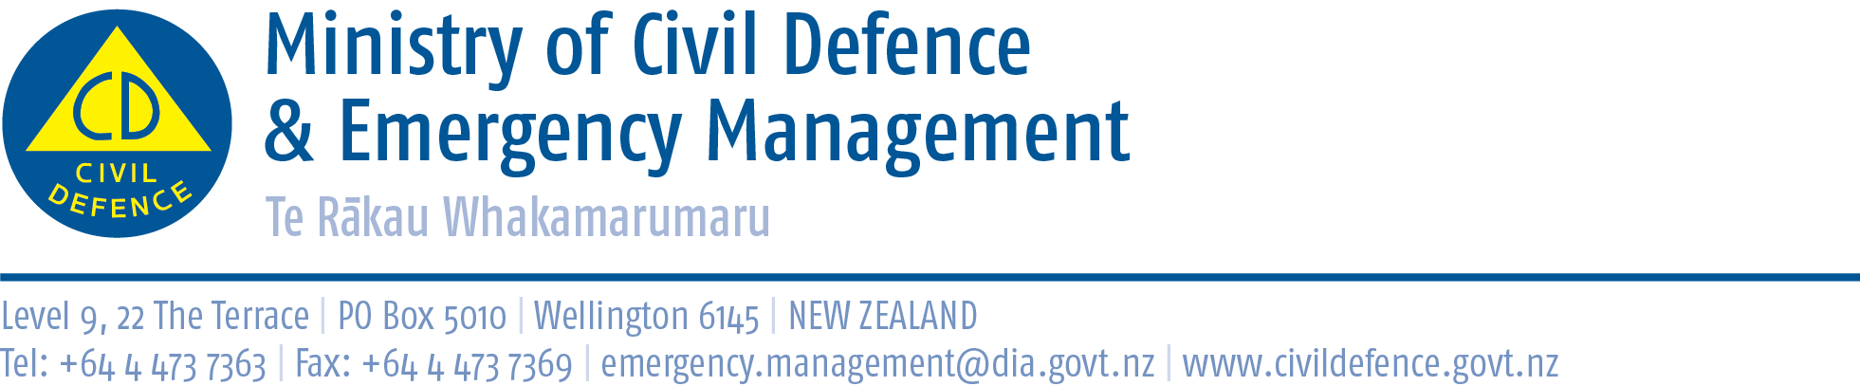
MEDIA RELEASE
23 September 2013
Get Ready Week 2013 kicks off today

Getting to know your neighbours and your community are the major themes for this year’s Get Ready Week which started today (23 September) and runs to 29 September, says John Hamilton, Director Civil Defence and Emergency Management.

Get Ready Week is supported by eight regional Civil Defence Emergency Management Groups across New Zealand.

John Hamilton says this year, Get Ready Week will be held against the backdrop of recent events including flooding and storm damage in central regions; earthquakes including severe shakes in Marlborough and Wellington and tsunami threats.
“These events are a timely reminder of the need for individuals, families and communities to get ready for a potential civil defence event. This year’s theme of, "Know your neighbours, know your community" provides a great opportunity for New Zealanders to get to know each other and make plans to help one another be prepared for a civil defence emergency.

“If we build awareness in local neighbourhoods across New Zealand then we can lift preparedness levels, improve community resilience, and ultimately save lives,” says John Hamilton.

Get Ready Week is being supported by a national television advertising programme starting today that will encourage people to make or update their plan and social media messaging alongside local and regional based activities.

John Hamilton says online materials and resources are available, including postcards and posters that can be printed out or shared and are aimed to encourage businesses, communities, schools, neighbours, families and friends to help one another to Get Ready. The material can be accessed at http://www.civildefence.govt.nz/memwebsite.nsf/wpg_URL/For-the-CDEM-Sector-Public-Education-Get-Ready-Week-2013?OpenDocument
ends

Other information
The United Nations organises a World Disaster Reduction Campaign each year which culminates on International Disaster Reduction Day, the second Wednesday in October. In New Zealand this is promoted as Get Ready Week and this year has been brought forward so schools can take part.

Schools have their own programme “What’s The Plan Stan?” that seeks to improve awareness and emergency preparedness in primary and intermediate schools by providing teachers and students with the knowledge and skills to act in a safe manner when a disaster occurs. Students’ increased awareness and understanding may also prompt their parents, families and communities to be better prepared.

So make time this week to check ... Do you know what radio stations to listen to for alerts and updates? Do you have enough water and food stored or does it need replacing? Do you have batteries ready for torches and radios? A first aid kit plus any essential medicines you need? Have you sat down at home to plan what you will do when an emergency occurs?

For more information, check inside the cover of the Yellow Pages for a guide or go online to www.getthru.govt.nz

Media Contact
Tony Wallace
Public Education Manager
Ministry of Civil Defence and Emergency Management
Phone 00 64 27 4402667, email: tony.wallace@dia.govt.nz

